Documentation Form

Overview

Owner History
Owner | From Date | To Date | Location | Cost
David Bailey | 2022-10-12 | -- | Centerville Antique Mall  200 W. Union Street  Centerville, IN 47330  765 855 5551  www.centervilleantiquemall.com | $112.50
 | If not purchased, the estimated cost for materials: $0

Display & Publication History
Date | Event | Location / Publication
Oct 7, 2024 | Montcomb County Quilter's Guild Meeting | Trinity Lutheran Church, Clinton Township, MI
Nov 18, 2024 | Anchor Bay Quilter’s Guild Meeting | New Baltimore, MI

General Description
Quilt Title or Name:  Red, Green & White Flower Reel / Dove Quilt | Fabric Date Range: 1850 ± 10 Years  Date Made: 1850 ± 10 Years  Method of Determination:
Item Type: | Size: Length: 82“ x Width: 65“
Appraisals:  Has this quilt been professionally appraised?  If so, when: --  ----------- | Other related files:
Additional Information: --

Images
Top | Back
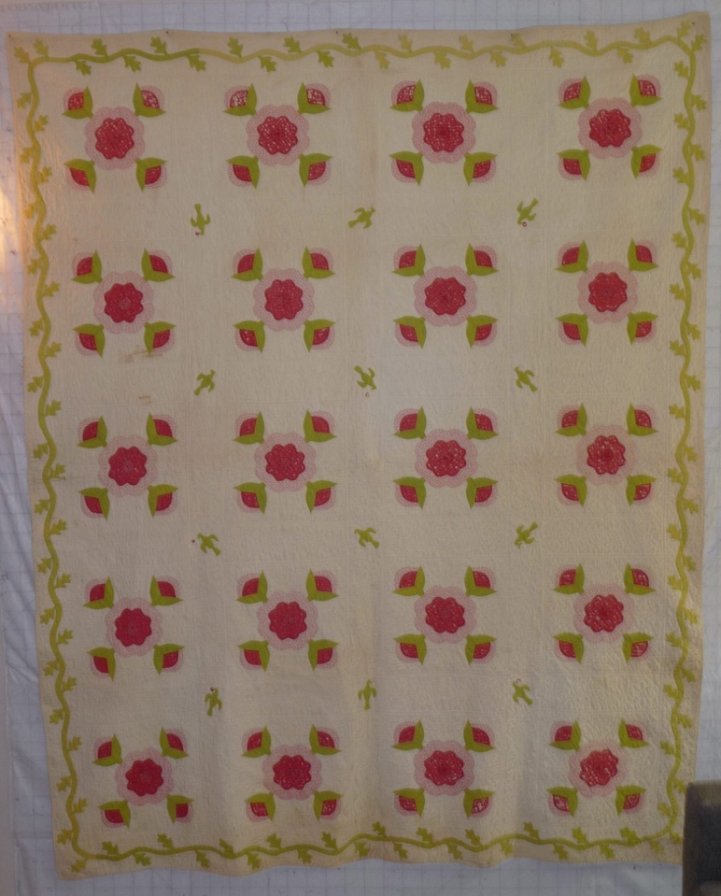 | 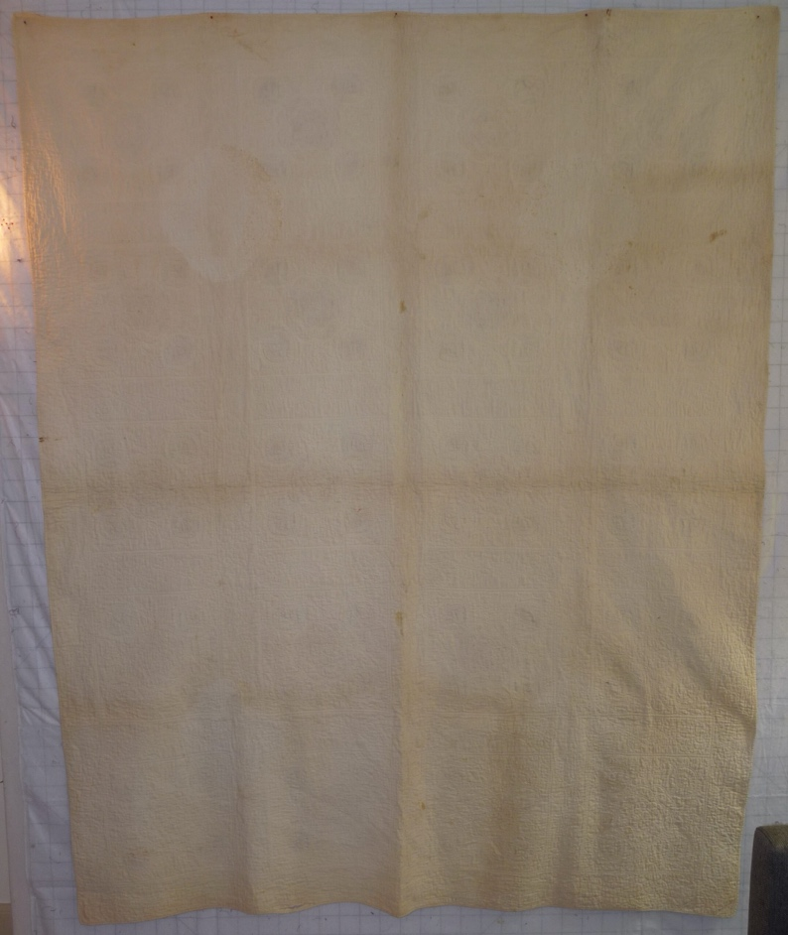

History

Provenance
Describe: --

Quilt Maker
Maker: unknown |  | Birth: -- |  | Death: --
 | Location: -- |  | Contributions: --

Purpose and Context
Expression
Art | Personal Enjoyment | Therapy
Income
Personal Income | Fundraising
Presentation
Anniversary | Wedding | Birth
Holiday | Birthday | Other gift
Charitable support
Relationships
Friendship | Commemorative | Memorial
Mourning | Reunion
Skill Building
Challenge / Contest | Learning / Teaching Sample
Use
Bed Quilt | Lap Quilt | Home Décor
Baby / Crib | Wall Hanging
Describe other purpose: --

Quilt Top Design & Construction

Quilt Top
Layout
. Describe: 4x5 grid of blocks with applique of roses and stems. Sashing present with cornerstones and dove & cherry applique. Border has leaf and vine applique. The red fabric for flowers likely shows some fall-out from a black printed dye. The green was likely obtained by a blue and yellow overdye. Since, the blue has started to fade and this results in a yellow green. The green have faded unevenly. While some of this might be explained by folding and light fading, some of the leaves are darker than the adjacent vine suggesting different dye lots or a different fabric source. The different greens are most noticable in the border along the short edges of the quilt. One half of one edge and nearly the entire other edge is darker than the long edges.
Blocks
Grid & Contained Crazy Details
 |  | Grid Dimensions: Length 5 x Width: 4
 |  | Block Size: Length: -0“ x Width: -0“
Block Pattern Details
 | Pattern source | <<Pattern Image>>
 | Pattern name & Brackman or other ID | <<Pattern Image>>

Piecing
Techniques
 |  | Machine pieced | String / Improvisational piecing
 |  | Hand pieced | Foundation piecing
 |  | Strip piecing | English paper piecing
 |  | Describe: --
 | Workmanship
 |  | Seams are stable | Seams are appropriately aligned
 |  | Seams are flat | Points are sharp
 |  | Describe piecing workmanship

Embellishments
Types:
 | Applique – Raw edge | Embroidery | Stuffed Work
 | Applique - Button-hole | Cording | Inking
 | Applique - Needle-turn | Beading | Painting
 | Applique - Reverse | Rhinestones / Gems | Marking lines noted
 | Applique - Other | Other: --
Workmanship
 | Stitches are appropriately small and even.
 | Edges are as design intends (straight, curved, pointed).
 | Work demonstrates appropriate skill for intended purpose.
 | Describe other techniques

Sashing
Length: 0“ x Width: 4“
Use of corner stones

Borders & Frames
Describe borders and frames in order from center to edge.
1 | Width: 4.00“
 |  | Describe: --

Top Assembly
Seams are stable | Top has no inappropriate tucks or puckers
Seams are flat | Top lays flat with no overly full areas
Seams are appropriately aligned

Color
Predominant colors
 | Red | Blue | Black
 | Orange | Violet/Purple | Grey
 | Yellow | Brown | White
 | Green | Beige / Tan
Specific Antique Colors |  | NONE NOTED | Neon prints
 | Red – claret / wine | Yellow – chrome | Blue – Lancaster
 | Red – madder / cinnamon | Green - chrome | Blue – Prussian / Lafayette
 | Red – turkey | Green – Nile | Brown – madder
 | Pinks - double | Blue – Cadet | Butterscotch
 | Orange - madder | Blue - Indigo | Bronze
 | Orange – cheddar / antimony / chrome |  | Late 1800’s Purple

Materials
Sources of Fabric |  | NOT KNOWN
 | Companies | Fabric Name & Number | Designer
 | -- | -- | --
 | Describe other sources: --
Fiber Types |  | NOT YET IDENTIFIED
 | Cotton | Silk | Wool
 | Cotton Blend | Linen | Synthetic
 | Describe & Clarify: --
Fabric Types |  | NOT KNOWN
 | Broadcloth | Sateen | Upholstery
 | Flannel | Satin | Chintz
 | Shirting | Muslin | Glazed
 | Suiting | Velvet | Handwoven
 | Denim | Felt | Lindsey-Woolsey
 | Describe & Clarify: --
Print Types |  | NOT YET IDENTIFIED
 | Batik | Floral | Plaid
 | Cheater Panel | Geometric | Solid / Plain
 | Checked / Gingham | Hand-dyed | Stamped
 | Conversation / Novelty | Victorian Mourning Prints | Stripes
 | Dotted | Multiple scraps
 | Feed sack / Feed sack-like | Paisley
 | Describe & Clarify: -

Images for Top
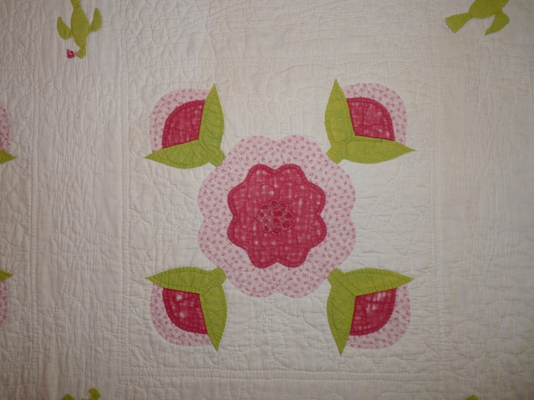 | 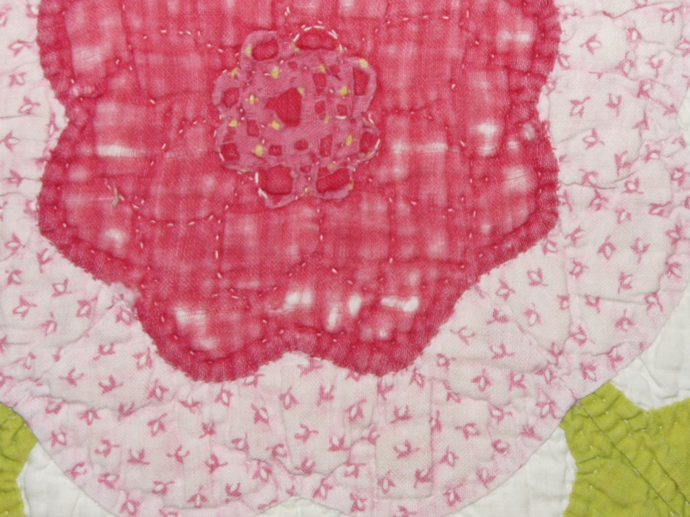

Top Inscriptions
None Found
Inscription is present. Describe location: --
Content
Makers names | Initials | Date
Single Name | Message | Place
Multiple Names
Transcription: --

Methods
Label | Ink – Ball point | Stencil
Printed onto fabric | Ink – Felt tip | Stamped
Quilted | Ink - Other | Pencil
Embroidery | Applique | Typewriter
Describe & Clarify: --

Images for Inscriptions

Quilt Back Design & Construction

Quilt Back
Layout
. Describe: -White cotton. Seams-

Stabilization Method
Stabilization Method:
Batting
Quilting Techniques
 | Machine Quilted | Machine – sit-down | Corded
 | Machine – computer guided | Hand Quilted | Stuffed work
 | Machine – manual long-arm | Quilt-as-you-go
 | Describe: --
Quilting Patterns
 | Meander / Free motion | Lines – single parallel | Cables
 | In-the-ditch / To the piece | Lines – double parallel | Feathers
 | Echo / Outlined | Lines – triple parallel | Wreaths
 | Stipple | Grid – crosshatch | Vines
 | Clamshell | Grid – square | Floral
 | Elbow / Fan | Grid - diamond | Leaves
 | Describe other: --
Thread Choices
 | Brand | Weight | Number & Name
 | -- | -- | --
Images for Quilting

Edge Finish
Edge Style:
Finishing Technique
Top Width: 0.13 “ | Binding | Rolled – top to back
Back Width: 0.13“ | Front – machine | Rolled – back to top
1/8 = 0.13, 3/8 = 0.38 | Front – hand | Knife edge
5/8 = 0.63, 7/8 = 0.88 | Back – machine | Turned
 | Back - hand
Embellishments
Fringe | Ruffles | Cording
Lace | Ribbon
Describe: --

Images for Edge

Condition

Flaws
Soiling
Dirty | Stains
Mildew stains | Musty Smell
Discoloration
Running / fugitive color | Faded / bleached color | Crocking
Fabric Damage
Tears / holes | Disintegrating / fall out | Insect damage
Thread bare | Shattering
Sewing / Quilting Damage
Split / open seams | Ties / tufting missing | Embellishments missing
Quilting threads missing | Batting has shifted
Storage Issues
Discoloration from wood | Damage from acid | Fold marks / creases
Describe additional condition issues: -Stains are on back-
Images for Condition Issues

Conservation, Restoration, Repairs
Describe Measures: --

Workmanship

Extension of Useful Life
Repair | Useful life of the item was extended.
Prevention of Damage
Conservation | All work is reversible.
Conservation | Further deterioration has been slowed, stabilized or prevented.
Maintaining Function & Integrity
Conservation | Work minimally interferes with the item’s overall appearance.
Restoration | Work blends well with the item’s overall appearance, style and age.
Restoration | Appropriate period reproductions were used.
Restoration | Vintage materials were used.
Restoration | Period appropriate techniques were used.
Restoration | Workmanship is of similar or better quality than original work.

Images for Conservation / Restoration / Repairs

