Documentation Form

Overview

Owner History
Owner | From Date | To Date | Location | Cost
David Bailey | 2021-12-29 | -- | Oakton Street Antique Center  2430 East Oakton Street  Arlington Heights, IL 60005  847 437 2514 | $119.00
 | If not purchased, the estimated cost for materials: $0

Display & Publication History
Date | Event | Location / Publication
Oct 7, 2024 | Montcomb County Quilter's Guild Meeting | Trinity Lutheran Church, Clinton Township, MI
Nov 18, 2024 | Anchor Bay Quilter’s Guild Meeting | New Baltimore, MI

General Description
Quilt Title or Name:  Crazy Quilt | Fabric Date Range: 1895 ± 15 Years  Date Made: 1900 ± 10 Years  Method of Determination:
Item Type: | Size: Length: 85“ x Width: 71“
Appraisals:  Has this quilt been professionally appraised?  If so, when: 2022-09-30  ----------- | Other related files:
Additional Information: --

Images
Top | Back
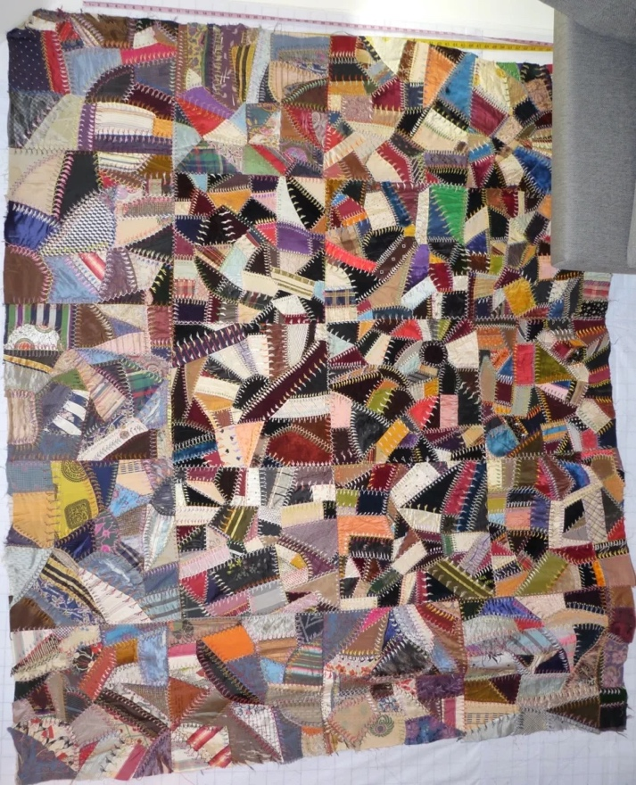 | 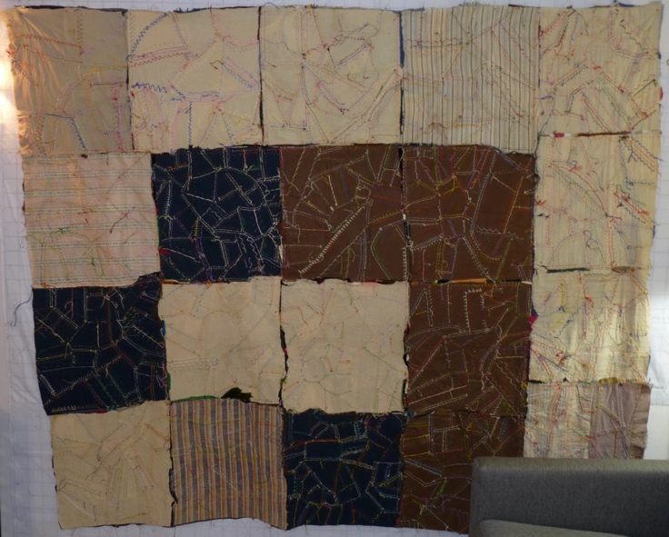

History

Provenance
Describe: --

Quilt Maker
Maker: unknown |  | Birth: -- |  | Death: --
 | Location: -- |  | Contributions: --

Purpose and Context
Expression
Art | Personal Enjoyment | Therapy
Income
Personal Income | Fundraising
Presentation
Anniversary | Wedding | Birth
Holiday | Birthday | Other gift
Charitable support
Relationships
Friendship | Commemorative | Memorial
Mourning | Reunion
Skill Building
Challenge / Contest | Learning / Teaching Sample
Use
Bed Quilt | Lap Quilt | Home Décor
Baby / Crib | Wall Hanging
Describe other purpose: --

Quilt Top Design & Construction

Quilt Top
Layout
. Describe: Contained crazy quilt design in a 5x4 grid of 17" blocks. Pieced and embroidered onto fabric foundation. it seems likely that some of the blocks were made from different fabric sources or experienced different storage conditions because their colors are not as vibrate..
Blocks
Grid & Contained Crazy Details
Grid Dimensions: Length 5 x Width: 4
Block Size: Length: 17“ x Width: 17“

Piecing
Techniques
 |  | Machine pieced | String / Improvisational piecing
 |  | Hand pieced | Foundation piecing
 |  | Strip piecing | English paper piecing
 |  | Describe: --
 | Workmanship
 |  | Seams are stable | Seams are appropriately aligned
 |  | Seams are flat | Points are sharp
 |  | Describe piecing workmanship

Embellishments
Types:
 | Applique – Raw edge | Embroidery | Stuffed Work
 | Applique - Button-hole | Cording | Inking
 | Applique - Needle-turn | Beading | Painting
 | Applique - Reverse | Rhinestones / Gems | Marking lines noted
 | Applique - Other | Other: --
Workmanship
 | Stitches are appropriately small and even.
 | Edges are as design intends (straight, curved, pointed).
 | Work demonstrates appropriate skill for intended purpose.
 | Describe other techniques

Top Assembly
Seams are stable | Top has no inappropriate tucks or puckers
Seams are flat | Top lays flat with no overly full areas
Seams are appropriately aligned

Color
Predominant colors
 | Red | Blue | Black
 | Orange | Violet/Purple | Grey
 | Yellow | Brown | White
 | Green | Beige / Tan
Specific Antique Colors |  | NONE NOTED | Neon prints
 | Red – claret / wine | Yellow – chrome | Blue – Lancaster
 | Red – madder / cinnamon | Green - chrome | Blue – Prussian / Lafayette
 | Red – turkey | Green – Nile | Brown – madder
 | Pinks - double | Blue – Cadet | Butterscotch
 | Orange - madder | Blue - Indigo | Bronze
 | Orange – cheddar / antimony / chrome |  | Late 1800’s Purple

Materials
Sources of Fabric |  | NOT KNOWN
 | Companies | Fabric Name & Number | Designer
 | -- | -- | --
 | Describe other sources: --
Fiber Types |  | NOT YET IDENTIFIED
 | Cotton | Silk | Wool
 | Cotton Blend | Linen | Synthetic
 | Describe & Clarify: --
Fabric Types |  | NOT KNOWN
 | Broadcloth | Sateen | Upholstery
 | Flannel | Satin | Chintz
 | Shirting | Muslin | Glazed
 | Suiting | Velvet | Handwoven
 | Denim | Felt | Lindsey-Woolsey
 | Describe & Clarify: -There are likely ribbons present also.-
Print Types |  | NOT YET IDENTIFIED
 | Batik | Floral | Plaid
 | Cheater Panel | Geometric | Solid / Plain
 | Checked / Gingham | Hand-dyed | Stamped
 | Conversation / Novelty | Victorian Mourning Prints | Stripes
 | Dotted | Multiple scraps
 | Feed sack / Feed sack-like | Paisley
 | Describe & Clarify: --

Images for Top

Top Inscriptions
None Found
Inscription is present. Describe location: --
Content
Makers names | Initials | Date
Single Name | Message | Place
Multiple Names
Transcription: --

Methods
Label | Ink – Ball point | Stencil
Printed onto fabric | Ink – Felt tip | Stamped
Quilted | Ink - Other | Pencil
Embroidery | Applique | Typewriter
Describe & Clarify: --

Images for Inscriptions

Condition

Flaws
Soiling
Dirty | Stains
Mildew stains | Musty Smell
Discoloration
Running / fugitive color | Faded / bleached color | Crocking
Fabric Damage
Tears / holes | Disintegrating / fall out | Insect damage
Thread bare | Shattering
Sewing / Quilting Damage
Split / open seams | Ties / tufting missing | Embellishments missing
Quilting threads missing | Batting has shifted
Storage Issues
Discoloration from wood | Damage from acid | Fold marks / creases
Describe additional condition issues: --
Images for Condition Issues

Conservation, Restoration, Repairs
Describe Measures: -I have started to replace some of the shattered silks. This work is being done by Mani Pillai. Replacement fabric was discarded silk ties from by husband.-

Workmanship

Extension of Useful Life
Repair | Useful life of the item was extended.
Prevention of Damage
Conservation | All work is reversible.
Conservation | Further deterioration has been slowed, stabilized or prevented.
Maintaining Function & Integrity
Conservation | Work minimally interferes with the item’s overall appearance.
Restoration | Work blends well with the item’s overall appearance, style and age.
Restoration | Appropriate period reproductions were used.
Restoration | Vintage materials were used.
Restoration | Period appropriate techniques were used.
Restoration | Workmanship is of similar or better quality than original work.

Images for Conservation / Restoration / Repairs
Before | After
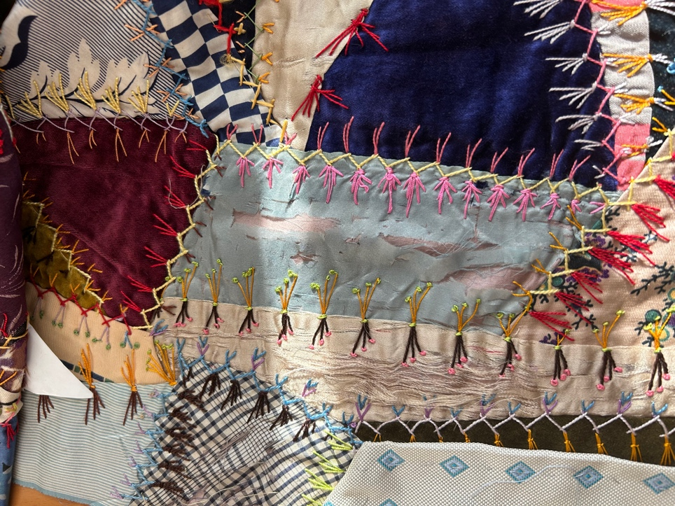 | 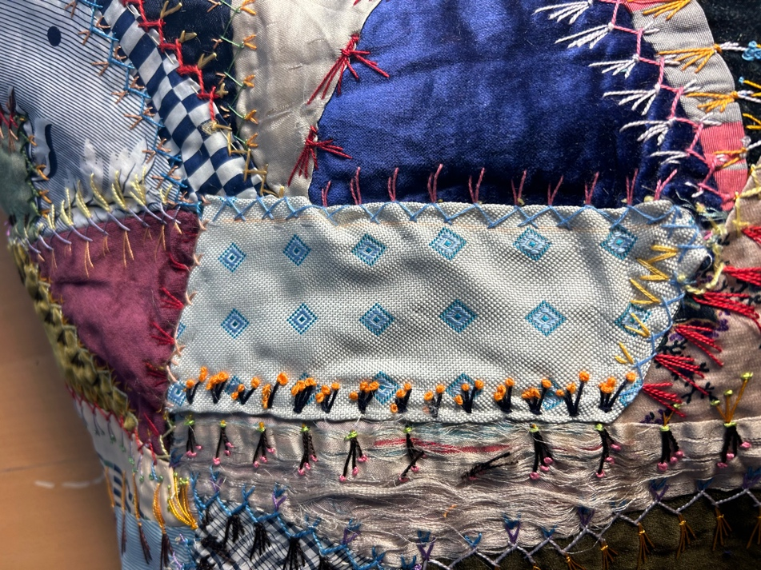
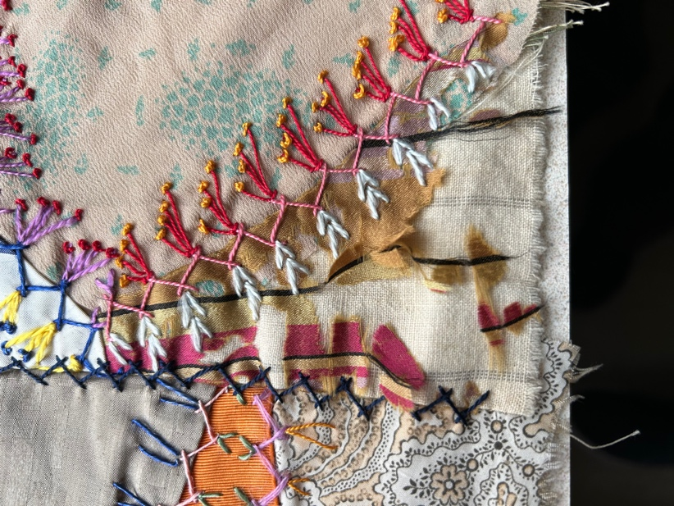 | 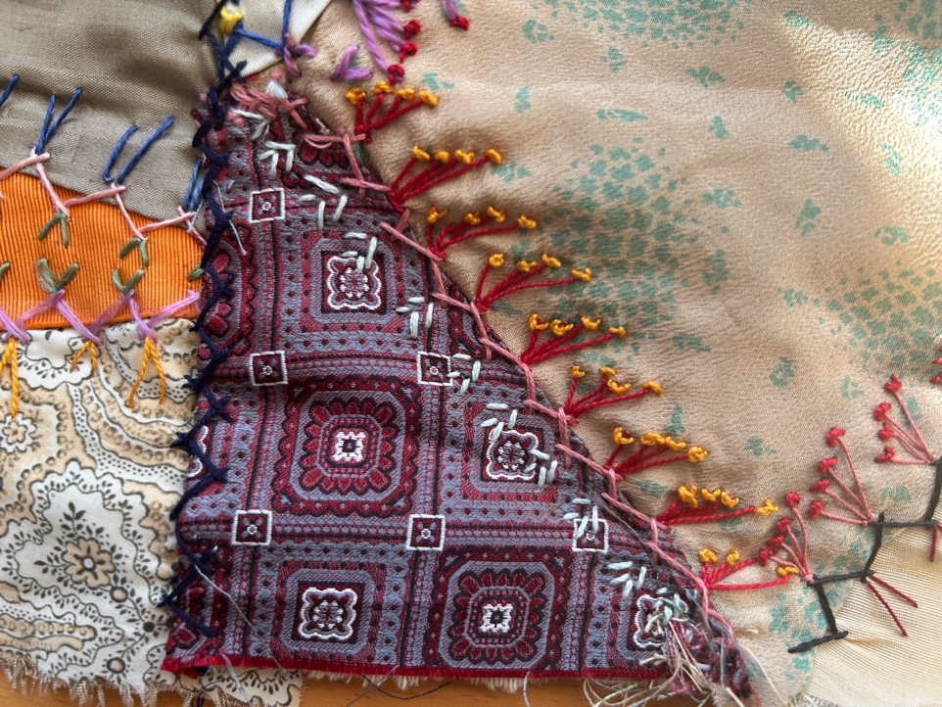
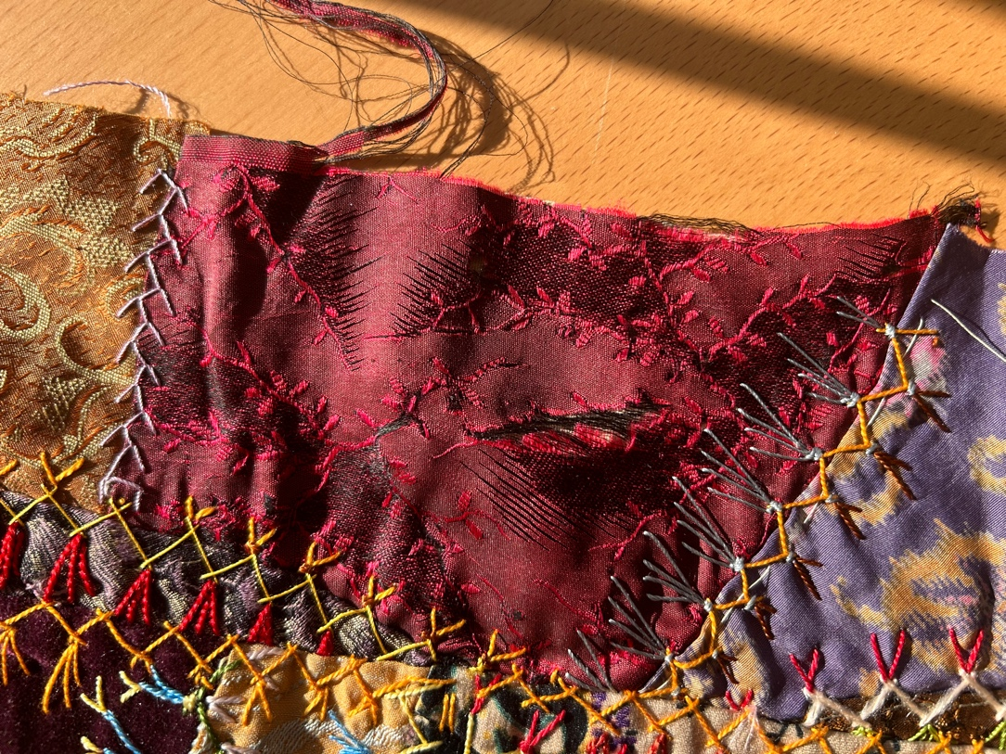 | 