Documentation Form

Overview

Owner History
Owner | From Date | To Date | Location | Cost
David Bailey | 2023-05-27 | -- | Wally's Castle  3637 Clyde Park Ave SW  Wyoming, MI 49509  thewallyscastle@gmail.com  616 330 0530  www.WallysMalls.com | $79.50
 | If not purchased, the estimated cost for materials: $0

Display & Publication History
Date | Event | Location / Publication
Oct 7, 2024 | Montcomb County Quilter's Guild Meeting | Trinity Lutheran Church, Clinton Township, MI
Nov 18, 2024 | Anchor Bay Quilter’s Guild Meeting | New Baltimore, MI

General Description
Quilt Title or Name:  Fox and Geese | Date Made: 1875 ± 10 Years  Method of Determination:  Fabric Date Range: 1875 ± 10 Years  Method of Determination:
Item Type: | Size: Length: 84“ x Width: 71“
Appraisals:  Has this quilt been professionally appraised?  If so, when: --  ----------- | Other related files:
Additional Information: --

Images
Top | Back
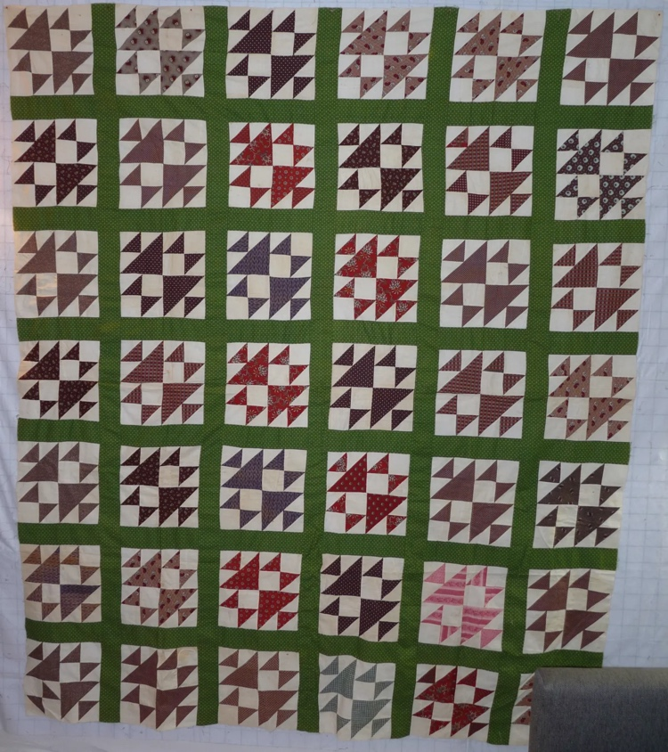 | 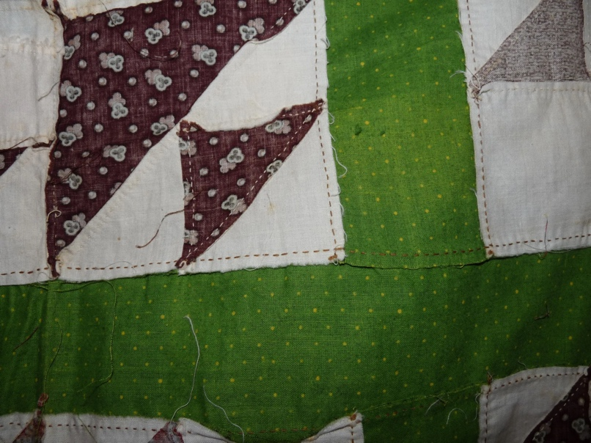

History

Provenance
Describe: --

Quilt Maker
Maker: unknown |  | Birth: -- |  | Death: --
 | Location: -- |  | Contributions: --

Purpose and Context
Expression
Art | Personal Enjoyment | Therapy
Income
Personal Income | Fundraising
Presentation
Anniversary | Wedding | Birth
Holiday | Birthday | Other gift
Charitable support
Relationships
Friendship | Commemorative | Memorial
Mourning | Reunion
Skill Building
Challenge / Contest | Learning / Teaching Sample
Use
Bed Quilt | Lap Quilt | Home Décor
Baby / Crib | Wall Hanging
Describe other purpose: --

Quilt Top Design & Construction

Quilt Top
Layout
. Describe: --
Blocks
Grid & Contained Crazy Details
 |  | Grid Dimensions: Length 7 x Width: 6
 |  | Block Size: Length: 10“ x Width: 10“
Block Pattern Details
 | Fox and Geese - BB ID 1316A | 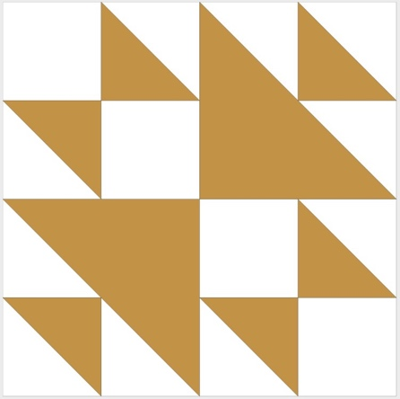

Piecing
Techniques
 |  | Machine pieced | String / Improvisational piecing
 |  | Hand pieced | Foundation piecing
 |  | Strip piecing | English paper piecing
 |  | Describe: --
 | Workmanship
 |  | Seams are stable | Seams are appropriately aligned
 |  | Seams are flat | Points are sharp
 |  | Describe piecing workmanship

Sashing
Length: 0“ x Width: 2“
Use of corner stones

Borders & Frames
Describe borders and frames in order from center to edge.
1 | Width: 2.50“
 |  | Describe: --

Top Assembly
Seams are stable | Top has no inappropriate tucks or puckers
Seams are flat | Top lays flat with no overly full areas
Seams are appropriately aligned

Color
Predominant colors
 | Red | Blue | Black
 | Orange | Violet/Purple | Grey
 | Yellow | Brown | White
 | Green | Beige / Tan
Specific Antique Colors |  | NONE NOTED | Neon prints
 | Red – claret / wine | Yellow – chrome | Blue – Lancaster
 | Red – madder / cinnamon | Green - chrome | Blue – Prussian / Lafayette
 | Red – turkey | Green – Nile | Brown – madder
 | Pinks - double | Blue – Cadet | Butterscotch
 | Orange - madder | Blue - Indigo | Bronze
 | Orange – cheddar / antimony / chrome |  | Late 1800’s Purple

Materials
Sources of Fabric |  | NOT KNOWN
 | Companies | Fabric Name & Number | Designer
 | -- | -- | --
 | Describe other sources: --
Fiber Types |  | NOT YET IDENTIFIED
 | Cotton | Silk | Wool
 | Cotton Blend | Linen | Synthetic
 | Describe & Clarify: --
Fabric Types |  | NOT KNOWN
 | Broadcloth | Sateen | Upholstery
 | Flannel | Satin | Chintz
 | Shirting | Muslin | Glazed
 | Suiting | Velvet | Handwoven
 | Denim | Felt | Lindsey-Woolsey
 | Describe & Clarify: --
Print Types |  | NOT YET IDENTIFIED
 | Batik | Floral | Plaid
 | Cheater Panel | Geometric | Solid / Plain
 | Checked / Gingham | Hand-dyed | Stamped
 | Conversation / Novelty | Victorian Mourning Prints | Stripes
 | Dotted | Multiple scraps
 | Feed sack / Feed sack-like | Paisley
 | Describe & Clarify: --

Images for Top
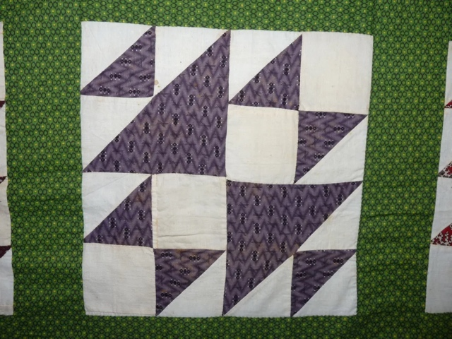 | 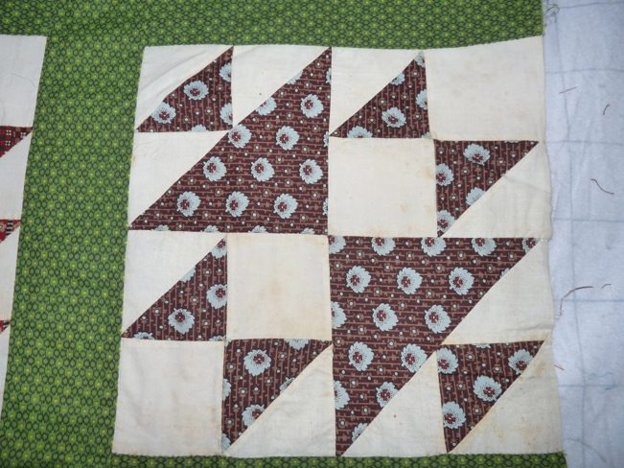
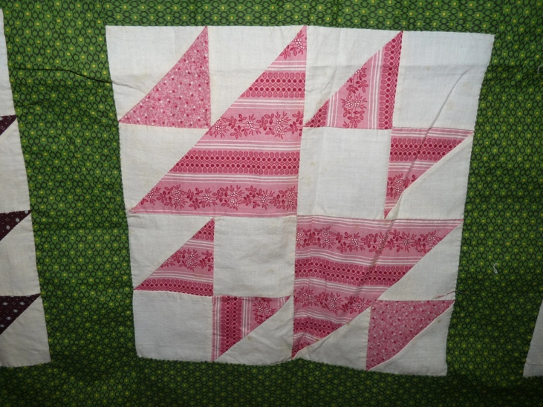

Top Inscriptions
None Found
Inscription is present. Describe location: --
Content
Makers names | Initials | Date
Single Name | Message | Place
Multiple Names
Transcription: --

Methods
Label | Ink – Ball point | Stencil
Printed onto fabric | Ink – Felt tip | Stamped
Quilted | Ink - Other | Pencil
Embroidery | Applique | Typewriter
Describe & Clarify: --

Images for Inscriptions

Condition

Flaws
Soiling
Dirty | Stains
Mildew stains | Musty Smell
Discoloration
Running / fugitive color | Faded / bleached color | Crocking
Fabric Damage
Tears / holes | Disintegrating / fall out | Insect damage
Thread bare | Shattering
Sewing / Quilting Damage
Split / open seams | Ties / tufting missing | Embellishments missing
Quilting threads missing | Batting has shifted
Storage Issues
Discoloration from wood | Damage from acid | Fold marks / creases
Describe additional condition issues: Some purples are starting to fade to tan.
Images for Condition Issues
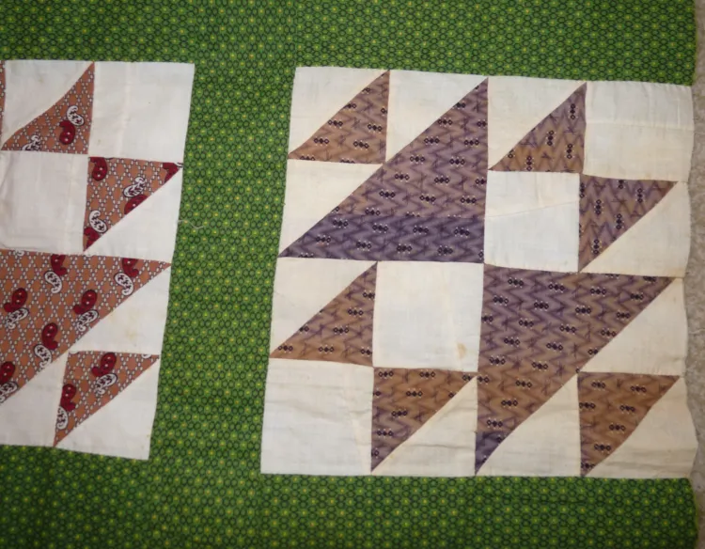

Conservation, Restoration, Repairs
Describe Measures: -No conservatio, restoration or repairs attempted. This may be a good candidate to conserve by finishing the quilt.-

Workmanship

Extension of Useful Life
Repair | Useful life of the item was extended.
Prevention of Damage
Conservation | All work is reversible.
Conservation | Further deterioration has been slowed, stabilized or prevented.
Maintaining Function & Integrity
Conservation | Work minimally interferes with the item’s overall appearance.
Restoration | Work blends well with the item’s overall appearance, style and age.
Restoration | Appropriate period reproductions were used.
Restoration | Vintage materials were used.
Restoration | Period appropriate techniques were used.
Restoration | Workmanship is of similar or better quality than original work.

Images for Conservation / Restoration / Repairs

