Documentation Form

Overview

Owner History
Owner | From Date | To Date | Location | Cost
David Bailey | 2023-04-29 | -- | Antique Center I & II  2213-19 S Church Street  Murfreesboro, TN 37310  615 896 5188  615 890 4252 | $49.00
 | If not purchased, the estimated cost for materials: $0

Display & Publication History
Date | Event | Location / Publication | Pro-Rated  Reimbursement
Oct 7, 2024 | Montcolm County Quilter's guild | Trinity Lutheran Church, Clinton Township, MI | $10

General Description
Quilt Title or Name:  Blue Half Square Triangles | Date Made: 1920 ± 10 Years  Method of Determination:  Fabric Date Range: 1905 ± 25 Years  Method of Determination:
Item Type:  1 piece in set | Size: Length: 49“ x Width: 49“
Appraisals:  Has this quilt been professionally appraised?  If so, when: --  ----------- | Other related files:
Additional Information: This sample came as a set of 25 blocks for about $50. The blocks were machine pieced – possibly treadle – into 9 patches of half-square triangles. The maker and background unknown. There are indigo blue, claret can cadet blue prints that suggest the late 1800’s. There are also a number of ginghams and fabric qualities that suggest the 1910’s and early 1920’s.

Images
Top
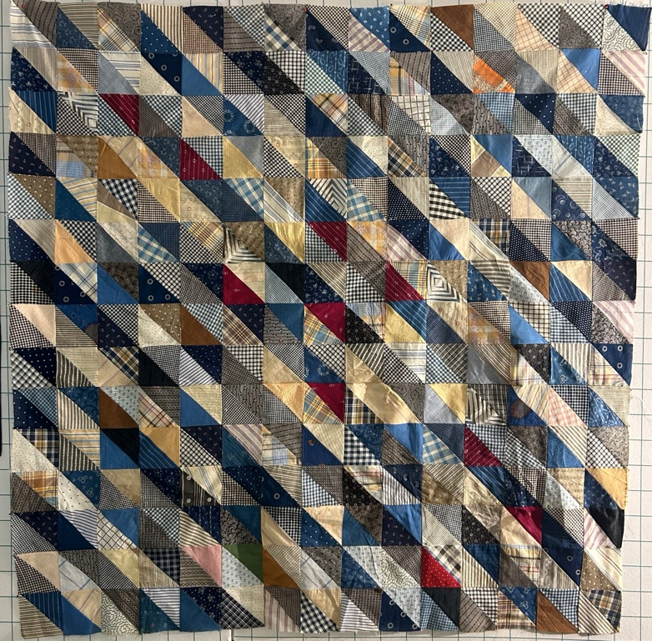 | 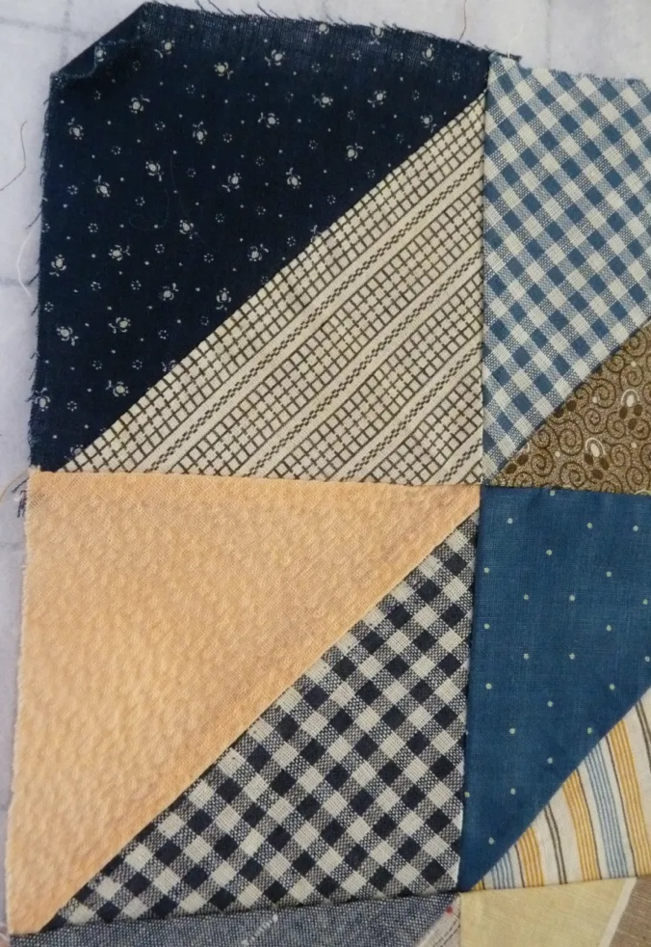

History

Provenance
Describe: --

Quilt Maker
Maker: unknown |  | Birth: -- |  | Death: --
 | Location: -- |  | Contributions: Construction of 9-patch HSTs.
Maker: David Bailey |  | Birth: July 20, 1967 |  | Death: --
 | Location: Chicago, IL |  | Contributions: Assembly of top.

Purpose and Context
Expression
Art | Personal Enjoyment | Therapy
Income
Personal Income | Fundraising
Presentation
Anniversary | Wedding | Birth
Holiday | Birthday | Other gift
Charitable support
Relationships
Friendship | Commemorative | Memorial
Mourning | Reunion
Skill Building
Challenge / Contest | Learning / Teaching Sample
Use
Bed Quilt | Lap Quilt | Home Décor
Baby / Crib | Wall Hanging
Describe other purpose: --

Quilt Top Design & Construction
Block Pattern Details
There are 25 nine-patch blocks each about 10.5" square. Each of the nine subunits for the nine-patch is a half-square triangle.

Piecing
Delete this & the following table rows as appropriate.
Techniques
 |  | Machine pieced. – likely treadle | String / Improvisational piecing
 |  | Hand pieced | Foundation piecing
 |  | Strip piecing | English paper piecing
 |  | Describe: --
 | Workmanship
 |  | Seams are stable | Seams are appropriately aligned
 |  | Seams are flat | Points are sharp
 |  | Describe piecing workmanship

Color
Predominant colors
 | Red | Blue | Black
 | Orange | Violet/Purple | Grey
 | Yellow | Brown | White
 | Green | Beige / Tan
Specific Antique Colors |  | NONE NOTED | Neon prints
 | Red – claret / wine | Yellow – chrome | Blue – Lancaster
 | Red – madder / cinnamon | Green - chrome | Blue – Prussian / Lafayette
 | Red – turkey | Green – Nile | Brown – madder
 | Pinks - double | Blue – Cadet | Butterscotch
 | Orange - madder | Blue - Indigo | Bronze
 | Orange – cheddar / antimony / chrome |  | Late 1800’s Purple

Materials
Sources of Fabric |  | NOT KNOWN
 | Companies | Fabric Name & Number | Designer
 | -- | -- | --
 | Describe other sources: --
Fiber Types |  | NOT YET IDENTIFIED
 | Cotton | Silk | Wool
 | Cotton Blend | Linen | Synthetic
 | Describe & Clarify: --
Fabric Types |  | NOT KNOWN
 | Broadcloth | Sateen | Upholstery
 | Flannel | Satin | Chintz
 | Shirting | Muslin | Glazed
 | Suiting | Velvet | Handwoven
 | Denim | Felt | Lindsey-Woolsey
 | Describe & Clarify: --
Print Types |  | NOT YET IDENTIFIED
 | Batik | Floral | Plaid
 | Cheater Panel | Geometric | Solid / Plain
 | Checked / Gingham | Hand-dyed | Stamped
 | Conversation / Novelty | Victorian Mourning Prints | Stripes
 | Dotted | Multiple scraps
 | Feed sack / Feed sack-like | Paisley
 | Describe & Clarify: --

Condition

Flaws
Soiling
Dirty | Stains
Mildew stains | Musty Smell
Discoloration
Running / fugitive color | Faded / bleached color | Crocking
Fabric Damage
Tears / holes | Disintegrating / fall out | Insect damage
Thread bare | Shattering
Sewing / Quilting Damage
Split / open seams | Ties / tufting missing | Embellishments missing
Quilting threads missing | Batting has shifted
Storage Issues
Discoloration from wood | Damage from acid | Fold marks / creases
Describe additional condition issues: --
Images for Condition Issues

Conservation, Restoration, Repairs
Describe Measures: -
2024-12-13
Some of the fabrics in this collection of blocks were starting to fray at the ends. I decided that assembly into a quilt top would stabilize most of the problems. The blocks were assembled into a rows and furrows setting as shown. This was done on a Bernina Quilter's Edition with cotton thread.
Two fabrics were distintegrating to the point that they could not be stably sewn. I provided a foundation for those fabrics and couched (not well) one of the fabrics. I believe that they were were both stabilized well enough for the top to be basted to a foundation and stored. This was done with spare fabrics from 2000 or more recently. The needle work was done by hand. I used Glide 40 wt (polyester) thread to better match the color.
FUTURE CONSIDERATIONS
If this top were to be made into a finished quilt, some of the loosely woven fabrics may be problematic. i blieve that the batting will likely beard through the weave. It will probably be best to put a layer of white muslin between the batting and the top or at least put a similar foundation or interfacing on the fabrics that will be the biggest issues.

Workmanship

Extension of Useful Life
Repair | Useful life of the item was extended.
Prevention of Damage
Conservation | All work is reversible.
Conservation | Further deterioration has been slowed, stabilized or prevented.
Maintaining Function & Integrity
Conservation | Work minimally interferes with the item’s overall appearance.
Restoration | Work blends well with the item’s overall appearance, style and age.
Restoration | Appropriate period reproductions were used.
Restoration | Vintage materials were used.
Restoration | Period appropriate techniques were used.
Restoration | Workmanship is of similar or better quality than original work.

Images for Conservation / Restoration / Repairs
Before  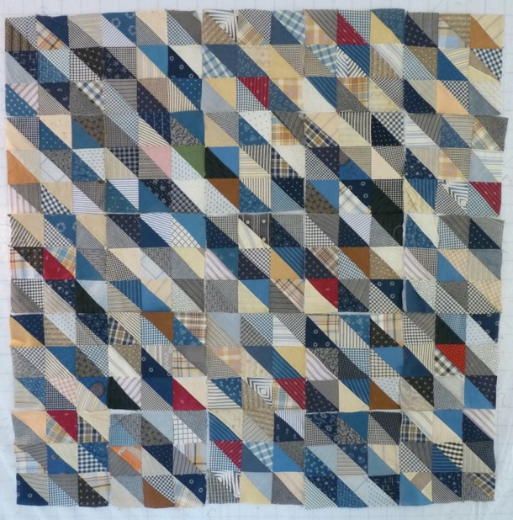 | After  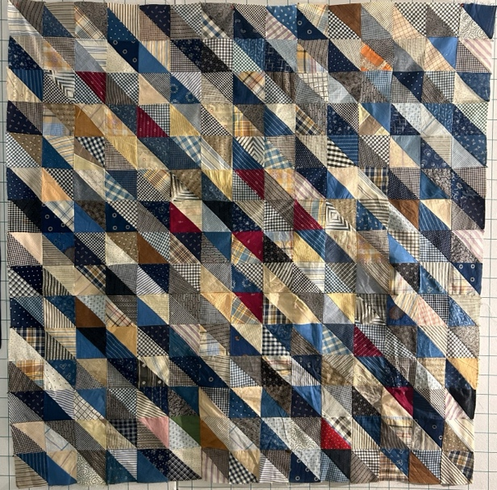
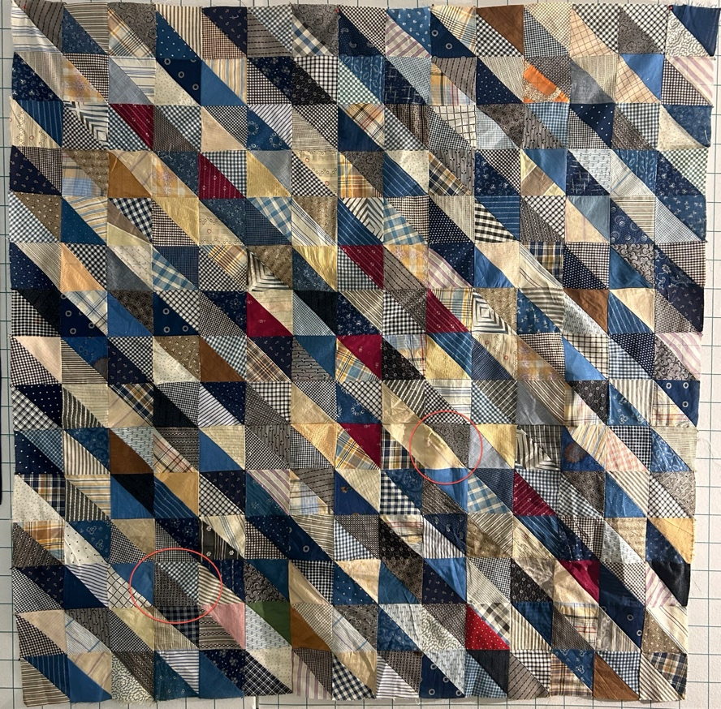 | 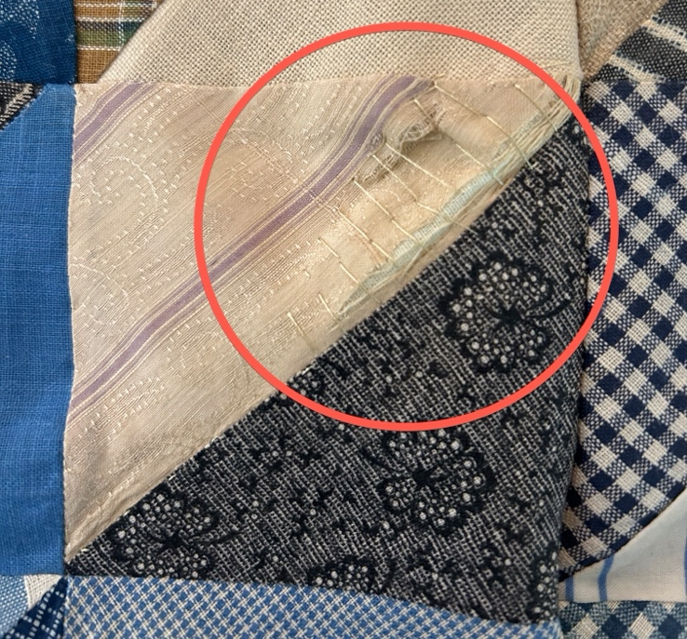
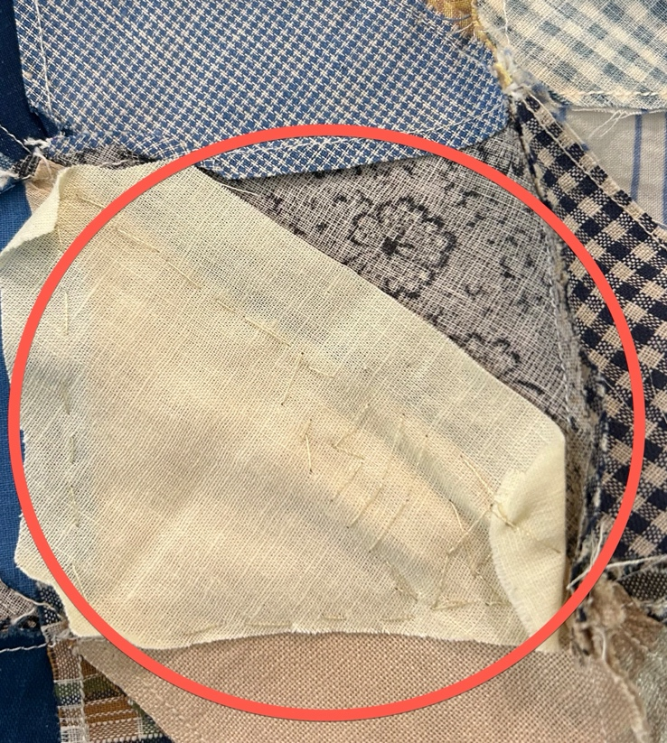 | 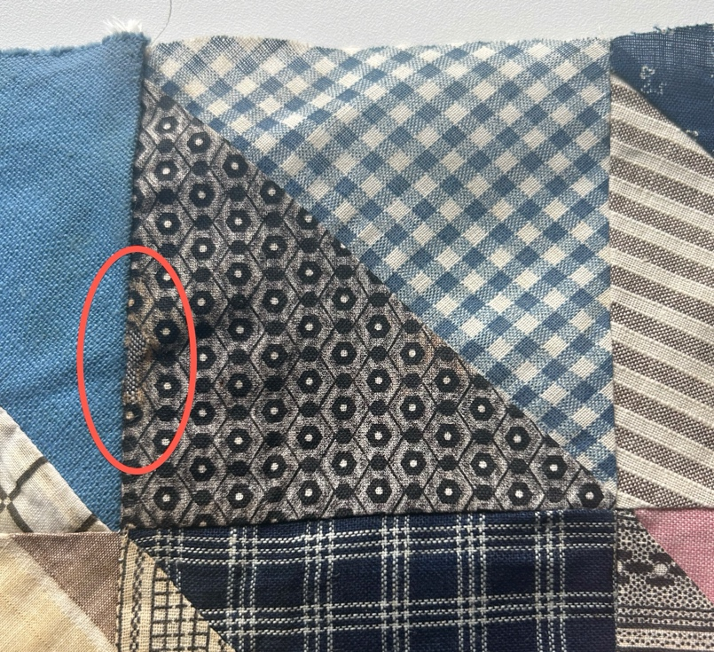
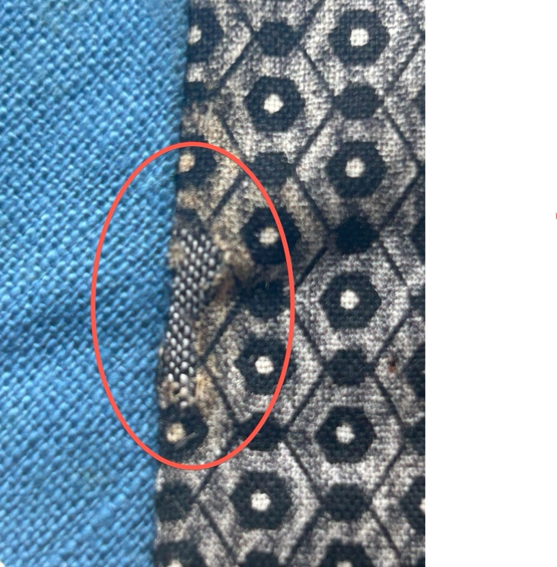 | 