Documentation Form

Overview

Owner History
Owner | From Date | To Date | Location | Cost
David Bailey | Aug 19, 2022 | -- | Wally's Castle  3637 Clyde Park Ave SW  WYOMING, MI 49509  thewallyscastle@gmail.com | $85.00
 | If not purchased, the estimated cost for materials: $0

Display & Publication History
Date | Event | Location / Publication
Nov 18, 2024 | Anchor Bay Quilter’s Guild Meeting | New Baltimore, MI
Oct 7, 2024 | Montcomb County Quilter's Guild Meeting | Trinity Lutheran Church, Clinton Township, MI

General Description
Quilt Title or Name:  Lone Star | Date Made: 1885 ± 10 Years  Method of Determination:  Fabric Date Range: 1885 ± 10 Years  Method of Determination:
Item Type: | Size: Length: 80“ x Width: 80“
Appraisals:  Has this quilt been professionally appraised?  If so, when: --  ----------- | Other related files:
Additional Information: --

Images
Top | Back
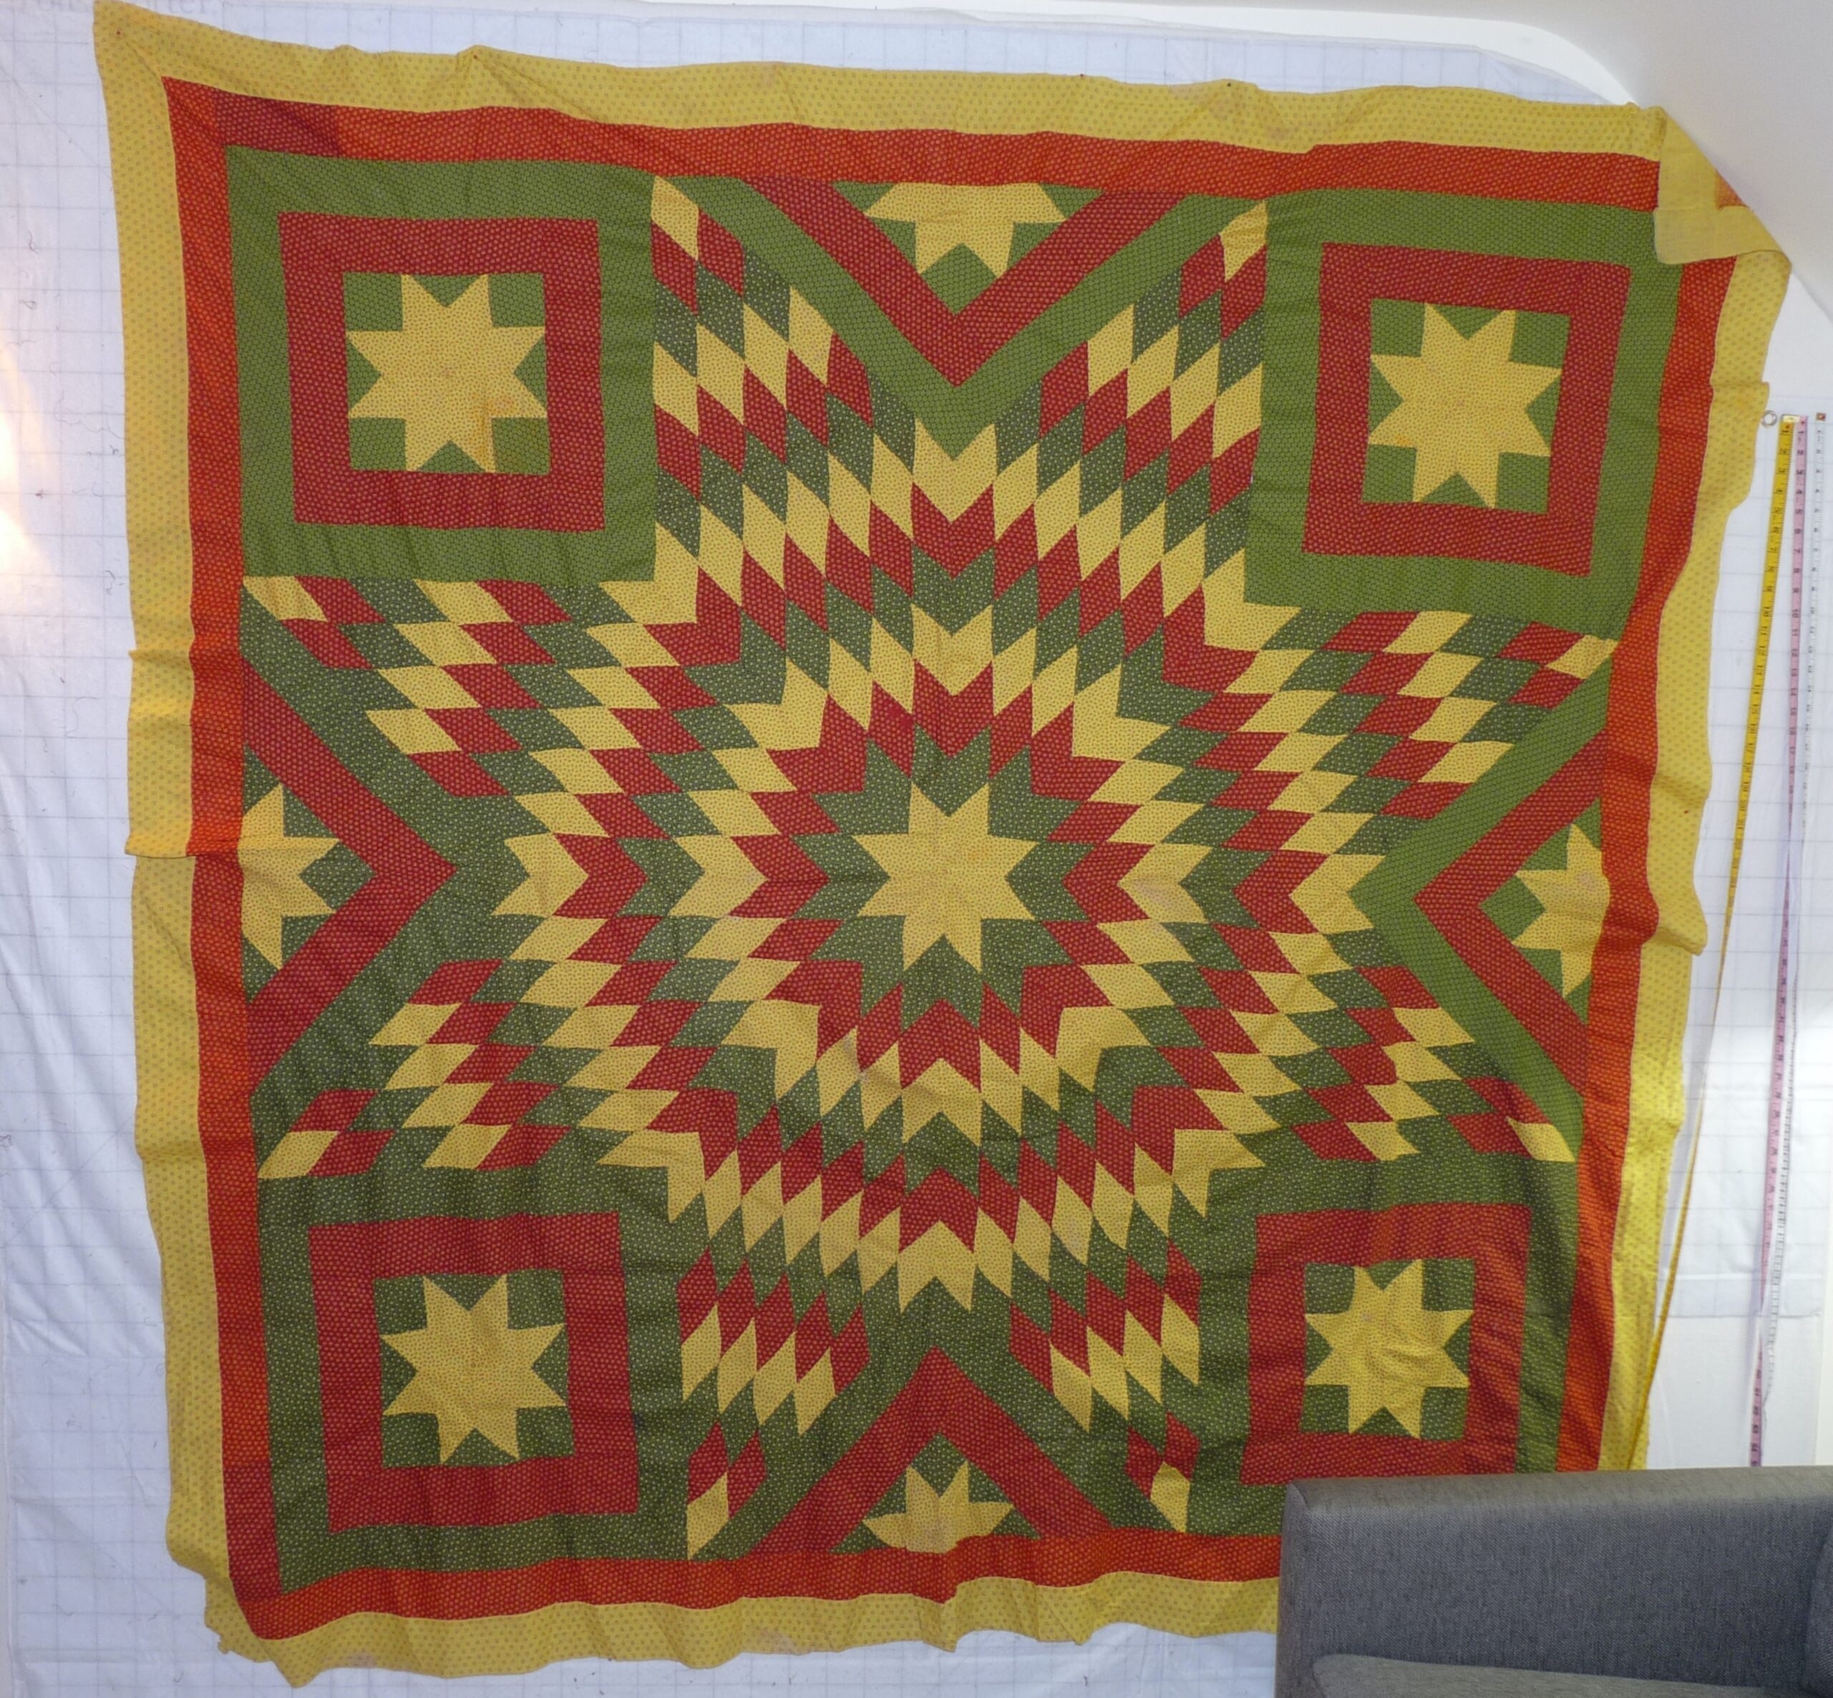

History

Provenance
Describe: --

Quilt Maker
Maker: unknown |  | Birth: -- |  | Death: --
 | Location: -- |  | Contributions: --

Purpose and Context
Expression
Art | Personal Enjoyment | Therapy
Income
Personal Income | Fundraising
Presentation
Anniversary | Wedding | Birth
Holiday | Birthday | Other gift
Charitable support
Relationships
Friendship | Commemorative | Memorial
Mourning | Reunion
Skill Building
Challenge / Contest | Learning / Teaching Sample
Use
Bed Quilt | Lap Quilt | Home Décor
Baby / Crib | Wall Hanging
Describe other purpose: --

Quilt Top Design & Construction

Quilt Top
Layout
. Describe: Diamonds to form a version of the lone star. BB ID's 4005 & 4005.5

Piecing
Delete this & the following table rows as appropriate.
Techniques
 |  | Machine pieced | String / Improvisational piecing
 |  | Hand pieced | Foundation piecing
 |  | Strip piecing | English paper piecing
 |  | Describe: --
 | Workmanship
 |  | Seams are stable | Seams are appropriately aligned
 |  | Seams are flat | Points are sharp
 |  | Describe piecing workmanship

Top Assembly
Seams are stable | Top has no inappropriate tucks or puckers
Seams are flat | Top lays flat with no overly full areas
Seams are appropriately aligned

Color
Predominant colors
 | Red | Blue | Black
 | Orange | Violet/Purple | Grey
 | Yellow | Brown | White
 | Green | Beige / Tan
Specific Antique Colors |  | NONE NOTED | Neon prints
 | Red – claret / wine | Yellow – chrome | Blue – Lancaster
 | Red – madder / cinnamon | Green - chrome | Blue – Prussian / Lafayette
 | Red – turkey | Green – Nile | Brown – madder
 | Pinks - double | Blue – Cadet | Butterscotch
 | Orange - madder | Blue - Indigo | Bronze
 | Orange – cheddar / antimony / chrome |  | Late 1800’s Purple

Materials
Sources of Fabric |  | NOT KNOWN
 | Companies | Fabric Name & Number | Designer
 | -- | -- | --
 | Describe other sources: --
Fiber Types |  | NOT YET IDENTIFIED
 | Cotton | Silk | Wool
 | Cotton Blend | Linen | Synthetic
 | Describe & Clarify: --
Fabric Types |  | NOT KNOWN
 | Broadcloth | Sateen | Upholstery
 | Flannel | Satin | Chintz
 | Shirting | Muslin | Glazed
 | Suiting | Velvet | Handwoven
 | Denim | Felt | Lindsey-Woolsey
 | Describe & Clarify: --
Print Types |  | NOT YET IDENTIFIED
 | Batik | Floral | Plaid
 | Cheater Panel | Geometric | Solid / Plain
 | Checked / Gingham | Hand-dyed | Stamped
 | Conversation / Novelty | Victorian Mourning Prints | Stripes
 | Dotted | Multiple scraps
 | Feed sack / Feed sack-like | Paisley
 | Describe & Clarify: --

Images for Top
 | 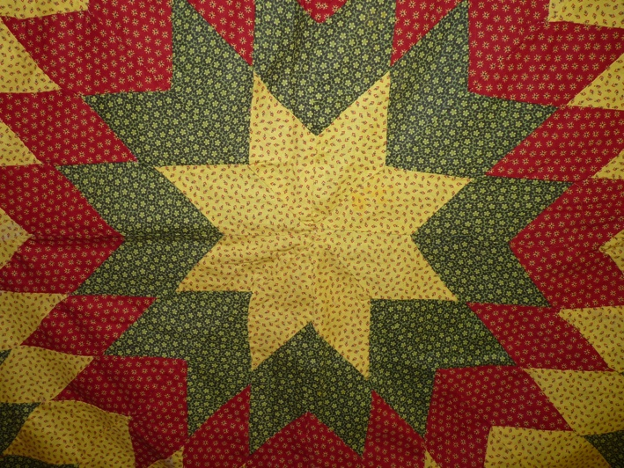 | 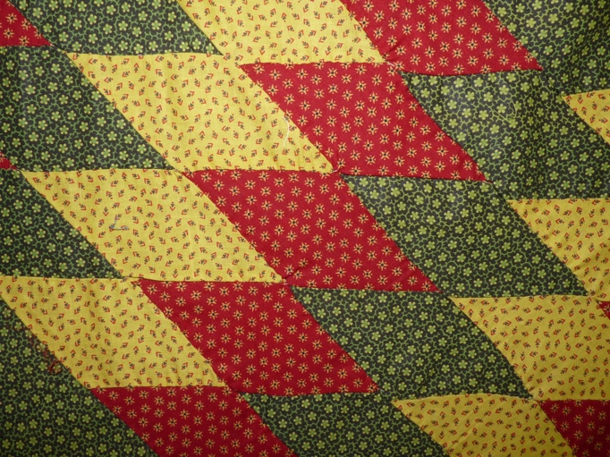

Top Inscriptions
None Found

Condition

Flaws
Soiling
Dirty | Stains
Mildew stains | Musty Smell
Discoloration
Running / fugitive color | Faded / bleached color | Crocking
Fabric Damage
Tears / holes | Disintegrating / fall out | Insect damage
Thread bare | Shattering
Sewing / Quilting Damage
Split / open seams | Ties / tufting missing | Embellishments missing
Quilting threads missing | Batting has shifted
Storage Issues
Discoloration from wood | Damage from acid | Fold marks / creases
Describe additional condition issues: --
Images for Condition Issues
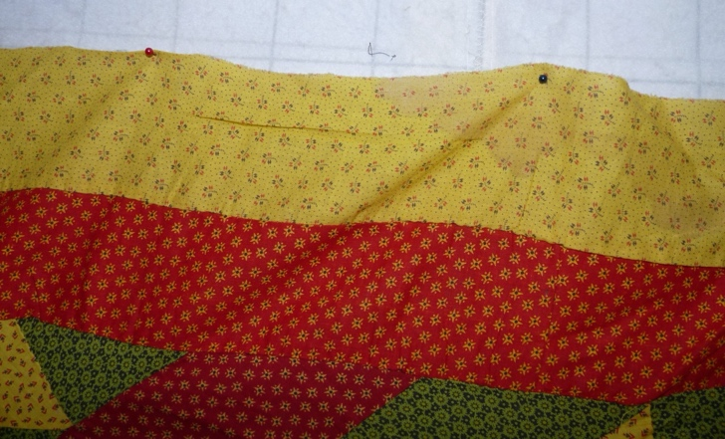 | 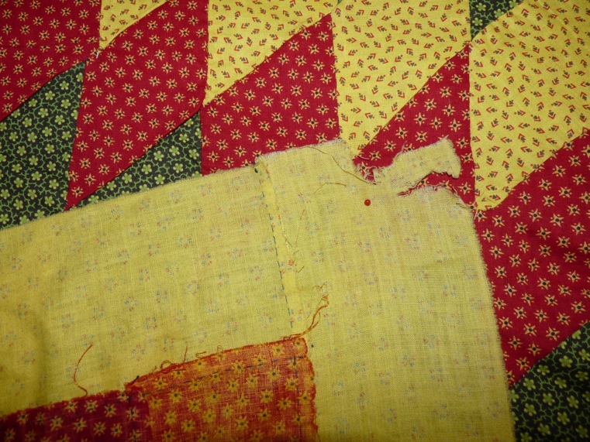

Conservation, Restoration, Repairs
Describe Measures:
2024-12-15: While I was mounting tops, fabrics and blocks onto stabilizing fabrics, I noticed that this top has a 1-2” seam that had opened. Before basting it to the foundation fabric I repaired the seam. I used a Glide (polyester) 40wt thread (shadow color). The seam is just below one of the corner satellite stars. I believe that it is the upper left star if you are viewing the top on the foundation fabric with label toward the bottom and on the back.
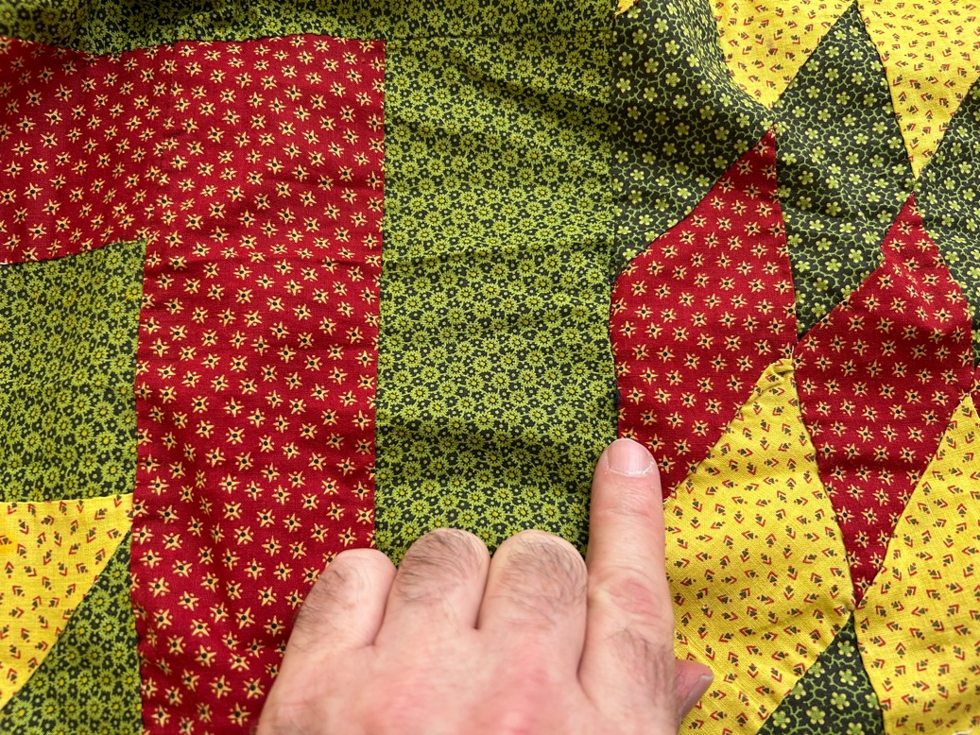 | 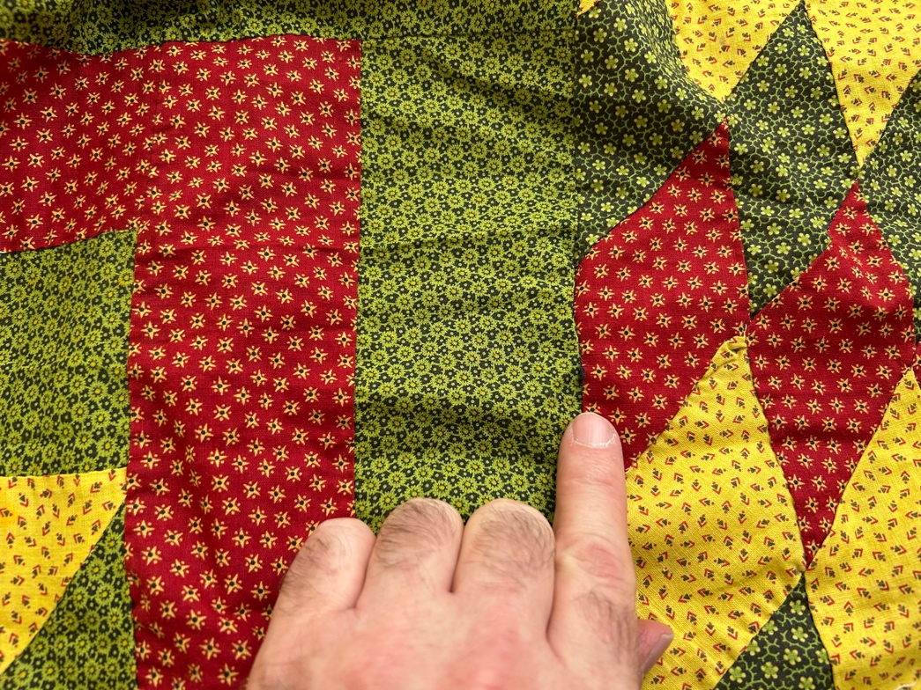

Workmanship

Extension of Useful Life
Repair | Useful life of the item was extended.
Prevention of Damage
Conservation | All work is reversible.
Conservation | Further deterioration has been slowed, stabilized or prevented.
Maintaining Function & Integrity
Conservation | Work minimally interferes with the item’s overall appearance.
Restoration | Work blends well with the item’s overall appearance, style and age.
Restoration | Appropriate period reproductions were used.
Restoration | Vintage materials were used.
Restoration | Period appropriate techniques were used.
Restoration | Workmanship is of similar or better quality than original work.

Images for Conservation / Restoration / Repairs

