Documentation Form

Overview

Owner History
Owner | From Date | To Date | Location | Cost
David Bailey | Dec 14, 2022 | -- | Anitique Market of Williamston  Booth 45  2991 Williamston Road  PO Box 10  Williamston, MI 48895  517 655 1350 | $160.00
 | If not purchased, the estimated cost for materials: $0

Display & Publication History
Date | Event | Location / Publication | Pro-Rated  Reimbursement
April 3-7, 2024 | Fisher Farm Qult Show | 16W680 Old Grand Avenue, Chicago, IL | $0
This quilt was found in central Michigan and carries 218 hand-written names in the sashing. The turkey red applique design is an oak leaf and reel design. The work is hand-appliqued, hand-pieced and hand-quilted. Some repair work can be seen along the edges. Census record searches have found 134 of the 218 names. 103 of these were residents of Union City, MI and 24 were residents of Sherwood, MI in the late 1870’s and early 1880’s. Union City and Sherwood are south of Battle Creek.

The large number of names suggests that this quilt was used as a community fund raiser. In such fund raisers, individuals paid to have their names listed on the quilt and the quilt was raffled off or awarded by lottery. Members of entire households can be found on the quilt. The names are nearly all listed with formal titles such as Mr John Smith and Mrs John Smith. While the census records indicate that individuals most frequently self-identified as farmers, other professions are also included. The quilt lists names of a doctor, a minister, a judge, a telegraph operator, a harness maker, a music teacher, a postmaster, a shoemaker, a travel agent, a pharmacist, a barber, bank presidents, elected officials and a business called Tower Brothers.

General Description
Quilt Title or Name:  Union City Signature Quilt | Date Made: 1881 ± 2 Years  Method of Determination:  Fabric Date Range: 1885 ± 35 Years  Method of Determination:
Item Type: | Size: Length: 88“ x Width: 67“
Appraisals:  Has this quilt been professionally appraised?  If so, when: --  ----------- | Other related files:  The Family Tree Maker file was too large to upload.  Research Notes
Additional Information:
This quilt was found in an antique mall. It has 218 names on it. Most of them map to people who lived in Branch County in the early 1880's. More specifically, the focus seems to be Union City.

Images
Top | Back
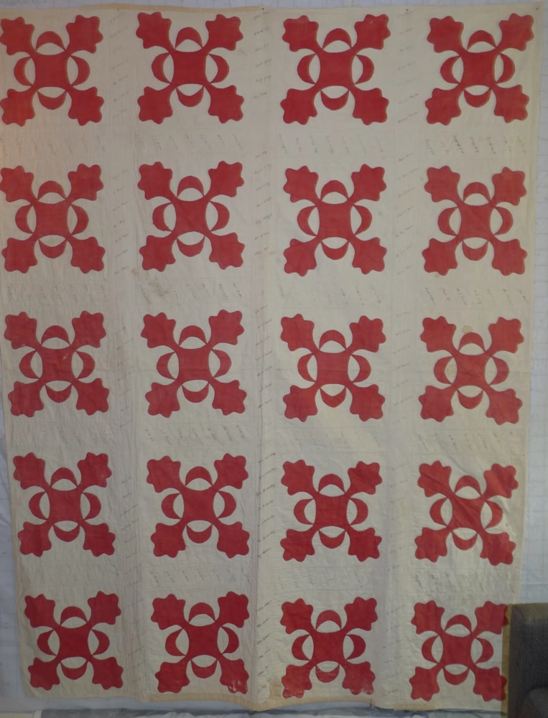 | 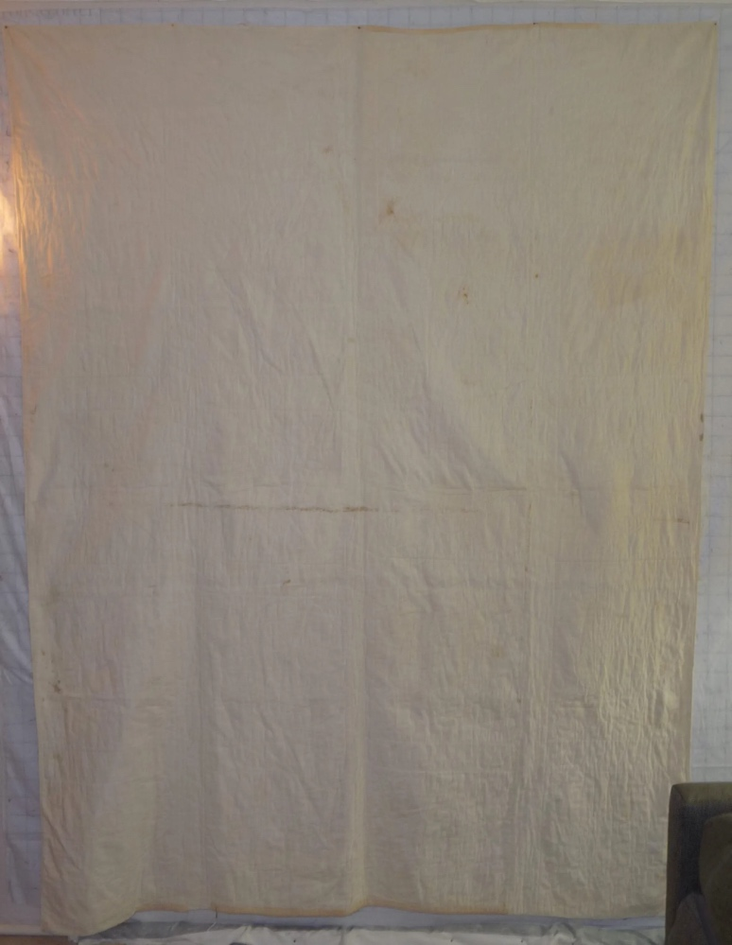

History

Provenance
Describe: I have circumstanial evidence that the quilt may have been made by a GAR auxiliary group in Union City, MI as a fund raiser for a Civil War Soldier's Moment.

Quilt Maker
Maker: unknown |  | Birth: -- |  | Death: --
 | Location: -- |  | Contributions: --

Purpose and Context
Expression
Art | Personal Enjoyment | Therapy
Income
Personal Income | Fundraising
Presentation
Anniversary | Wedding | Birth
Holiday | Birthday | Other gift
Charitable support
Relationships
Friendship | Commemorative | Memorial
Mourning | Reunion
Skill Building
Challenge / Contest | Learning / Teaching Sample
Use
Bed Quilt | Lap Quilt | Home Décor
Baby / Crib | Wall Hanging
Describe other purpose: Because of the 218 names on the front of the quilt, it is likely it was used as a fund raiser.

Quilt Top Design & Construction

Quilt Top
Layout
. Describe: --
Blocks
Grid & Contained Crazy Details
 |  | Grid Dimensions: Length 4 x Width: 5
 |  | Block Size: Length: 15“ x Width: 15“
Block Pattern Details
 | Encyclopeida of Applique Quilt Patterns | 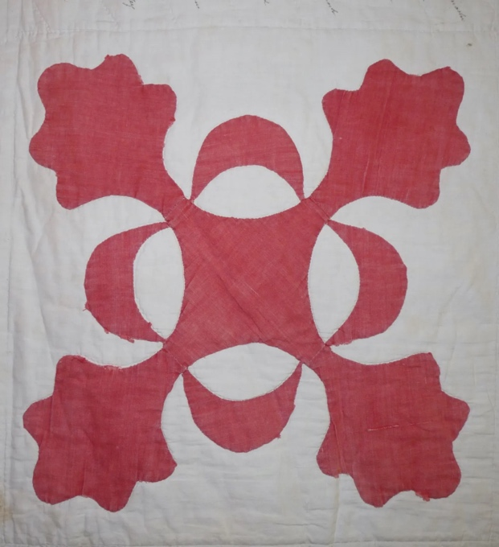
 | Oak Leaf and Reel - 17.16, 17.17, 17.18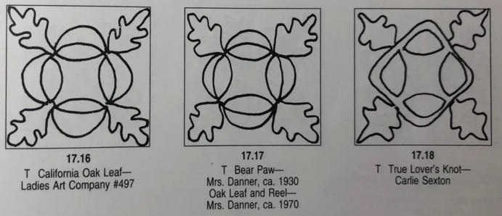

Piecing
Techniques
 |  | Machine pieced | String / Improvisational piecing
 |  | Hand pieced | Foundation piecing
 |  | Strip piecing | English paper piecing
 |  | Describe: --
 | Workmanship
 |  | Seams are stable | Seams are appropriately aligned
 |  | Seams are flat | Points are sharp
 |  | Describe piecing workmanship

Embellishments
Types:
 | Applique – Raw edge | Embroidery | Stuffed Work
 | Applique - Button-hole | Cording | Inking
 | Applique - Needle-turn | Beading | Painting
 | Applique - Reverse | Rhinestones / Gems | Marking lines noted
 | Applique - Other | Other: --
Workmanship
 | Stitches are appropriately small and even.
 | Edges are as design intends (straight, curved, pointed).
 | Work demonstrates appropriate skill for intended purpose.
 | Describe other techniques

Sashing
Length: 0“ x Width: 3“
Use of corner stones

Top Assembly
Seams are stable | Top has no inappropriate tucks or puckers
Seams are flat | Top lays flat with no overly full areas
Seams are appropriately aligned

Color
Predominant colors
 | Red | Blue | Black
 | Orange | Violet/Purple | Grey
 | Yellow | Brown | White
 | Green | Beige / Tan
Specific Antique Colors |  | NONE NOTED
 | Red – claret / wine | Yellow – chrome | Blue – Lancaster
 | Red – madder / cinnamon | Green - chrome | Blue – Prussian / Lafayette
 | Red – turkey | Green – Nile | Brown – madder
 | Pinks - double | Blue – Cadet | Butterscotch
 | Orange - madder | Blue - Indigo | Bronze
 | Orange – cheddar / antimony / chrome |  | Late 1800’s Purple

Materials
Sources of Fabric |  | NOT KNOWN
 | Companies | Fabric Name & Number | Designer
 | -- | -- | --
 | Describe other sources: --
Fiber Types |  | NOT YET IDENTIFIED
 | Cotton | Silk | Wool
 | Cotton Blend | Linen | Synthetic
 | Describe & Clarify: --
Fabric Types |  | NOT KNOWN
 | Broadcloth | Sateen | Upholstery
 | Flannel | Satin | Chintz
 | Shirting | Muslin | Glazed
 | Suiting | Velvet | Handwoven
 | Denim | Felt | Lindsey-Woolsey
 | Describe & Clarify: --
Print Types |  | NOT YET IDENTIFIED
 | Batik | Floral | Plaid
 | Cheater Panel | Geometric | Solid / Plain
 | Checked / Gingham | Hand-dyed | Stamped
 | Conversation / Novelty | Victorian Mourning Prints | Stripes
 | Dotted | Multiple scraps
 | Feed sack / Feed sack-like | Paisley
 | Describe & Clarify: --

Top Inscriptions
None Found
Inscription is present. Describe location: --
Content
Makers names | Initials | Date
Single Name | Message | Place
Multiple Names
Transcription: There are 218 names listed on the front of the quilt. From this I am inferring that it was used as a fund raiser. Pay to put your name on the quilt. Then the quilt was raffled off.

Methods
Label | Ink – Ball point | Stencil
Printed onto fabric | Ink – Felt tip | Stamped
Quilted | Ink - Other | Pencil
Embroidery | Applique | Typewriter
Describe & Clarify: --

Images for Inscriptions
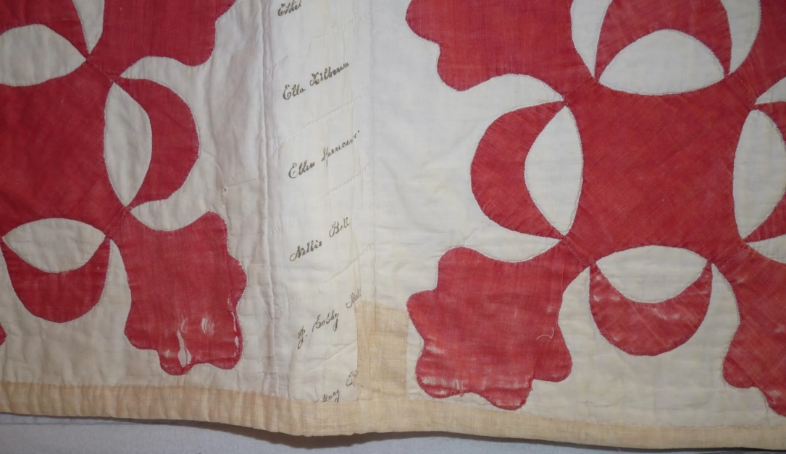

Quilt Back Design & Construction

Quilt Back
Layout
. Describe: White, cotton, broad cloth

Stabilization Method
Stabilization Method:
Batting
Quilting Techniques
 | Machine Quilted | Machine – sit-down | Corded
 | Machine – computer guided | Hand Quilted | Stuffed work
 | Machine – manual long-arm | Quilt-as-you-go
Quilting Patterns
 | Meander / Free motion | Lines – single parallel | Cables
 | In-the-ditch / To the piece | Lines – double parallel | Feathers
 | Echo / Outlined | Lines – triple parallel | Wreaths
 | Stipple | Grid – crosshatch | Vines
 | Clamshell | Grid – square | Floral
 | Elbow / Fan | Grid - diamond | Leaves
 | Describe other: --
Thread Choices
 | Brand | Weight | Number & Name
 | -- | -- | --
Images for Quilting

Edge Finish
Edge Style:
Finishing Technique
Top Width: 0.13 “ | Binding | Rolled – top to back
Back Width: 0.13“ | Front – machine | Rolled – back to top
1/8 = 0.13, 3/8 = 0.38 | Front – hand | Knife edge
5/8 = 0.63, 7/8 = 0.88 | Back – machine | Turned
 | Back - hand
Embellishments
Fringe | Ruffles | Cording
Lace | Ribbon
Describe: Binding has likely been replaced over the years.

Images for Edge

Condition

Flaws
Soiling
Dirty | Stains
Mildew stains | Musty Smell
Discoloration
Running / fugitive color | Faded / bleached color | Crocking
Fabric Damage
Tears / holes | Disintegrating / fall out | Insect damage
Thread bare | Shattering
Sewing / Quilting Damage
Split / open seams | Ties / tufting missing | Embellishments missing
Quilting threads missing | Batting has shifted
Storage Issues
Discoloration from wood | Damage from acid | Fold marks / creases
Describe additional condition issues: This piece has some major condition issues and I doubt that they can be rescued without doing damage to the names. The back is in fairly bad shape. The turkey red is wearing out. Some of the front white is missing where names were once written.
Images for Condition Issues
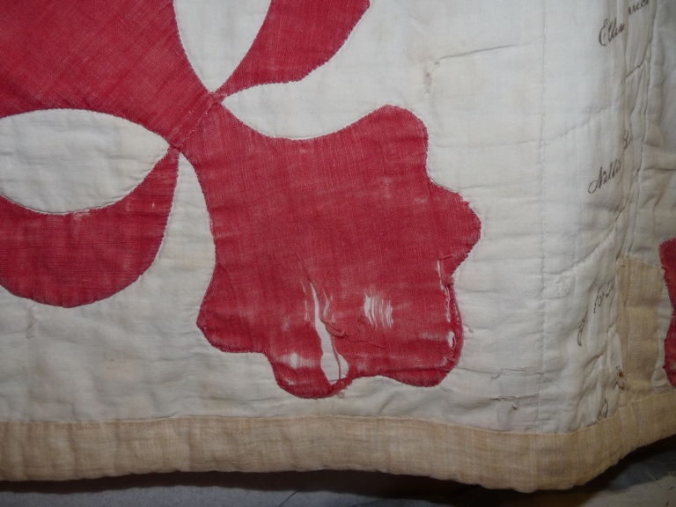 | 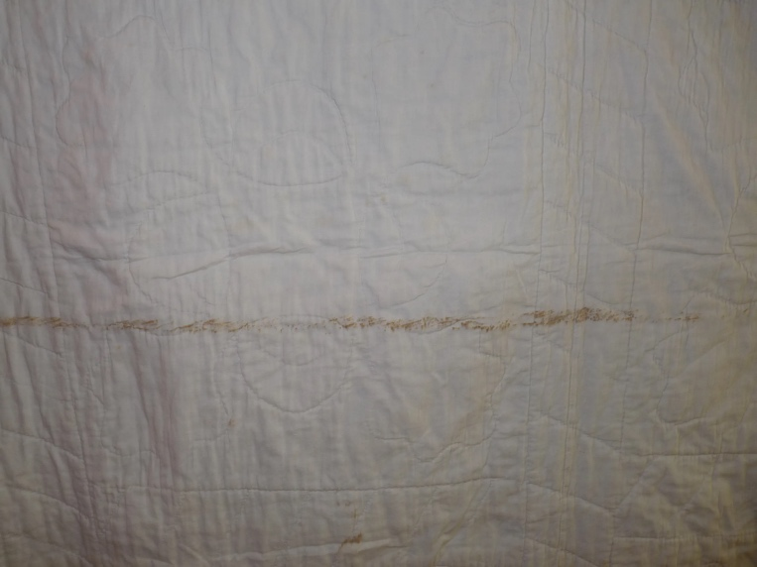

Conservation, Restoration, Repairs
Describe Measures: it appears someone may have replaced the binding, but little else has been attempted.

Workmanship

Extension of Useful Life
Repair | Useful life of the item was extended.
Prevention of Damage
Conservation | All work is reversible.
Conservation | Further deterioration has been slowed, stabilized or prevented.
Maintaining Function & Integrity
Conservation | Work minimally interferes with the item’s overall appearance.
Restoration | Work blends well with the item’s overall appearance, style and age.
Restoration | Appropriate period reproductions were used.
Restoration | Vintage materials were used.
Restoration | Period appropriate techniques were used.
Restoration | Workmanship is of similar or better quality than original work.

Images for Conservation / Restoration / Repairs

