Documentation Form

Overview

Owner History
Owner | From Date | To Date | Location | Cost
David Bailey | Jun 11, 2023 | -- | Saugatuck Antique Pavilion  2948 Blue Star Highway  PO Box 189  Douglas, MI 49406  269 857 6041 | $337.50
 | If not purchased, the estimated cost for materials: $0

Display & Publication History
Date | Event | Location / Publication
Nov 18, 2024 | Anchor Bay Quilter’s Guild Meeting | New Baltimore, MI
Oct 7, 2024 | Montcomb County Quilter's Guild Meeting | Trinity Lutheran Church, Clinton Township, MI
April 3-7, 2024 | Fisher Farm Quilt Show | 16W680 Old Grand Avenue
Caption:
This quilt features cotton applique blocks and pineapple applique in the borders. The needle turn applique, assembly and quilting were all done by hand. The quilt was found in southwestern Michigan. Research of census records indicate that there were several Anna Grossmans who lived in the midwest in the 1860’s and 1870’s. The most likely candidate appears to be Anna Eckert (1835-1906).

Anna Eckert was born in Chambersburg Pennsylvania to German immigrants. Anna married David Grossman in 1859 in Chambersburg. Between 1859 and 1878, she had 11 children. By 1868, she and her husband moved to a new home on the north edge of Dayton Ohio. While in Dayton, David Grossman was a cabinet maker for several decades. Assuming that the quilt was indeed made in 1868, it was made between the birth of her 5th and 6th children – David and William. By 1900 Anna and David had moved once again. This time they moved to Johnson Township in northeastern Indiana and started a farm. When Anna died in 1906 she was buried in Wolcottville near Shipshewana, Indiana. David Grossman died two years later.

General Description
Quilt Title or Name:  Anna Grossman’s Quilt | Date Made: 1868 ± 0 Years  Method of Determination:  Fabric Date Range: 1863 ± 12 Years  Method of Determination:
Item Type: | Size: Length: 78“ x Width: 77“
Appraisals:  Has this quilt been professionally appraised?  If so, when: --  ----------- | Other related files:  Family Tree Maker Files  Research Notes
Additional Information: The vendor claimed that the quilt had been appraised, but did not provide the appraisal.

Images
Top | Back
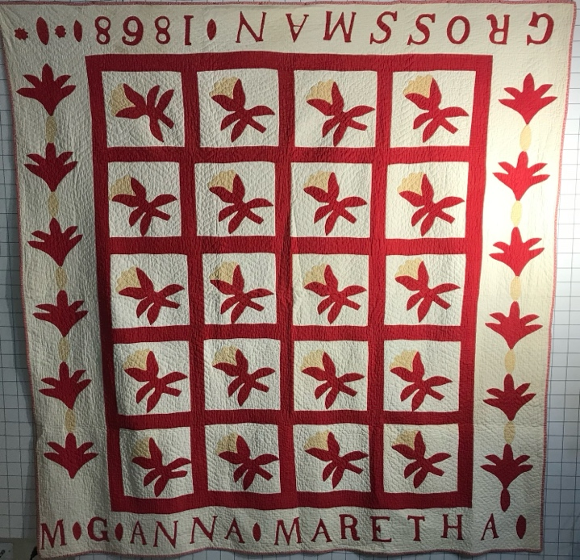 | 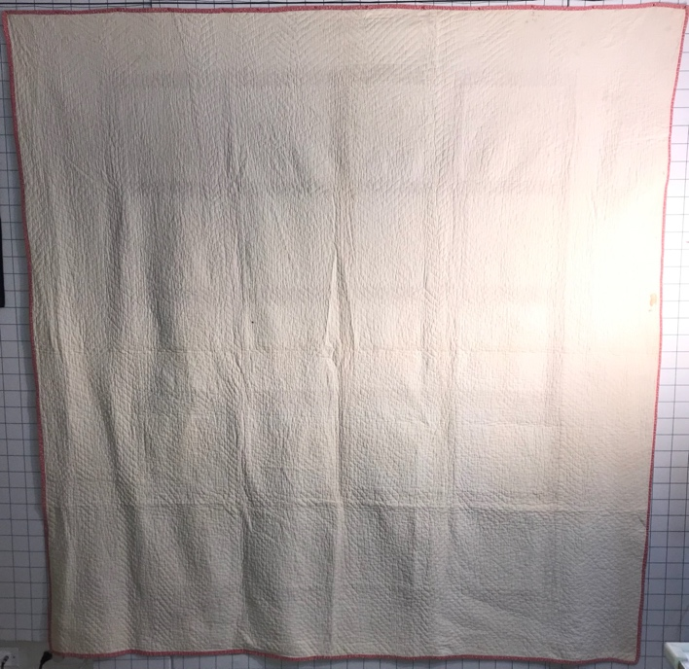

History

Provenance
Describe: --

Quilt Maker
Maker: Anna Grossman |  | Birth: 1835 |  | Death: 1906
 | Location: Dayton, OH |  | Contributions: Assumption is she is responsible for the full quilt.

Purpose and Context
Expression
Art | Personal Enjoyment | Therapy
Income
Personal Income | Fundraising
Presentation
Anniversary | Wedding | Birth
Holiday | Birthday | Other gift
Charitable support
Relationships
Friendship | Commemorative | Memorial
Mourning | Reunion
Skill Building
Challenge / Contest | Learning / Teaching Sample
Use
Bed Quilt | Lap Quilt | Home Décor
Baby / Crib | Wall Hanging
Describe other purpose: --

Quilt Top Design & Construction

Quilt Top
Layout
. Describe: 4x5 grid of white fabric with appliqued cotton bolls. The size of the blocks is not square and the appliqued boll not consistently aligned. This caused the sashing to be offset for one block.. Red sashing. White borders with appliqued pineapples, date and name.
Blocks
Grid & Contained Crazy Details
Grid Dimensions: Length 5 x Width: 4
Block Size: Length: 7“ x Width: 9“

Embellishments
Types:
 | Applique – Raw edge | Embroidery | Stuffed Work
 | Applique - Button-hole | Cording | Inking
 | Applique - Needle-turn | Beading | Painting
 | Applique - Reverse | Rhinestones / Gems | Marking lines noted
 | Applique - Other | Other: --
Workmanship
 | Stitches are appropriately small and even.
 | Edges are as design intends (straight, curved, pointed).
 | Work demonstrates appropriate skill for intended purpose.
 | Cotton bolls and pineapples. The borders have an appliqued inscription. See below.

Sashing
Length: 0“ x Width: 2“
Use of corner stones

Borders & Frames
Describe borders and frames in order from center to edge.
1 | Width: 6.75“ |  | Describe: for two sides of the quilt (with letters)
1 | Width: 11“ |  | Describe: for two sides of the quilt (with pineapples)

Top Assembly
Seams are stable | Top has no inappropriate tucks or puckers
Seams are flat | Top lays flat with no overly full areas
Seams are appropriately aligned

Color
Predominant colors
 | Red | Blue | Black
 | Orange | Violet/Purple | Grey
 | Yellow | Brown | White
 | Green | Beige / Tan
Specific Antique Colors |  | NONE NOTED
 | Red – claret / wine | Yellow – chrome | Blue – Lancaster
 | Red – madder / cinnamon | Green - chrome | Blue – Prussian / Lafayette
 | Red – turkey | Green – Nile | Brown – madder
 | Pinks - double | Blue – Cadet | Butterscotch
 | Orange - madder | Blue - Indigo | Bronze
 | Orange – cheddar / antimony / chrome |  | Late 1800’s Purple

Materials
Sources of Fabric |  | NOT KNOWN
 | Companies | Fabric Name & Number | Designer
 | -- | -- | --
 | Describe other sources: --
Fiber Types |  | NOT YET IDENTIFIED
 | Cotton | Silk | Wool
 | Cotton Blend | Linen | Synthetic
 | Describe & Clarify: --
Fabric Types |  | NOT KNOWN
 | Broadcloth | Sateen | Upholstery
 | Flannel | Satin | Chintz
 | Shirting | Muslin | Glazed
 | Suiting | Velvet | Handwoven
 | Denim | Felt | Lindsey-Woolsey
 | Describe & Clarify: --
Print Types |  | NOT YET IDENTIFIED
 | Batik | Floral | Plaid
 | Cheater Panel | Geometric | Solid / Plain
 | Checked / Gingham | Hand-dyed | Stamped
 | Conversation / Novelty | Victorian Mourning Prints | Stripes
 | Dotted | Multiple scraps
 | Feed sack / Feed sack-like | Paisley
 | Describe & Clarify: --

Top Inscriptions
None Found
Inscription is present. Describe location: Border
Content
Makers names | Initials | Date
Single Name | Message | Place
Multiple Names
Transcription: M * G * Anna * Maretha (one edge)
Grossman * 1868 * (second edge)

Methods
Label | Ink – Ball point | Stencil
Printed onto fabric | Ink – Felt tip | Stamped
Quilted | Ink - Other | Pencil
Embroidery | Applique | Typewriter
Describe & Clarify: Applique

Images
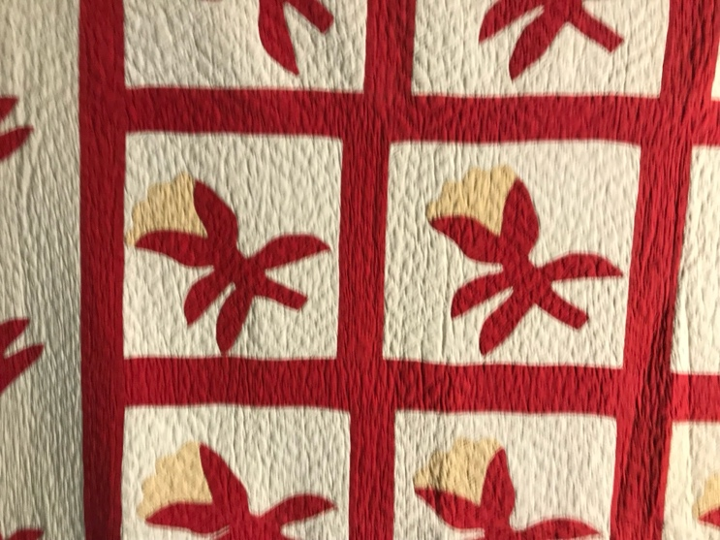 | 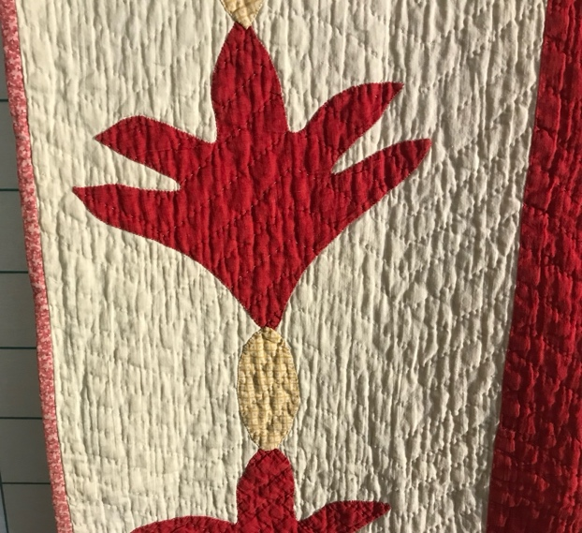
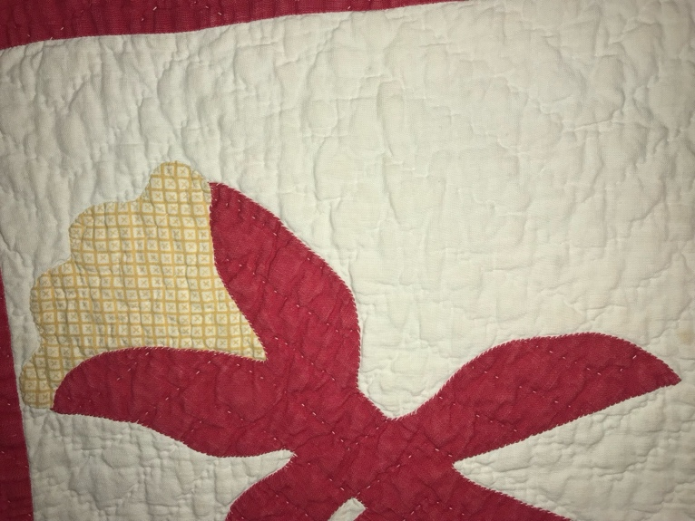

Quilt Back Design & Construction

Quilt Back
Layout
. Describe: White. no seam
Materials
Sources of Fabric |  | NOT KNOWN
 | Companies | Fabric Name & Number | Designer
 | -- | -- | --
 | Describe other sources: --
Fiber Types |  | NOT YET IDENTIFIED
 | Cotton | Silk | Wool
 | Cotton Blend | Linen | Synthetic
 | Describe & Clarify: --
Fabric Types |  | NOT KNOWN
 | Broadcloth | Sateen | Upholstery
 | Flannel | Satin | Chintz
 | Shirting | Muslin | Glazed
 | Suiting | Velvet | Handwoven
 | Denim | Felt | Lindsey-Woolsey
 | Describe & Clarify: --
Print Types |  | NOT YET IDENTIFIED
 | Batik | Floral | Plaid
 | Cheater Panel | Geometric | Solid / Plain
 | Checked / Gingham | Hand-dyed | Stamped
 | Conversation / Novelty | Victorian Mourning Prints | Stripes
 | Dotted | Multiple scraps
 | Feed sack / Feed sack-like | Paisley
 | Describe & Clarify: --

Images for Back
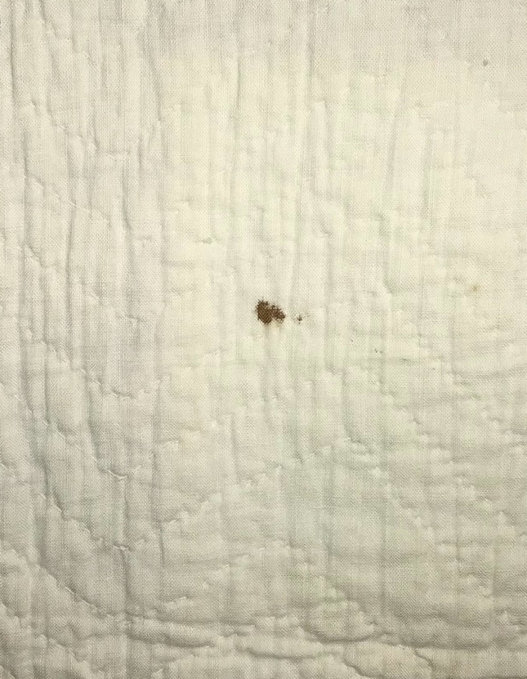 | 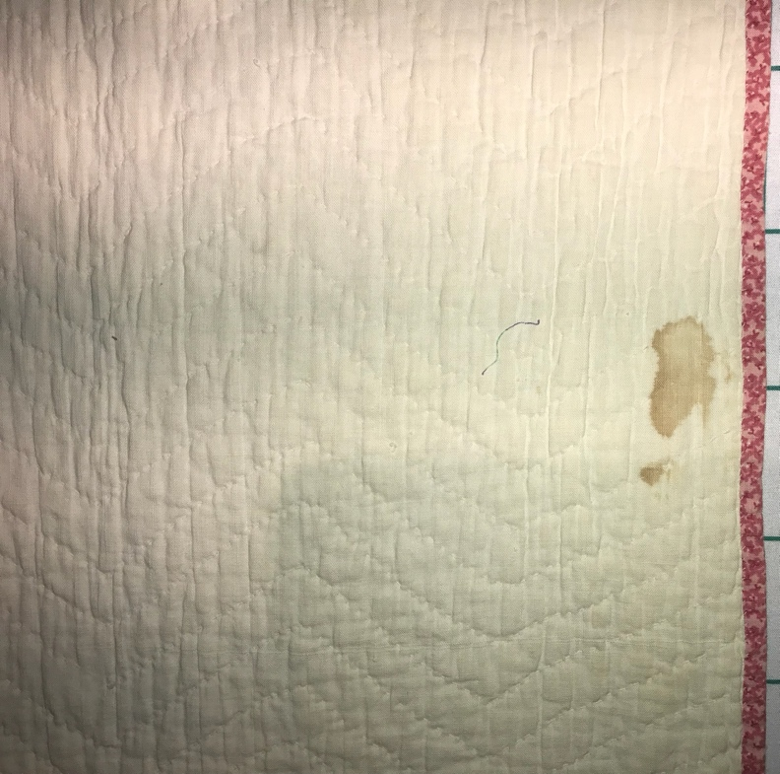

Stabilization Method
Stabilization Method:
Batting
Quilting Techniques
 | Machine Quilted | Machine – sit-down | Corded
 | Machine – computer guided | Hand Quilted | Stuffed work
 | Machine – manual long-arm | Quilt-as-you-go
Quilting Patterns
 | Meander / Free motion | Lines – single parallel | Cables
 | In-the-ditch / To the piece | Lines – double parallel | Feathers
 | Echo / Outlined | Lines – triple parallel | Wreaths
 | Stipple | Grid – crosshatch | Vines
 | Clamshell | Grid – square | Floral
 | Elbow / Fan | Grid - diamond | Leaves
 | Describe other: --
Thread Choices
 | Brand | Weight | Number & Name
 | -- | -- | --
Images for Quilting
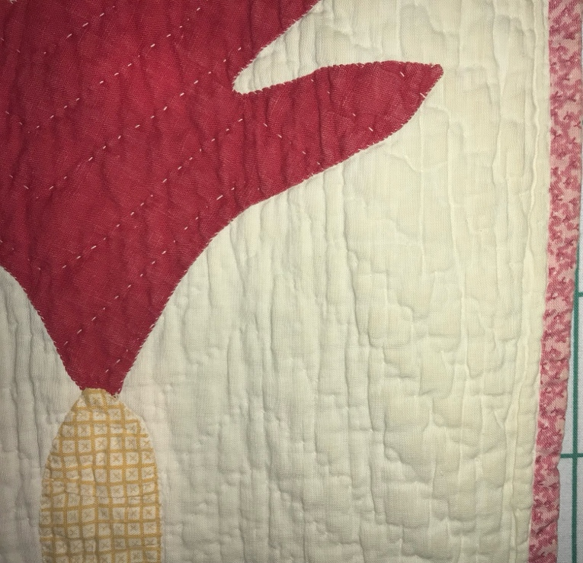

Edge Finish
Edge Style:
Finishing Technique
Top Width: 0.38 “ | Binding | Rolled – top to back
Back Width: 0.5“ | Front – machine | Rolled – back to top
1/8 = 0.13, 3/8 = 0.38 | Front – hand | Knife edge
5/8 = 0.63, 7/8 = 0.88 | Back – machine | Turned
 | Back - hand
Embellishments
Fringe | Ruffles | Cording
Lace | Ribbon
Describe: The binding is a double pink fabric. I wonder if it was original. I don't feel a second binding under the double pink.

Images for Edge
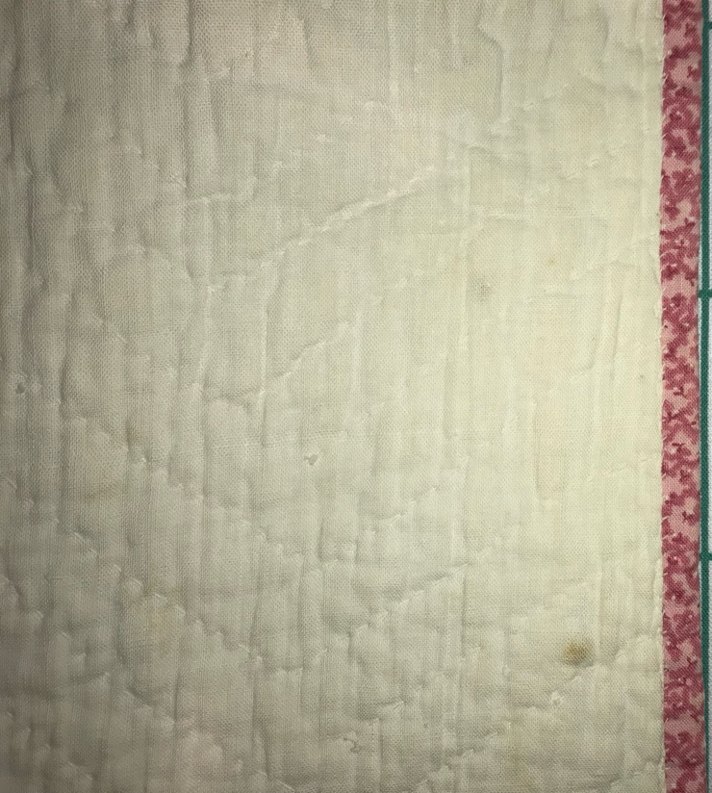

Condition

Flaws
Soiling
Dirty | Stains
Mildew stains | Musty Smell
Discoloration
Running / fugitive color | Faded / bleached color | Crocking
Fabric Damage
Tears / holes | Disintegrating / fall out | Insect damage
Thread bare | Shattering
Sewing / Quilting Damage
Split / open seams | Ties / tufting missing | Embellishments missing
Quilting threads missing | Batting has shifted
Storage Issues
Discoloration from wood | Damage from acid | Fold marks / creases
Describe additional condition issues: There are very minor condition issues. There are a few small stains. The seams are still strong and the turkey red is still vibrant. The look of the quilting suggests that the quilting thread shrunk at a different rate than the cotton fabric, so I think it has been washed.
Images for Condition Issues

Conservation, Restoration, Repairs
Describe Measures: --

Workmanship

Extension of Useful Life
Repair | Useful life of the item was extended.
Prevention of Damage
Conservation | All work is reversible.
Conservation | Further deterioration has been slowed, stabilized or prevented.
Maintaining Function & Integrity
Conservation | Work minimally interferes with the item’s overall appearance.
Restoration | Work blends well with the item’s overall appearance, style and age.
Restoration | Appropriate period reproductions were used.
Restoration | Vintage materials were used.
Restoration | Period appropriate techniques were used.
Restoration | Workmanship is of similar or better quality than original work.

Images for Conservation / Restoration / Repairs

