Documentation Form

Overview

Owner History
Owner | From Date | To Date | Location | Cost
David Bailey | Dec 23, 2021 | -- | Centerville Antique Mall, llc  200 W. Union Street  Centerville IN 47330  765 855 5551 | $21.40
 | If not purchased, the estimated cost for materials: $0

Display & Publication History
Date | Event | Location / Publication
Nov 18, 2024 | Anchor Bay Quilter’s Guild Meeting | New Baltimore, MI
Oct 7, 2024 | Montcomb County Quilter's Guild Meeting | Trinity Lutheran Church, Clinton Township, MI
April 3-7, 2023 | Fisher Farm Quilt Show | 16W680 Old Grand Avenue
Caption:
This is a “hired-hand” quilt. Its 42” by 80” size was likely intended to cover a worker’s cot. The quilt was made from men’s wool suiting. The wool rectangles are placed edge-to-edge with no overlap or seam allowance. The decorative embroidery that outlines each rectangle hold the piecing together and attaches the pieces to an underlying fabric foundation. The rectangles and their foundation were used as the top layer of the quilt sandwich. This piece is sparsely tied, not quilted. As a result the thick layer of cotton batting has drifted toward the edges of the quilt and created pillows. Based on the fabric, estimates are that the quilt was made between 1900 and 1910. The quilt was found in east central Indiana.

Work by unknown.

General Description
Quilt Title or Name:  Hired-Hand Tied Comforter | Date Made: 1905 ± 10 Years  Method of Determination:  Fabric Date Range: 1893 ± 18 Years  Method of Determination:
Item Type: | Size: Length: 80“ x Width: 42“
Appraisals:  Has this quilt been professionally appraised?  If so, when: Aug 19, 2022  ----------- | Other related files:
Additional Information: The age of this quilt is being inferred on a few different things. There is foundation fabric that seems consistent with the late 1800's. A machine stitch has been used to adhere the rectangles to the foundation (after 1860's). The suiting is consistent with the 1900's. The embroidery style seems to echo crazy quilts of the same time period (1890-1920.)

Images
Top | Back
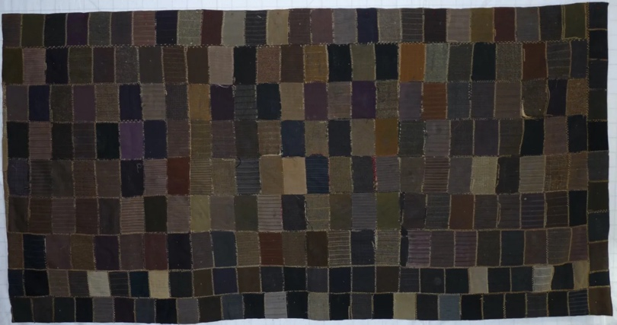 | 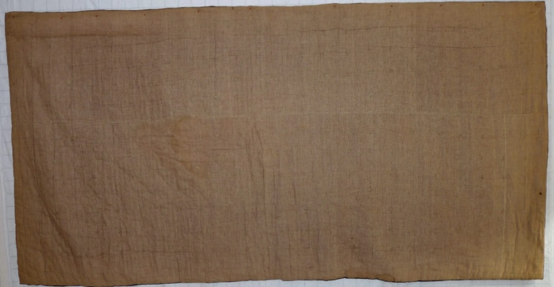

History

Provenance
Describe: --

Quilt Maker
Maker: unkonwn |  | Birth: -- |  | Death: --
 | Location: -- |  | Contributions: --

Purpose and Context
Expression
Art | Personal Enjoyment | Therapy
Income
Personal Income | Fundraising
Presentation
Anniversary | Wedding | Birth
Holiday | Birthday | Other gift
Charitable support
Relationships
Friendship | Commemorative | Memorial
Mourning | Reunion
Skill Building
Challenge / Contest | Learning / Teaching Sample
Use
Bed Quilt | Lap Quilt | Home Décor
Baby / Crib | Wall Hanging
Describe other purpose: --

Quilt Top Design & Construction

Quilt Top
Layout
. Describe: Rectangles that are 3-4"x 5".

Piecing
Techniques
 |  | Machine pieced | String / Improvisational piecing
 |  | Hand pieced | Foundation piecing
 |  | Strip piecing | English paper piecing
 |  | Describe: --
 | Workmanship
 |  | Seams are stable | Seams are appropriately aligned
 |  | Seams are flat | Points are sharp
 |  | There is significant workmanship issues. There are many seams that have released. As best as i am able to tell, the quilt was put together using different fabric foundations to raw edge applique the men's suiting swatches. The edges were further stabilized by the use of embroidery. Over time, the seams have released. No doubt that the sheer weight of the quilt contributed to the seams failing.

Embellishments
Types:
 | Applique – Raw edge | Embroidery | Stuffed Work
 | Applique - Button-hole | Cording | Inking
 | Applique - Needle-turn | Beading | Painting
 | Applique - Reverse | Rhinestones / Gems | Marking lines noted
 | Applique - Other | Other: --
Workmanship
 | Stitches are appropriately small and even.
 | Edges are as design intends (straight, curved, pointed).
 | Work demonstrates appropriate skill for intended purpose.
 | Describe other techniques

Top Assembly
Seams are stable | Top has no inappropriate tucks or puckers
Seams are flat | Top lays flat with no overly full areas
Seams are appropriately aligned

Color
Predominant colors
 | Red | Blue | Black
 | Orange | Violet/Purple | Grey
 | Yellow | Brown | White
 | Green | Beige / Tan
Specific Antique Colors |  | NONE NOTED
 | Red – claret / wine | Yellow – chrome | Blue – Lancaster
 | Red – madder / cinnamon | Green - chrome | Blue – Prussian / Lafayette
 | Red – turkey | Green – Nile | Brown – madder
 | Pinks - double | Blue – Cadet | Butterscotch
 | Orange - madder | Blue - Indigo | Bronze
 | Orange – cheddar / antimony / chrome |  | Late 1800’s Purple

Materials
Sources of Fabric |  | NOT KNOWN
 | Companies | Fabric Name & Number | Designer
 | -- | -- | --
 | Describe other sources: --
Fiber Types |  | NOT YET IDENTIFIED
 | Cotton | Silk | Wool
 | Cotton Blend | Linen | Synthetic
 | Describe & Clarify: --
Fabric Types |  | NOT KNOWN
 | Broadcloth | Sateen | Upholstery
 | Flannel | Satin | Chintz
 | Shirting | Muslin | Glazed
 | Suiting | Velvet | Handwoven
 | Denim | Felt | Lindsey-Woolsey
 | Describe & Clarify: --
Print Types |  | NOT YET IDENTIFIED
 | Batik | Floral | Plaid
 | Cheater Panel | Geometric | Solid / Plain
 | Checked / Gingham | Hand-dyed | Stamped
 | Conversation / Novelty | Victorian Mourning Prints | Stripes
 | Dotted | Multiple scraps
 | Feed sack / Feed sack-like | Paisley
 | Describe & Clarify: --

Images for Inscriptions
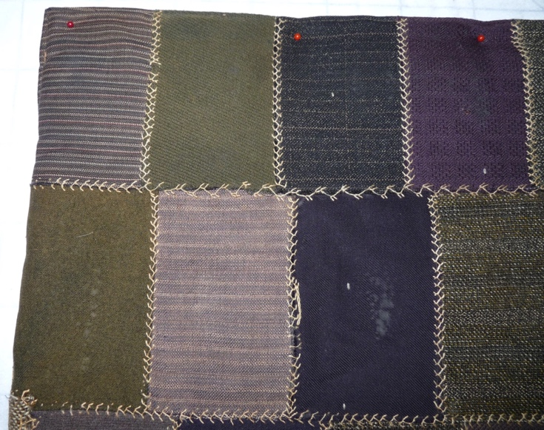 | 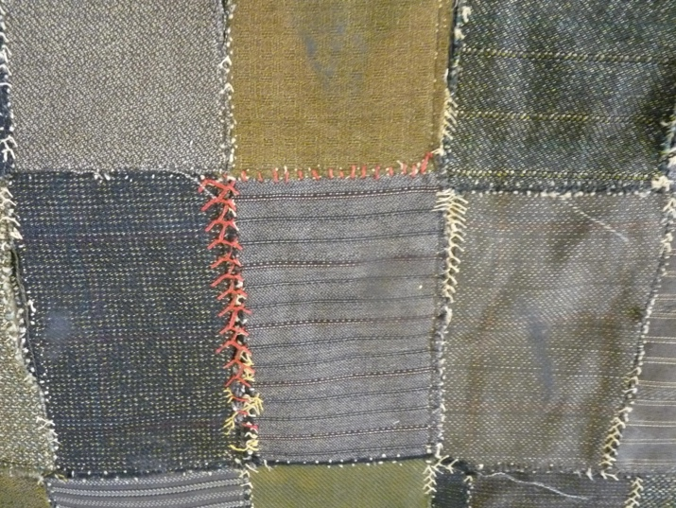

Quilt Back Design & Construction

Quilt Back
Layout
. Describe: Appears to be a gold/brown cotton - possibly a type of flannel?

Stabilization Method
Stabilization Method:
Delete this & the following table rows as appropriate.
Tied Details
 | Average Distance Between Knots: 3” | Placement:
 |  | Fiber: Wool yarn
Images for Quilting

Edge Finish
Edge Style:
Finishing Technique
Top Width: 0.00 “ | Binding | Rolled – top to back
Back Width: 0.00“ | Front – machine | Rolled – back to top
1/8 = 0.13, 3/8 = 0.38 | Front – hand | Knife edge
5/8 = 0.63, 7/8 = 0.88 | Back – machine | Turned
 | Back - hand
Embellishments
Fringe | Ruffles | Cording
Lace | Ribbon
Describe: --

Images for Edge
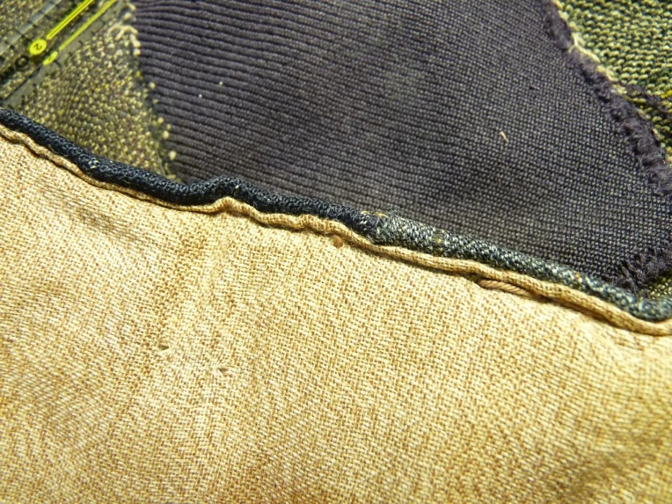

Condition

Flaws
Soiling
Dirty | Stains
Mildew stains | Musty Smell
Discoloration
Running / fugitive color | Faded / bleached color | Crocking
Fabric Damage
Tears / holes | Disintegrating / fall out | Insect damage
Thread bare | Shattering
Sewing / Quilting Damage
Split / open seams | Ties / tufting missing | Embellishments missing
Quilting threads missing | Batting has shifted
Storage Issues
Discoloration from wood | Damage from acid | Fold marks / creases
Describe additional condition issues:

Images for Condition Issues
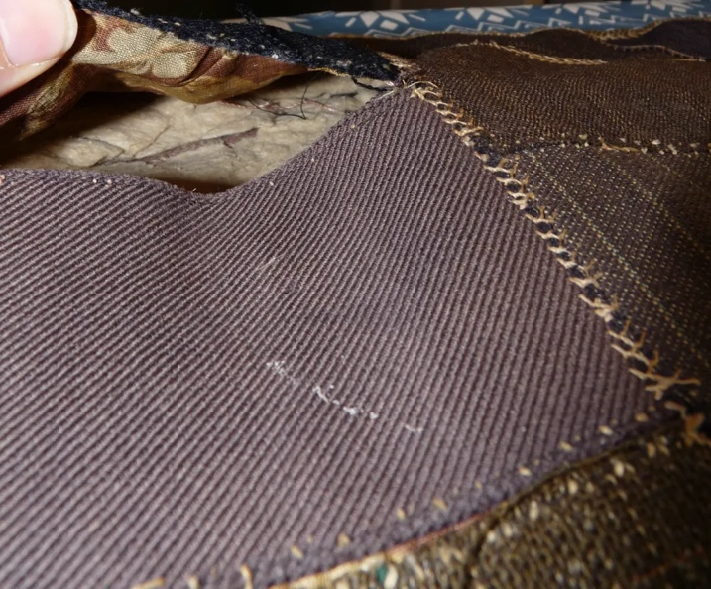

Conservation, Restoration, Repairs
Describe Measures: Some repair measures are apparent. - Some seams have been resewn and the embroider has been done in red in some areas.
This quilt deserves some restroration attention:
- Repair the torn foundation.
- Retattach the suiting to the foundaation.
- Replace the seam embellishments where missing.
- Not sure what to do about the shifting batting.
- Clean up the knife edge binding where it has released.

Workmanship

Extension of Useful Life
Repair | Useful life of the item was extended.
Prevention of Damage
Conservation | All work is reversible.
Conservation | Further deterioration has been slowed, stabilized or prevented.
Maintaining Function & Integrity
Conservation | Work minimally interferes with the item’s overall appearance.
Restoration | Work blends well with the item’s overall appearance, style and age.
Restoration | Appropriate period reproductions were used.
Restoration | Vintage materials were used.
Restoration | Period appropriate techniques were used.
Restoration | Workmanship is of similar or better quality than original work.

Images for Conservation / Restoration / Repairs

