Documentation Form

Overview

Owner History
Owner | From Date | To Date | Location | Cost
David Bailey | 1992 | -- | Cleveland, OH | $0.00
 | If not purchased, the estimated cost for materials: $15

Display & Publication History
Date | Event | Location / Publication | Pro-Rated  Reimbursement
-- | -- | -- | $0

General Description
Quilt Title or Name:  Cross Stitch Wolf | Date Made: 1992 ± 0 Years  Method of Determination:  Fabric Date Range: -- ± 0 Years  Method of Determination:
Item Type: | Size: Length: 15“ x Width: 14“
Appraisals:  Has this quilt been professionally appraised?  If so, when: --  ----------- | Other related files:  Scanned Patterns  Images  EQ 8 Files  Research Notes
Additional Information: I made this item after the Polar Bear counted cross stitch. i finished it in 1992 while I was in graduate school. Again the pattern came from the Cross My Heart line, Endangered Species, 1988.

Images
Top
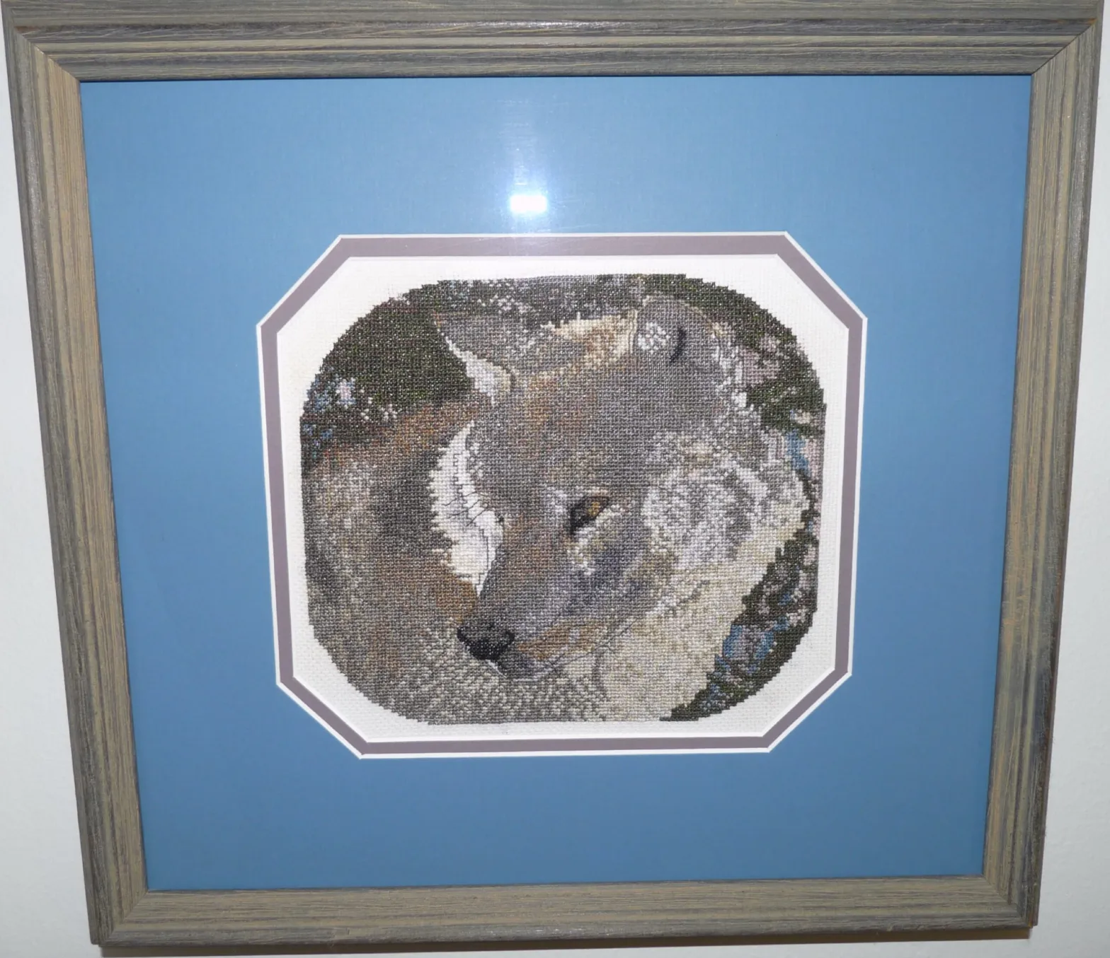

History

Provenance
Describe: --

Quilt Maker
Maker: David Bailey |  | Birth: July 20, 1967 |  | Death: --
 | Location: Cleveland, OH |  | Contributions: stitching

Purpose and Context
Expression
Art | Personal Enjoyment | Therapy
Income
Personal Income | Fundraising
Presentation
Anniversary | Wedding | Birth
Holiday | Birthday | Other gift
Charitable support
Relationships
Friendship | Commemorative | Memorial
Mourning | Reunion
Skill Building
Challenge / Contest | Learning / Teaching Sample
Use
Bed Quilt | Lap Quilt | Home Décor
Baby / Crib | Wall Hanging
Describe other purpose: --

Condition

Flaws
Soiling
Dirty | Stains
Mildew stains | Musty Smell
Discoloration
Running / fugitive color | Faded / bleached color | Crocking
Fabric Damage
Tears / holes | Disintegrating / fall out | Insect damage
Thread bare | Shattering
Sewing / Quilting Damage
Split / open seams | Ties / tufting missing | Embellishments missing
Quilting threads missing | Batting has shifted
Storage Issues
Discoloration from wood | Damage from acid | Fold marks / creases
Describe additional condition issues: --
Images for Condition Issues

Conservation, Restoration, Repairs
Describe Measures: --

Workmanship

Extension of Useful Life
Repair | Useful life of the item was extended.
Prevention of Damage
Conservation | All work is reversible.
Conservation | Further deterioration has been slowed, stabilized or prevented.
Maintaining Function & Integrity
Conservation | Work minimally interferes with the item’s overall appearance.
Restoration | Work blends well with the item’s overall appearance, style and age.
Restoration | Appropriate period reproductions were used.
Restoration | Vintage materials were used.
Restoration | Period appropriate techniques were used.
Restoration | Workmanship is of similar or better quality than original work.

Images for Conservation / Restoration / Repairs

