Documentation Form

Overview

Owner History
Owner | From Date | To Date | Location | Cost
DJ Trela | 1971 | -- | Chicago, IL | $0.00
 | If not purchased, the estimated cost for materials: $0

Display & Publication History
Date | Event | Location / Publication | Pro-Rated  Reimbursement
-- | -- | -- | $0

General Description
Quilt Title or Name:  Needlepoint Flowers | Date Made: 1970 ± 10 Years  Method of Determination:  Fabric Date Range: -- ± 0 Years  Method of Determination:
Item Type: | Size: Length: 11“ x Width: 11“
Appraisals:  Has this quilt been professionally appraised?  If so, when: --  ----------- | Other related files:  Scanned Patterns  Images  EQ 8 Files  Research Notes
Additional Information: DJ Trela inherited this piece from his grandmother, Anna Andersen when Anna died in 1971. Based on the design of this piece, I expect it was not made much before 1950. Anna lived in Chicago, Wisconsin and Florida. Needlepoint canvas. 10 stitches / inch.

Images
Top | Back
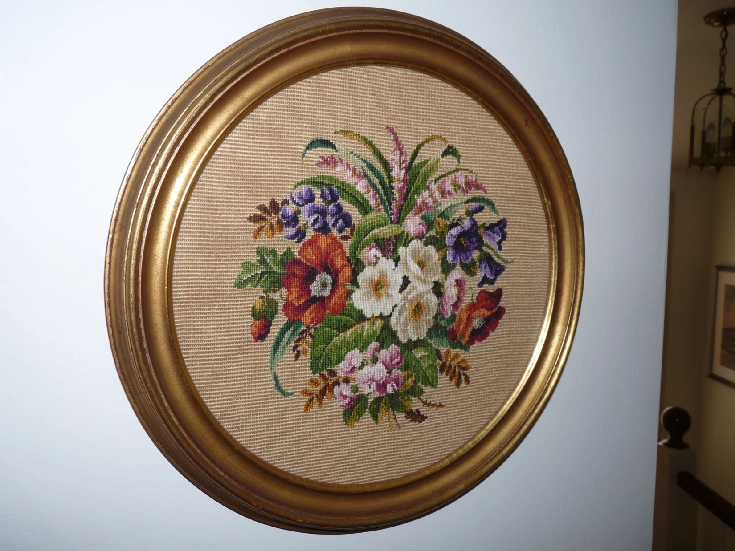

History

Provenance
Describe: --

Quilt Maker
Maker: Anna Anderson |  | Birth: 1887 |  | Death: 1971
 | Location: -- |  | Contributions: --

Purpose and Context
Expression
Art | Personal Enjoyment | Therapy
Income
Personal Income | Fundraising
Presentation
Anniversary | Wedding | Birth
Holiday | Birthday | Other gift
Charitable support
Relationships
Friendship | Commemorative | Memorial
Mourning | Reunion
Skill Building
Challenge / Contest | Learning / Teaching Sample
Use
Bed Quilt | Lap Quilt | Home Décor
Baby / Crib | Wall Hanging
Describe other purpose: --

Condition

Flaws
Soiling
Dirty | Stains
Mildew stains | Musty Smell
Discoloration
Running / fugitive color | Faded / bleached color | Crocking
Fabric Damage
Tears / holes | Disintegrating / fall out | Insect damage
Thread bare | Shattering
Sewing / Quilting Damage
Split / open seams | Ties / tufting missing | Embellishments missing
Quilting threads missing | Batting has shifted
Storage Issues
Discoloration from wood | Damage from acid | Fold marks / creases
Describe additional condition issues: --
Images for Condition Issues

Conservation, Restoration, Repairs
Describe Measures: --

Workmanship

Extension of Useful Life
Repair | Useful life of the item was extended.
Prevention of Damage
Conservation | All work is reversible.
Conservation | Further deterioration has been slowed, stabilized or prevented.
Maintaining Function & Integrity
Conservation | Work minimally interferes with the item’s overall appearance.
Restoration | Work blends well with the item’s overall appearance, style and age.
Restoration | Appropriate period reproductions were used.
Restoration | Vintage materials were used.
Restoration | Period appropriate techniques were used.
Restoration | Workmanship is of similar or better quality than original work.

Images for Conservation / Restoration / Repairs

