Documentation Form

Overview

Owner History
Owner | From Date | To Date | Location | Cost
David Bailey | Dec 23, 2021 | July 29, 2022 | Flint, MI | $0.00
 | If not purchased, the estimated cost for materials: $80
Barbara Morgan | July 29, 2022 | Aug 4, 2022 | Ohio | $0.00
Ellen Cufr | Aug 4, 2022 | -- | Ohio | $0.00

Display & Publication History
Date | Event | Location / Publication | Pro-Rated  Reimbursement
-- | -- | -- | $0

General Description
Quilt Title or Name:  Dumbell Table Topper | Date Made: April 6, 2022  Exact  circa +/- 0 Years  Method of Determination:  Fabric Dates: 1920+/10, 2022
Item Type: | Size: Length: 37“ x Width: 37“
Appraisals:  Has this quilt been professionally appraised?  If so, when: --  ----------- | Other related files:  Thank you note from Ellen Cufr.
Additional Information: This table started with me as 38 loose blocks at the Antiques Village (651 Lyons Rd) in Dayton, OH 45459 (937) 291-5060 on Dec 23, 2021. The fabric for the blocks dates to ca 1880 to 1940 and they were hand-stitched. The price for the set of 38 was about $36.50. February 19, 2022, I washed and whitened, assembled the top, quilted and bound it. This work was done by April 6, 2022. 36 of the blocks were used on the front of the quilt. The remaining two were placed into the back and aligned with the top so that the quilting patterns matched.
During that summer, a friend (Barbara Morgan) of my mother (Linda Bailey) began to have failing health and Barbara's daughter started to look for new homes for Barbara's sewing equipment. I inherited a Bernina sewing machine with a cabinet that was made my Barbara's husband.
In return for this, I offered Barbara one of my first completed projects. Shortly after I gave the table topper to Barbara, she died and the topper when to her daughter.

Images
Top | Back
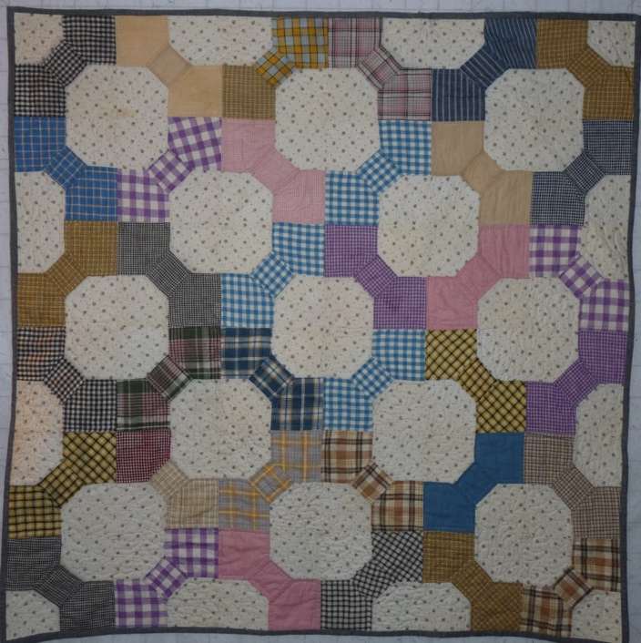 | 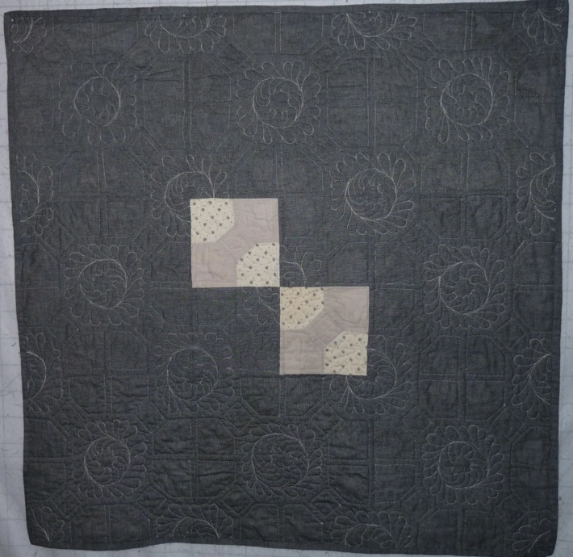

History

Provenance
Describe: --

Quilt Maker
Maker: unkonwn |  | Birth: -- |  | Death: --
 | Location: -- |  | Contributions: hand-piecedd bow tie blocks
Maker: David Bailey |  | Birth: July 20, 1967 |  | Death: --
 | Location: Flint, MI |  | Contributions: Assembly, Quilting, Binding

Purpose and Context
Expression
Art | Personal Enjoyment | Therapy
Income
Personal Income | Fundraising
Presentation
Anniversary | Wedding | Birth
Holiday | Birthday | Other gift
Charitable support
Relationships
Friendship | Commemorative | Memorial
Mourning | Reunion
Skill Building
Challenge / Contest | Learning / Teaching Sample
Use
Bed Quilt | Lap Quilt | Home Décor
Baby / Crib | Wall Hanging
Describe other purpose: --

Quilt Top Design & Construction

Quilt Top
Layout
. Describe: --
Blocks
Grid & Contained Crazy Details
 |  | Grid Dimensions: Length 6 x Width: 6
 |  | Block Size: Length: 7“ x Width: 7“
Block Pattern Details
 | - | 
 | Bow Tie Blocks (BB ID 2533) with Dumbell setting (BB ID 1429a. Four blocks shown to the right.

Piecing
Techniques
 |  | Machine pieced | String / Improvisational piecing
 |  | Hand pieced | Foundation piecing
 |  | Strip piecing | English paper piecing
 |  | Describe: --
 | Workmanship
 |  | Seams are stable | Seams are appropriately aligned
 |  | Seams are flat | Points are sharp
 |  | Describe piecing workmanship

Top Assembly
Seams are stable | Top has no inappropriate tucks or puckers
Seams are flat | Top lays flat with no overly full areas
Seams are appropriately aligned

Color
Predominant colors
 | Red | Blue | Black
 | Orange | Violet/Purple | Grey
 | Yellow | Brown | White
 | Green | Beige / Tan
Specific Antique Colors |  | NONE NOTED
 | Red – claret / wine | Yellow – chrome | Blue – Lancaster
 | Red – madder / cinnamon | Green - chrome | Blue – Prussian / Lafayette
 | Red – turkey | Green – Nile | Brown – madder
 | Pinks - double | Blue – Cadet | Butterscotch
 | Orange - madder | Blue - Indigo | Bronze
 | Orange – cheddar / antimony / chrome |  | Late 1800’s Purple

Materials
Sources of Fabric |  | NOT KNOWN
 | Companies | Fabric Name & Number | Designer
 | -- | -- | --
 | Describe other sources: --
Fiber Types |  | NOT YET IDENTIFIED
 | Cotton | Silk | Wool
 | Cotton Blend | Linen | Synthetic
 | Describe & Clarify: --
Fabric Types |  | NOT KNOWN
 | Broadcloth | Sateen | Upholstery
 | Flannel | Satin | Chintz
 | Shirting | Muslin | Glazed
 | Suiting | Velvet | Handwoven
 | Denim | Felt | Lindsey-Woolsey
 | Describe & Clarify: --
Print Types |  | NOT YET IDENTIFIED
 | Batik | Floral | Plaid
 | Cheater Panel | Geometric | Solid / Plain
 | Checked / Gingham | Hand-dyed | Stamped
 | Conversation / Novelty | Victorian Mourning Prints | Stripes
 | Dotted | Multiple scraps
 | Feed sack / Feed sack-like | Paisley
 | Describe & Clarify: --

Top Inscriptions
None Found
Inscription is present. Describe location: --
Content
Makers names | Initials | Date
Single Name | Message | Place
Multiple Names
Transcription: --

Methods
Label | Ink – Ball point | Stencil
Printed onto fabric | Ink – Felt tip | Stamped
Quilted | Ink - Other | Pencil
Embroidery | Applique | Typewriter
Describe & Clarify: --

Images for Inscriptions

Quilt Back Design & Construction

Quilt Back
Layout
. Describe: A grey chambray was used as backing and into this was pieced the last two bow tie blocks. See picture below for piecing strategy.

Back Inscriptions
None found
Inscription is present. Describe location: --
Content
Makers names | Initials | Date
Single Name | Message | Place
Multiple Names
Transcription: --

Methods
Label | Ink – Ball point | Stencil
Printed onto fabric | Ink – Felt tip | Stamped
Quilted | Ink - Other | Pencil
Embroidery | Applique | Typewriter
Describe & Clarify: --

Images for Back
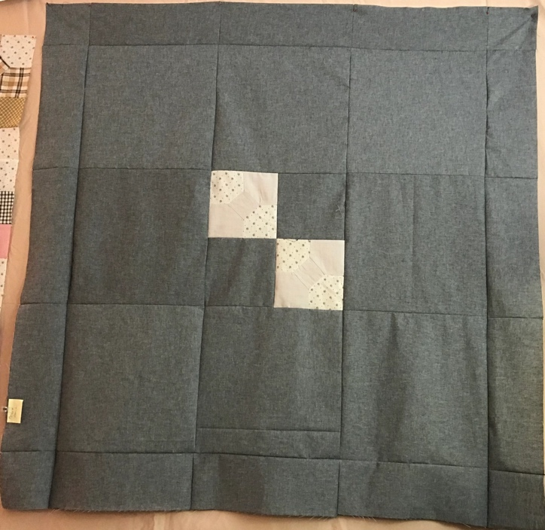

Stabilization Method
Stabilization Method:
Batting
Quilting Techniques
 | Machine Quilted | Machine – sit-down | Corded
 | Machine – computer guided | Hand Quilted | Stuffed work
 | Machine – manual long-arm | Quilt-as-you-go
Quilting Patterns
 | Meander / Free motion | Lines – single parallel | Cables
 | In-the-ditch / To the piece | Lines – double parallel | Feathers
 | Echo / Outlined | Lines – triple parallel | Wreaths
 | Stipple | Grid – crosshatch | Vines
 | Clamshell | Grid – square | Floral
 | Elbow / Fan | Grid - diamond | Leaves
 | Describe other: --
Thread Choices
 | Brand | Weight | Number & Name
 | -- | -- | --
Images for Quilting
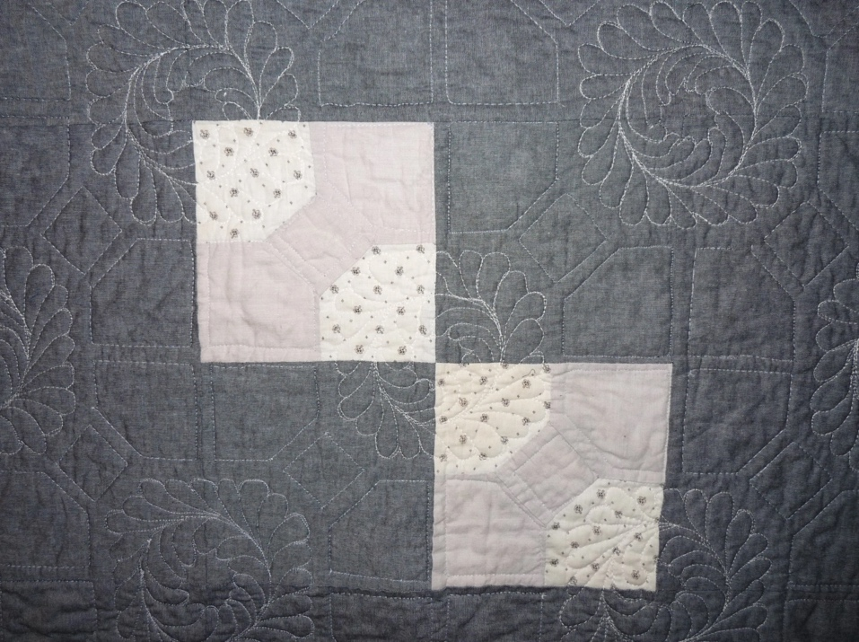

Edge Finish
Edge Style:
Finishing Technique
Top Width: 0.50 “ | Binding | Rolled – top to back
Back Width: 0.50“ | Front – machine | Rolled – back to top
1/8 = 0.13, 3/8 = 0.38 | Front – hand | Knife edge
5/8 = 0.63, 7/8 = 0.88 | Back – machine | Turned
 | Back - hand
Embellishments
Fringe | Ruffles | Cording
Lace | Ribbon
Describe: --

Images for Edge

Condition

Flaws
Soiling
Dirty | Stains
Mildew stains | Musty Smell
Discoloration
Running / fugitive color | Faded / bleached color | Crocking
Fabric Damage
Tears / holes | Disintegrating / fall out | Insect damage
Thread bare | Shattering
Sewing / Quilting Damage
Split / open seams | Ties / tufting missing | Embellishments missing
Quilting threads missing | Batting has shifted
Storage Issues
Discoloration from wood | Damage from acid | Fold marks / creases
Describe additional condition issues: --
Images for Condition Issues

Conservation, Restoration, Repairs
Describe Measures: Loose blocks were washed, assembled and the quilt was finished.

Workmanship

Extension of Useful Life
Repair | Useful life of the item was extended.
Prevention of Damage
Conservation | All work is reversible.
Conservation | Further deterioration has been slowed, stabilized or prevented.
Maintaining Function & Integrity
Conservation | Work minimally interferes with the item’s overall appearance.
Restoration | Work blends well with the item’s overall appearance, style and age.
Restoration | Appropriate period reproductions were used.
Restoration | Vintage materials were used.
Restoration | Period appropriate techniques were used.
Restoration | Workmanship is of similar or better quality than original work.

Images for Conservation / Restoration / Repairs
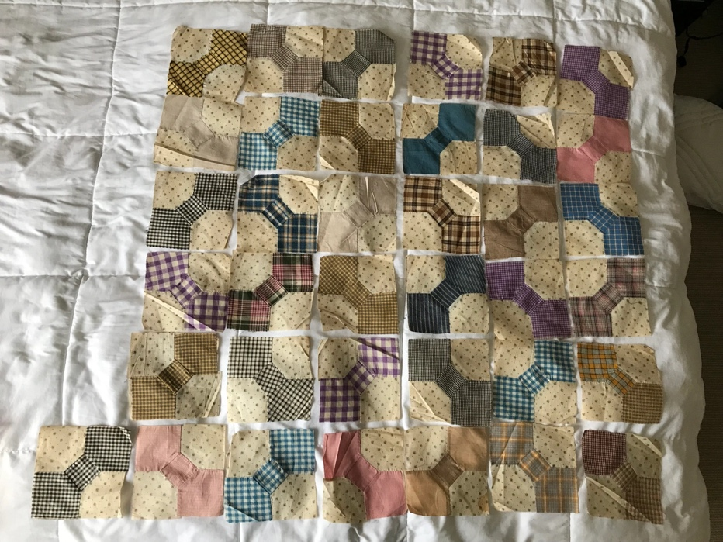 | 