Documentation Form

Overview

Owner History
Owner | From Date | To Date | Location | Cost
BeforeDavid Bailey | Dec 23, 2021 | Feb 14, 2024 | Chicago, IL | $0.00
 | If not purchased, the estimated cost for materials: $133
Leslie Dietsch | Feb 14, 2024 | -- | Chicago, IL | $0.00

Display & Publication History
Date | Event | Location / Publication | Pro-Rated  Reimbursement
-- | -- | -- | $0

General Description
Quilt Title or Name:  Yellow Dresden Plate | Date Made: Sep 14, 2022 to January 2024  Exact  circa +/- 0 Years  Method of Determination:  Fabric Range: 1940 +/- 10, 2024
Item Type: | Size: Length: 84“ x Width: 72“
Appraisals:  Has this quilt been professionally appraised?  If so, when: --  ----------- | Other related files:  Scanned Patterns  Images  EQ 8 Files  Research Notes
Additional Information: This quilt started as a top that I found in Centerville, IN at the Centerville Antique Mall. (220 W Union Street. Zip 47330.) The quilt cost $36-37. I took it home and vacuumed and rinsed it. I basted it into a quilt sandwich in Sep 2022 and finished quilting it in early 2024. it was then given as a gift to Leslie. The orginal fabrics in the top are circa 1940. I added the white border to the top and yardage for the back along with the batting..

Images
Top | Back
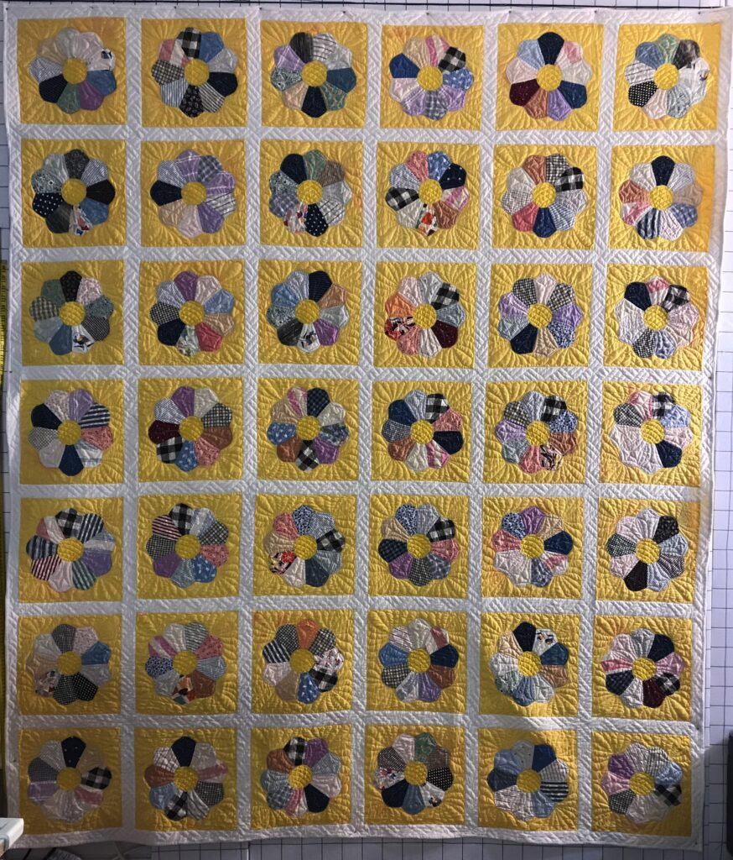 | 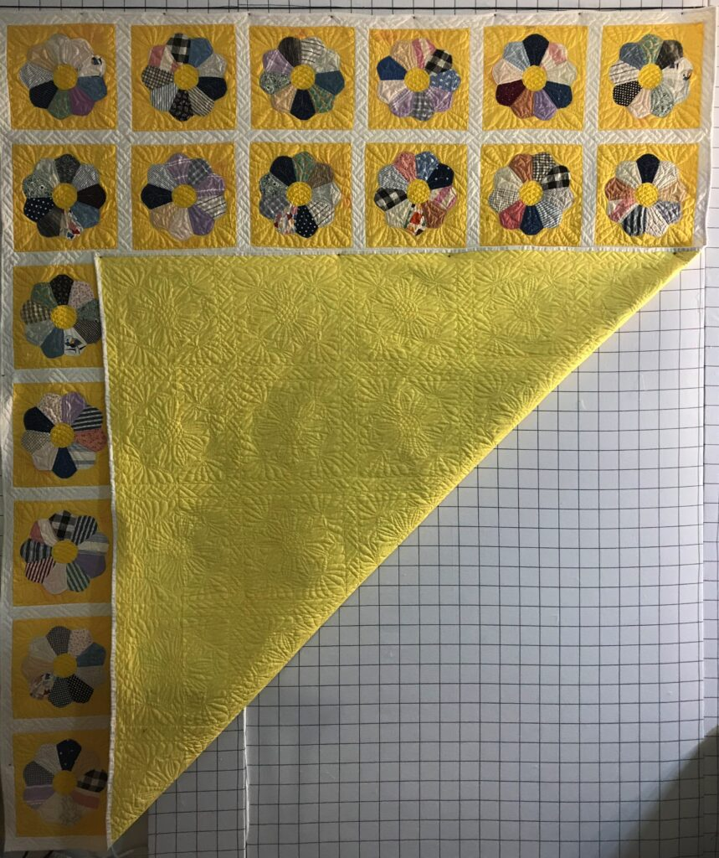

History

Provenance
Describe: --

Quilt Maker
Maker: unknown |  | Birth: -- |  | Death: --
 | Location: -- |  | Contributions: piecing
Maker: David Bailey |  | Birth: July 20, 1967 |  | Death: --
 | Location: Chicago, IL |  | Contributions: outer border, backing, batting, quilting, binding

Purpose and Context
Expression
Art | Personal Enjoyment | Therapy
Income
Personal Income | Fundraising
Presentation
Anniversary | Wedding | Birth
Holiday | Birthday | Other gift
Charitable support
Relationships
Friendship | Commemorative | Memorial
Mourning | Reunion
Skill Building
Challenge / Contest | Learning / Teaching Sample
Use
Bed Quilt | Lap Quilt | Home Décor
Baby / Crib | Wall Hanging
Describe other purpose: --

Quilt Top Design & Construction

Quilt Top
Layout
. Describe: --
Blocks
Grid & Contained Crazy Details
 |  | Grid Dimensions: Length 6 x Width: 7
 |  | Block Size: Length: 11“ x Width: 11“
Block Pattern Details
 | Pattern source | <<Pattern Image>>
 | 9 Blade dresden plate - version of BB ID 3452 | <<Pattern Image>>

Piecing
Delete this & the following table rows as appropriate.
Techniques
 |  | Machine pieced | String / Improvisational piecing
 |  | Hand pieced | Foundation piecing
 |  | Strip piecing | English paper piecing
 |  | Describe: --
 | Workmanship
 |  | Seams are stable | Seams are appropriately aligned
 |  | Seams are flat | Points are sharp
 |  | Describe piecing workmanship

Embellishments
Delete this & the following table rows as appropriate.
Types:
 | Applique – Raw edge | Embroidery | Stuffed Work
 | Applique - Button-hole | Cording | Inking
 | Applique - Needle-turn | Beading | Painting
 | Applique - Reverse | Rhinestones / Gems | Marking lines noted
 | Applique - Other | Other: --
Workmanship
 | Stitches are appropriately small and even.
 | Edges are as design intends (straight, curved, pointed).
 | Work demonstrates appropriate skill for intended purpose.
 | Describe other techniques

Sashing
Delete this & the following table rows as appropriate.
Length: -0“ x Width: 1“
Use of corner stones

Borders & Frames
Delete this & the following table rows as appropriate.
Describe borders and frames in order from center to edge.
1 | Width: 1.50“ |  | Describe: --

Top Assembly
Seams are stable | Top has no inappropriate tucks or puckers
Seams are flat | Top lays flat with no overly full areas
Seams are appropriately aligned

Color
Predominant colors
 | Red | Blue | Black
 | Orange | Violet/Purple | Grey
 | Yellow | Brown | White
 | Green | Beige / Tan
Specific Antique Colors |  | NONE NOTED
 | Red – claret / wine | Yellow – chrome | Blue – Lancaster
 | Red – madder / cinnamon | Green - chrome | Blue – Prussian / Lafayette
 | Red – turkey | Green – Nile | Brown – madder
 | Pinks - double | Blue – Cadet | Butterscotch
 | Orange - madder | Blue - Indigo | Bronze
 | Orange – cheddar / antimony / chrome |  | Late 1800’s Purple

Materials
Sources of Fabric |  | NOT KNOWN
 | Companies | Fabric Name & Number | Designer
 | -- | -- | --
 | Describe other sources: --
Fiber Types |  | NOT YET IDENTIFIED
 | Cotton | Silk | Wool
 | Cotton Blend | Linen | Synthetic
 | Describe & Clarify: --
Fabric Types |  | NOT KNOWN
 | Broadcloth | Sateen | Upholstery
 | Flannel | Satin | Chintz
 | Shirting | Muslin | Glazed
 | Suiting | Velvet | Handwoven
 | Denim | Felt | Lindsey-Woolsey
 | Describe & Clarify: --
Print Types |  | NOT YET IDENTIFIED
 | Batik | Floral | Plaid
 | Cheater Panel | Geometric | Solid / Plain
 | Checked / Gingham | Hand-dyed | Stamped
 | Conversation / Novelty | Victorian Mourning Prints | Stripes
 | Dotted | Multiple scraps
 | Feed sack / Feed sack-like | Paisley
 | Describe & Clarify: --

Top Inscriptions
None Found
Inscription is present. Describe location: --
Content
Makers names | Initials | Date
Single Name | Message | Place
Multiple Names
Transcription: --

Methods
Label | Ink – Ball point | Stencil
Printed onto fabric | Ink – Felt tip | Stamped
Quilted | Ink - Other | Pencil
Embroidery | Applique | Typewriter
Describe & Clarify: --

Images for Inscriptions

Quilt Back Design & Construction

Quilt Back
Layout
. Describe: --

Back Assembly
Seams are stable | Back has no inappropriate tucks or puckers
Seams are flat | Back lays flat with no overly full areas
Seams are appropriately aligned

Color
Predominant colors
 | Red | Blue | Black
 | Orange | Violet/Purple | Grey
 | Yellow | Brown | White
 | Green | Beige / Tan
Specific Antique Colors |  | NONE NOTED
 | Red – claret / wine | Yellow – chrome | Blue – Lancaster
 | Red – madder / cinnamon | Green - chrome | Blue – Prussian / Lafayette
 | Red – turkey | Green – Nile | Brown – madder
 | Pinks - double | Blue – Cadet | Butterscotch
 | Orange - madder | Blue - Indigo | Bronze
 | Orange – cheddar / antimony / chrome |  | Late 1800’s Purple

Materials
Sources of Fabric |  | NOT KNOWN
 | Companies | Fabric Name & Number | Designer
 | -- | -- | --
 | Describe other sources: --
Fiber Types |  | NOT YET IDENTIFIED
 | Cotton | Silk | Wool
 | Cotton Blend | Linen | Synthetic
 | Describe & Clarify: --
Fabric Types |  | NOT KNOWN
 | Broadcloth | Sateen | Upholstery
 | Flannel | Satin | Chintz
 | Shirting | Muslin | Glazed
 | Suiting | Velvet | Handwoven
 | Denim | Felt | Lindsey-Woolsey
 | Describe & Clarify: --
Print Types |  | NOT YET IDENTIFIED
 | Batik | Floral | Plaid
 | Cheater Panel | Geometric | Solid / Plain
 | Checked / Gingham | Hand-dyed | Stamped
 | Conversation / Novelty | Victorian Mourning Prints | Stripes
 | Dotted | Multiple scraps
 | Feed sack / Feed sack-like | Paisley
 | Describe & Clarify: --

Back Inscriptions
None found
Inscription is present. Describe location: --
Content
Makers names | Initials | Date
Single Name | Message | Place
Multiple Names
Transcription: --

Methods
Label | Ink – Ball point | Stencil
Printed onto fabric | Ink – Felt tip | Stamped
Quilted | Ink - Other | Pencil
Embroidery | Applique | Typewriter
Describe & Clarify: --

Images for Back

Stabilization Method
Stabilization Method:
Batting
Quilting Techniques
 | Machine Quilted | Machine – sit-down | Corded
 | Machine – computer guided | Hand Quilted | Stuffed work
 | Machine – manual long-arm | Quilt-as-you-go
Quilting Patterns
 | Meander / Free motion | Lines – single parallel | Cables
 | In-the-ditch / To the piece | Lines – double parallel | Feathers
 | Echo / Outlined | Lines – triple parallel | Wreaths
 | Stipple | Grid – crosshatch | Vines
 | Clamshell | Grid – square | Floral
 | Elbow / Fan | Grid - diamond | Leaves
 | Describe other: --
Thread Choices
 | Brand | Weight | Number & Name
 | Clear Monofilament | -- | --
 | Glide | 40 | Buttercup - 80134
 | Glide | 40 | Bone - 17443
Images for Quilting
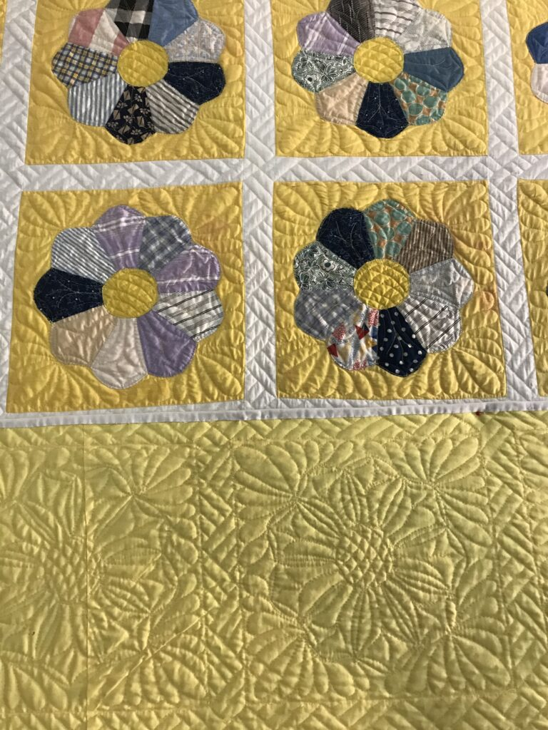

Edge Finish
Edge Style:
Finishing Technique
Top Width: 0.38 “ | Binding | Rolled – top to back
Back Width: 0.38“ | Front – machine | Rolled – back to top
1/8 = 0.13, 3/8 = 0.38 | Front – hand | Knife edge
5/8 = 0.63, 7/8 = 0.88 | Back – machine | Turned
 | Back - hand
Embellishments
Fringe | Ruffles | Cording
Lace | Ribbon
Describe: --

Images for Edge

Condition

Flaws
Soiling
Dirty | Stains
Mildew stains | Musty Smell
Discoloration
Running / fugitive color | Faded / bleached color | Crocking
Fabric Damage
Tears / holes | Disintegrating / fall out | Insect damage
Thread bare | Shattering
Sewing / Quilting Damage
Split / open seams | Ties / tufting missing | Embellishments missing
Quilting threads missing | Batting has shifted
Storage Issues
Discoloration from wood | Damage from acid | Fold marks / creases
Describe additional condition issues: There were a few conditions issues when the top was originally purchased. it was dirty and there were a few stains. I rinsed it and used a whitener. This lightened some of the colors and caused a small amount of bleeding from some reds into the yellow.
Images for Condition Issues

Conservation, Restoration, Repairs
Describe Measures: The quilt top was dirty and had some stains (probably rust) when I bought it. Vacumming did not remove the dirt. I rinsed it and and used small amount of whiter. This resulted in a lightening of the colors and a bit of bleeding from some red fabric into the yellow. I feel that this was necessary because the water ran black with the initial rinsing when the bleeding occurred.
At this point, the top was quilted. While this was not necessarily resversible, it did secure the raw edges of the fabric and stabilized it again the batting and another sheet of fabric.

Workmanship

Extension of Useful Life
Repair | Useful life of the item was extended.
Prevention of Damage
Conservation | All work is reversible.
Conservation | Further deterioration has been slowed, stabilized or prevented.
Maintaining Function & Integrity
Conservation | Work minimally interferes with the item’s overall appearance.
Restoration | Work blends well with the item’s overall appearance, style and age.
Restoration | Appropriate period reproductions were used.
Restoration | Vintage materials were used.
Restoration | Period appropriate techniques were used.
Restoration | Workmanship is of similar or better quality than original work.

Images for Conservation / Restoration / Repairs
Before rinsing  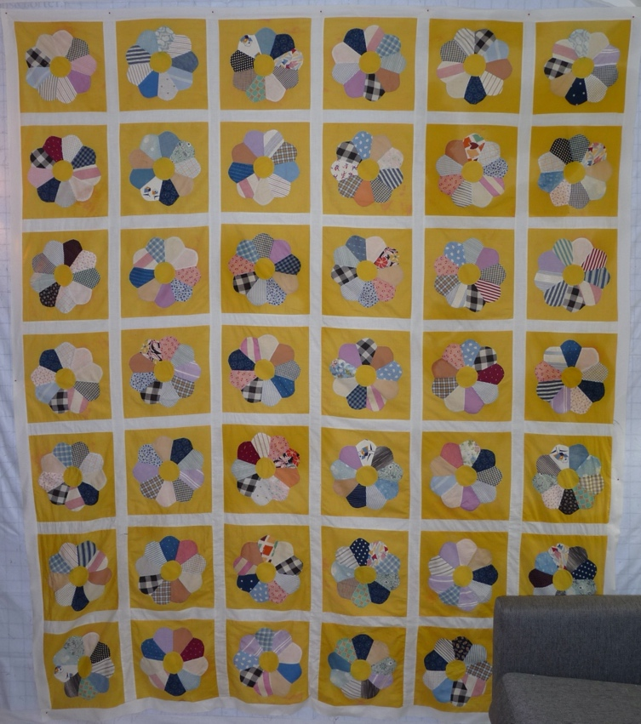 | After rinsing and whitening  