Documentation Form

Overview

Owner History
Owner | From Date | To Date | Location | Cost
David Bailey | Dec 25, 2018 | -- | Flint, MI | $0.00
 | If not purchased, the estimated cost for materials: $0

Display & Publication History
Date | Event | Location / Publication | Pro-Rated  Reimbursement
-- | -- | -- | $0

General Description
Quilt Title or Name:  Grandpa's Memory Shadow Box | Date Made: 2018  Exact  circa +/- 0 Years  Method of Determination:
Item Type: | Size: Length: 21“ x Width: 21“
Appraisals:  Has this quilt been professionally appraised?  If so, when: --  ----------- | Other related files:
Additional Information: My Grandfather, Harold Bailey, died in January 2018. My parents made each of Harold grandchildren - my two sisters and I - a shadow box of items from his household. The wooden frame was handcrafted by by father. The background quilt was made by my mother. The shadow boxes were given as Christmas gifts that year.

Images
Top | Back
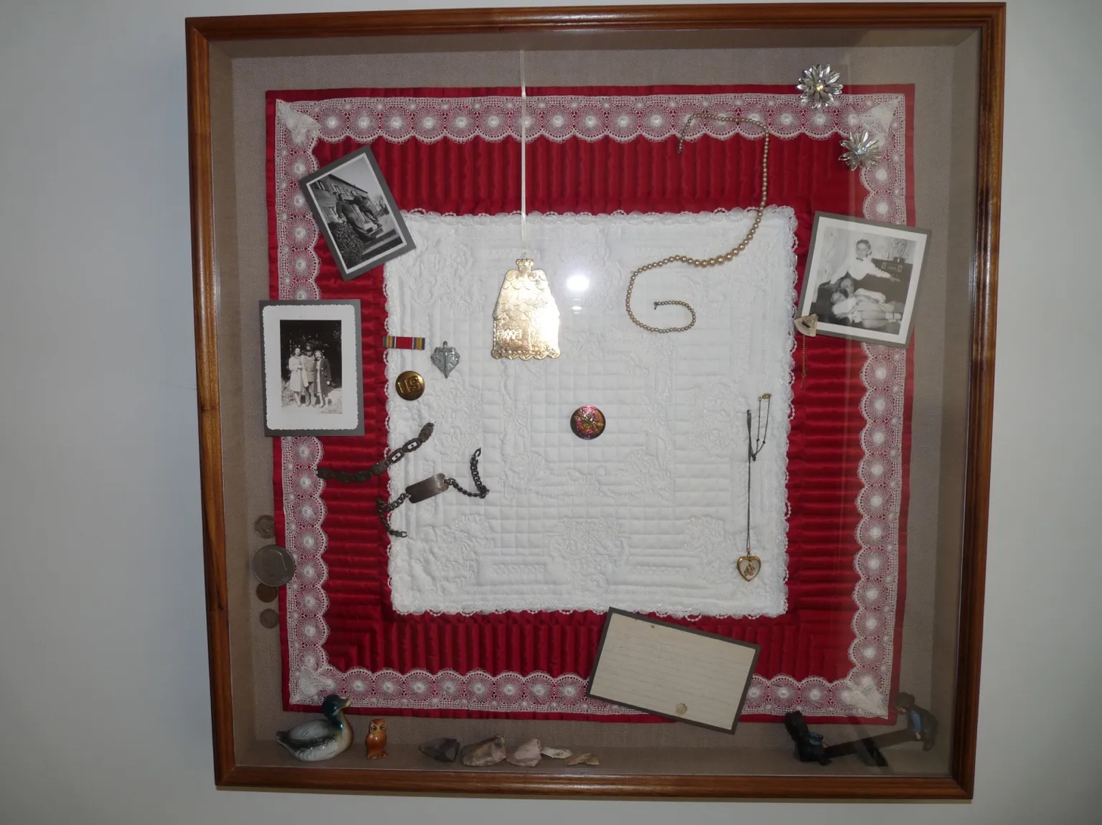

History

Provenance
Describe: --

Quilt Maker
Maker: Linda Bailey |  | Birth: Sep 9 1948 |  | Death: --
 | Location: Newton Falls, OH |  | Contributions: all aspects of background quilt.

Purpose and Context
Expression
Art | Personal Enjoyment | Therapy
Income
Personal Income | Fundraising
Presentation
Anniversary | Wedding | Birth
Holiday | Birthday | Other gift
Charitable support
Relationships
Friendship | Commemorative | Memorial
Mourning | Reunion
Skill Building
Challenge / Contest | Learning / Teaching Sample
Use
Bed Quilt | Lap Quilt | Home Décor
Baby / Crib | Wall Hanging
Describe other purpose: --

Quilt Top Design & Construction

Quilt Top
Layout
. Describe: The quilt is a white whole cloth design with red borders. It is quilted with piano keys, grids, and flowers. The quilt has been embellished with white lace around the outside of the white area and the outside of the red border. It was bound in red. The red fabric is either a satin or a sateen.

Top Inscriptions
None Found
Inscription is present. Describe location: --
Content
Makers names | Initials | Date
Single Name | Message | Place
Multiple Names
Transcription: --

Methods
Label | Ink – Ball point | Stencil
Printed onto fabric | Ink – Felt tip | Stamped
Quilted | Ink - Other | Pencil
Embroidery | Applique | Typewriter
Describe & Clarify: A written/printed note was provided with the gift explaining its significance. The notie is taped to the back of my shadow box.

Images for Inscriptions

Stabilization Method
Stabilization Method:
Batting
Quilting Techniques
 | Machine Quilted | Machine – sit-down | Corded
 | Machine – computer guided | Hand Quilted | Stuffed work
 | Machine – manual long-arm | Quilt-as-you-go

Edge Finish
Edge Style:
Finishing Technique
Top Width: 0.00 “ | Binding | Rolled – top to back
Back Width: 0.00“ | Front – machine | Rolled – back to top
1/8 = 0.13, 3/8 = 0.38 | Front – hand | Knife edge
5/8 = 0.63, 7/8 = 0.88 | Back – machine | Turned
 | Back - hand
Embellishments
Fringe | Ruffles | Cording
Lace | Ribbon
Describe: --

Images for Edge

Condition

Flaws
Soiling
Dirty | Stains
Mildew stains | Musty Smell
Discoloration
Running / fugitive color | Faded / bleached color | Crocking
Fabric Damage
Tears / holes | Disintegrating / fall out | Insect damage
Thread bare | Shattering
Sewing / Quilting Damage
Split / open seams | Ties / tufting missing | Embellishments missing
Quilting threads missing | Batting has shifted
Storage Issues
Discoloration from wood | Damage from acid | Fold marks / creases
Describe additional condition issues: --
Images for Condition Issues

Conservation, Restoration, Repairs
Describe Measures: --

Workmanship

Extension of Useful Life
Repair | Useful life of the item was extended.
Prevention of Damage
Conservation | All work is reversible.
Conservation | Further deterioration has been slowed, stabilized or prevented.
Maintaining Function & Integrity
Conservation | Work minimally interferes with the item’s overall appearance.
Restoration | Work blends well with the item’s overall appearance, style and age.
Restoration | Appropriate period reproductions were used.
Restoration | Vintage materials were used.
Restoration | Period appropriate techniques were used.
Restoration | Workmanship is of similar or better quality than original work.

Images for Conservation / Restoration / Repairs

