Documentation Form

Overview

Owner History
Owner | From Date | To Date | Location | Cost
David Bailey | July 2023 | -- | Chicago, IL | $0.00
 | If not purchased, the estimated cost for materials: $160

Display & Publication History
Date | Event | Location / Publication | Pro-Rated  Reimbursement
-- | -- | -- | $0

General Description
Quilt Title or Name:  Plaid Patchwork | Date Made: July 2023  Exact  circa +/- 0 Years  Method of Determination:
Item Type: | Size: Length: 90“ x Width: 55“  Fabric Date Range: 2011 ± 11 years
Appraisals:  Has this quilt been professionally appraised?  If so, when: --  ----------- | Other related files:  Scanned Patterns  EQ 8 Files (Zip file)  Research Notes – Family Tree Maker (Zip file)
Additional Information: This quilt's main field and binding is made of plaid shirting. Some of the shirting was taken from old shirts in my closet, some was found at an old antique mall. Total cost for the shirting $17.90. I bought the fabric for the backing and borders.

Images
Top | Back
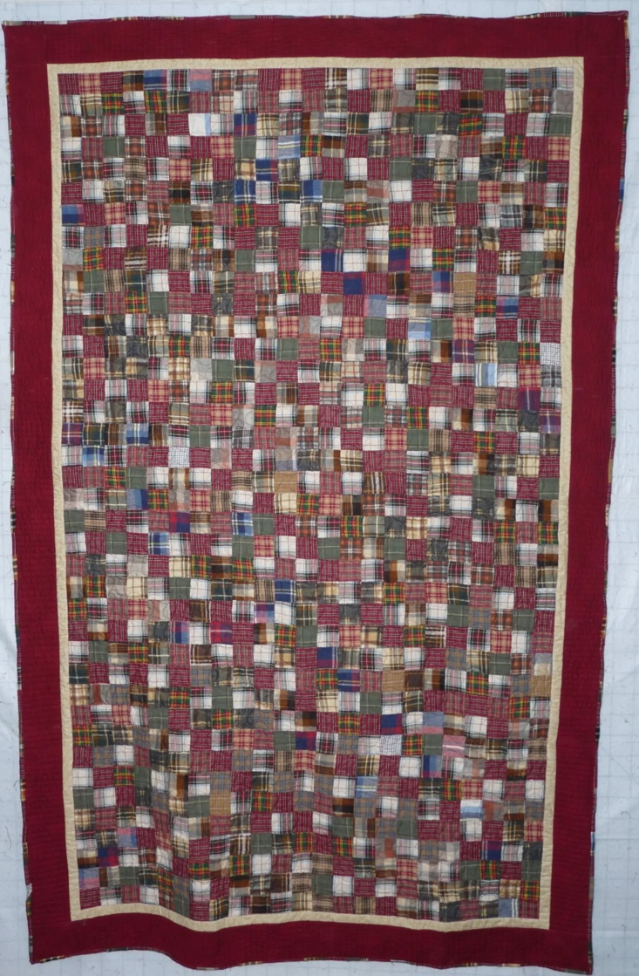 | 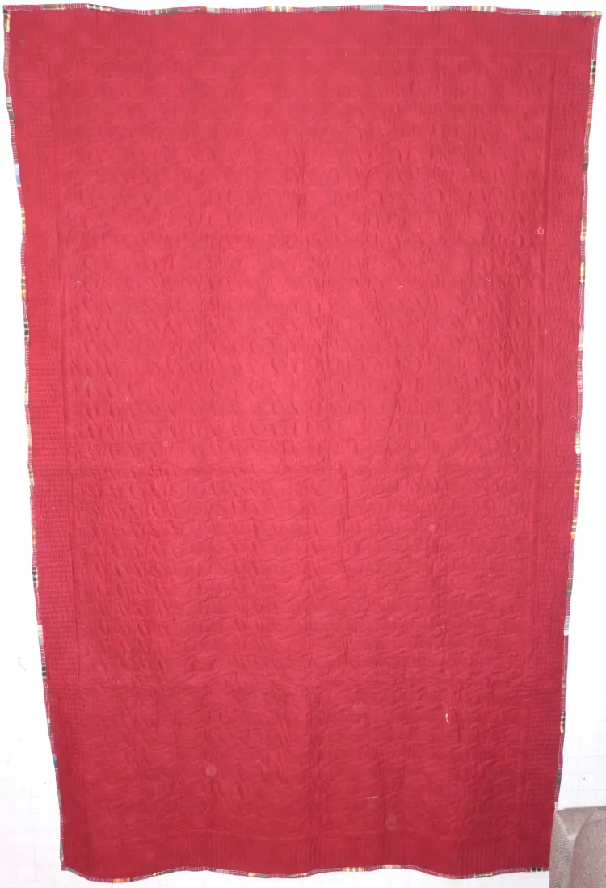

History

Provenance
Describe: None

Quilt Maker
Maker: David Bailey |  | Birth: July 20, 1967 |  | Death: --
 | Location: Chicago, IL |  | Contributions: Piecing, Assembly, Quilting, Binding

Purpose and Context
Expression
Art | Personal Enjoyment | Therapy
Income
Personal Income | Fundraising
Presentation
Anniversary | Wedding | Birth
Holiday | Birthday | Other gift
Charitable support
Relationships
Friendship | Commemorative | Memorial
Mourning | Reunion
Skill Building
Challenge / Contest | Learning / Teaching Sample
Use
Bed Quilt | Lap Quilt | Home Décor
Baby / Crib | Wall Hanging
Describe other purpose: --

Quilt Top Design & Construction

Quilt Top
Layout
. Describe: --
One Patch Shape Details
Describe: 2"

Piecing
Techniques
 |  | Machine pieced | String / Improvisational piecing
 |  | Hand pieced | Foundation piecing
 |  | Strip piecing | English paper piecing
 |  | Describe: --
 | Workmanship
 |  | Seams are stable | Seams are appropriately aligned
 |  | Seams are flat | Points are sharp
 |  | Describe piecing workmanship

Borders & Frames
Describe borders and frames in order from center to edge.
1 | Width: 1“ |  | Describe: Gold - Benartex 821524 - Winter Wool 961807 Cream
2 | Width: 4“ |  | Describe: Red - Timeless Treasures 570559 - Surface C1000 Cranberry

Top Assembly
Seams are stable | Top has no inappropriate tucks or puckers
Seams are flat | Top lays flat with no overly full areas
Seams are appropriately aligned

Color
Predominant colors
 | Red | Blue | Black
 | Orange | Violet/Purple | Grey
 | Yellow | Brown | White
 | Green | Beige / Tan
Specific Antique Colors |  | NONE NOTED
 | Red – claret / wine | Yellow – chrome | Blue – Lancaster
 | Red – madder / cinnamon | Green - chrome | Blue – Prussian / Lafayette
 | Red – turkey | Green – Nile | Brown – madder
 | Pinks - double | Blue – Cadet | Butterscotch
 | Orange - madder | Blue - Indigo | Bronze
 | Orange – cheddar / antimony / chrome |  | Late 1800’s Purple

Materials
Sources of Fabric |  | NOT KNOWN
 | Companies | Fabric Name & Number | Designer
 | -- | -- | --
 | Describe other sources: --
Fiber Types |  | NOT YET IDENTIFIED
 | Cotton | Silk | Wool
 | Cotton Blend | Linen | Synthetic
 | Describe & Clarify: --
Fabric Types |  | NOT KNOWN
 | Broadcloth | Sateen | Upholstery
 | Flannel | Satin | Chintz
 | Shirting | Muslin | Glazed
 | Suiting | Velvet | Handwoven
 | Denim | Felt | Lindsey-Woolsey
 | Describe & Clarify: --
Print Types |  | NOT YET IDENTIFIED
 | Batik | Floral | Plaid
 | Cheater Panel | Geometric | Solid / Plain
 | Checked / Gingham | Hand-dyed | Stamped
 | Conversation / Novelty | Victorian Mourning Prints | Stripes
 | Dotted | Multiple scraps
 | Feed sack / Feed sack-like | Paisley
 | Describe & Clarify: --

Quilt Back Design & Construction

Quilt Back
Layout
. Describe: Timeless Treasures 570559 - Surface C1000 Cranberry

Back Assembly
Seams are stable | Top has no inappropriate tucks or puckers
Seams are flat | Top lays flat with no overly full areas
Seams are appropriately aligned

Color
Predominant colors
 | Red | Blue | Black
 | Orange | Violet/Purple | Grey
 | Yellow | Brown | White
 | Green | Beige / Tan
Specific Antique Colors |  | NONE NOTED
 | Red – claret / wine | Yellow – chrome | Blue – Lancaster
 | Red – madder / cinnamon | Green - chrome | Blue – Prussian / Lafayette
 | Red – turkey | Green – Nile | Brown – madder
 | Pinks - double | Blue – Cadet | Butterscotch
 | Orange - madder | Blue - Indigo | Bronze
 | Orange – cheddar / antimony / chrome |  | Late 1800’s Purple

Materials
Fiber Types |  | NOT YET IDENTIFIED
 | Cotton | Silk | Wool
 | Cotton Blend | Linen | Synthetic
 | Describe & Clarify: --
Fabric Types |  | NOT KNOWN
 | Broadcloth | Sateen | Upholstery
 | Flannel | Satin | Chintz
 | Shirting | Muslin | Glazed
 | Suiting | Velvet | Handwoven
 | Denim | Felt | Lindsey-Woolsey
 | Describe & Clarify: --
Print Types |  | NOT YET IDENTIFIED
 | Batik | Floral | Plaid
 | Cheater Panel | Geometric | Solid / Plain
 | Checked / Gingham | Hand-dyed | Stamped
 | Conversation / Novelty | Victorian Mourning Prints | Stripes
 | Dotted | Multiple scraps
 | Feed sack / Feed sack-like | Paisley
 | Describe & Clarify: --

Back Inscriptions
None found
Inscription is present. Describe location: --
Content
Makers names | Initials | Date
Single Name | Message | Place
Multiple Names
Transcription: --

Methods
Label | Ink – Ball point | Stencil
Printed onto fabric | Ink – Felt tip | Stamped
Quilted | Ink - Other | Pencil
Embroidery | Applique | Typewriter
Describe & Clarify: --

Images for Back

Stabilization Method
Stabilization Method:
Batting
Quilting Techniques
 | Machine Quilted | Machine – sit-down | Corded
 | Machine – computer guided | Hand Quilted | Stuffed work
 | Machine – manual long-arm | Quilt-as-you-go
Quilting Patterns
 | Meander / Free motion | Lines – single parallel | Cables
 | In-the-ditch / To the piece | Lines – double parallel | Feathers
 | Echo / Outlined | Lines – triple parallel | Wreaths
 | Stipple | Grid – crosshatch | Vines
 | Clamshell | Grid – square | Floral
 | Elbow / Fan | Grid - diamond | Leaves
 | Describe other: S-curves
Thread Choices
 | Brand | Weight | Number & Name
 | -- | -- | --
Images for Quilting
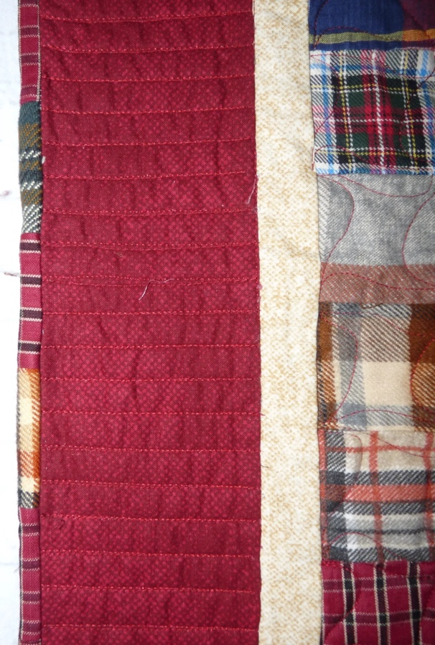 | 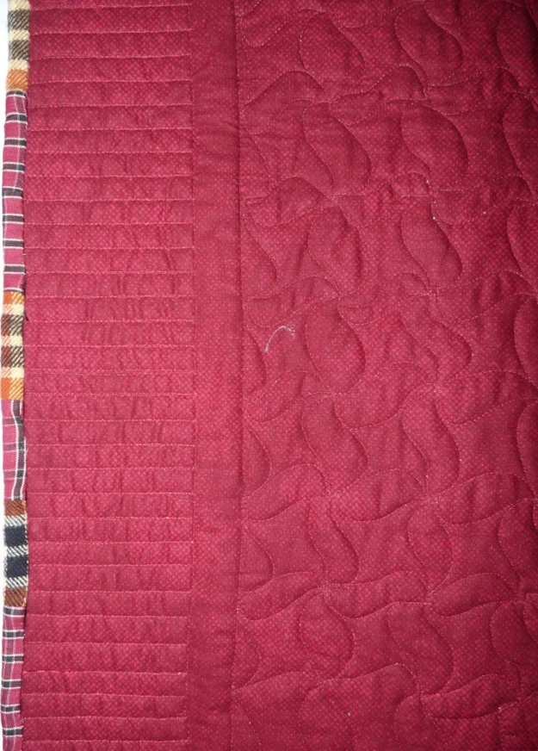

Edge Finish
Edge Style:
Finishing Technique
Top Width: 0.5 “ | Binding | Rolled – top to back
Back Width: 0.5“ | Front – machine | Rolled – back to top
1/8 = 0.13, 3/8 = 0.38 | Front – hand | Knife edge
5/8 = 0.63, 7/8 = 0.88 | Back – machine | Turned
 | Back - hand
Embellishments
Fringe | Ruffles | Cording
Lace | Ribbon
Describe: Binding is pieced. Seams were not done on the bias so thicker fabric resulted in lumps along the batting. - A very long boa constrictor with many meals recently eaten. Width of the binding varies between 0.5 and 0.75 inches.

Images for Edge
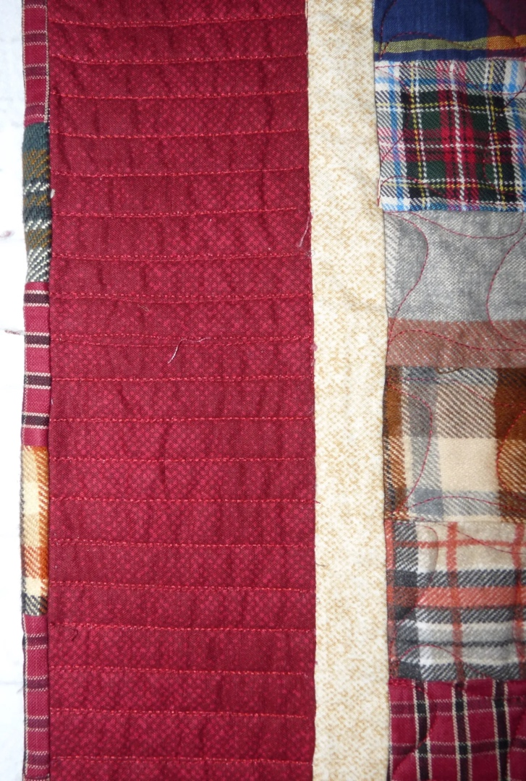

Condition

Flaws
Soiling
Dirty | Stains
Mildew stains | Musty Smell
Discoloration
Running / fugitive color | Faded / bleached color | Crocking
Fabric Damage
Tears / holes | Disintegrating / fall out | Insect damage
Thread bare | Shattering
Sewing / Quilting Damage
Split / open seams | Ties / tufting missing | Embellishments missing
Quilting threads missing | Batting has shifted
Storage Issues
Discoloration from wood | Damage from acid | Fold marks / creases
Describe additional condition issues: --
Images for Condition Issues

Conservation, Restoration, Repairs
Describe Measures: None

Workmanship

Extension of Useful Life
Repair | Useful life of the item was extended.
Prevention of Damage
Conservation | All work is reversible.
Conservation | Further deterioration has been slowed, stabilized or prevented.
Maintaining Function & Integrity
Conservation | Work minimally interferes with the item’s overall appearance.
Restoration | Work blends well with the item’s overall appearance, style and age.
Restoration | Appropriate period reproductions were used.
Restoration | Vintage materials were used.
Restoration | Period appropriate techniques were used.
Restoration | Workmanship is of similar or better quality than original work.

Images for Conservation / Restoration / Repairs

