Documentation Form

Overview

Owner History
Owner | From Date | To Date | Location | Cost
David Bailey | March 2021 | -- | Flint, MI | $0.00
 | If not purchased, the estimated cost for materials: $270

Display & Publication History
Date | Event | Location / Publication | Pro-Rated  Reimbursement
April 3-7, 2024 | Fisher Farm Quilt Show | 16W680 Old Grand Avenue | $0
This quilt is made almost entirely from old shirts that I could no longer wear. The only yardage is the deep blue chambray found in the border. The pattern is a variation of Bonnie Hunter’s Virginia Bound in her Scraps and Shirttails book. The quilt block consists of 15 separate pieces of fabric. Foundation piecing was critical to maintain a consistent block size, adjust for different thicknesses of fabric and controlling unruly fabric weaves that had been warped by years of wear and washing.

Finished March 2021
David Bailey, Flint, MI. Foundation piecing.
Linda Bailey, Newton Falls, OH. Long-arm quilting.
Mani Pillai, Chicago, IL. Hand binding.

General Description
Quilt Title or Name:  Teamwork | Date Made: December 2020 to March 2021  Exact  circa +/- 0 Years  Method of Determination:
Item Type: | Size: Length: 79“ x Width: 65“  Fabric Date Range: 2015 ± 5 years
Appraisals:  Has this quilt been professionally appraised?  If so, when: September 30, 2022  ----------- | Other related files:  Scanned Patterns  EQ 8 Files
Additional Information: This quilt started with a Bonnie Hunter design. Her design was much more scrappy and used wonky angles for each of the strips. I recreated the design in EQ8 to plan the piecing and straighten out the fabric pieces. This gave me the option to play with the layout. DJ and I select a different layout than Bonnie's original one.
This quilt is made with old shirting from my closet and maybe two other shirts from a local thrift store when I needed deeper yellow tones for the color contrast that I was looking for. This is my first full quilt sized piecing project, so I decided to do this with paper foundation piecing to keep my seams on track.

Images
Top | Back
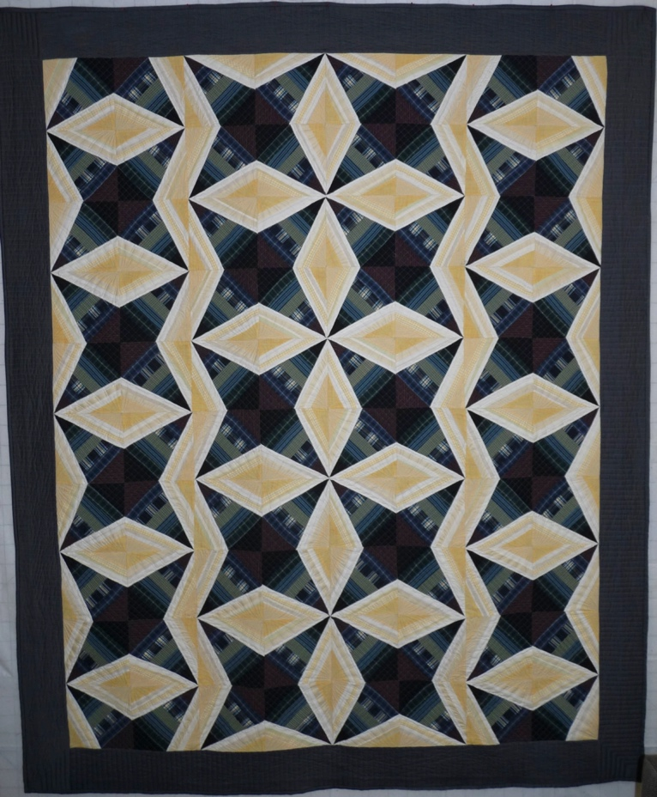 | 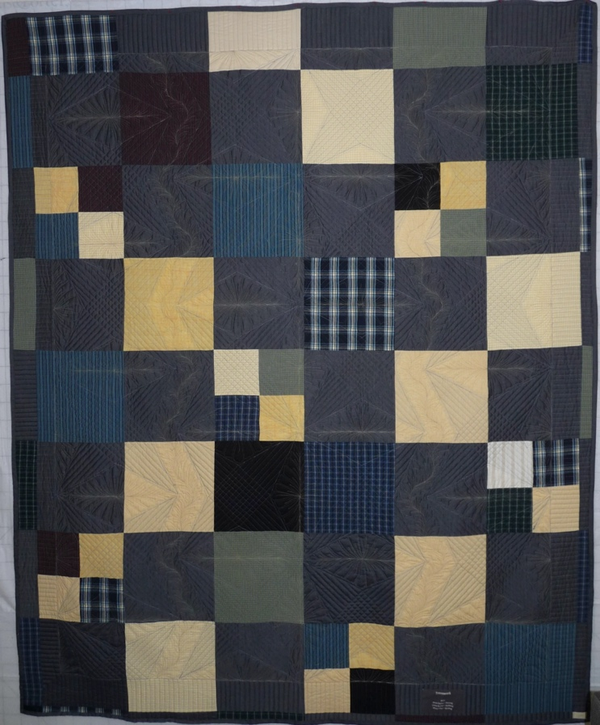

History

Provenance
Describe: --

Quilt Maker
Maker: David Bailey |  | Birth: July 20, 1967 |  | Death: --
 | Location: Flint, MI |  | Contributions: Design changes, fabric selection, piecing
Maker: Linda Bailey |  | Birth: Sep 9, 1948 |  | Death: --
 | Location: Newton Falls, OH |  | Contributions: Quilting
Maker: Mani Pilai |  | Birth: -- |  | Death: --
 | Location: Chicago, IL |  | Contributions: Binding application

Purpose and Context
Expression
Art | Personal Enjoyment | Therapy
Income
Personal Income | Fundraising
Presentation
Anniversary | Wedding | Birth
Holiday | Birthday | Other gift
Charitable support
Relationships
Friendship | Commemorative | Memorial
Mourning | Reunion
Skill Building
Challenge / Contest | Learning / Teaching Sample
Use
Bed Quilt | Lap Quilt | Home Décor
Baby / Crib | Wall Hanging
Describe other purpose: --

Quilt Top Design & Construction

Quilt Top
Layout
. Describe: --
Blocks
Grid & Contained Crazy Details
 | Grid Dimensions: Length 10 x Width: 8
 | Block Size: Length: 6“ x Width: 6“
Block Pattern Details
-- | 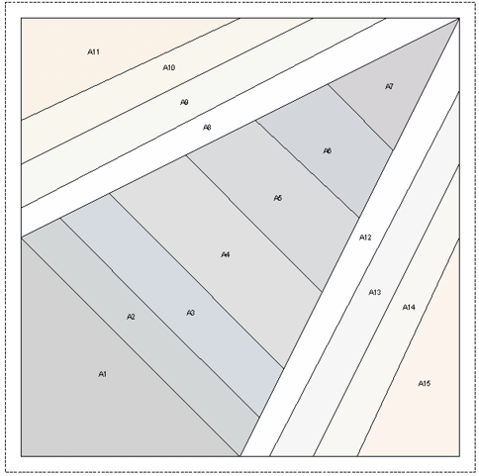
Modified version of Sugar Cone (BB ID 1252) & Mountain Star (BB ID 1250)
Sugar Cone | 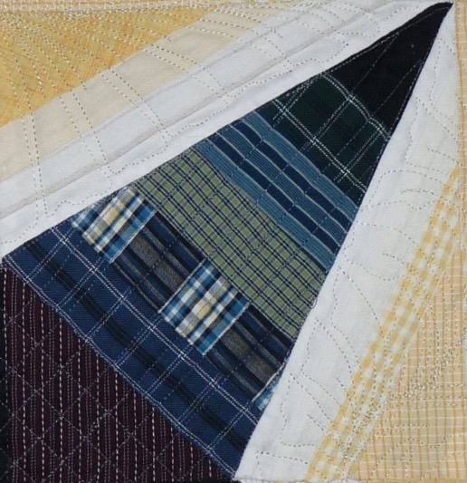
Mountain Star

Piecing
Techniques
 |  | Machine pieced | String / Improvisational piecing
 |  | Hand pieced | Foundation piecing
 |  | Strip piecing | English paper piecing
 |  | Describe: --
 | Workmanship
 |  | Seams are stable | Seams are appropriately aligned
 |  | Seams are flat | Points are sharp
 |  | Describe piecing workmanship

Borders & Frames
Describe borders and frames in order from center to edge.
1 | Width: 4.74“ |  | Describe: Denim colored chambray

Top Assembly
Seams are stable | Top has no inappropriate tucks or puckers
Seams are flat | Top lays flat with no overly full areas
Seams are appropriately aligned

Color
Predominant colors
 | Red | Blue | Black
 | Orange | Violet/Purple | Grey
 | Yellow | Brown | White
 | Green | Beige / Tan
Specific Antique Colors |  | NONE NOTED
 | Red – claret / wine | Yellow – chrome | Blue – Lancaster
 | Red – madder / cinnamon | Green - chrome | Blue – Prussian / Lafayette
 | Red – turkey | Green – Nile | Brown – madder
 | Pinks - double | Blue – Cadet | Butterscotch
 | Orange - madder | Blue - Indigo | Bronze
 | Orange – cheddar / antimony / chrome |  | Late 1800’s Purple

Materials
Sources of Fabric |  | NOT KNOWN
 | Companies | Fabric Name & Number | Designer
 | -- | -- | --
 | Describe other sources: --
Fiber Types |  | NOT YET IDENTIFIED
 | Cotton | Silk | Wool
 | Cotton Blend | Linen | Synthetic
 | Describe & Clarify: --
Fabric Types |  | NOT KNOWN
 | Broadcloth | Sateen | Upholstery
 | Flannel | Satin | Chintz
 | Shirting | Muslin | Glazed
 | Suiting | Velvet | Handwoven
 | Denim | Felt | Lindsey-Woolsey
 | Describe & Clarify: --
Print Types |  | NOT YET IDENTIFIED
 | Batik | Floral | Plaid
 | Cheater Panel | Geometric | Solid / Plain
 | Checked / Gingham | Hand-dyed | Stamped
 | Conversation / Novelty | Victorian Mourning Prints | Stripes
 | Dotted | Multiple scraps
 | Feed sack / Feed sack-like | Paisley
 | Describe & Clarify: --

Top Inscriptions
None Found
Inscription is present. Describe location: --
Content
Makers names | Initials | Date
Single Name | Message | Place
Multiple Names
Transcription: --

Methods
Label | Ink – Ball point | Stencil
Printed onto fabric | Ink – Felt tip | Stamped
Quilted | Ink - Other | Pencil
Embroidery | Applique | Typewriter
Describe & Clarify: --

Images for Inscriptions

Quilt Back Design & Construction

Quilt Back
Layout
. Describe: Made from same materials as front, but assembled as single patch squares and four patches. The block size is about 9.5".

Back Assembly
Seams are stable | Back has no inappropriate tucks or puckers
Seams are flat | Back lays flat with no overly full areas
Seams are appropriately aligned

Back Inscriptions
None found
Inscription is present. Describe location: --
Content
Makers names | Initials | Date
Single Name | Message | Place
Multiple Names
Transcription: --

Methods
Label | Ink – Ball point | Stencil
Printed onto fabric | Ink – Felt tip | Stamped
Quilted | Ink - Other | Pencil
Embroidery | Applique | Typewriter
Describe & Clarify: --

Images for Back

Stabilization Method
Stabilization Method:
Batting
Quilting Techniques
 | Machine Quilted | Machine – sit-down | Corded
 | Machine – computer guided | Hand Quilted | Stuffed work
 | Machine – manual long-arm | Quilt-as-you-go
Quilting Patterns
 | Meander / Free motion | Lines – single parallel | Cables
 | In-the-ditch / To the piece | Lines – double parallel | Feathers
 | Echo / Outlined | Lines – triple parallel | Wreaths
 | Stipple | Grid – crosshatch | Vines
 | Clamshell | Grid – square | Floral
 | Elbow / Fan | Grid - diamond | Leaves
 | Describe other: --
Thread Choices
 | Brand | Weight | Number & Name
 | -- | -- | --
Images for Quilting
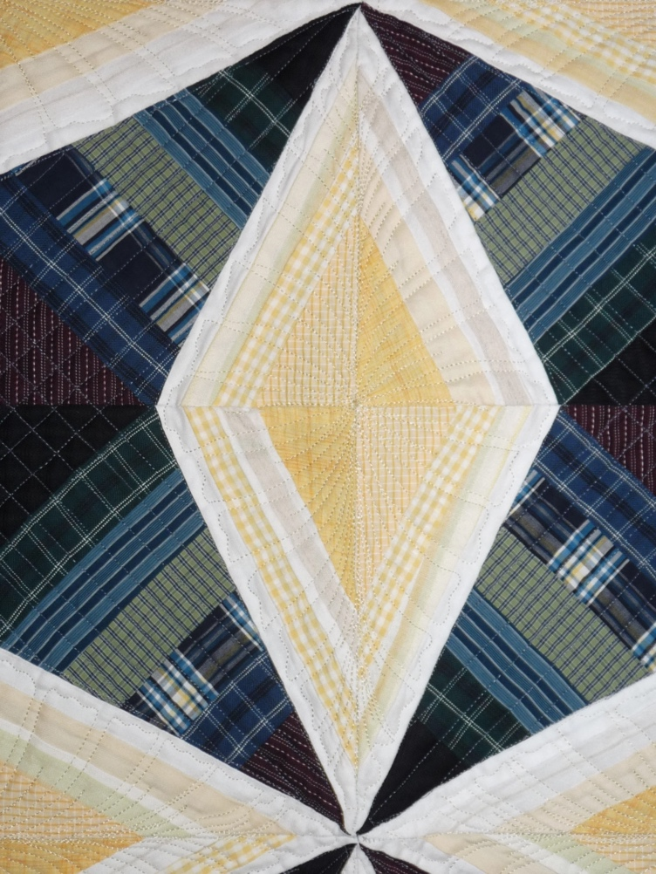

Edge Finish
Edge Style:
Finishing Technique
Top Width: 0.50 “ | Binding | Rolled – top to back
Back Width: 0.50“ | Front – machine | Rolled – back to top
1/8 = 0.13, 3/8 = 0.38 | Front – hand | Knife edge
5/8 = 0.63, 7/8 = 0.88 | Back – machine | Turned
 | Back - hand
Embellishments
Fringe | Ruffles | Cording
Lace | Ribbon
Describe: --

Images for Edge

Condition

Flaws
Soiling
Dirty | Stains
Mildew stains | Musty Smell
Discoloration
Running / fugitive color | Faded / bleached color | Crocking
Fabric Damage
Tears / holes | Disintegrating / fall out | Insect damage
Thread bare | Shattering
Sewing / Quilting Damage
Split / open seams | Ties / tufting missing | Embellishments missing
Quilting threads missing | Batting has shifted
Storage Issues
Discoloration from wood | Damage from acid | Fold marks / creases
Describe additional condition issues: --
Images for Condition Issues

Conservation, Restoration, Repairs
Describe Measures: --

Workmanship

Extension of Useful Life
Repair | Useful life of the item was extended.
Prevention of Damage
Conservation | All work is reversible.
Conservation | Further deterioration has been slowed, stabilized or prevented.
Maintaining Function & Integrity
Conservation | Work minimally interferes with the item’s overall appearance.
Restoration | Work blends well with the item’s overall appearance, style and age.
Restoration | Appropriate period reproductions were used.
Restoration | Vintage materials were used.
Restoration | Period appropriate techniques were used.
Restoration | Workmanship is of similar or better quality than original work.

Images for Conservation / Restoration / Repairs

