Documentation Form

Overview

Owner History
Owner | From Date | To Date | Location | Cost
David Bailey | Feb 22, 2023 | -- | Flint, MI | $0.00
 | If not purchased, the estimated cost for materials: $312

Display & Publication History
Date | Event | Location / Publication | Pro-Rated  Reimbursement
April 3-7, 2024 | Fisher Farm Quilt Show | 16W680 Old Grand Avenue | $0
The quilt’s name reminds me that piecing can change a fabric’s personality. While making this quilt, my goal was to work with a fabric that was out of my comfort zone. I am typically drawn to color themes that quietly transition from one fabric to another, but for this quilt I chose a Kaffe Fasset print that was big, bold and relatively colorful by my usual standards.

The quilt top was pieced using Maxine Rosenthal’s one-block-wonder technique. This allowed me to group the hexagons by color and to arrange the color groups to create subtle transitions. As I auditioned different arrangements, the kaleidoscopic patterns reminded me of flowers driving on a summer pond. For the sake of comparing the effect of piecing, the back of the quilt is made from unpieced yardage of the same fabric.
Finished February 2023.
David Bailey, Chicago, IL. Piecing and Quilting. Quilting was done on a domestic machine.

General Description
Quilt Title or Name:  After and Before | Date Made: Dec 30, 2021 - Feb 22, 2023  Exact  circa +/- 0 Years  Method of Determination:  Fabric Date Range: 2022
Item Type: | Size: Length: 93“ x Width: 69“
Appraisals:  Has this quilt been professionally appraised?  If so, when: --  ----------- | Other related files:00  EQ 8 Files
Additional Information: This quilt was made with the One-Block-Wonder method where 6 fabric repeats are layered exactly on top of each other and then cut into equalateral triangles. These are sewn so that hexagons are formed with a repeated pattern every 60 degrees. This technique has the effect of allowing the colors of the fabric to be rearranged for very different effects from the original print. The backing fabric for this quilt is the same as the fabric used in the main field.

This quilt has 25 rows fo 56 equalateral triangels for 1400 triangles. The border is also peiced from triangles but shows a flat edge, so some of the equalaterial traingles were cut in half and pieced. This added another 114 triangles for a total of 1514 triangles of various shapes for the entire quilt.

The back ground brown fabric print has directionality. The triangles were cut and pieced so that the dashes all pointed to the center of their hexagon.

Images
Top | Back
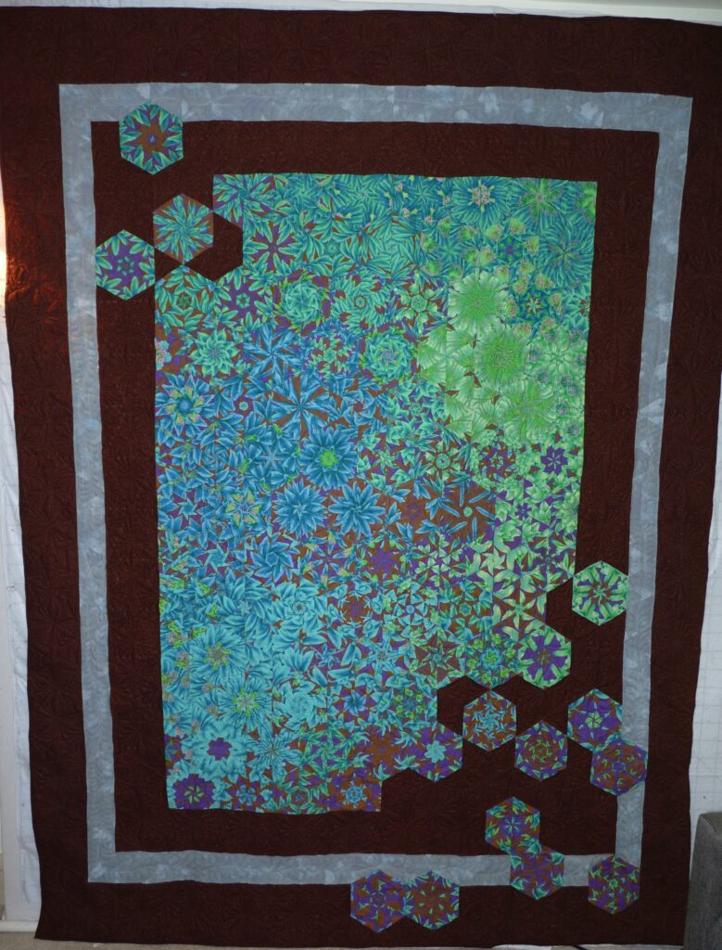 | 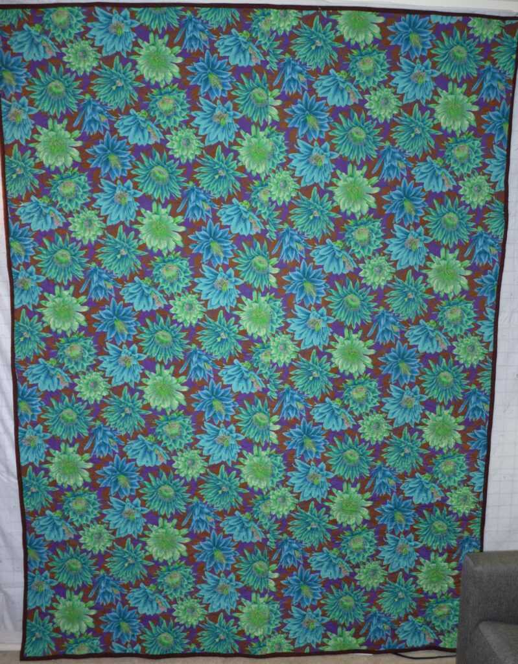

History

Provenance
Describe: None

Quilt Maker
Maker: David Bailey |  | Birth: July 20, 1967 |  | Death: --
 | Location: Flint, MI |  | Contributions: Design, piecing, quilting, binding.

Purpose and Context
Expression
Art | Personal Enjoyment | Therapy
Income
Personal Income | Fundraising
Presentation
Anniversary | Wedding | Birth
Holiday | Birthday | Other gift
Charitable support
Relationships
Friendship | Commemorative | Memorial
Mourning | Reunion
Skill Building
Challenge / Contest | Learning / Teaching Sample
Use
Bed Quilt | Lap Quilt | Home Décor
Baby / Crib | Wall Hanging
Describe other purpose: --

Quilt Top Design & Construction

Quilt Top
Layout
. Describe: Equalateral Triangles.
One Patch Shape Details
Describe: --

Piecing
Techniques
 |  | Machine pieced | String / Improvisational piecing
 |  | Hand pieced | Foundation piecing
 |  | Strip piecing | English paper piecing
 |  | Describe: --
 | Workmanship
 |  | Seams are stable | Seams are appropriately aligned
 |  | Seams are flat | Points are sharp
 |  | Describe piecing workmanship

Borders & Frames
Describe borders and frames in order from center to edge.
1 | Width: 6“ |  | Describe: --
2 | Width: 3“ |  | Describe: --
3 | Width: 6“ |  | Describe: --

Top Assembly
Seams are stable | Top has no inappropriate tucks or puckers
Seams are flat | Top lays flat with no overly full areas
Seams are appropriately aligned

Color
Predominant colors
 | Red | Blue | Black
 | Orange | Violet/Purple | Grey
 | Yellow | Brown | White
 | Green | Beige / Tan
Specific Antique Colors |  | NONE NOTED
 | Red – claret / wine | Yellow – chrome | Blue – Lancaster
 | Red – madder / cinnamon | Green - chrome | Blue – Prussian / Lafayette
 | Red – turkey | Green – Nile | Brown – madder
 | Pinks - double | Blue – Cadet | Butterscotch
 | Orange - madder | Blue - Indigo | Bronze
 | Orange – cheddar / antimony / chrome |  | Late 1800’s Purple

Materials
Sources of Fabric |  | NOT KNOWN
 | Companies | Fabric Name & Number | Designer
 | Free Spirit | Cool Cactus Flower Emerald | Kaffe Fassett
 | Windham Fabrics | Bear Camp Dashes Brown | --
 | Moda Fabrics | Grunge Ash | --
 | Describe other sources: --
Fiber Types |  | NOT YET IDENTIFIED
 | Cotton | Silk | Wool
 | Cotton Blend | Linen | Synthetic
 | Describe & Clarify: --
Fabric Types |  | NOT KNOWN
 | Broadcloth | Sateen | Upholstery
 | Flannel | Satin | Chintz
 | Shirting | Muslin | Glazed
 | Suiting | Velvet | Handwoven
 | Denim | Felt | Lindsey-Woolsey
 | Describe & Clarify: --
Print Types |  | NOT YET IDENTIFIED
 | Batik | Floral | Plaid
 | Cheater Panel | Geometric | Solid / Plain
 | Checked / Gingham | Hand-dyed | Stamped
 | Conversation / Novelty | Victorian Mourning Prints | Stripes
 | Dotted | Multiple scraps
 | Feed sack / Feed sack-like | Paisley
 | Describe & Clarify: --

Top Inscriptions
None Found
Inscription is present. Describe location: --
Content
Makers names | Initials | Date
Single Name | Message | Place
Multiple Names
Transcription: --

Methods
Label | Ink – Ball point | Stencil
Printed onto fabric | Ink – Felt tip | Stamped
Quilted | Ink - Other | Pencil
Embroidery | Applique | Typewriter
Describe & Clarify: --

Images for Inscriptions

Quilt Back Design & Construction

Quilt Back
Layout
. Describe: One seam
Back Assembly
Seams are stable | Back has no inappropriate tucks or puckers
Seams are flat | Back lays flat with no overly full areas
Seams are appropriately aligned

Back Inscriptions
None found
Inscription is present. Describe location: --
Content
Makers names | Initials | Date
Single Name | Message | Place
Multiple Names
Transcription: --

Methods
Label | Ink – Ball point | Stencil
Printed onto fabric | Ink – Felt tip | Stamped
Quilted | Ink - Other | Pencil
Embroidery | Applique | Typewriter
Describe & Clarify: --

Images for Back

Stabilization Method
Stabilization Method:
Batting
Quilting Techniques
 | Machine Quilted | Machine – sit-down | Corded
 | Machine – computer guided | Hand Quilted | Stuffed work
 | Machine – manual long-arm | Quilt-as-you-go
Quilting Patterns
 | Meander / Free motion | Lines – single parallel | Cables
 | In-the-ditch / To the piece | Lines – double parallel | Feathers
 | Echo / Outlined | Lines – triple parallel | Wreaths
 | Stipple | Grid – crosshatch | Vines
 | Clamshell | Grid – square | Floral
 | Elbow / Fan | Grid - diamond | Leaves
 | Describe other: -Lines and S-curves-
Thread Choices
 | Brand | Weight | Number & Name
 | Glide | 40 | Persian - 65473
 | Glide | 40 | Spice Brown - 27582
 | Glide | 40 | Fog - 10CG6

Images for Quilting
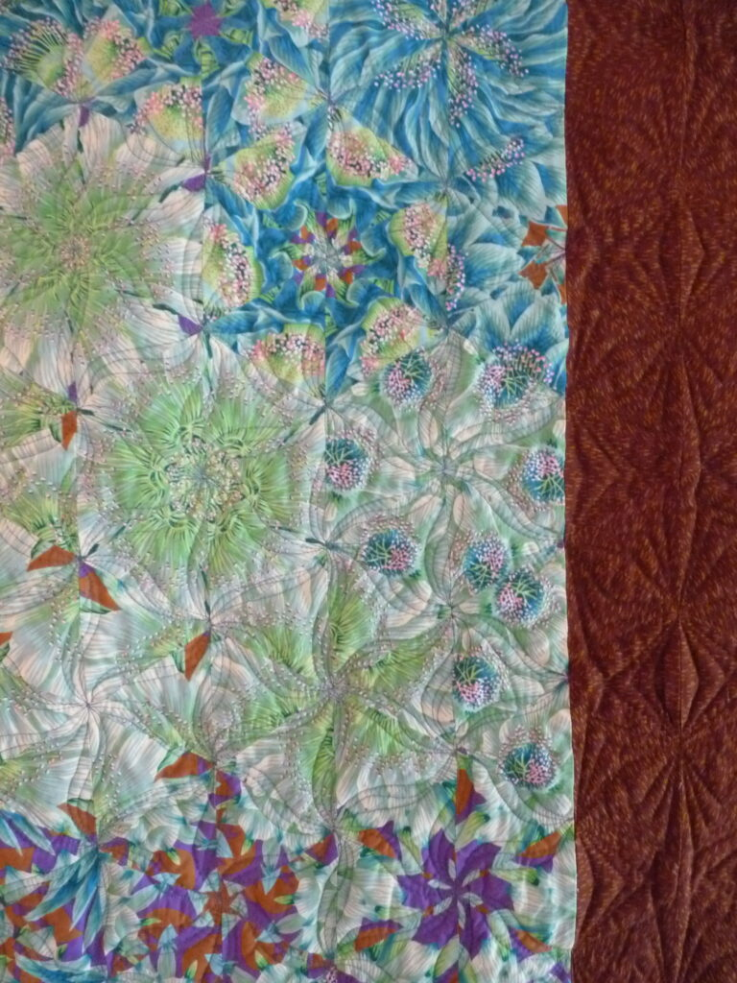 | 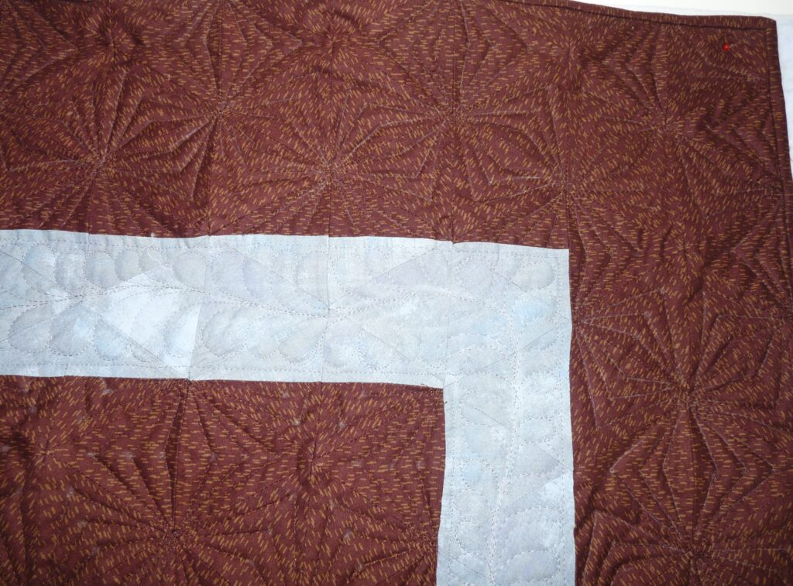

Edge Finish
Edge Style:
Finishing Technique
Top Width: 0.38 “ | Binding | Rolled – top to back
Back Width: 0.63“ | Front – machine | Rolled – back to top
1/8 = 0.13, 3/8 = 0.38 | Front – hand | Knife edge
5/8 = 0.63, 7/8 = 0.88 | Back – machine | Turned
 | Back - hand
Embellishments
Fringe | Ruffles | Cording
Lace | Ribbon
Describe: --

Images for Edge

Condition

Flaws
Soiling
Dirty | Stains
Mildew stains | Musty Smell
Discoloration
Running / fugitive color | Faded / bleached color | Crocking
Fabric Damage
Tears / holes | Disintegrating / fall out | Insect damage
Thread bare | Shattering
Sewing / Quilting Damage
Split / open seams | Ties / tufting missing | Embellishments missing
Quilting threads missing | Batting has shifted
Storage Issues
Discoloration from wood | Damage from acid | Fold marks / creases
Describe additional condition issues: --
Images for Condition Issues

Conservation, Restoration, Repairs
Describe Measures: None

Workmanship

Extension of Useful Life
Repair | Useful life of the item was extended.
Prevention of Damage
Conservation | All work is reversible.
Conservation | Further deterioration has been slowed, stabilized or prevented.
Maintaining Function & Integrity
Conservation | Work minimally interferes with the item’s overall appearance.
Restoration | Work blends well with the item’s overall appearance, style and age.
Restoration | Appropriate period reproductions were used.
Restoration | Vintage materials were used.
Restoration | Period appropriate techniques were used.
Restoration | Workmanship is of similar or better quality than original work.

Images for Conservation / Restoration / Repairs

