Documentation Form

Overview

Owner History
Owner | From Date | To Date | Location | Cost
David Bailey | March 12, 2023 | -- | Chicago, IL & Flint, MI | $0.00
 | If not purchased, the estimated cost for materials: $550

Display & Publication History
Date | Event | Location / Publication | Pro-Rated  Reimbursement
April 3-7, 2024 | Fisher Farm Quilt Show | 16W680 Old Grand Avenue | $0
I was browsing fabric at Top Shelf Quilts in Mokena, IL where I saw a finished version of this quilt. I was so struck by the fabric and piecing design, I knew that I wanted to make one of my own. The pattern is called Tonga Canyon and is published by Timeless Treasures to promote their batik fabric line.
Finished March 2023.
David Bailey, Chicago, IL. Piecing.
Linda Bailey, Newton Falls, OH. Long-Arm Quilting.

General Description
Quilt Title or Name:  Tonga Canyon Quilt | Date Made: March 23, 2023  Exact  circa +/- 0 Years  Method of Determination:  Fabric Dates: 2023
Item Type: | Size: Length: 104“ x Width: 103“
Appraisals:  Has this quilt been professionally appraised?  If so, when: --  ----------- | Other related files:  Scanned Patterns  Images  EQ 8 Files  Research Notes
Additional Information: --

Images
Top | Back
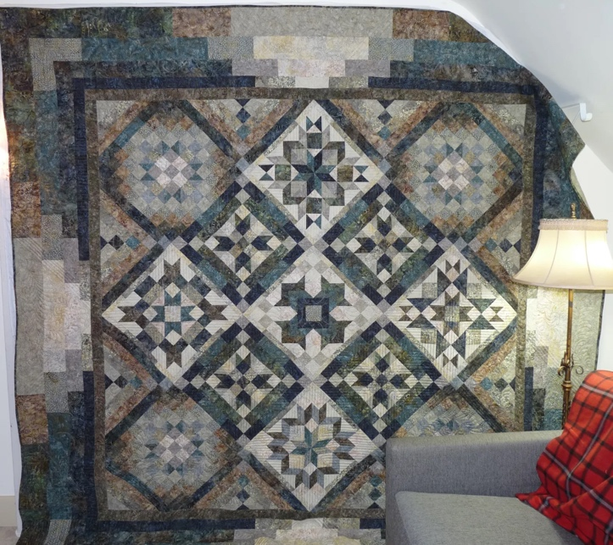 | 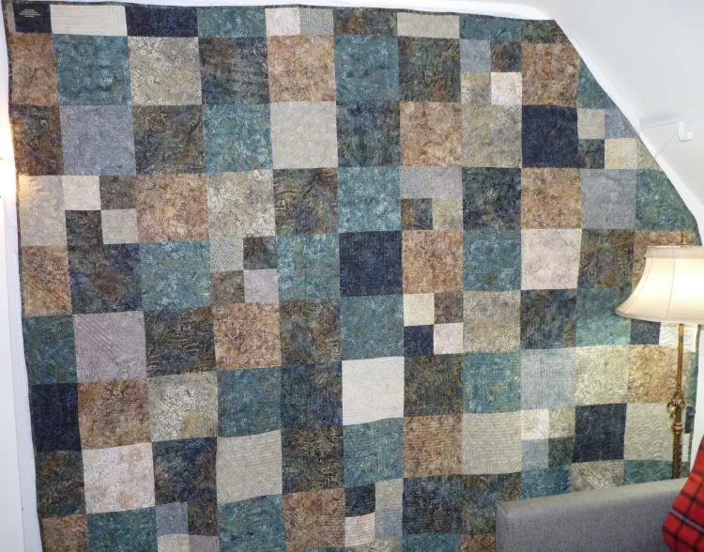

History

Provenance
Describe: --

Quilt Maker
Maker: David Bailey |  | Birth: July 20, 1967 |  | Death: --
 | Location: Flint, MI and Chicago, IL |  | Contributions: Piecing, Binding
Maker: Linda Bailey |  | Birth: Sep 9, 1948 |  | Death: --
 | Location: Newton Falls, OH |  | Contributions: Quilting
Purpose and Context
Expression
Art | Personal Enjoyment | Therapy
Income
Personal Income | Fundraising
Presentation
Anniversary | Wedding | Birth
Holiday | Birthday | Other gift
Charitable support
Relationships
Friendship | Commemorative | Memorial
Mourning | Reunion
Skill Building
Challenge / Contest | Learning / Teaching Sample
Use
Bed Quilt | Lap Quilt | Home Décor
Baby / Crib | Wall Hanging
Describe other purpose: --

Quilt Top Design & Construction

Quilt Top
Layout
. Describe: 3x3 grid, set on-point. Blocks are pieced stars of various types. Setting squares and triangels are also pieced.
Blocks
Grid & Contained Crazy Details
 |  | Grid Dimensions: Length 3 x Width: 3
 |  | Block Size: Length: 18“ x Width: 18“
Block Pattern Details
 | Piecing patterns came with quilt patterns and consiste of various stars which include: | <<Pattern Image>>
 | BB ID 1802 A, B, C - Father's Choice  BB ID 1138 - Ribbon Star  BB ID 1141a - Anna's Choice Quilt  BB ID 1986 God's Eye | <<Pattern Image>>

Piecing
Techniques
 |  | Machine pieced | String / Improvisational piecing
 |  | Hand pieced | Foundation piecing
 |  | Strip piecing | English paper piecing
 |  | Describe: --
 | Workmanship
 |  | Seams are stable | Seams are appropriately aligned
 |  | Seams are flat | Points are sharp
 |  | Describe piecing workmanship

Borders & Frames
Describe borders and frames in order from center to edge.
1 | Width: 1.88“ |  | Describe: --
2 | Width: 2“ |  | Describe: --
3 | Width: 2“ |  | Describe: --
4 | Width: 3“ |  | Describe: --
5 | Width: 5.1“ |  | Describe: --

Top Assembly
Seams are stable | Top has no inappropriate tucks or puckers
Seams are flat | Top lays flat with no overly full areas
Seams are appropriately aligned

Color
Predominant colors
 | Red | Blue | Black
 | Orange | Violet/Purple | Grey
 | Yellow | Brown | White
 | Green | Beige / Tan
Specific Antique Colors |  | NONE NOTED
 | Red – claret / wine | Yellow – chrome | Blue – Lancaster
 | Red – madder / cinnamon | Green - chrome | Blue – Prussian / Lafayette
 | Red – turkey | Green – Nile | Brown – madder
 | Pinks - double | Blue – Cadet | Butterscotch
 | Orange - madder | Blue - Indigo | Bronze
 | Orange – cheddar / antimony / chrome |  | Late 1800’s Purple

Materials
Sources of Fabric |  | NOT KNOWN
 | Companies | Fabric Name & Number | Designer
 | -- | -- | --
 | Describe other sources: See pattern download files. The fabrics in the files were the onces that were used for this quilt.
Fiber Types |  | NOT YET IDENTIFIED
 | Cotton | Silk | Wool
 | Cotton Blend | Linen | Synthetic
 | Describe & Clarify: --
Fabric Types |  | NOT KNOWN
 | Broadcloth | Sateen | Upholstery
 | Flannel | Satin | Chintz
 | Shirting | Muslin | Glazed
 | Suiting | Velvet | Handwoven
 | Denim | Felt | Lindsey-Woolsey
 | Describe & Clarify: --
Print Types |  | NOT YET IDENTIFIED
 | Batik | Floral | Plaid
 | Cheater Panel | Geometric | Solid / Plain
 | Checked / Gingham | Hand-dyed | Stamped
 | Conversation / Novelty | Victorian Mourning Prints | Stripes
 | Dotted | Multiple scraps
 | Feed sack / Feed sack-like | Paisley
 | Describe & Clarify: --

Quilt Back Design & Construction

Quilt Back
Layout
. Describe: The back is pieced from the same fabrics as the top. It is made from squares and four patches of the same size.
One Patch Shape Details
Describe: --

Piecing
Techniques
 |  | Machine pieced | String / Improvisational piecing
 |  | Hand pieced | Foundation piecing
 |  | Strip piecing | English paper piecing
 |  | Describe: --
 | Workmanship
 |  | Seams are stable | Seams are appropriately aligned
 |  | Seams are flat | Points are sharp
 |  | Describe piecing workmanship

Back Assembly
Seams are stable | Top has no inappropriate tucks or puckers
Seams are flat | Top lays flat with no overly full areas
Seams are appropriately aligned

Color
Predominant colors
 | Red | Blue | Black
 | Orange | Violet/Purple | Grey
 | Yellow | Brown | White
 | Green | Beige / Tan
Specific Antique Colors |  | NONE NOTED
 | Red – claret / wine | Yellow – chrome | Blue – Lancaster
 | Red – madder / cinnamon | Green - chrome | Blue – Prussian / Lafayette
 | Red – turkey | Green – Nile | Brown – madder
 | Pinks - double | Blue – Cadet | Butterscotch
 | Orange - madder | Blue - Indigo | Bronze
 | Orange – cheddar / antimony / chrome |  | Late 1800’s Purple

Materials
Sources of Fabric |  | NOT KNOWN
 | Companies | Fabric Name & Number | Designer
 | -- | -- | --
 | Describe other sources: --
Fiber Types |  | NOT YET IDENTIFIED
 | Cotton | Silk | Wool
 | Cotton Blend | Linen | Synthetic
 | Describe & Clarify: --
Fabric Types |  | NOT KNOWN
 | Broadcloth | Sateen | Upholstery
 | Flannel | Satin | Chintz
 | Shirting | Muslin | Glazed
 | Suiting | Velvet | Handwoven
 | Denim | Felt | Lindsey-Woolsey
 | Describe & Clarify: --
Print Types |  | NOT YET IDENTIFIED
 | Batik | Floral | Plaid
 | Cheater Panel | Geometric | Solid / Plain
 | Checked / Gingham | Hand-dyed | Stamped
 | Conversation / Novelty | Victorian Mourning Prints | Stripes
 | Dotted | Multiple scraps
 | Feed sack / Feed sack-like | Paisley
 | Describe & Clarify: --

Back Inscriptions
None found
Inscription is present. Describe location: --
Content
Makers names | Initials | Date
Single Name | Message | Place
Multiple Names
Transcription: --

Methods
Label | Ink – Ball point | Stencil
Printed onto fabric | Ink – Felt tip | Stamped
Quilted | Ink - Other | Pencil
Embroidery | Applique | Typewriter
Describe & Clarify: --

Stabilization Method
Stabilization Method:
Batting
Quilting Techniques
 | Machine Quilted | Machine – sit-down | Corded
 | Machine – computer guided | Hand Quilted | Stuffed work
 | Machine – manual long-arm | Quilt-as-you-go
Quilting Patterns
 | Meander / Free motion | Lines – single parallel | Cables
 | In-the-ditch / To the piece | Lines – double parallel | Feathers
 | Echo / Outlined | Lines – triple parallel | Wreaths
 | Stipple | Grid – crosshatch | Vines
 | Clamshell | Grid – square | Floral
 | Elbow / Fan | Grid - diamond | Leaves
 | Describe other: --
Thread Choices
 | Brand | Weight | Number & Name
 | -- | -- | --

Images for Quilting
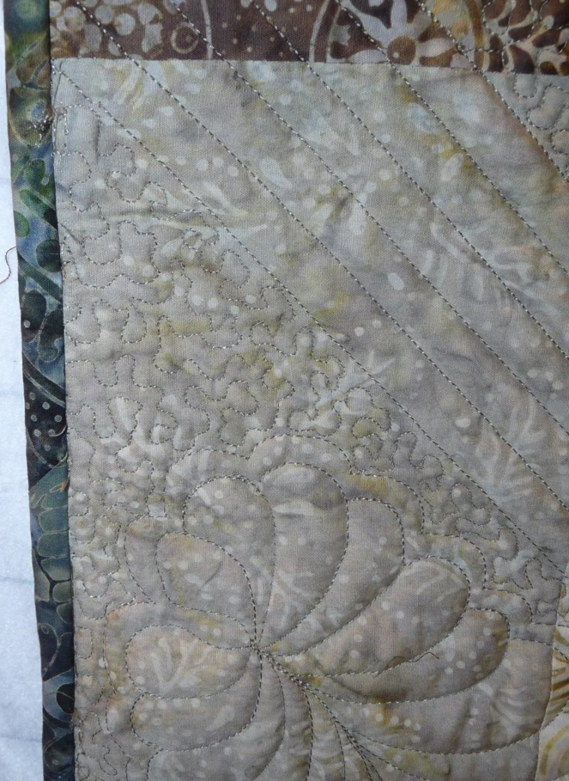 | 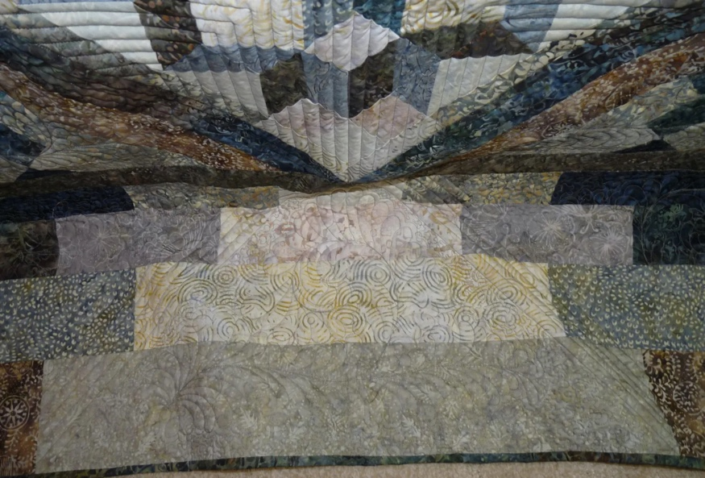

Edge Finish
Edge Style:
Finishing Technique
Top Width: 0.38 “ | Binding | Rolled – top to back
Back Width: 0.38“ | Front – machine | Rolled – back to top
1/8 = 0.13, 3/8 = 0.38 | Front – hand | Knife edge
5/8 = 0.63, 7/8 = 0.88 | Back – machine | Turned
 | Back - hand
Embellishments
Fringe | Ruffles | Cording
Lace | Ribbon
Describe: --

Images for Edge

Condition

Flaws
Soiling
Dirty | Stains
Mildew stains | Musty Smell
Discoloration
Running / fugitive color | Faded / bleached color | Crocking
Fabric Damage
Tears / holes | Disintegrating / fall out | Insect damage
Thread bare | Shattering
Sewing / Quilting Damage
Split / open seams | Ties / tufting missing | Embellishments missing
Quilting threads missing | Batting has shifted
Storage Issues
Discoloration from wood | Damage from acid | Fold marks / creases
Describe additional condition issues: --
Images for Condition Issues

Conservation, Restoration, Repairs
Describe Measures: None

Workmanship

Extension of Useful Life
Repair | Useful life of the item was extended.
Prevention of Damage
Conservation | All work is reversible.
Conservation | Further deterioration has been slowed, stabilized or prevented.
Maintaining Function & Integrity
Conservation | Work minimally interferes with the item’s overall appearance.
Restoration | Work blends well with the item’s overall appearance, style and age.
Restoration | Appropriate period reproductions were used.
Restoration | Vintage materials were used.
Restoration | Period appropriate techniques were used.
Restoration | Workmanship is of similar or better quality than original work.

Images for Conservation / Restoration / Repairs

