Documentation Form

Overview

Acquisition Information
Owner | From Date | To Date | Location | Cost
David Bailey | Aug 15, 2024 | -- | Chicago, IL | $0.00
 | If not purchased, the estimated cost for materials: $150.00

Display & Publication History
Date | Event | Location / Publication | Pro-Rated  Reimbursement
-- | -- | -- | $0.00

General Description
Quilt Title or Name:  Mondrianeque | Date Made: Aug 15, 2024  Exact circa +/- 0 Years  Fabric Dates: 2021
Item Type: | Method of Determination:
Length: 80“ x Width: 68“ | This quilt was appraised in Year.
Additional Information: Other information

- Electric Quilt 8 File

Images
Top | Back
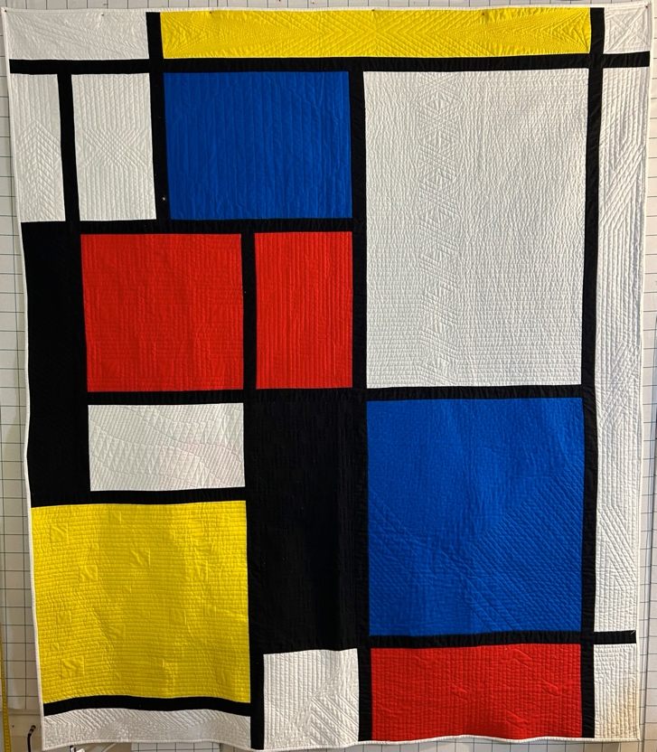 | 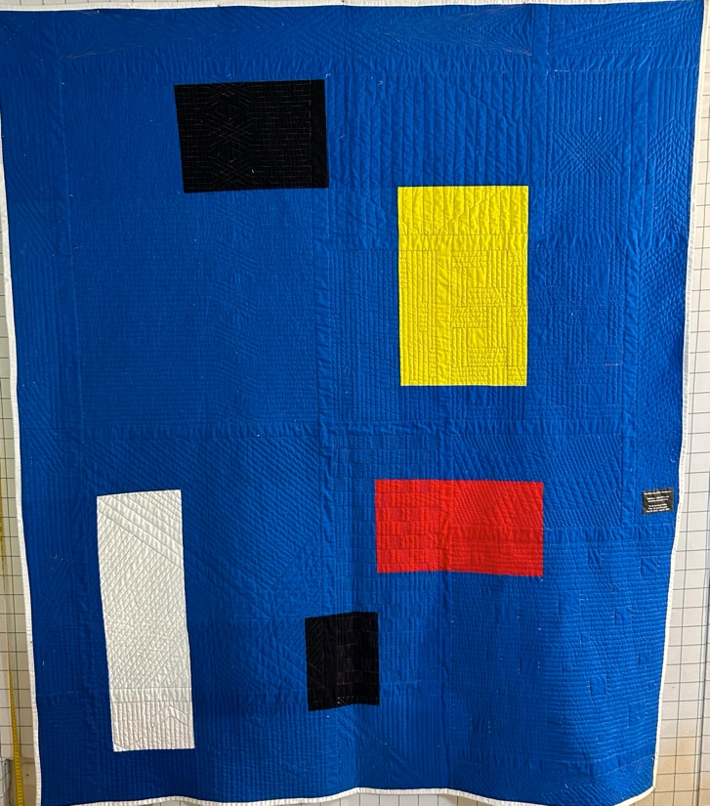

History

Provenance
This quilt was made for DJ Trela by his husband. DJ requested a quilt inspired by Piet Mondrian. The design for this quilt closely follows a Mondrian piece from the early 1920s. Tableau II Red Blue Black and Grey. I used pictures of the original and imported them into Electric Quilt 8 and used these as a template to rough out the blocks. The designed was adjusted to create usable sizes. My goal for the quilting was to use only straight lines. Even if I wanted the illusion of curves in some places.
Image of original Piet Mondrian work:
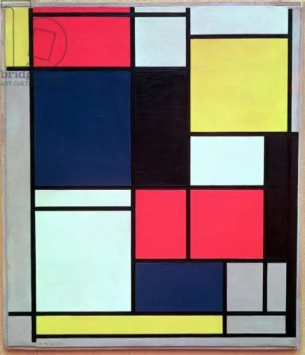

Quilt Maker
David Bailey |  | Birth: July 20, 1968 | Death: --
 | Chicago, IL | Design adaptation, fabric choice, piecing, quilting, binding.

Purpose and Context
Expression
Art | Personal Enjoyment | Therapy
Income
Personal Income | Fundraising
Presentation
Anniversary | Wedding | Birth
Holiday | Birthday | Other gift
Charitable support
Relationships
Friendship | Commemorative | Memorial
Mourning | Reunion
Skill Building
Challenge / Contest | Learning / Teaching Sample
Use
Bed Quilt | Lap Quilt | Home Décor
Baby / Crib | Wall Hanging
Describe purpose

Condition

Flaws
Soiling
Dirty | Stains
Mildew stains | Musty Smell
Discoloration
Running / fugitive color | Faded / bleached color | Crocking
Fabric Damage
Tears / holes | Disintegrating / fall out | Insect damage
Thread bare | Shattering
Sewing / Quilting Damage
Split / open seams | Ties / tufting missing | Embellishments missing
Quilting threads missing | Batting has shifted
Storage Issues
Discoloration from wood | Damage from acid | Fold marks / creases
The red bled from behind the quilt into a smaller one of the white blocks. It left a shadow.
Images for Condition Issues

Design & Construction

Quilt Top
Layout Design:
 | One Patch Shape Details
 |  |  | The shapes are squares and rectangles. They are not laid out in a grid pattern. The size of the blocks frequently made them whole cloth for quilting designs.
Piecing Techniques
 |  | Machine pieced | String / Improvisational piecing
 |  | Hand pieced | Foundation piecing
 |  | Strip piecing | English paper piecing
 |  | Describe other piecing techniques
 | Piecing Workmanship
 |  | Seams are stable | Seams are appropriately aligned
 |  | Seams are flat | Points are sharp
 |  | Describe piecing workmanship

Sashing
Length: “ x Width: 1“
Use of corner stones

Top Assembly
 | Seams are stable | Seams are appropriately aligned
 | Seams are flat | Top has no inappropriate tucks or puckers
 |  | Top lays flat with no overly full areas
Color
Predominant colors
 | Red | Blue | Black
 | Orange | Violet/Purple | Grey
 | Yellow | Brown | White
 | Green | Beige / Tan

Materials
Sources of Fabric
 | Companies | Designer | Fabric Name & Number
 | Kona | Designer name | 1387 White
 | Kona | Designer name | 1194 Lipstick (Red)
 | Kona | Designer name | 90 Pacific (Blue)
 | Kona | Designer name | 1077 Citrus (Yellow)
 | Kona | Designer name | 1019 Black
Fiber Types
 | Cotton | Silk | Wool
 | Cotton Blend | Linen | Synthetic
 | Not Yet Identified
 | Describe other fibers
Fabric Types
 | Broadcloth | Sateen | Upholstery
 | Flannel | Satin | Chintz
 | Shirting | Muslin | Glazed
 | Suiting | Velvet | Handwoven
 | Denim | Felt | Lindsey-Woolsey
 | Describe other fabrics

Quilt Back
Layout Design:
One Patch Shape Details
The back uses the same fabrics as the top except the piecing was less detailed.

Back Inscriptions
Content
Makers names | Initials | Date
Single Name | Message | Place
Multiple Names

Methods
Label | Ink – Ball point | Stencil
Printed onto fabric | Ink – Felt tip | Stamped
Quilted | Ink - Other | Pencil
Embroidery | Applique | Typewriter

Describe location and copy of inscription

Quilting
Stabilization Method:
Quilting Techniques
 | Machine Quilted | Hand Quilted | Quilt-as-you-go
 | Machine – long-arm | Stuffed work | Corded
 | Machine – sit-down
Quilting Patterns
 | Meander / Free motion | Lines – single parallel | Cables
 | In-the-ditch / To the piece | Lines – double parallel | Feathers
 | Echo / Outlined | Lines – triple parallel | Wreaths
 | Stipple | Grid – crosshatch | Vines
 | Clamshell | Grid – square | Floral
 | Elbow / Fan | Grid - diamond | Leaves
 | The goal was the do the entire quilt with straight lines because of the Mondrian aesthetic.
Batting
 |  | Reported by maker.

Images for Quilting
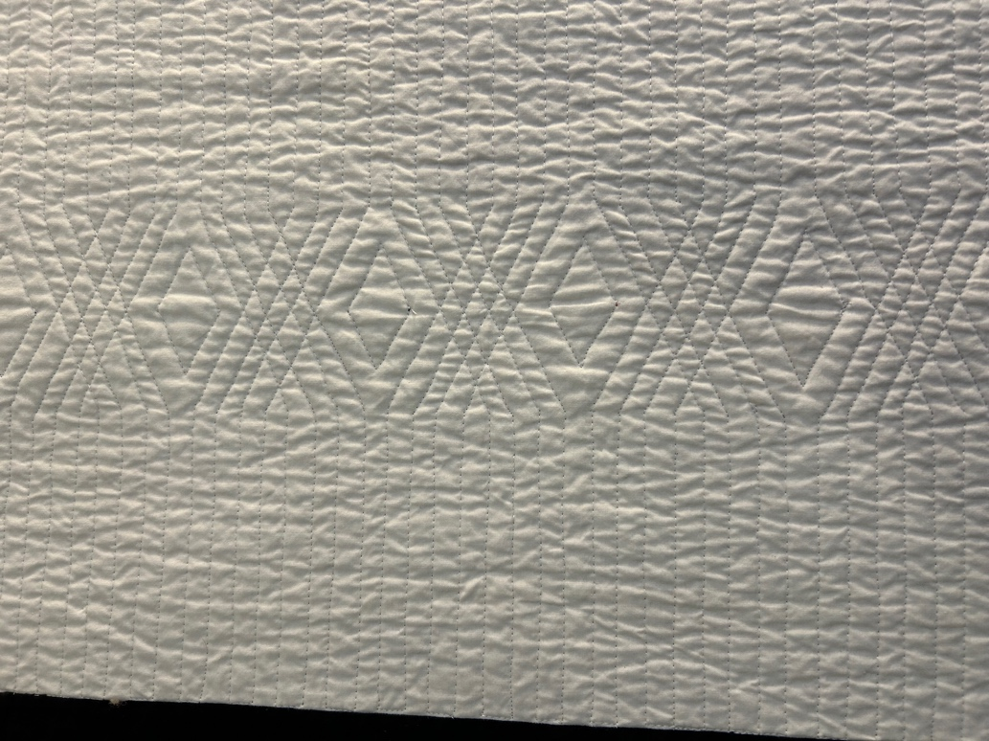 | 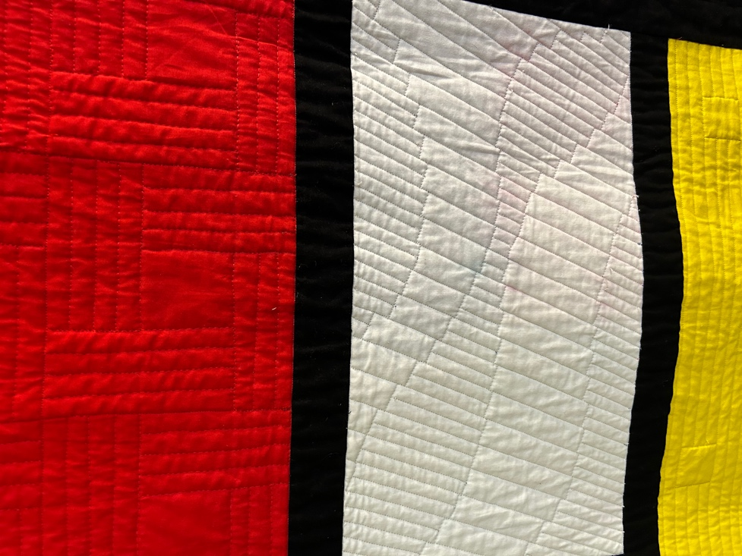
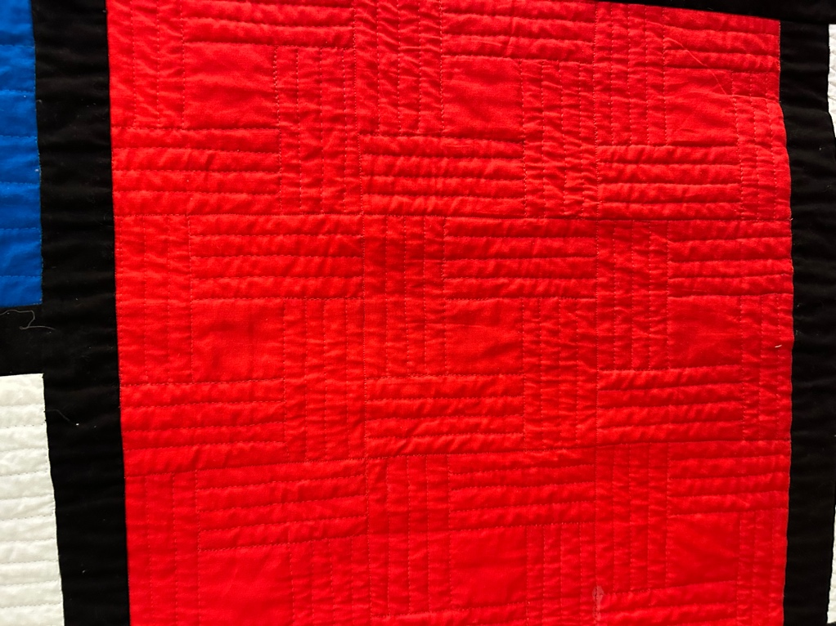 | 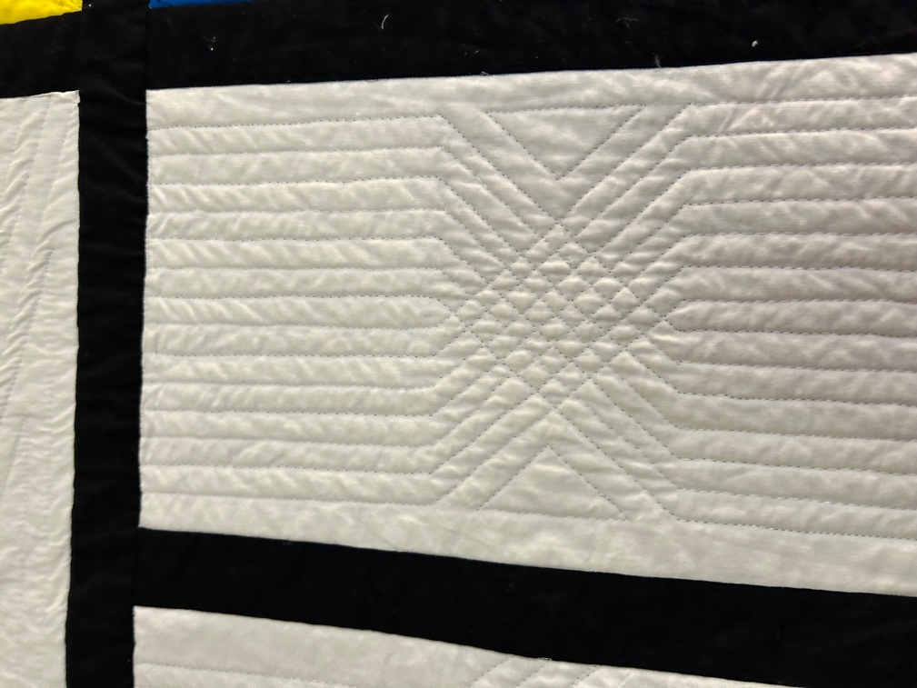
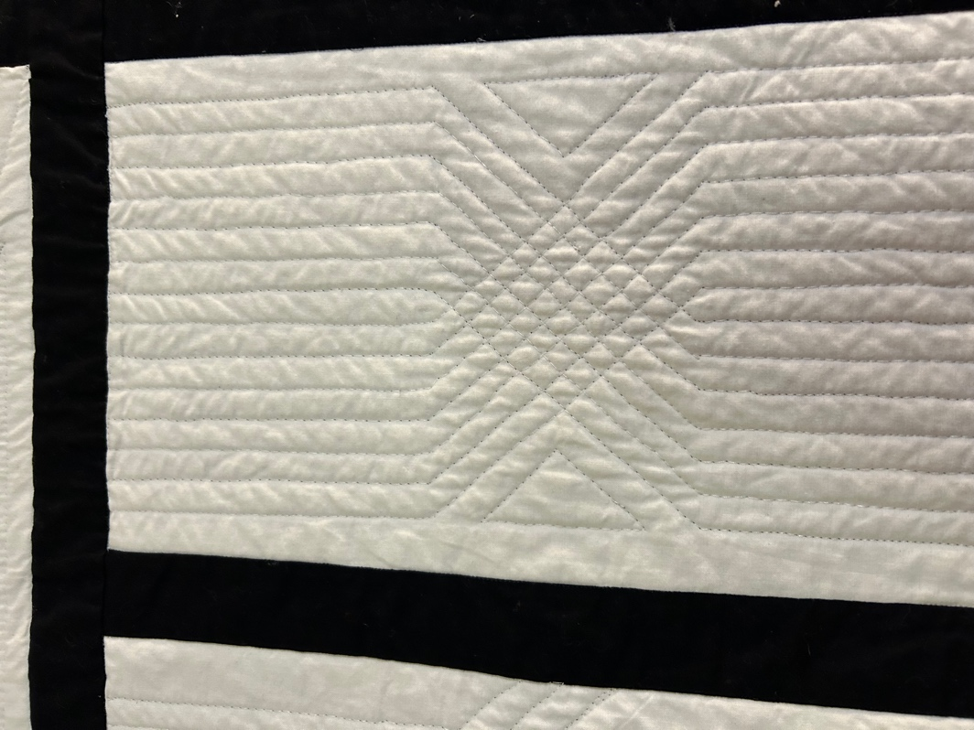 | 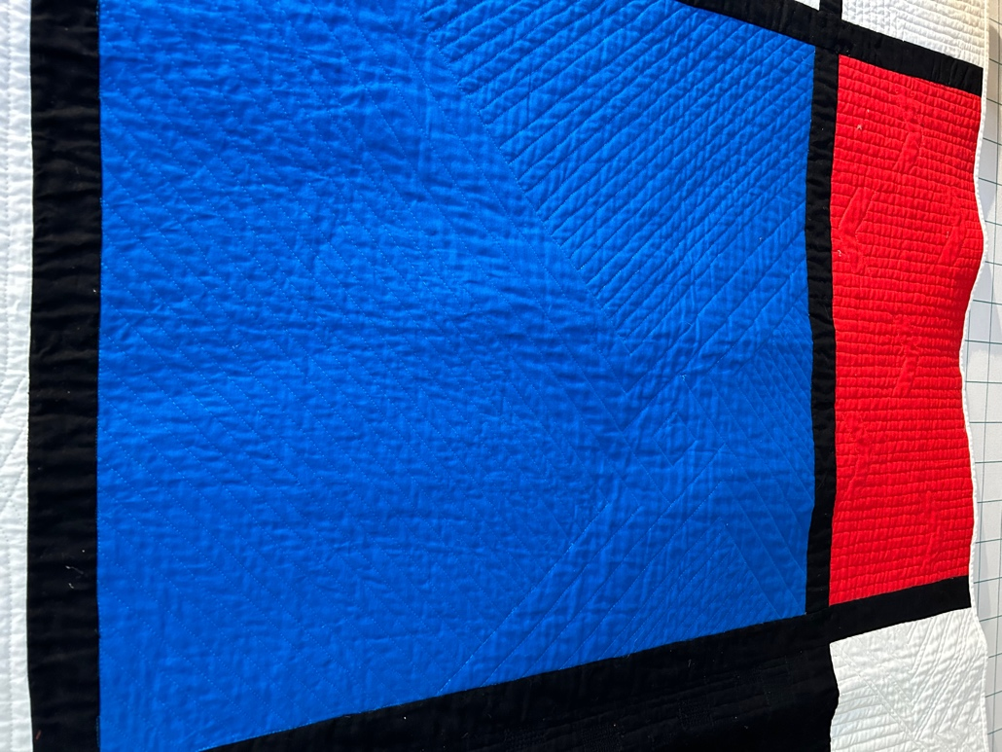

Edge Finish
Embellishments
Fringe | Ruffles | Cording
Lace | Ribbon
Techniques
Top Width: 0.25 “ | Binding | Rolled – top to back
Back Width: 0.5“ | Front – machine | Rolled – back to top
 | Front – hand | Knife edge
 | Back – machine | Turned
 | Back - hand

