Documentation Form

Overview

Acquisition Information
Owner | From Date | To Date | Location | Cost
David Bailey | July 1, 2023 | -- | Flint, MI | $0.00
 | If not purchased, the estimated cost for materials: $83.00

Display & Publication History
Date | Event | Location / Publication | Pro-Rated  Reimbursement
-- | -- | -- | -

General Description
Quilt Title or Name:  Rainbow Blocks | Date Made: July 1, 2023  Exact circa +/- 0 Years  Fabric Dates: 2023
Item Type: | Method of Determination:
Length: 48“ x Width: 31“ | This quilt was appraised in Year.
Additional Information: Other information

Images
Top | Back
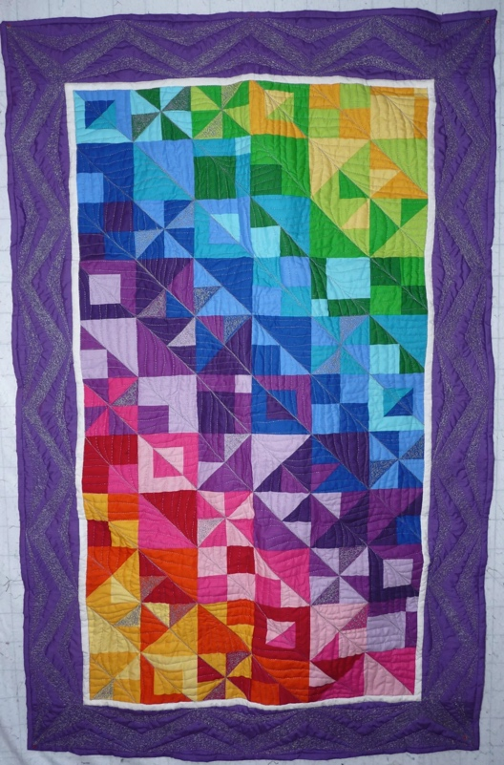 | 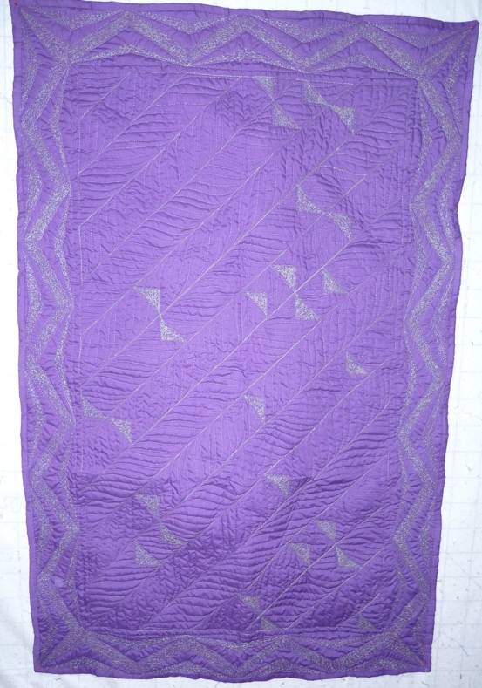

History

Provenance
I liked the panel and thought it would be good practice for quilting. I tried some new stuff. I didn't like it. I know why. No need to make that mistake twice.

Quilt Maker
David Bailey |  | Birth: July 20, 1967 | Death: --
 | Flint, MI | Assembly, Quilting, Binding

Purpose and Context
Expression
Art | Personal Enjoyment | Therapy
Income
Personal Income | Fundraising
Presentation
Anniversary | Wedding | Birth
Holiday | Birthday | Other gift
Charitable support
Relationships
Friendship | Commemorative | Memorial
Mourning | Reunion
Skill Building
Challenge / Contest | Learning / Teaching Sample
Use
Bed Quilt | Lap Quilt | Home Décor
Baby / Crib | Wall Hanging
Describe purpose

Condition

Flaws
Soiling
Dirty | Stains
Mildew stains | Musty Smell
Discoloration
Running / fugitive color | Faded / bleached color | Crocking
Fabric Damage
Tears / holes | Disintegrating / fall out | Insect damage
Thread bare | Shattering
Sewing / Quilting Damage
Split / open seams | Ties / tufting missing | Embellishments missing
Quilting threads missing | Batting has shifted
Storage Issues
Discoloration from wood | Damage from acid | Fold marks / creases
Describe condition issues
Images for Condition Issues

Design & Construction

Quilt Top
Layout Design: - A panel of printed blocks. The blocks are HST, QST, and pinwheels. I added the 0.5” white border and the 4.75” purple border. I added the white mostly because the purple fabric that I had to use didn’t match the panel.
Color
Materials
Sources of Fabric
 | Companies | Designer | Fabric Name & Number
 | Michael Miller Northcott | Phase II Cosmopolitan Blue | -
 | -
Fiber Types
 | Cotton | Silk | Wool
 | Cotton Blend | Linen | Synthetic
 | Not Yet Identified
 | Describe other fibers
Fabric Types
 | Broadcloth | Sateen | Upholstery
 | Flannel | Satin | Chintz
 | Shirting | Muslin | Glazed
 | Suiting | Velvet | Handwoven
 | Denim | Felt | Lindsey-Woolsey
 | Describe other fabrics

Quilt Back
Layout Design:
Materials
Fiber Types
 | Cotton | Silk | Wool
 | Cotton Blend | Linen | Synthetic
 | Describe other fibers
Fabric Types
 | Broadcloth | Sateen | Upholstery
 | Flannel | Satin | Chintz
 | Shirting | Muslin | Glazed
 | Suiting | Velvet | Handwoven
 | Denim | Felt | Lindsey-Woolsey
 | Describe other fabrics
Print Types
 | Batik | Floral | Plaid
 | Cheater Panel | Geometric | Solid / Plain
 | Checked / Gingham | Hand-dyed | Stamped
 | Conversation / Novelty | Victorian Mourning Prints | Stripes
 | Dotted | Multiple scraps
 | Feed sack / Feed sack-like | Paisley
 | Describe other print types

Back Inscriptions
Content
Makers names | Initials | Date
Single Name | Message | Place
Multiple Names

Methods
Label | Ink – Ball point | Stencil
Printed onto fabric | Ink – Felt tip | Stamped
Quilted | Ink - Other | Pencil
Embroidery | Applique | Typewriter

Describe location and copy of inscription
Images for Inscriptions

Quilting
Stabilization Method:
Quilting Techniques
 | Machine Quilted | Hand Quilted | Quilt-as-you-go
 | Machine – long-arm | Stuffed work | Corded
 | Machine – sit-down
Quilting Patterns
 | Meander / Free motion | Lines – single parallel | Cables
 | In-the-ditch / To the piece | Lines – double parallel | Feathers
 | Echo / Outlined | Lines – triple parallel | Wreaths
 | Stipple | Grid – crosshatch | Vines
 | Clamshell | Grid – square | Floral
 | Elbow / Fan | Grid - diamond | Leaves
 | Outlines, S-lines, stipple
Batting
 |  | Communicated by maker.
Images for Quilting

Edge Finish
Embellishments
Fringe | Ruffles | Cording
Lace | Ribbon
Techniques
Top Width: 0.38 “ | Binding | Rolled – top to back
Back Width: 0.5” | Front – machine | Rolled – back to top
 | Front – hand | Knife edge
 | Back – machine | Turned
 | Back - hand
Describe binding

Images for Edge

Conservation, Restoration, Repairs
Conservation
Measures to prevent further loss of quality. Examples:
- Stabilized with netting
Describe conversation measures

Restoration
Measures to return the item back to similar condition as its original state using vintage materials and techniques. Examples:
- Patched with vintage / period fabrics, not reproductions.
Describe restoration measures

Repairs
Measures taken to keep the item usable. Examples:
- Cut down to smaller size.
- Patched with new fabrics
- Rebound
- Tears / holes sewn together
Describe repair measures

Images for Conservation / Restoration / Repairs

