Documentation Form

Overview

Acquisition Information
Owner | From Date | To Date | Location | Cost
David Bailey | Nov 2, 2022 | -- | Flint, MI | $0.00
 | At the time of completion the estimate materials cost were $241.

Display & Publication History
Date | Event | Location / Publication | Pro-Rated  Reimbursement
-- | -- | -- | --

General Description
Quilt Title or Name:  Dance of the Dragonflies | Date Made: Nov 2, 2022  Exact circa +/- 0 Years  Fabric Date Range: 2022
Item Type: | Method of Determination:
Length: 42“ x Width: 42“ | This quilt was appraised in Year.
Additional Information: Other information

Images
Top | Back
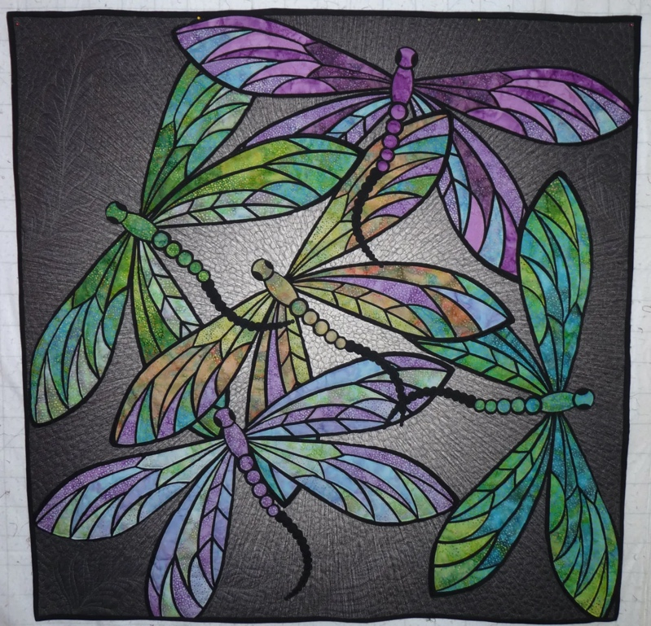 | 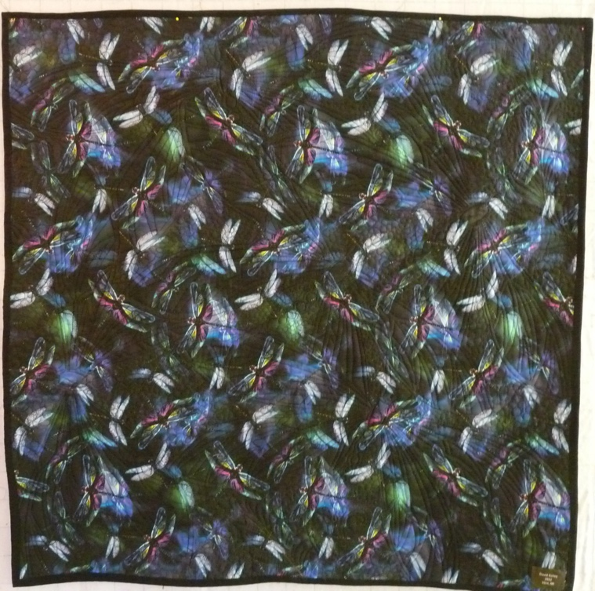

History

Provenance
I made this quilt because I liked the pattern. It just made me happy. – And it gave me a chance to learn applique.

Quilt Maker
David Bailey |  | Birth: July 20 1967 | Death: --
 | Flint, MI | Applique, quilting, binding

Purpose and Context
Expression
Art | Personal Enjoyment | Therapy
Income
Personal Income | Fundraising
Presentation
Anniversary | Wedding | Birth
Holiday | Birthday | Other gift
Charitable support
Relationships
Friendship | Commemorative | Memorial
Mourning | Reunion
Skill Building
Challenge / Contest | Learning / Teaching Sample
Use
Bed Quilt | Lap Quilt | Home Décor
Baby / Crib | Wall Hanging
Describe purpose

Condition

Design & Construction

Quilt Top
Layout Design:

Embellishments
Applique – raw-edge | Embroidery | Stuffed Work
Button-hole | Cording | Inking
Needle-turn | Beading | Painting
Reverse | Rhinestones / Gems | Marking lines noted
Color
Materials
Sources of Fabric
 | Companies | Designer | Fabric Name & Number
 | Hoffman Fabrics |  | SuperNova – Burst P4287-238
 | Hoffman Fabric | Sew-In-To-It | Kit: Dance of the Dragonflies
Fiber Types
 | Cotton | Silk | Wool
 | Cotton Blend | Linen | Synthetic
 | Not Yet Identified
 | Describe other fibers
Fabric Types
 | Broadcloth | Sateen | Upholstery
 | Flannel | Satin | Chintz
 | Shirting | Muslin | Glazed
 | Suiting | Velvet | Handwoven
 | Denim | Felt | Lindsey-Woolsey
 | Describe other fabrics

Print Types
 | Batik | Floral | Plaid
 | Cheater Panel | Geometric | Solid / Plain
 | Checked / Gingham | Hand-dyed | Stamped
 | Conversation / Novelty | Victorian Mourning Prints | Stripes
 | Dotted | Multiple scraps
 | Feed sack / Feed sack-like | Paisley
 | -

Quilt Back
Layout Design:
Color
Predominant colors
 | Red | Blue | Black
 | Orange | Purple | Grey
 | Yellow | Brown | White
 | Green | Beige / Tan
Materials
 | Sources of Fabric
 |  | Companies | Designer |  | Fabric Name & Number
 |  | Hoffman | - |  | Dragon fly dream R4632 162
 |  | -
 | Fiber Types
 |  | Cotton | Silk |  | Wool
 |  | Cotton Blend | Linen |  | Synthetic
 |  | Describe other fibers
 | Fabric Types
 |  | Broadcloth | Sateen |  | Upholstery
 |  | Flannel | Satin |  | Chintz
 |  | Shirting | Muslin |  | Glazed
 |  | Suiting | Velvet |  | Handwoven
 |  | Denim | Felt |  | Lindsey-Woolsey
 |  | Describe other fabrics

Back Inscriptions
Content
Makers names | Initials | Date
Single Name | Message | Place
Multiple Names

Methods
Label | Ink – Ball point | Stencil
Printed onto fabric | Ink – Felt tip | Stamped
Quilted | Ink - Other | Pencil
Embroidery | Applique | Typewriter

Describe location and copy of inscription

Quilting
Stabilization Method:
Quilting Techniques
 | Machine Quilted | Hand Quilted | Quilt-as-you-go
 | Machine – long-arm | Stuffed work | Corded
 | Machine – sit-down
Quilting Patterns
 | Meander / Free motion | Lines – single parallel | Cables
 | In-the-ditch / To the piece | Lines – double parallel | Feathers
 | Echo / Outlined | Lines – triple parallel | Wreaths
 | Stipple | Grid – crosshatch | Vines
 | Clamshell | Grid – square | Floral
 | Elbow / Fan | Grid - diamond | Leaves
 | Pebbles
Batting
 |  | Two layers of batting were used. One of cotton and one of wool.
 |  | Describe method of determination
Images for Quilting
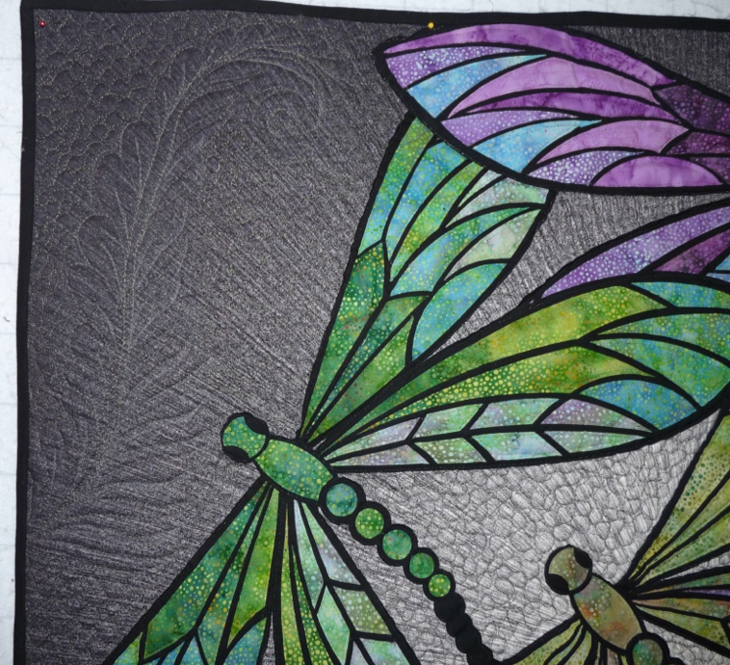 | 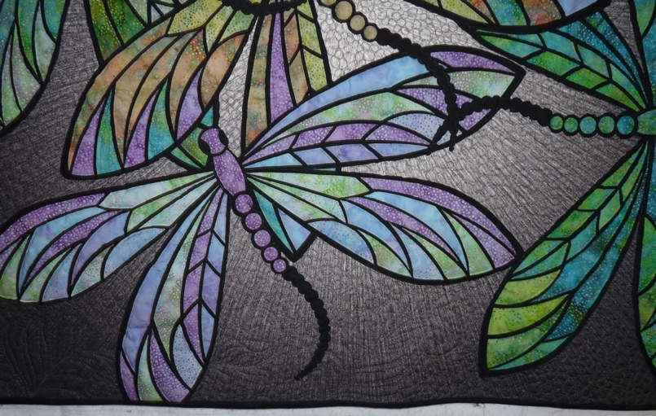

Edge Finish
Techniques
Top Width: 0.38 “ | Binding | Rolled – top to back
Back Width: 0.25“ | Front – machine | Rolled – back to top
 | Front – hand | Knife edge
 | Back – machine | Turned
 | Back - hand
Describe binding

Images for Edge

Conservation, Restoration, Repairs
Conservation
Measures to prevent further loss of quality. Examples:
- Stabilized with netting
Describe conversation measures

Restoration
Measures to return the item back to similar condition as its original state using vintage materials and techniques. Examples:
- Patched with vintage / period fabrics, not reproductions.
Describe restoration measures

Repairs
Measures taken to keep the item usable. Examples:
- Cut down to smaller size.
- Patched with new fabrics
- Rebound
- Tears / holes sewn together
Describe repair measures

Images for Conservation / Restoration / Repairs

