Documentation Form

Overview

Acquisition Information
Owner | From Date | To Date | Location | Cost
David Bailey | December 2009 | -- | Newton Falls, Ohio | $0.00

Display & Publication History
Date | Event | Location / Publication | Pro-Rated  Reimbursement
-- | -- | -- | --

General Description
Quilt Title or Name:  DJ's Garden Quilt | Date Made: November 2009  Exact circa +/- 0 Years
Item Type: | Method of Determination:
Length: 80“ x Width: 51“ | This quilt was appraised in Year.
Additional Information: -

Images
Top | Back
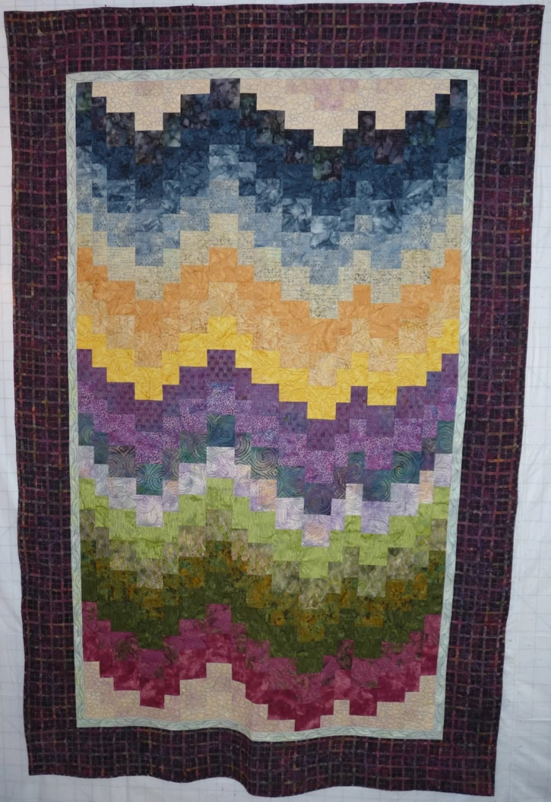 | 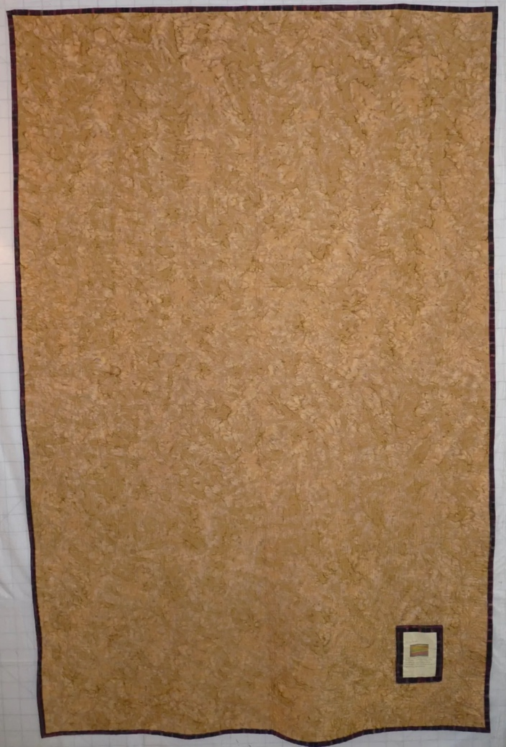

History

Provenance
This quilt was made by Linda Bailey and given to DJ Trela for Xmas of 2009. The design was inspired by a visit that Linda made earlier that year to Flint, MI where she was able to walk in DJ’s flower garden. DJ Trela is Linda Bailey’s son-in-law.

Quilt Maker
Linda Bailey |  | Birth: Sep 9, 1958 | Death: --
 | Newton Falls, Ohio | piecing, quilting, binding

Purpose and Context
Expression
Art | Personal Enjoyment | Therapy
Income
Personal Income | Fundraising
Presentation
Anniversary | Wedding | Birth
Holiday | Birthday | Other gift
Charitable support
Relationships
Friendship | Commemorative | Memorial
Mourning | Reunion
Skill Building
Challenge / Contest | Learning / Teaching Sample
Use
Bed Quilt | Lap Quilt | Home Décor
Baby / Crib | Wall Hanging
Describe purpose

Condition

Flaws
Soiling
Dirty | Stains
Mildew stains | Musty Smell
Discoloration
Running / fugitive color | Faded / bleached color | Crocking
Fabric Damage
Tears / holes | Disintegrating / fall out | Insect damage
Thread bare | Shattering
Sewing / Quilting Damage
Split / open seams | Ties / tufting missing | Embellishments missing
Quilting threads missing | Batting has shifted
Storage Issues
Discoloration from wood | Damage from acid | Fold marks / creases
Describe condition issues
Images for Condition Issues

Design & Construction

Quilt Top
Layout Design:
One Patch Shape Details
The layout is a bargello design from strip sets that were staggard against each other for the setting.
Borders & Frames
 | Describe borders and frames in order from center to edge.
 |  | Width: 1“
 |  | Width: 6“
Top Assembly
 | Seams are stable | Seams are appropriately aligned
 | Seams are flat | Top has no inappropriate tucks or puckers
 |  | Top lays flat with no overly full areas
Color
Jewel Tones
Materials
Fiber Types
 | Cotton | Silk | Wool
 | Cotton Blend | Linen | Synthetic
 | Not Yet Identified
 | Describe other fibers
Fabric Types
 | Broadcloth | Sateen | Upholstery
 | Flannel | Satin | Chintz
 | Shirting | Muslin | Glazed
 | Suiting | Velvet | Handwoven
 | Denim | Felt | Lindsey-Woolsey
 | Describe other fabrics
Print Types
 | Batik | Floral | Plaid
 | Cheater Panel | Geometric | Solid / Plain
 | Checked / Gingham | Hand-dyed | Stamped
 | Conversation / Novelty | Victorian Mourning Prints | Stripes
 | Dotted | Multiple scraps
 | Feed sack / Feed sack-like | Paisley
 | Describe other print types

Quilt Back
Layout Design:
Back Assembly
 | Seams are stable | Seams are appropriately aligned
 | Seams are flat | Top has no inappropriate tucks or puckers
 |  | Top lays flat with no overly full areas
Color
Predominant colors
 | Red | Blue | Black
 | Orange | Purple | Grey
 | Yellow | Brown | White
 | Green | Beige / Tan
Materials
Fiber Types
 | Cotton | Silk | Wool
 | Cotton Blend | Linen | Synthetic
 | Describe other fibers
Fabric Types
 | Broadcloth | Sateen | Upholstery
 | Flannel | Satin | Chintz
 | Shirting | Muslin | Glazed
 | Suiting | Velvet | Handwoven
 | Denim | Felt | Lindsey-Woolsey
 | Describe other fabrics
Print Types
 | Batik | Floral | Plaid
 | Cheater Panel | Geometric | Solid / Plain
 | Checked / Gingham | Hand-dyed | Stamped
 | Conversation / Novelty | Victorian Mourning Prints | Stripes
 | Dotted | Multiple scraps
 | Feed sack / Feed sack-like | Paisley
 | Describe other print types
Images for Back

Back Inscriptions
Content
Makers names | Initials | Date
Single Name | Message | Place
Multiple Names

Methods
Label | Ink – Ball point | Stencil
Printed onto fabric | Ink – Felt tip | Stamped
Quilted | Ink - Other | Pencil
Embroidery | Applique | Typewriter

Trip Around the Garden - This quilt is a stitched memory of DJ Trela's wonderful gardens. Made by Linda Bailey in2009 as a Christmas gift. As your garden is a place of peace and comfort in it's season, let this quilt provide that comfort and warmth while the garden rests.
Images for Inscriptions
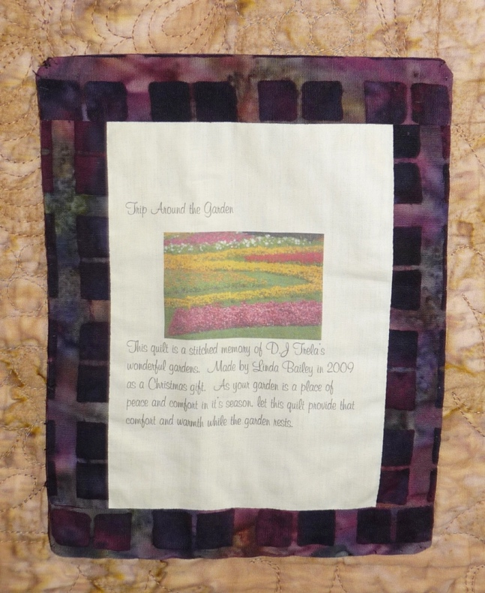

Quilting
Stabilization Method:
Quilting Techniques
 | Machine Quilted – long arm |  | Stuffed work |  | Corded
 | Hand Quilted |  | Quilt-as-you-go
Quilting Patterns
 | Meander / Free motion |  | Lines – single parallel |  | Cables
 | In-the-ditch / To the piece |  | Lines – double parallel |  | Feathers
 | Echo / Outlined |  | Lines – triple parallel |  | Wreaths
 | Stipple |  | Grid – crosshatch |  | Vines
 | Clamshell |  | Grid – square |  | Floral
 | Elbow / Fan |  | Grid - diamond |  | Leaves
 | The quilting on this quilt is done free motion with out computer guidance.
Batting
 |  |  | Discussion with maker.
Images for Quilting
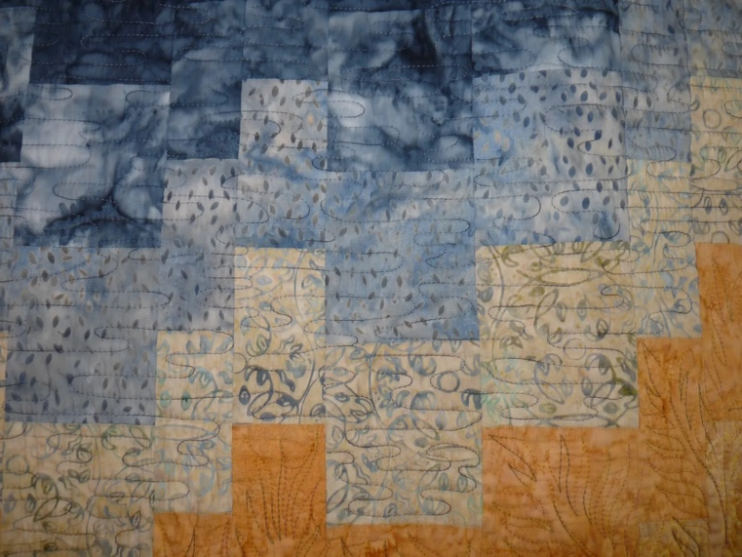 | 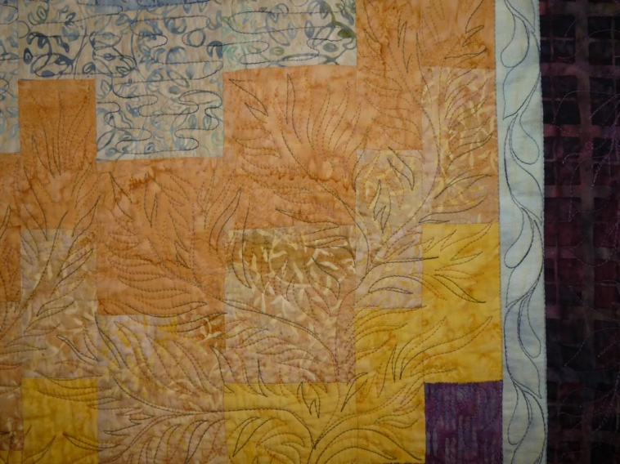
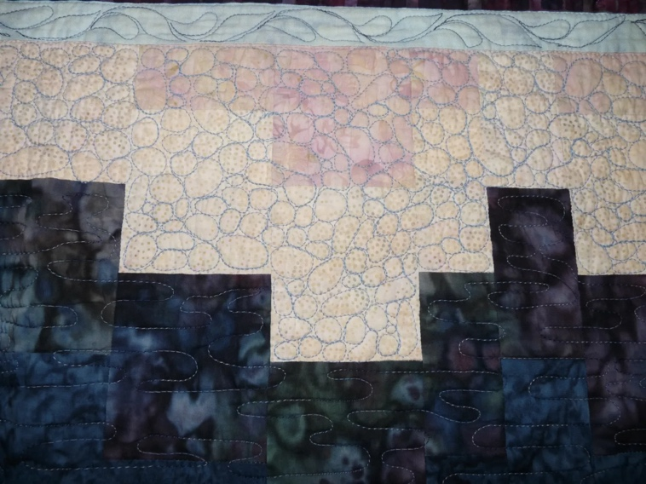 | 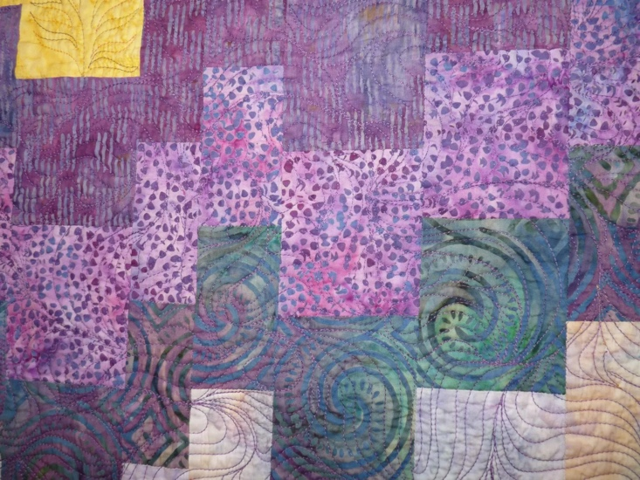
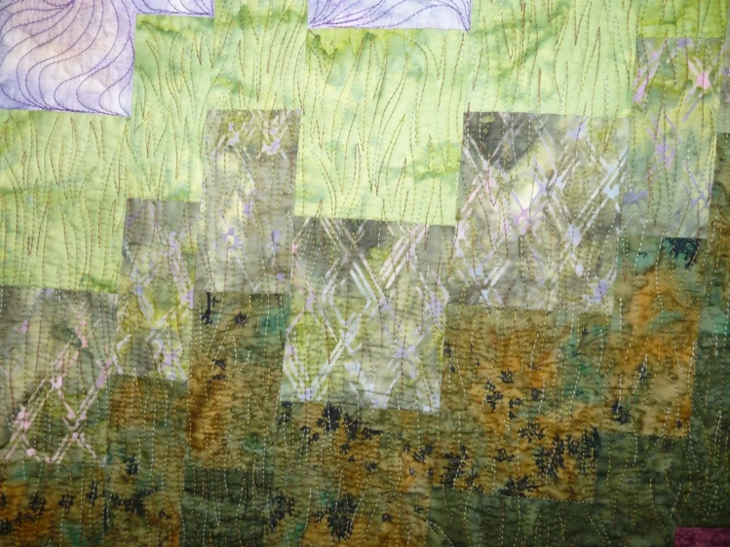 | 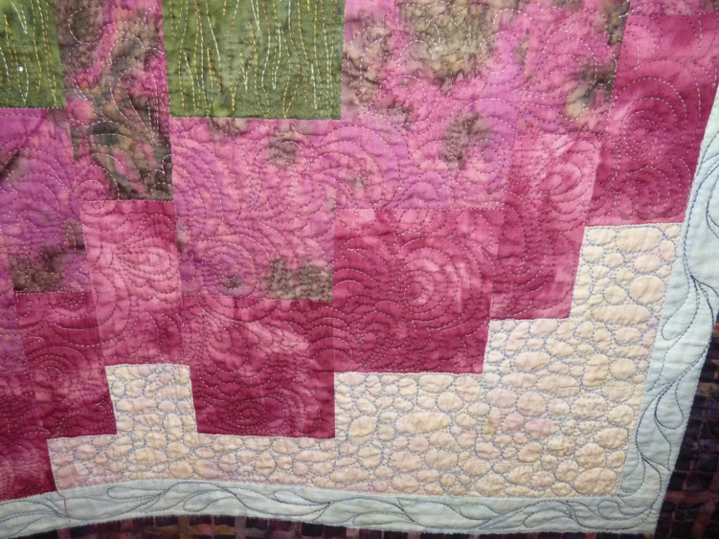

Edge Finish
Techniques
Top Width: 0.00 “ | Binding | Rolled – top to back
Back Width: 0.00“ | Front – machine | Rolled – back to top
 | Front – hand | Knife edge
 | Back – machine | Turned
 | Back - hand

