Documentation Form

Overview

Acquisition Information
Owner | From Date | To Date | Location | Cost
David Bailey | Nov 2020 | -- | Flint, MI

Display & Publication History
Date | Event | Location / Publication | Pro-Rated  Reimbursement
-- | - | - | ($0.00)

General Description
Quilt Title or Name:  DJ's Memory Quilt | Date Made: September - November 2020  Exact circa +/- 0 Years
Item Type: | Method of Determination:
Length: 88“ x Width: 64“ | This quilt was appraised in Year.
Additional Information: Estimated cost of supplies at time of completion was $200.

Zip file of pictures & EQ File

Images
Top | Back
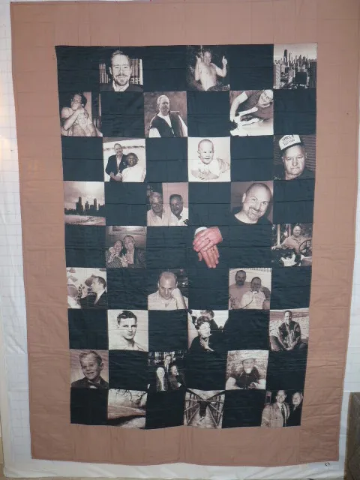 | 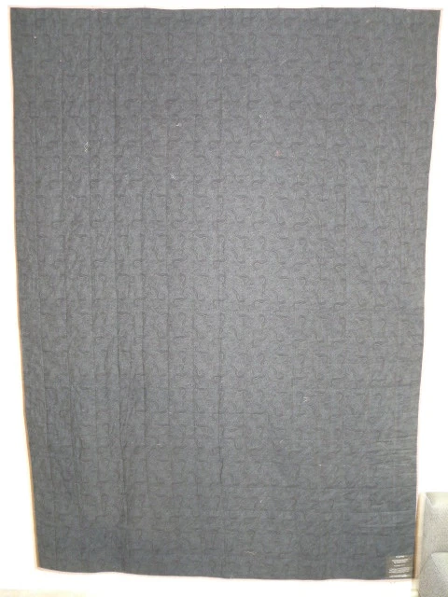
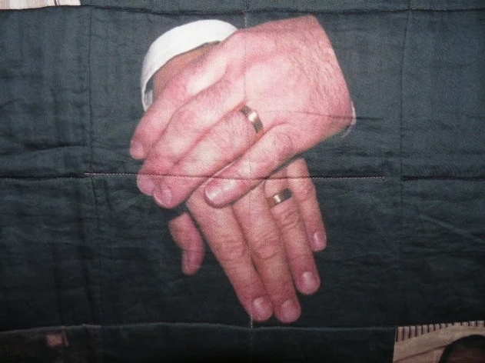 | 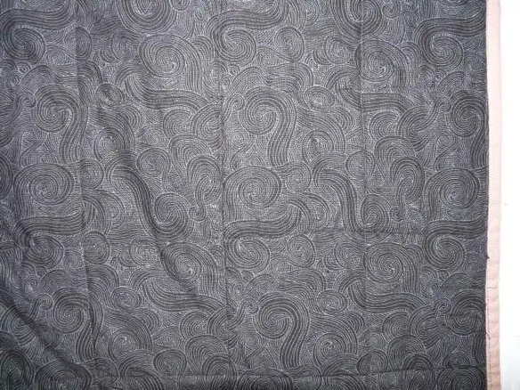

History

Provenance
This quilt was made during the first year of the COVID-19 pandemic as a gift from the maker to his husband. It was also the first quilt the maker made. It was done on a machine without functioning feed dogs. The maker used this activity as a distraction from the new cycle. It was given as a Xmas gift in 2020.

Quilt Maker
David Bailey |  | Birth: July 20, 1967
 | Flint, MI | Fabric design, application of borders, quilting, binding.

Purpose and Context
Expression
Art | Personal Enjoyment | Therapy
Income
Personal Income | Fundraising
Presentation
Anniversary | Wedding | Birth
Holiday | Birthday | Other gift
Charitable support
Relationships
Friendship | Commemorative | Memorial
Mourning | Reunion
Skill Building
Challenge / Contest | Learning / Teaching Sample
Use
Bed Quilt | Lap Quilt | Home Décor
Baby / Crib | Wall Hanging
Describe purpose

Condition

Design & Construction

Quilt Top
Layout Design:

Borders & Frames
 | Describe borders and frames in order from center to edge.
 |  | Width: 8“
Top Assembly
 | Seams are stable | Seams are appropriately aligned
 | Seams are flat | Top has no inappropriate tucks or puckers
 |  | Top lays flat with no overly full areas
Color
Predominant colors
 | Red | Blue | Black
 | Orange | Violet/Purple | Grey
 | Yellow | Brown | White
 | Green | Beige / Tan

Materials
Sources of Fabric
 | Companies | Designer | Fabric Name & Number
 | My Fabric Design.com | David Bailey | custom printing
cotton sateen.
Borders are Kona Cotton
Fiber Types
 | Cotton | Silk | Wool
 | Cotton Blend | Linen | Synthetic
 | Not Yet Identified
 | Describe other fibers
Fabric Types
 | Broadcloth | Sateen | Upholstery
 | Flannel | Satin | Chintz
 | Shirting | Muslin | Glazed
 | Suiting | Velvet | Handwoven
 | Denim | Felt | Lindsey-Woolsey
 | Describe other fabrics

Quilt Back
Layout Design:
Color
Predominant colors
 | Red | Blue | Black
 | Orange | Purple | Grey
 | Yellow | Brown | White
 | Green | Beige / Tan
Antique Colors
 | Red – claret / wine | Yellow – chrome | Blue – Lancaster
 | Red – madder / cinnamon | Green - chrome | Blue – Prussian / Lafayette
 | Red – turkey | Green – Nile | Brown – madder
 | Pinks - double | Blue – Cadet | Butterscotch
 | Orange - madder | Blue - Indigo | Bronze
 | Orange – cheddar / antimony / chrome

Materials
Sources of Fabric - unknown
Fiber Types
 | Cotton | Silk | Wool
 | Cotton Blend | Linen | Synthetic
 | Describe other fibers
Fabric Types
 | Broadcloth | Sateen | Upholstery
 | Flannel | Satin | Chintz
 | Shirting | Muslin | Glazed
 | Suiting | Velvet | Handwoven
 | Denim | Felt | Lindsey-Woolsey
 | Describe other fabrics

Images for Back
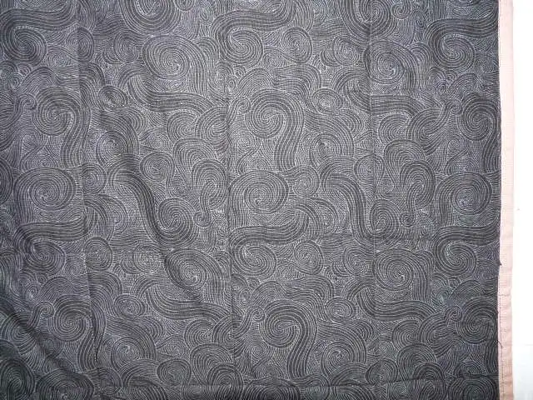

Back Inscriptions
Content
Makers names | Initials | Date
Single Name | Message | Place
Multiple Names

Methods
Label | Ink – Ball point | Stencil
Printed onto fabric | Ink – Felt tip | Stamped
Quilted | Ink - Other | Pencil
Embroidery | Applique | Typewriter

Label is applied to lower right corner. "To DJ. Designed and Quilted by David Bailey. December 2020. A memory quilt can literally wrap you in your memories and leave you feeling warm. I hope we make many more memories together.

Quilting
Stabilization Method:
Quilting Techniques
 | Machine Quilted - sitdown | Stuffed work | Corded
 | Hand Quilted | Quilt-as-you-go
Quilting Patterns
 | Meander / Free motion | Lines – single parallel | Cables
 | In-the-ditch / To the piece | Lines – double parallel | Feathers
 | Echo / Outlined | Lines – triple parallel | Wreaths
 | Stipple | Grid – crosshatch | Vines
 | Clamshell | Grid – square | Floral
 | Elbow / Fan | Grid - diamond | Leaves
 | Describe other quilting patterns
Batting
 |  | 80/20 batting / per maker.
Images for Quilting

Edge Finish
Techniques
Top Width: 0.38 “ | Binding | Rolled – top to back
Back Width: 0.38“ | Front – machine | Rolled – back to top
 | Front – hand | Knife edge
 | Back – machine | Turned
 | Back - hand

Conservation, Restoration, Repairs
Conservation
Measures to prevent further loss of quality. Examples:
- Stabilized with netting
no measures

Restoration
Measures to return the item back to similar condition as its original state using vintage materials and techniques. Examples:
- Patched with vintage / period fabrics, not reproductions.
no measures

Repairs
Measures taken to keep the item usable. Examples:
- Cut down to smaller size.
- Patched with new fabrics
- Rebound
- Tears / holes sewn together
no measures

Images for Conservation / Restoration / Repairs

