Documentation Form

Overview

Acquisition Information
Owner | From Date | To Date | Location | Cost
David Bailey | Mar 22, 2022 | -- | Old Mill Antiques  208 Mason Street  Mason, MI | $25.00

Display & Publication History
Date | Event | Location / Publication | Pro-Rated  Reimbursement
-- | -- | - | ($0.00)

General Description
Quilt Title or Name:  Pieced Tulips | Date Made: ca 1945  Exact circa +/- 10 Years  Fabric Range: 1945+/-10 years
Item Type: | Method of Determination:
Length: 85“ x Width: 83“ | This quilt was appraised in Year.
Additional Information: Other information

Images
Top | Back
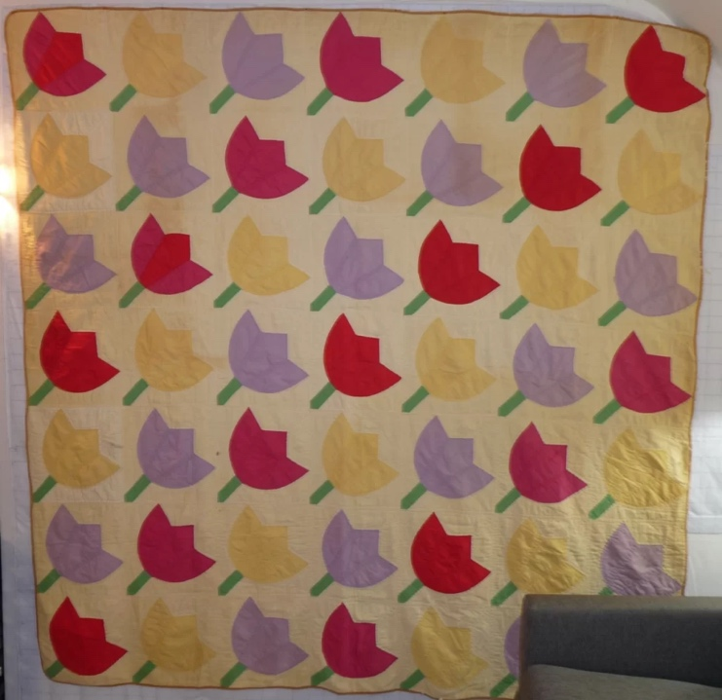 | 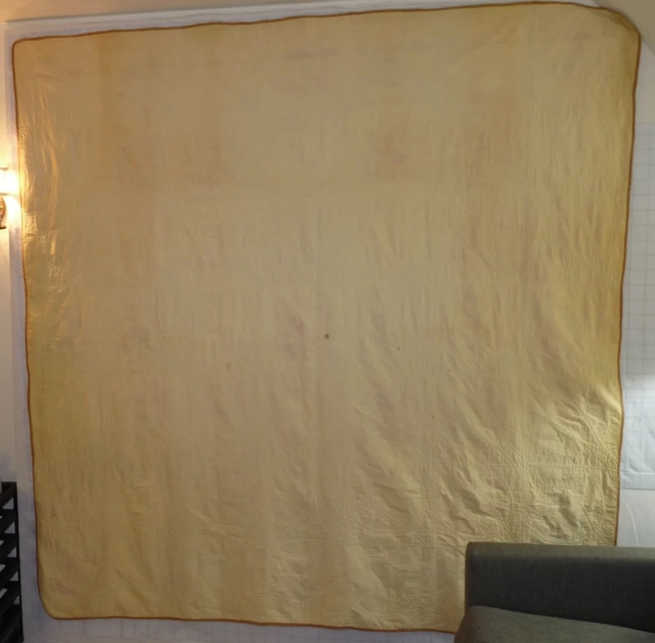
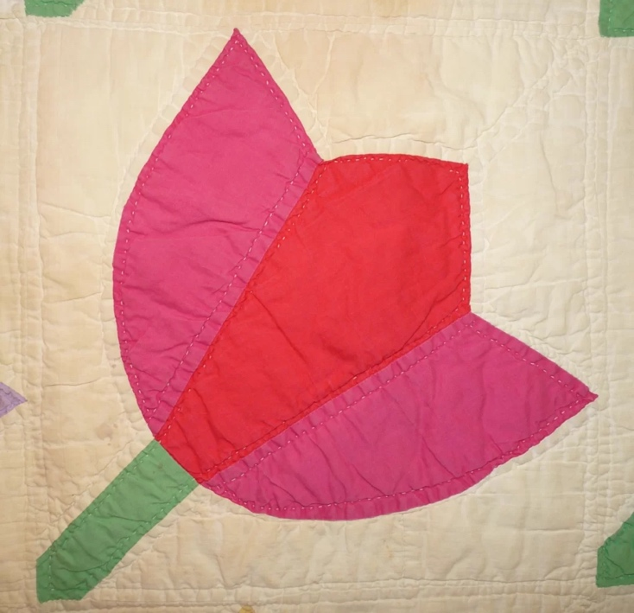

History

Provenance
No history is known for this quilt.

Quilt Maker
Unknown | Birth: - | Death: -

Purpose and Context
The purpose of this quilt is not know. It appears to have been used.

Condition

Flaws
Soiling
Dirty | Stains
Mildew stains | Musty Smell
Discoloration
Running / fugitive color | Faded / bleached color | Crocking
Fabric Damage
Tears / holes | Disintegrating / fall out | Insect damage
Thread bare | Shattering
Sewing / Quilting Damage
Split / open seams | Ties / tufting missing | Embellishments missing
Quilting threads missing | Batting has shifted
Storage Issues
Discoloration from wood | Damage from acid | Fold marks / creases
The quilt has significant yellowing on the background. The top is becoming threadbare in some areas and the binding is starting to come away from the edge of the quilt in places.
Images for Condition Issues
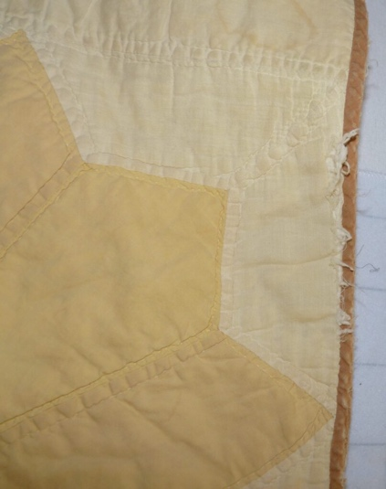

Design & Construction

Quilt Top
Layout Design:
 |  |  | Block Size: Length: 12“ x Width: 12“
 | Block Pattern Details
 |  | Not known
Piecing Techniques
 |  | Machine pieced | String / Improvisational piecing
 |  | Hand pieced | Foundation piecing
 |  | Strip piecing | English paper piecing
 |  | Describe other piecing techniques
 | Piecing Workmanship
 |  | Seams are stable | Seams are appropriately aligned
 |  | Seams are flat | Points are sharp
 |  | Piecing work is very good.

Top Assembly
 | Seams are stable | Seams are appropriately aligned
 | Seams are flat | Top has no inappropriate tucks or puckers
 |  | Top lays flat with no overly full areas
Color
Predominant colors
 | Red | Blue | Black
 | Orange | Violet/Purple | Grey
 | Yellow | Brown | White
 | Green | Beige / Tan

Fiber Types
 | Cotton | Silk | Wool
 | Cotton Blend | Linen | Synthetic
 | Not Yet Identified
 | Describe other fibers
Fabric Types
 | Broadcloth | Sateen | Upholstery
 | Flannel | Satin | Chintz
 | Shirting | Muslin | Glazed
 | Suiting | Velvet | Handwoven
 | Denim | Felt | Lindsey-Woolsey
 | Describe other fabrics

Quilt Back
Layout Design:
 | One Patch Shape Details
Fiber Types
 |  | Cotton | Silk |  | Wool
 |  | Cotton Blend | Linen |  | Synthetic
 |  | Describe other fibers
Fabric Types
 |  | Broadcloth | Sateen |  | Upholstery
 |  | Flannel | Satin |  | Chintz
 |  | Shirting | Muslin |  | Glazed
 |  | Suiting | Velvet |  | Handwoven
 |  | Denim | Felt |  | Lindsey-Woolsey
 |  | Describe other fabrics

Quilting
Quilting Techniques
 | Machine Quilted | Stuffed work | Corded
 | Hand Quilted | Quilt-as-you-go
Quilting Patterns
 | Meander / Free motion | Lines – single parallel | Cables
 | In-the-ditch / To the piece | Lines – double parallel | Feathers
 | Echo / Outlined | Lines – triple parallel | Wreaths
 | Stipple | Grid – crosshatch | Vines
 | Clamshell | Grid – square | Floral
 | Elbow / Fan | Grid - diamond | Leaves
 | Describe other quilting patterns
Batting
 |  | Density

Edge Finish
Embellishments
Techniques
Top Width: 0.00 “ | Binding | Rolled – top to back
Back Width: 0.00“ | Front – machine | Rolled – back to top
 | Front – hand | Knife edge
 | Back – machine | Turned
 | Back - hand
Rolled front to back.

Images for Edge

Conservation, Restoration, Repairs
Conservation
Measures to prevent further loss of quality. Examples:
- Stabilized with netting
No measures.

Restoration
Measures to return the item back to similar condition as its original state using vintage materials and techniques. Examples:
- Patched with vintage / period fabrics, not reproductions.
No measures

Repairs
Measures taken to keep the item usable. Examples:
- Cut down to smaller size.
- Patched with new fabrics
- Rebound
- Tears / holes sewn together
No measures

Images for Conservation / Restoration / Repairs

