Documentation Form

Overview

Acquisition Information
Owner | From Date | To Date | Location | Cost
David Bailey | April 30, 2022 | -- | Michigan Antique Festivals  Davisburg, MI | $80.00

Display & Publication History
Date | Event | Location / Publication | Pro-Rated  Reimbursement
- | - | - | ($0.00)

General Description
Quilt Title or Name:  The Grapevine Quilt | Date Made: 1945  Exact circa +/- 10 Years  Fabric Range: 1945 +/- 10 years
Item Type: | Method of Determination:
Length: 100“ x Width: 88“ | This quilt was appraised in Year.
Additional Information: Other information

Images
Top | Back
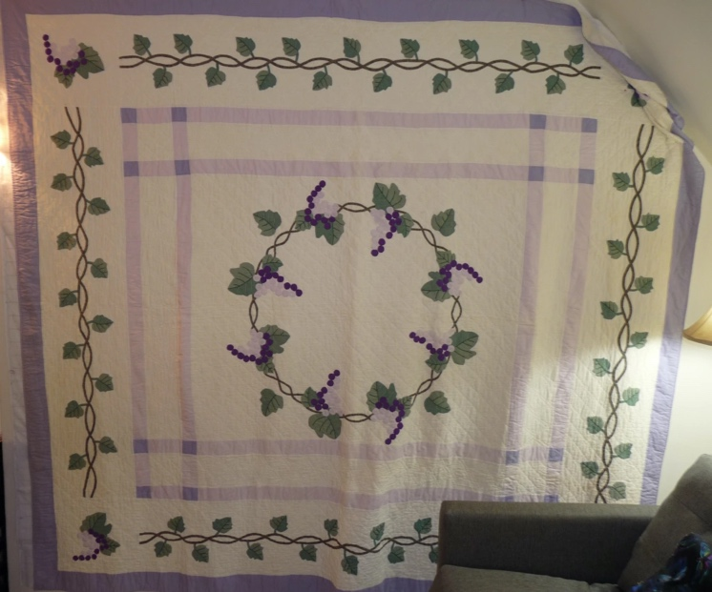 | 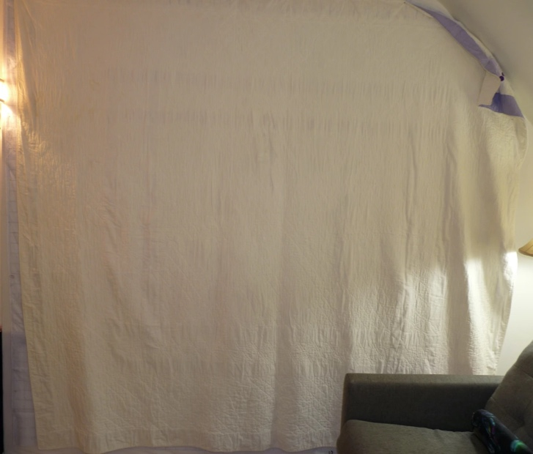
Close ups of Top
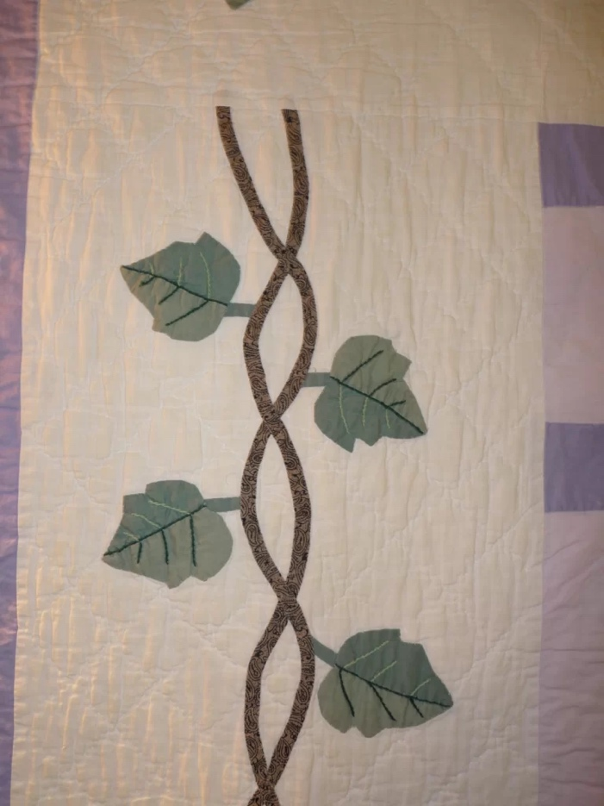 | 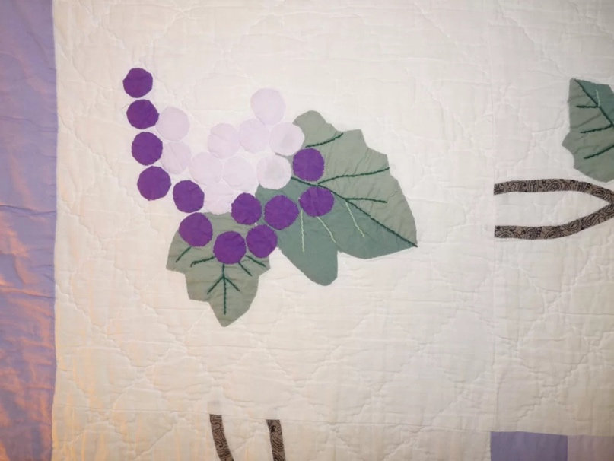
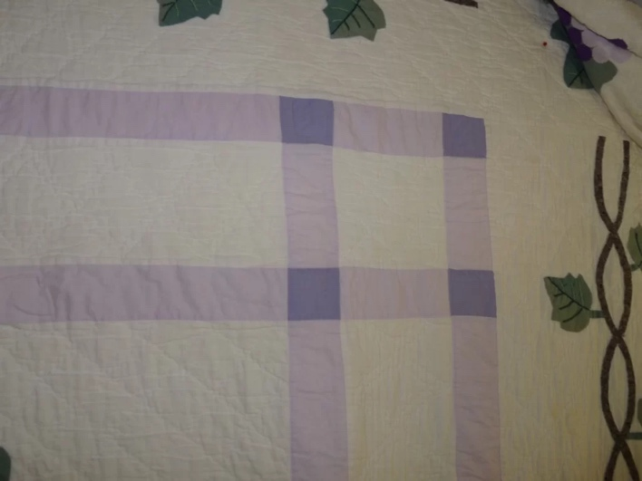

History

Provenance
No known provenance.

Quilt Maker
unknown | Birth: -- | Death: --

Purpose and Context
Expression
Art | Personal Enjoyment | Therapy
Income
Personal Income | Fundraising
Presentation
Anniversary | Wedding | Birth
Holiday | Birthday | Other gift
Charitable support
Relationships
Friendship | Commemorative | Memorial
Mourning | Reunion
Skill Building
Challenge / Contest | Learning / Teaching Sample
Use
Bed Quilt | Lap Quilt | Home Décor
Baby / Crib | Wall Hanging
Purpose not known. - Likely utilitarian or guest room quilt.

Condition

Flaws
Soiling
Dirty | Stains
Mildew stains | Musty Smell
Discoloration
Running / fugitive color | Faded / bleached color | Crocking
Fabric Damage
Tears / holes | Disintegrating / fall out | Insect damage
Thread bare | Shattering
Sewing / Quilting Damage
Split / open seams | Ties / tufting missing | Embellishments missing
Quilting threads missing | Batting has shifted
Storage Issues
Discoloration from wood | Damage from acid | Fold marks / creases
Describe condition issues
Images for Condition Issues
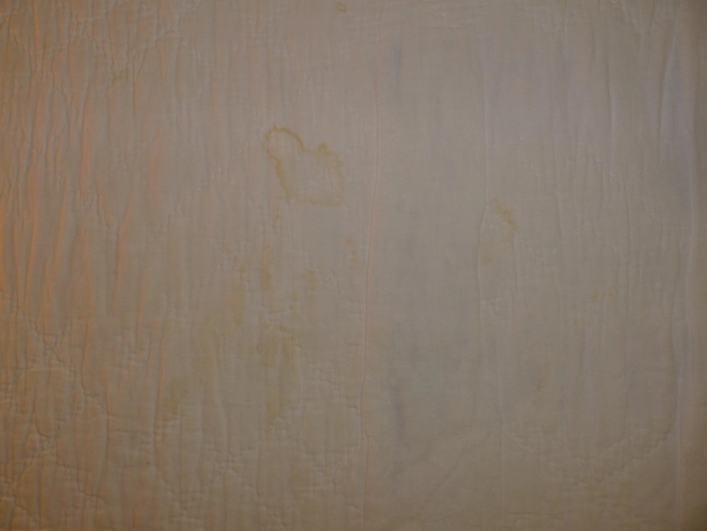

Design & Construction

Quilt Top
Layout Design:
Central with grapevine applique with three frames/shashing and one boarder. The frames/sashing are approximately 2” - purple, 5” - white and 2” - purple. The boarder is about 12” and has a an applique grapevine.

Embellishments
Applique | Embroidery | Stuffed Work
Button-hole | Cording | Inking
Needle-turn | Beading | Painting
Reverse | Rhinestones / Gems | Marking lines noted
Embellishment Workmanship
Stitches are appropriately small and even.
Edges are as design intends (straight, curved, pointed).
Work demonstrates appropriate skill for intended purpose.
The stitches for the applique work is functional. The material is securily applied to the foundation fabric. The stitches are generally visible but not conspiquous.

Sashing
Use of corner stones

Borders & Frames
 | Describe borders and frames in order from center to edge.
 |  | Width: 0“
Top Assembly
 | Seams are stable | Seams are appropriately aligned
 | Seams are flat | Top has no inappropriate tucks or puckers
 |  | Top lays flat with no overly full areas
Color
Predominant colors
 | Red | Blue | Black
 | Orange | Violet/Purple | Grey
 | Yellow | Brown | White
 | Green | Beige / Tan
Antique Colors
 | Red – claret / wine | Yellow – chrome | Blue – Lancaster
 | Red – madder / cinnamon | Green - chrome | Blue – Prussian / Lafayette
 | Red – turkey | Green – Nile | Brown – madder
 | Pinks - double | Blue – Cadet | Butterscotch
 | Orange - madder | Blue - Indigo | Bronze
 | Orange – cheddar / antimony / chrome |  | Late 1800’s Purple

Materials
Sources of Fabric
 | Companies | Designer | Fabric Name & Number
 | Company name | Designer name | Fabric name & code
 | Describe other sources - scraps, cloths, cutter quilts
Fiber Types
 | Cotton | Silk | Wool
 | Cotton Blend | Linen | Synthetic
 | Not Yet Identified
 | Describe other fibers
Fabric Types
 | Broadcloth | Sateen | Upholstery
 | Flannel | Satin | Chintz
 | Shirting | Muslin | Glazed
 | Suiting | Velvet | Handwoven
 | Denim | Felt | Lindsey-Woolsey
 | Describe other fabrics
Print Types
 | Batik | Floral | Plaid
 | Cheater Panel | Geometric | Solid / Plain
 | Checked / Gingham | Hand-dyed | Stamped
 | Conversation / Novelty | Victorian Mourning Prints | Stripes
 | Dotted | Multiple scraps
 | Feed sack / Feed sack-like | Paisley
 | Describe other print types

Quilt Back
Layout Design:
Color
Predominant colors
 | Red |  | Blue | Black
 | Orange |  | Purple | Grey
 | Yellow |  | Brown | White
 | Green |  | Beige / Tan
Fiber Types
 |  | Cotton | Silk | Wool
 |  | Cotton Blend | Linen | Synthetic
 |  | Describe other fibers
Fabric Types
 |  | Broadcloth | Sateen | Upholstery
 |  | Flannel | Satin | Chintz
 |  | Shirting | Muslin | Glazed
 |  | Suiting | Velvet | Handwoven
 |  | Denim | Felt | Lindsey-Woolsey
 |  | Describe other fabrics

Quilting
Stabilization Method:
Quilting Techniques
 | Machine Quilted | Stuffed work | Corded
 | Hand Quilted | Quilt-as-you-go
Quilting Patterns
 | Meander / Free motion | Lines – single parallel | Cables
 | In-the-ditch / To the piece | Lines – double parallel | Feathers
 | Echo / Outlined | Lines – triple parallel | Wreaths
 | Stipple | Grid – crosshatch | Vines
 | Clamshell | Grid – square | Floral
 | Elbow / Fan | Grid - diamond | Leaves
 | Describe other quilting patterns
Batting
 |  | Density
Images for Quilting
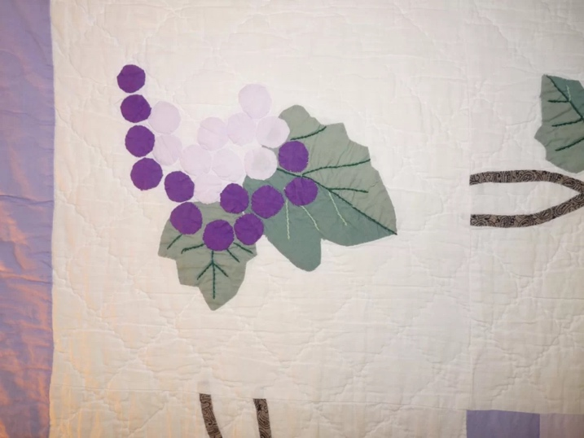

Edge Finish
Embellishments
Fringe | Ruffles |  | Cording
Lace | Ribbon
Techniques
Top Width: 0.00 “ | Binding |  | Rolled – top to back
Back Width: 0.00“ | Front – machine |  | Rolled – back to top
 | Front – hand |  | Knife edge
 | Back – machine |  | Turned
 | Back - hand

Conservation, Restoration, Repairs
Conservation
Measures to prevent further loss of quality. Examples:
- Stabilized with netting
no measures

Restoration
Measures to return the item back to similar condition as its original state using vintage materials and techniques. Examples:
- Patched with vintage / period fabrics, not reproductions.
no measures

Repairs
Measures taken to keep the item usable. Examples:
- Cut down to smaller size.
- Patched with new fabrics
- Rebound
- Tears / holes sewn together
no measures

Images for Conservation / Restoration / Repairs

