Documentation Form

Images
Top | Back
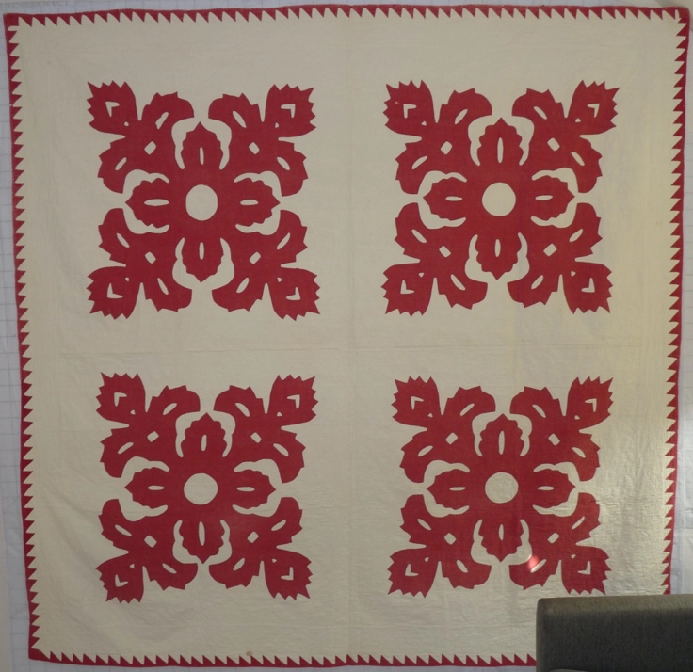 | 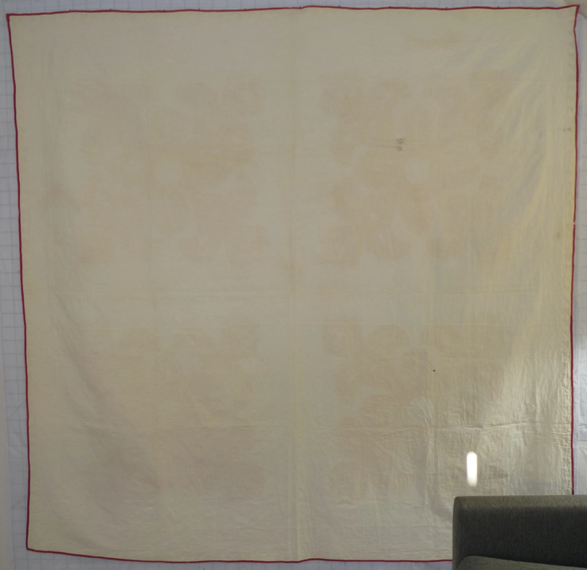

Overview

Acquisition Information
Owner | From Date | To Date | Location | Cost
David Bailey | Dec 20 2021 | -- | Ohio Valley Antique Mall  7285 Route 4 (Dixie Highway)  Fairfield, OH 45014  513 874 7855  www.ohiovalleyantiques.com | $150.00

Display & Publication History
Date | Event | Location / Publication
Nov 18, 2024 | Anchor Bay Quilter’s Guild Meeting | New Baltimore, MI
Oct 7, 2024 | Montcomb County Quilter's Guild Meeting | Trinity Lutheran Church, Clinton Township, MI
Apr 3-7, 2024 | Fisher Farm Quilt Show | 16W680 Old Grand Avenue  Bensenville, IL
 | This 1850’s quilt consists of four appliqued blocks and was found in south-western Ohio. The turkey-red applique pattern is called a cock’s comb and was likely produced using scherenschnitte and reverse applique techniques. The applique was applied by hand. The four blocks were likely assembled using a treadle machine. The batting is a very thin layer of cotton. The appliqued hound’s tooth border also serves as the binding.

General Description
Quilt Title or Name:  4-Block Cockscomb | Date Made: 1865  Exact circa +/- 10 Years  Fabric Dates: 1885+/- 35
Item Type: | Method of Determination:
Length: 78“ x Width: 78“ | This quilt was appraised in  2022.  2026
Additional Information: Other information
----------

History

Provenance
No known provenance.

Quilt Maker
unknown |  | Birth: -- | Death: --
 | - | -

Purpose and Context
Purpose is unknown.

Condition

Flaws
Soiling
Dirty | Stains
Mildew stains | Musty Smell
Discoloration
Running / fugitive color | Faded / bleached color | Crocking
Fabric Damage
Tears / holes | Disintegrating / fall out | Insect damage
Thread bare | Shattering
Sewing / Quilting Damage
Split / open seams | Ties / tufting missing | Embellishments missing
Quilting threads missing | Batting has shifted
Storage Issues
Discoloration from wood | Damage from acid | Fold marks / creases
A few small blood stains and a small dirt stain.
Images for Condition Issues
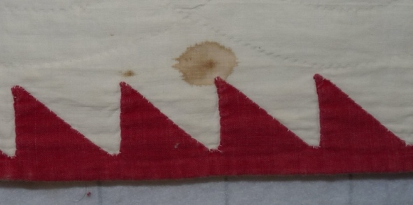 | 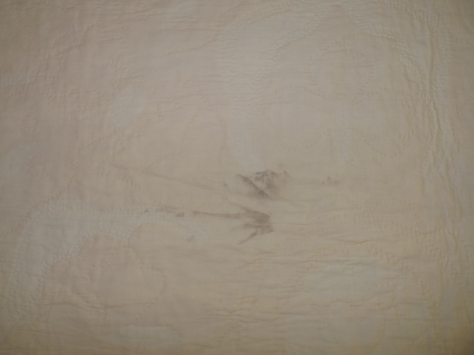

Design & Construction

Quilt Top
Layout Design:
Block Pattern Details
 | 4-Block Format | 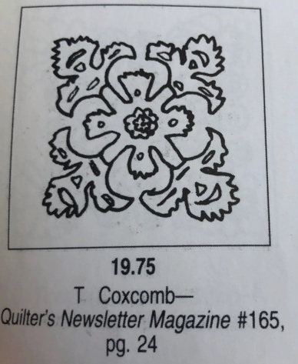
 | T Coxcomb – BB ID 19.75 (Applique)

Embellishments
Applique | Embroidery | Stuffed Work
Button-hole | Cording | Inking
Needle-turn | Beading | Painting
Reverse | Rhinestones / Gems | Marking lines noted
Embellishment Workmanship
Stitches are appropriately small and even.
Edges are as design intends (straight, curved, pointed).
Work demonstrates appropriate skill for intended purpose.
Describe other techniques

Top Assembly
 | Seams are stable | Seams are appropriately aligned
 | Seams are flat | Top has no inappropriate tucks or puckers
 |  | Top lays flat with no overly full areas

Color
Predominant colors
 | Red | Blue | Black
 | Orange | Violet/Purple | Grey
 | Yellow | Brown | White
 | Green | Beige / Tan
Antique Colors
 | Red – claret / wine | Yellow – chrome | Blue – Lancaster
 | Red – madder / cinnamon | Green - chrome | Blue – Prussian / Lafayette
 | Red – turkey | Green – Nile | Brown – madder
 | Pinks - double | Blue – Cadet | Butterscotch
 | Orange - madder | Blue - Indigo | Bronze
 | Orange – cheddar / antimony / chrome |  | Late 1800’s Purple

Materials
Fiber Types
 | Cotton | Silk | Wool
 | Cotton Blend | Linen | Synthetic
 | Not Yet Identified
 | Describe other fibers
Fabric Types
 | Broadcloth | Sateen | Upholstery
 | Flannel | Satin | Chintz
 | Shirting | Muslin | Glazed
 | Suiting | Velvet | Handwoven
 | Denim | Felt | Lindsey-Woolsey
 | Describe other fabrics
Print Types
 | Batik | Floral | Plaid
 | Cheater Panel | Geometric | Solid / Plain
 | Checked / Gingham | Hand-dyed | Stamped
 | Conversation / Novelty | Victorian Mourning Prints | Stripes
 | Dotted | Multiple scraps
 | Feed sack / Feed sack-like | Paisley
 | Describe other print types

Top Inscriptions
Content
Makers names | Initials | Date
Single Name | Message | Place
Multiple Names

Methods
Label | Ink – Ball point | Stencil
Printed onto fabric | Ink – Felt tip | Stamped
Quilted | Ink - Other | Pencil
Embroidery | Applique | Typewriter

Describe location and copy of inscription

Images for Top

Quilt Back
Layout Design:
Back Assembly
 | Seams are stable | Seams are appropriately aligned
 | Seams are flat | Top has no inappropriate tucks or puckers
 |  | Top lays flat with no overly full areas
Color
Predominant colors
 | Red | Blue | Black
 | Orange | Purple | Grey
 | Yellow | Brown | White
 | Green | Beige / Tan
Materials
Sources of Fabric
 | Companies | Designer | Fabric Name & Number
 | Company name | Designer name | Fabric name & code
 | Describe other sources - scraps, cloths, cutter quilts
Fiber Types
 | Cotton | Silk | Wool
 | Cotton Blend | Linen | Synthetic
 | Describe other fibers
Fabric Types
 | Broadcloth | Sateen | Upholstery
 | Flannel | Satin | Chintz
 | Shirting | Muslin | Glazed
 | Suiting | Velvet | Handwoven
 | Denim | Felt | Lindsey-Woolsey
 | Describe other fabrics
Print Types
 | Batik | Floral | Plaid
 | Cheater Panel | Geometric | Solid / Plain
 | Checked / Gingham | Hand-dyed | Stamped
 | Conversation / Novelty | Victorian Mourning Prints | Stripes
 | Dotted | Multiple scraps
 | Feed sack / Feed sack-like | Paisley
 | Describe other print types

Quilting
Stabilization Method:
Quilting Techniques
 | Machine Quilted | Stuffed work | Corded
 | Hand Quilted | Quilt-as-you-go
Quilting Patterns
 | Meander / Free motion | Lines – single parallel | Cables
 | In-the-ditch / To the piece | Lines – double parallel | Feathers
 | Echo / Outlined | Lines – triple parallel | Wreaths
 | Stipple | Grid – crosshatch | Vines
 | Clamshell | Grid – square | Floral
 | Elbow / Fan | Grid - diamond | Leaves
 | Describe other quilting patterns
Batting
 |  | Describe method of determination

Edge Finish
Embellishments
Fringe | Ruffles | Cording
Lace | Ribbon
Techniques
Top Width: 0.00 “ | Binding | Rolled – top to back
Back Width: 0.00“ | Front – machine | Rolled – back to top
 | Front – hand | Knife edge
 | Back – machine | Turned
 | Back - hand
Binding is turkey red. It is likely applied to the back by treadle machine and then rolled to the front where it was hand applied as a hound's tooth applique.

Conservation, Restoration, Repairs
Conservation
Measures to prevent further loss of quality. Examples:
- Stabilized with netting
No conservation measures.

Restoration
Measures to return the item back to similar condition as its original state using vintage materials and techniques. Examples:
- Patched with vintage / period fabrics, not reproductions.
No restoration measures.

Repairs
Measures taken to keep the item usable. Examples:
- Cut down to smaller size.
- Patched with new fabrics
- Rebound
- Tears / holes sewn together
No repair measures.

Images for Conservation / Restoration / Repairs

