Documentation Form

Overview

Acquisition Information
Owner | From Date | To Date | Location | Cost
David Bailey | Dec 21, 2021 | -- | West Chester Antique Center  4924 Union Center Pavilion Dr  West Chester, OH 45069  513 486 2098 | $75.00

Display & Publication History
Date | Event | Location / Publication | Pro-Rated  Reimbursement
-- | -- | -- | ($0.00)

General Description
Quilt Title or Name:  Grandmother's Flower Garden | Date Made: 1935  Exact circa +/- 10 Years  Fabric Date Range: 1935+/10
Item Type: | Method of Determination:
Length: 72“ x Width: 56“ | This quilt was appraised in Year.
Additional Information: Other information

Images
Top | Back
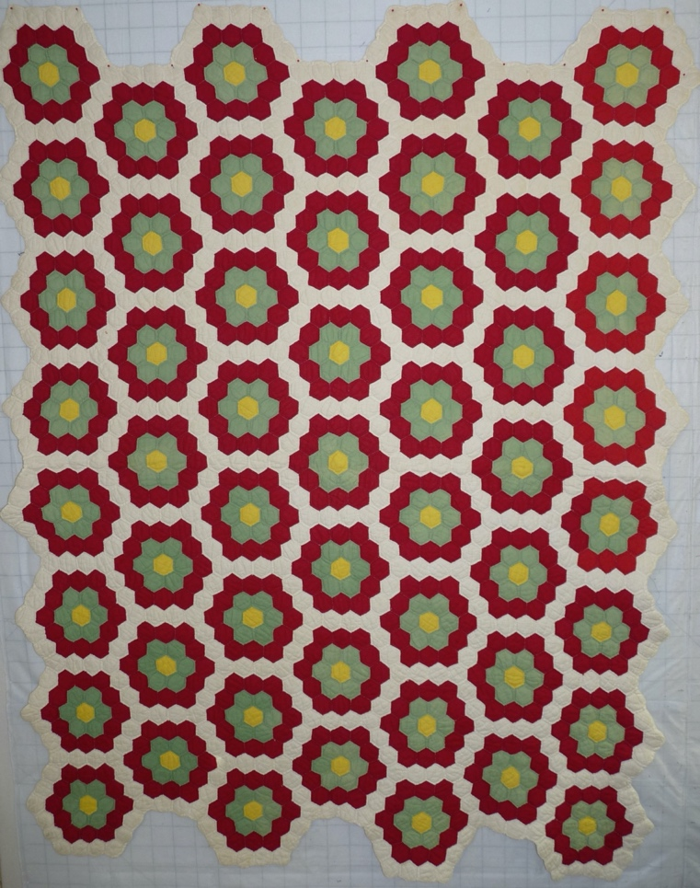 | 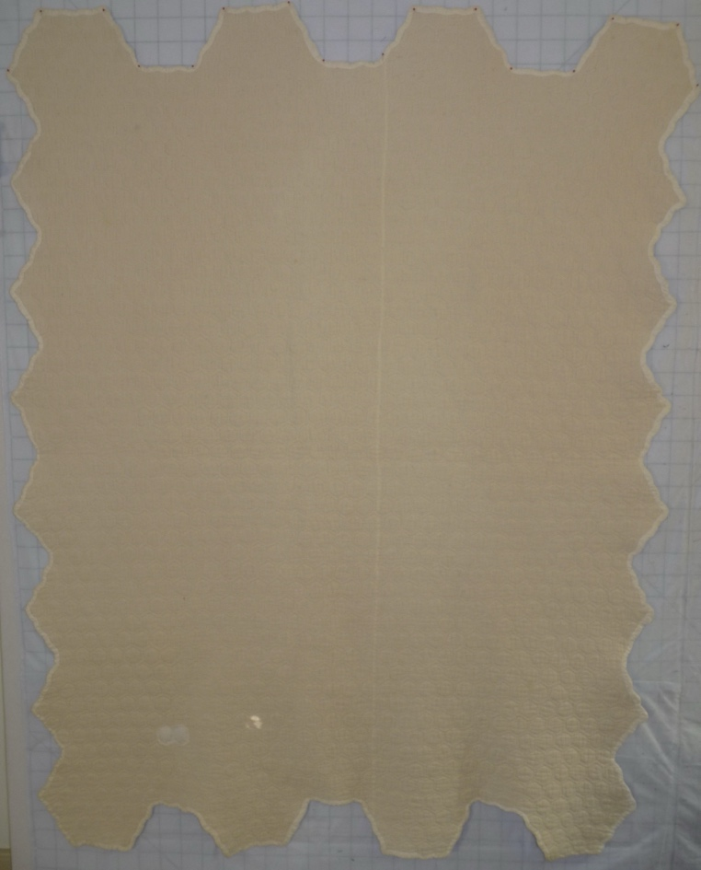
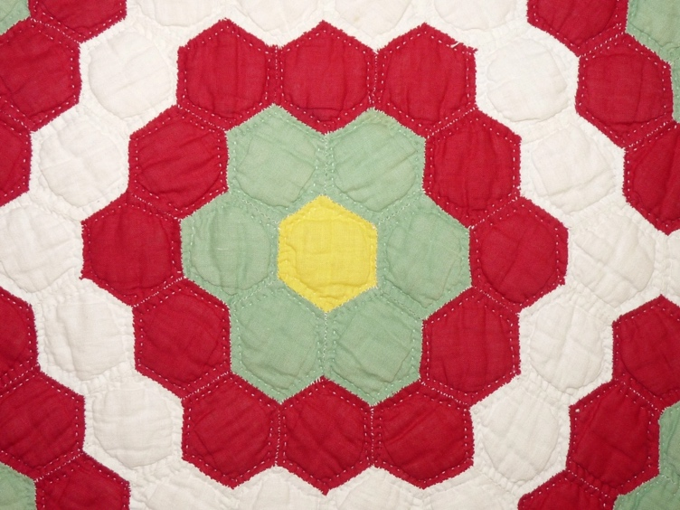

History

Provenance
-

Quilt Maker
Unknown |  | Birth: - | Death: -
 | - | -

Purpose and Context
The quilt's purpose is unkown. It was likely utilitarian.

Condition

Flaws
Soiling
Dirty | Stains
Mildew stains | Musty Smell
Discoloration
Running / fugitive color | Faded / bleached color | Crocking
Fabric Damage
Tears / holes | Disintegrating / fall out | Insect damage
Thread bare | Shattering
Sewing / Quilting Damage
Split / open seams | Ties / tufting missing | Embellishments missing
Quilting threads missing | Batting has shifted
Storage Issues
Discoloration from wood | Damage from acid | Fold marks / creases
Stains are minor Quilt has been used..

Design & Construction

Quilt Top
Layout Design:
 | One Patch Shape Details
 |  |  | Hexagons ~1.5" edge to edge
 | Block Pattern Details
 |  | Pattern source | 
 |  | Grandmother's Flower Garden, BB ID 160k
Piecing Techniques
 |  | Machine pieced | String / Improvisational piecing
 |  | Hand pieced | Foundation piecing
 |  | Strip piecing | English paper piecing
 |  | Describe other piecing techniques
 | Piecing Workmanship
 |  | Seams are stable | Seams are appropriately aligned
 |  | Seams are flat | Points are sharp
 |  | Describe piecing workmanship

Color
Predominant colors
 | Red | Blue | Black
 | Orange | Violet/Purple | Grey
 | Yellow | Brown | White
 | Green | Beige / Tan
Antique Colors
 | Red – claret / wine | Yellow – chrome | Blue – Lancaster
 | Red – madder / cinnamon | Green - chrome | Blue – Prussian / Lafayette
 | Red – turkey | Green – Nile | Brown – madder
 | Pinks - double | Blue – Cadet | Butterscotch
 | Orange - madder | Blue - Indigo | Bronze
 | Orange – cheddar / antimony / chrome |  | Late 1800’s Purple

Materials
Sources of Fabric
 | Companies | Designer | Fabric Name & Number
 | unknown | unknown | unknown
 | --
Fiber Types
 | Cotton | Silk | Wool
 | Cotton Blend | Linen | Synthetic
 | Not Yet Identified
 | Describe other fibers

Quilt Back
Layout Design:

Back Assembly
 | Seams are stable | Seams are appropriately aligned
 | Seams are flat | Top has no inappropriate tucks or puckers
 |  | Top lays flat with no overly full areas
Color
Predominant colors
 | Red | Blue | Black
 | Orange | Purple | Grey
 | Yellow | Brown | White
 | Green | Beige / Tan

Materials
Fiber Types
 | Cotton | Silk | Wool
 | Cotton Blend | Linen | Synthetic
 | Backing appears to be a loose weave cotton - almost feedsack like.

Quilting
Stabilization Method:
Quilting Techniques
 | Machine Quilted | Stuffed work | Corded
 | Hand Quilted | Quilt-as-you-go
Quilting Patterns
 | 1/4" to the piece.
Batting
 |  | Flop test

Edge Finish
Embellishments
Fringe | Ruffles | Cording
Lace | Ribbon
Techniques
Top Width: 0.00 “ | Binding | Rolled – top to back
Back Width: 0.00“ | Front – machine | Rolled – back to top
 | Front – hand | Knife edge
 | Back – machine | Turned
 | Back - hand
Describe binding

Images for Edge
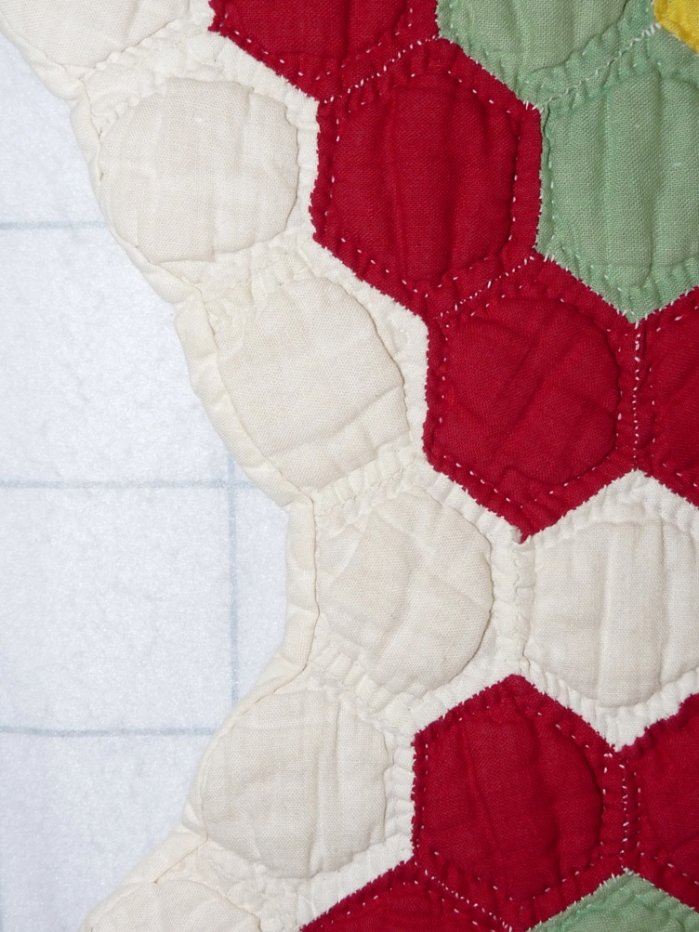 | 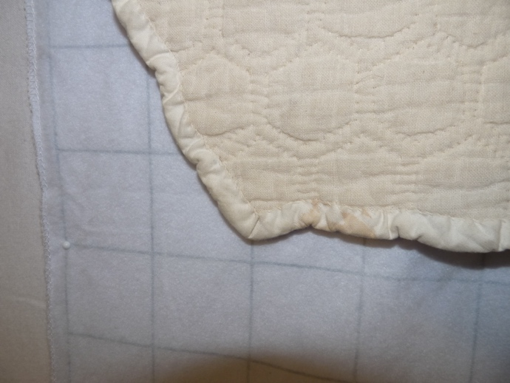

Conservation, Restoration, Repairs
Conservation
Measures to prevent further loss of quality. Examples:
- Stabilized with netting
No conservation measures taken.

Restoration
Measures to return the item back to similar condition as its original state using vintage materials and techniques. Examples:
- Patched with vintage / period fabrics, not reproductions.
No restoration measures taken.

Repairs
Measures taken to keep the item usable. Examples:
- Cut down to smaller size.
- Patched with new fabrics
- Rebound
- Tears / holes sewn together
There is a patch repair on the back of the quilt. It is not clear if it was to repair a hole on the back of the quilt or if this was used to allow access to the top for a repair. The repair outlines pieces on the top.

Images for Conservation / Restoration / Repairs
