Documentation Form

Overview

Acquisition Information
Owner | From Date | To Date | Location | Cost
David Bailey | July, 2024 | -- | Naperville, IL | $0.00

Display & Publication History
Date | Event | Location / Publication | Pro-Rated  Reimbursement
- | - | - | ($0.00)

General Description
Quilt Title or Name:  Fox and Geese Blocks | Fabric Date Range: 1870  Exact circa +/- 10 Years
Item Type:  3 blocks | Method of Determination:
Length: 9“ x Width: 9“ | This quilt was appraised in Year.
Additional Information: Hand Stitched

Images
Top | Back
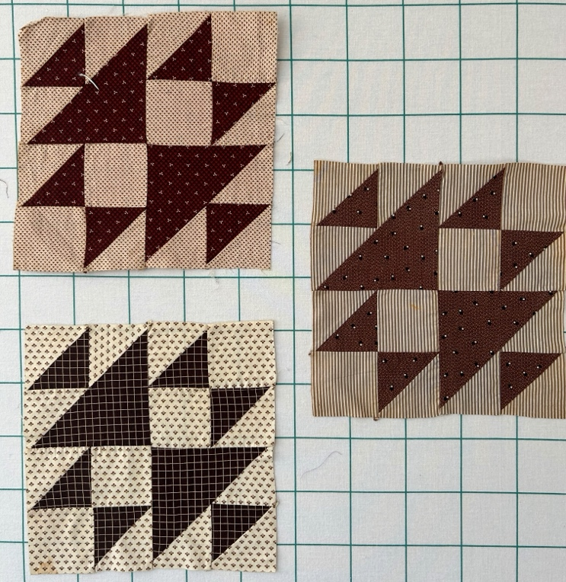 | 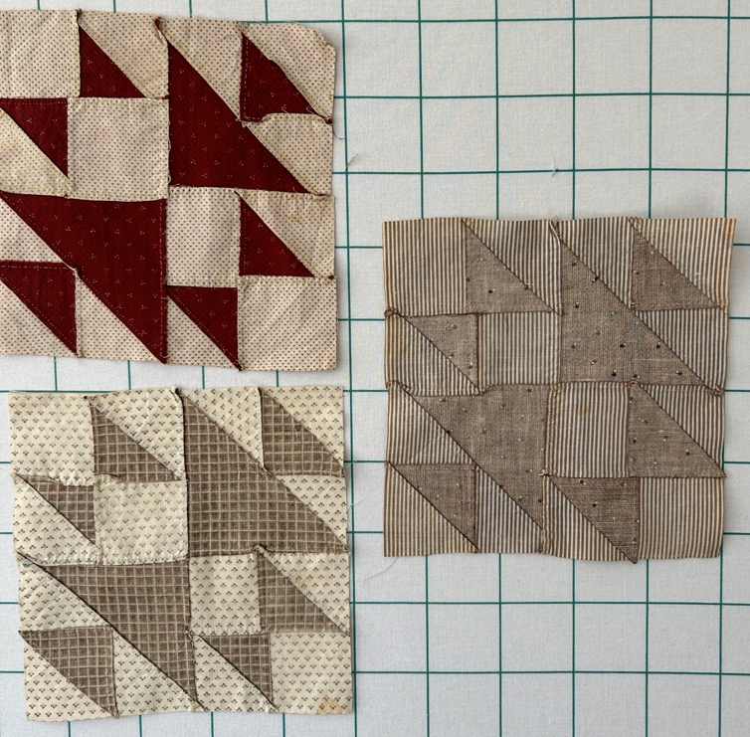
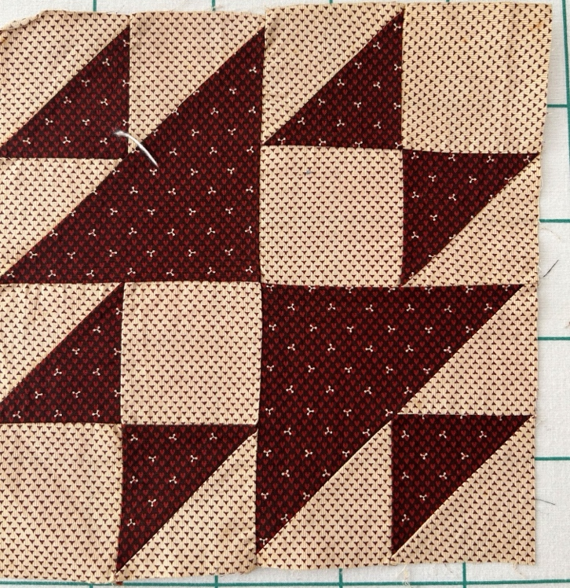 | 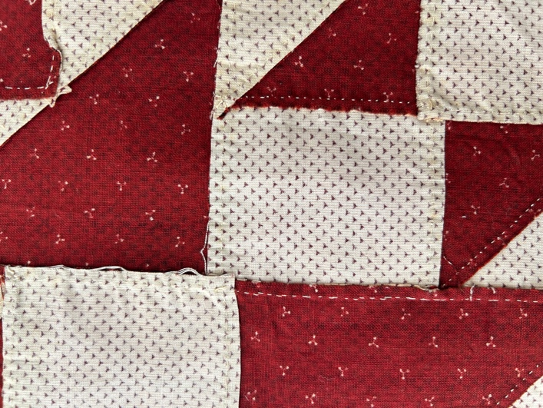
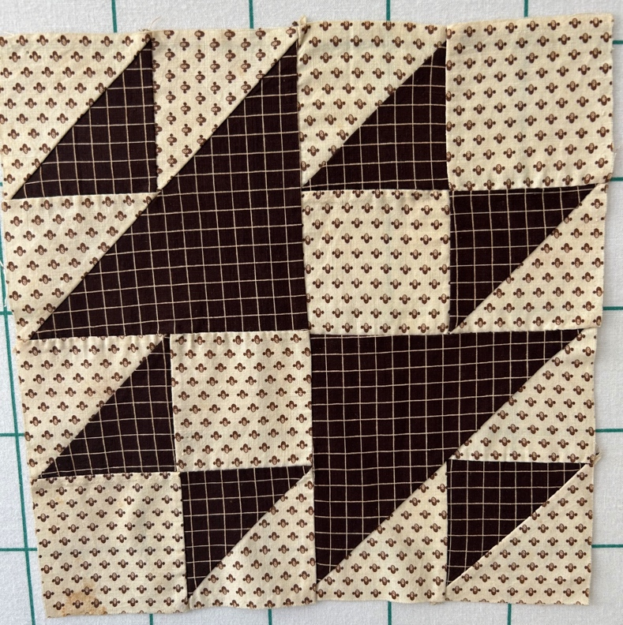
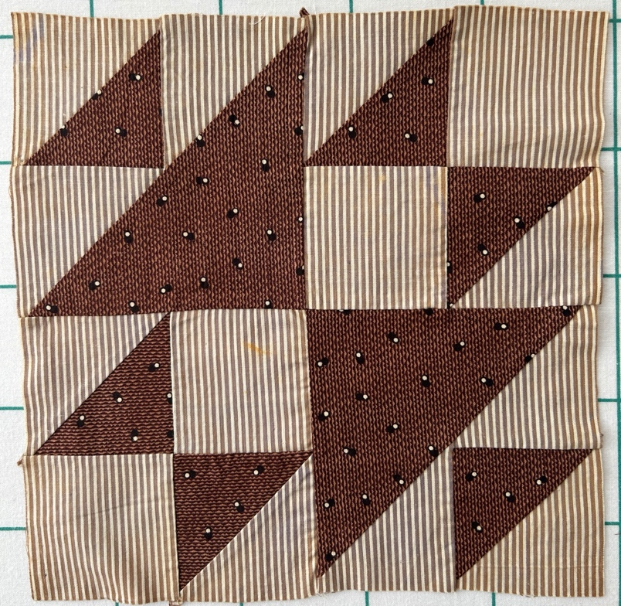

History

Provenance
Given to me by Chris Moline from an unknown appraiser who is retiring.

Quilt Maker
Unknown

Condition

Flaws
Soiling
Dirty | Stains
Mildew stains | Musty Smell
Discoloration
Running / fugitive color | Faded / bleached color | Crocking
Fabric Damage
Tears / holes | Disintegrating / fall out | Insect damage
Thread bare | Shattering
Sewing / Quilting Damage
Split / open seams | Ties / tufting missing | Embellishments missing
Quilting threads missing | Batting has shifted
Storage Issues
Discoloration from wood | Damage from acid | Fold marks / creases
One small orange/rust stain. One fabric (striped background) was a fugitve purple.

Images for Condition Issues
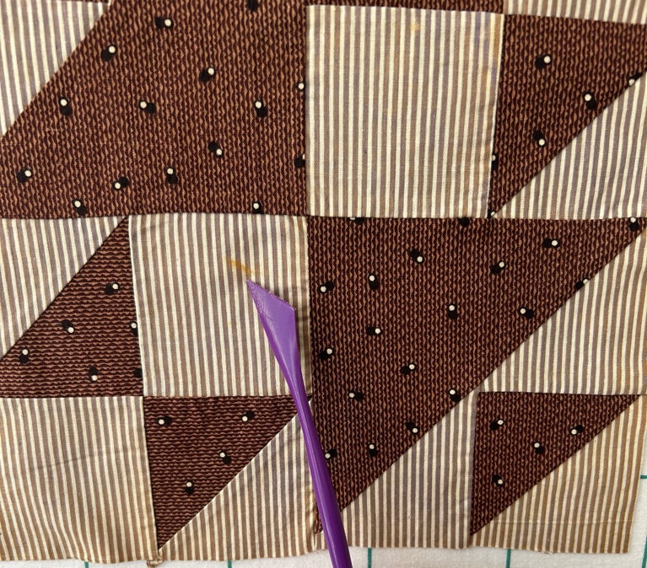 | 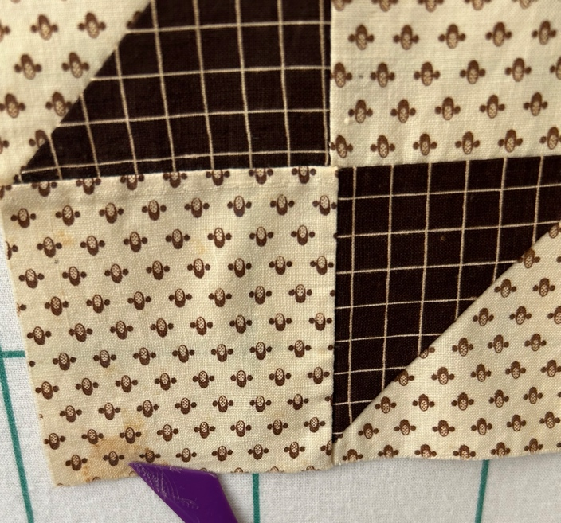
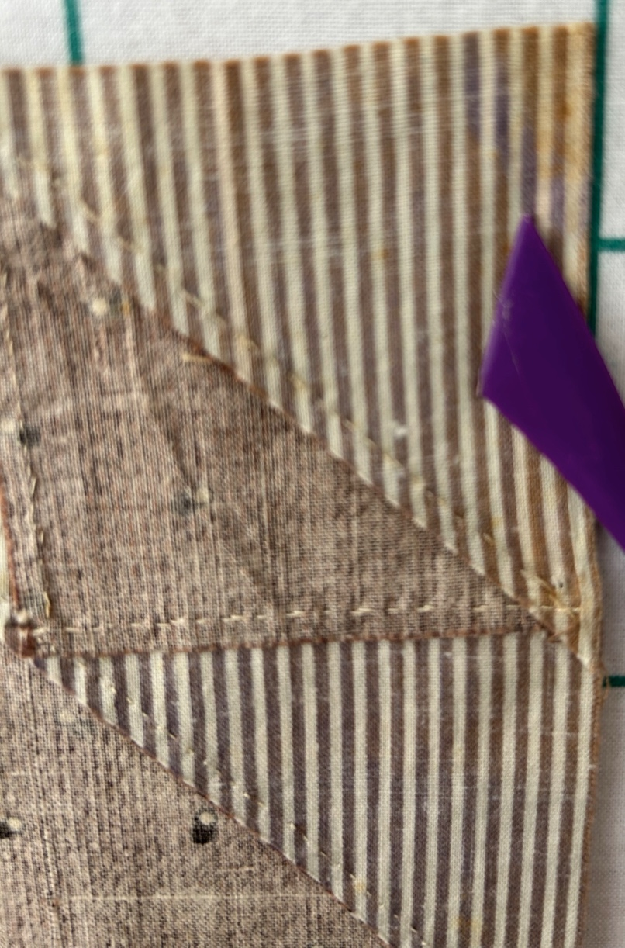

Design & Construction

Quilt Top
Layout Design:
 | Grid & Contained Crazy Details
 |  |  | Grid Dimensions: Length 0 x Width: 0
 |  |  | Block Size: Length: 9“ x Width: 9“
 | Block Pattern Details
 |  | Source unknown: | 
 |  | 1316a - Fox and Geese
Piecing Techniques
 |  | Machine pieced | String / Improvisational piecing
 |  | Hand pieced | Foundation piecing
 |  | Strip piecing | English paper piecing
 |  | Describe other piecing techniques
 | Piecing Workmanship
 |  | Seams are stable | Seams are appropriately aligned
 |  | Seams are flat | Points are sharp
 |  | Describe piecing workmanship

Embellishments
Applique | Embroidery | Stuffed Work
Button-hole | Cording | Inking
Needle-turn | Beading | Painting
Reverse | Rhinestones / Gems | Marking lines noted
Embellishment Workmanship
Stitches are appropriately small and even.
Edges are as design intends (straight, curved, pointed).
Work demonstrates appropriate skill for intended purpose.
Describe other techniques

Color
Predominant colors
 | Red | Blue | Black
 | Orange | Violet/Purple | Grey
 | Yellow | Brown | White
 | Green | Beige / Tan
Antique Colors
 | Red – claret / wine | Yellow – chrome | Blue – Lancaster
 | Red – madder / cinnamon | Green - chrome | Blue – Prussian / Lafayette
 | Red – turkey | Green – Nile | Brown – madder
 | Pinks - double | Blue – Cadet | Butterscotch
 | Orange - madder | Blue - Indigo | Bronze
 | Orange – cheddar / antimony / chrome |  | Late 1800’s Purple

Materials
Sources of Fabric
 | Companies | Designer | Fabric Name & Number
 | Company name | Designer name | Fabric name & code
 | Describe other sources - scraps, cloths, cutter quilts
Fiber Types
 | Cotton | Silk | Wool
 | Cotton Blend | Linen | Synthetic
 | Not Yet Identified
 | Describe other fibers
Fabric Types
 | Broadcloth | Sateen | Upholstery
 | Flannel | Satin | Chintz
 | Shirting | Muslin | Glazed
 | Suiting | Velvet | Handwoven
 | Denim | Felt | Lindsey-Woolsey
 | Describe other fabrics
Print Types
 | Batik | Floral | Plaid
 | Cheater Panel | Geometric | Solid / Plain
 | Checked / Gingham | Hand-dyed | Stamped
 | Conversation / Novelty | Victorian Mourning Prints | Stripes
 | Dotted | Multiple scraps
 | Feed sack / Feed sack-like | Paisley
 | Describe other print types

Conservation, Restoration, Repairs
Conservation
Measures to prevent further loss of quality. Examples:
- Stabilized with netting
Describe conversation measures

Restoration
Measures to return the item back to similar condition as its original state using vintage materials and techniques. Examples:
- Patched with vintage / period fabrics, not reproductions.
Describe restoration measures

Repairs
Measures taken to keep the item usable. Examples:
- Cut down to smaller size.
- Patched with new fabrics
- Rebound
- Tears / holes sewn together
Describe repair measures

Images for Conservation / Restoration / Repairs

