Documentation Form

Images
Top | Back
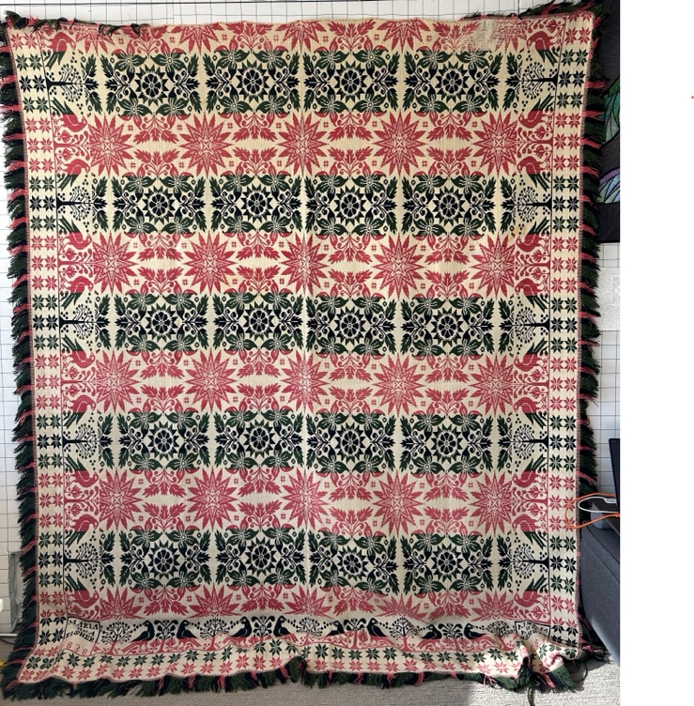 | 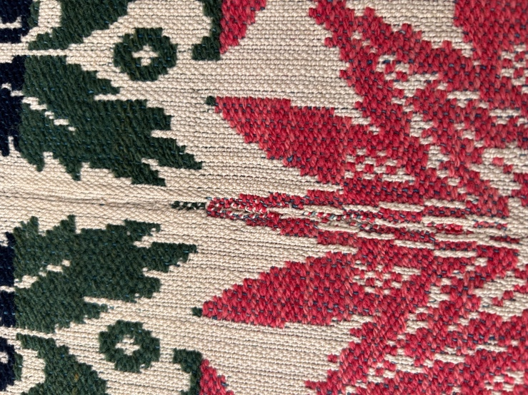
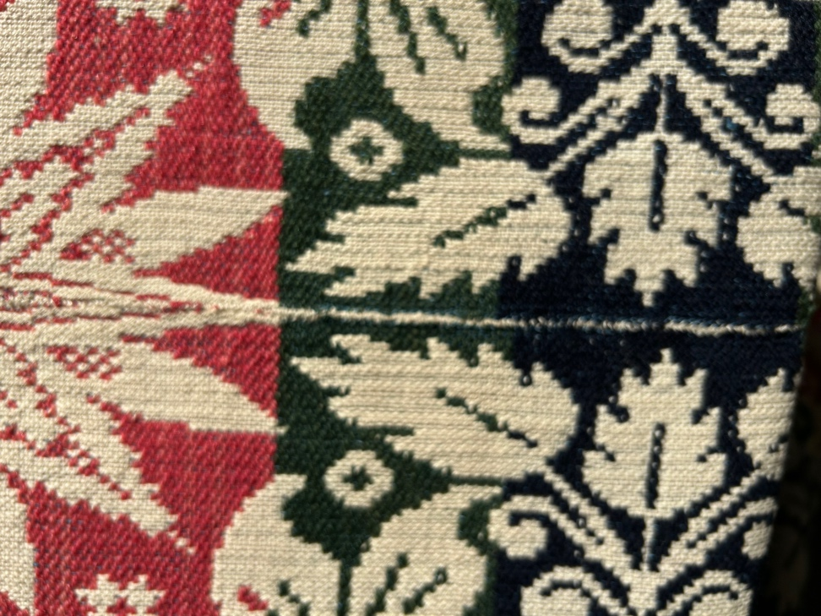 | 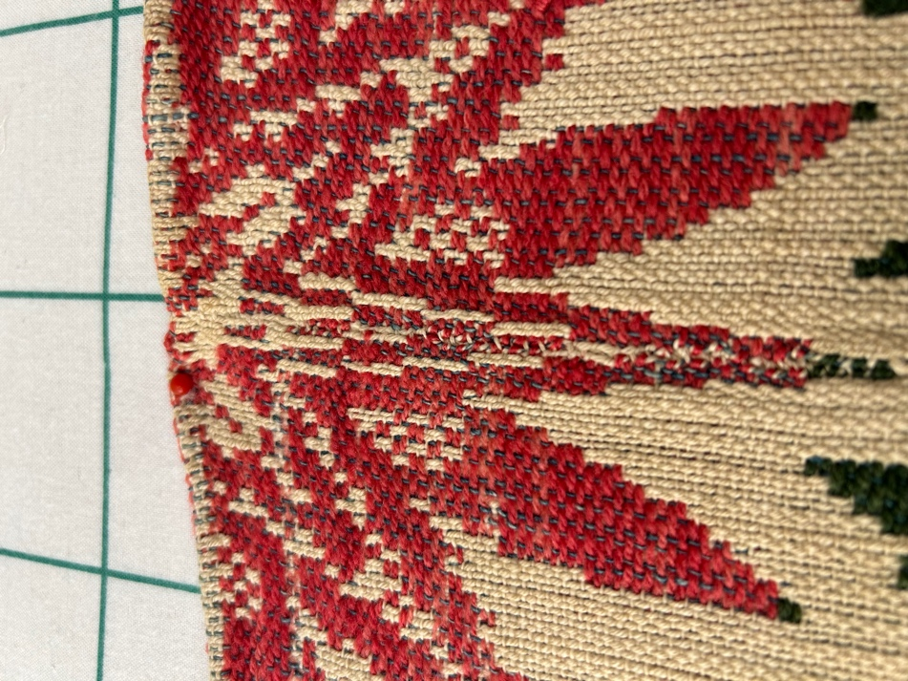
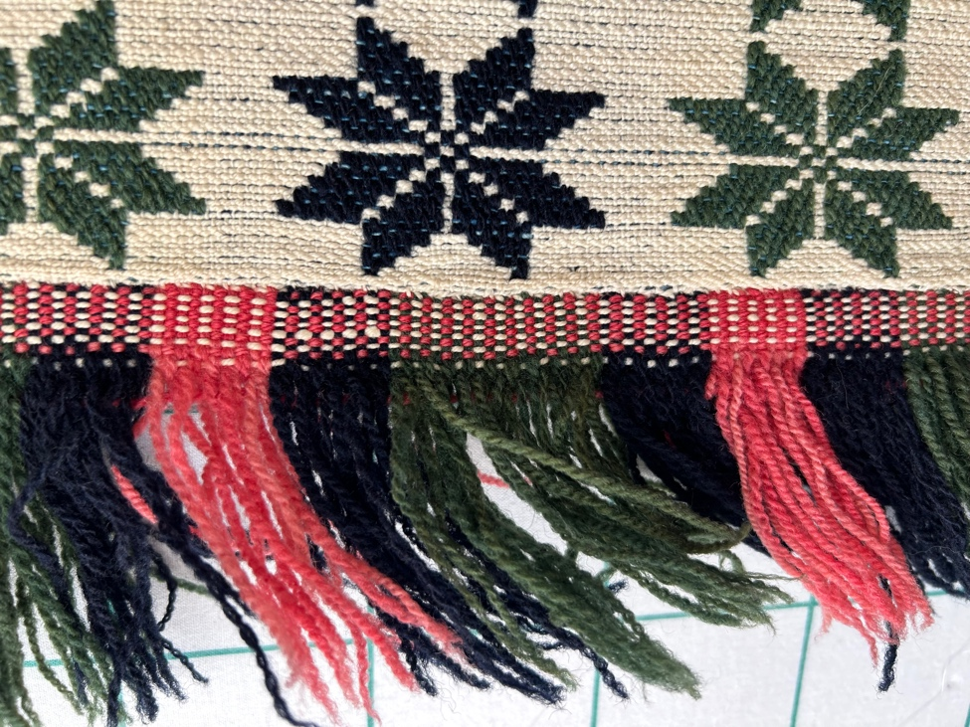 | 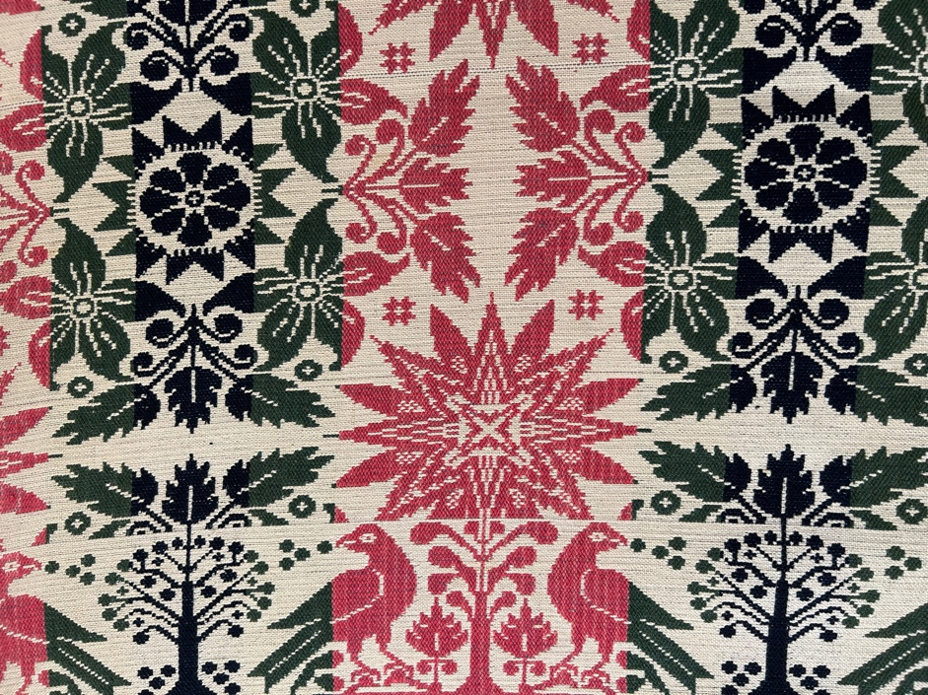
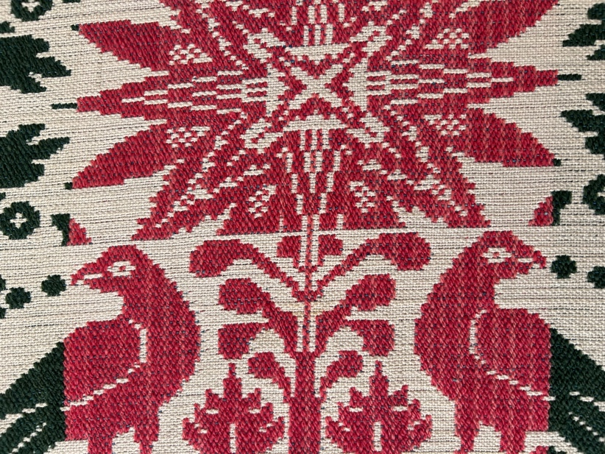

Overview

Acquisition Information
Owner | From Date | To Date | Location | Cost
David Bailey | October 22, 2024 | - | The Antique Market of Michigan City, Inc. | $300.00

Display & Publication History
Date | Event | Location / Publication
Nov 18, 2024 | Anchor Bay Quilter’s Guild Meeting | New Baltimore, MI
Oct 7, 2024 | Montcomb County Quilter's Guild Meeting | Trinity Lutheran Church, Clinton Township, MI

General Description
Quilt Title or Name:  Ann Marie Fisher Coverlet | Date Made: 1838  Exact circa +/- 0 Years
Item Type: | Method of Determination:
Length: 83“ x Width: 99“ | This quilt was appraised in Year.  Researched Information  Appraisal
Additional Information: This is a woven coverlet. The date is determined by the date woven into the coverlet. Note the research file link above. This is the basis for attributing the weaving of this coverlet to Henry Philby (Philpy).
Notes that may be relevant. The pattern shown in the research file is not exactly that shown in the research file. The stars in this coverlet are red and white. There is a third color in the stars shown in the research file. I am assuming that Philby is still the weaver because the rest of the patterns is so similar.
The fringe on my coverlet is not part of the orginally woven fibers. It appears to have been made and then attached after the two halves were assembled.

History

Provenance
This coverlet was found at an antique mall in Michigan City, IN in Booth #1. The note associated with the coverlet read, "1838 Pennsylvania Coverlet 82" x 100" Woven for Ann Maria Fisher by Henry Philby in Lebanon County Pennsylvania - "Double Lilies and Sunburst" pattern in multi color weave. This coverlet pattern can be found on page 66 in the book Amer Coverlet & Weavers."
The name Marie Ann Fisher is woven into the Coverlet. I did not find the name of the weaver.

Construction notes: The quilt appears to have been woven as two pieces. Both pieces used the same pattern and then they were sewn together. The seam can be best observed down the center when looking at the back of the quilt.

Weaver
Henry Philby? | Birth: - | -

Condition

Flaws
Soiling
Dirty | Stains
Mildew stains | Musty Smell
Discoloration
Running / fugitive color | Faded / bleached color | Crocking
Fabric Damage
Tears / holes | Disintegrating / fall out | Insect damage
Thread bare | Shattering
Sewing / Quilting Damage
Split / open seams | Ties / tufting missing | Embellishments missing
Quilting threads missing | Batting has shifted
Storage Issues
Discoloration from wood | Damage from acid | Fold marks / creases
There are a few minor stains and small hole or two near the top edge.
Images for Condition Issues
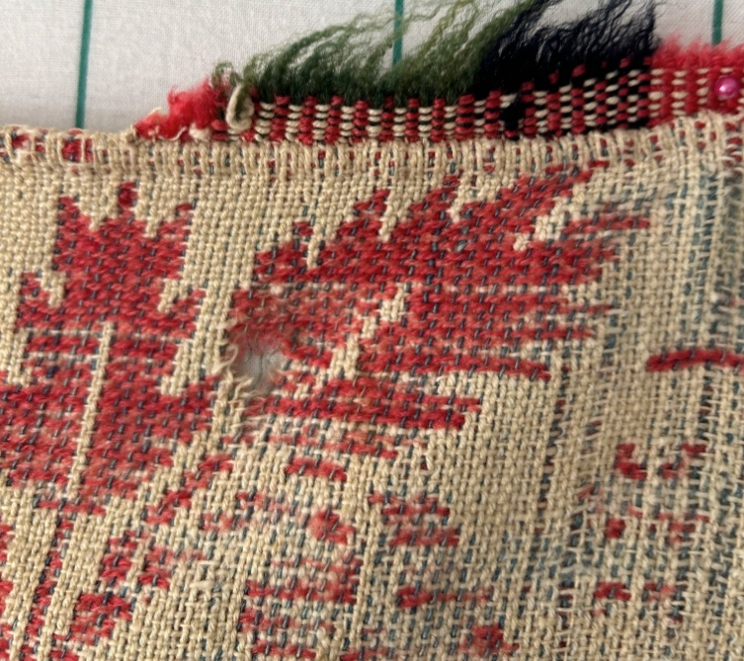 | 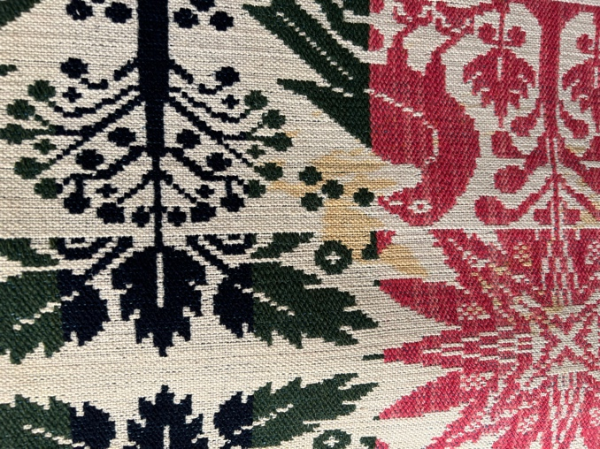

Coverlet Top
26 warp strands / inch. 21 weft strands /inch.

Color
Predominant colors
 | Red |  | Blue | Black
 | Orange |  | Violet/Purple | Grey
 | Yellow |  | Brown | White
 | Green |  | Beige / Tan
Fiber Types
 |  | Cotton | Silk | Wool
 |  | Cotton Blend | Linen | Synthetic
 |  | Not Yet Identified
 |  | I am not clear about the fibers. My guess is that it is a combination of fibers – wool and either cotton or linen. There are 26 warp strands per inch and about 24 weft strands per inch.

Inscriptions
Content
Makers names | Initials | Date
Single Name | Message | Place
Multiple Names

Methods
Label | Ink – Ball point | Stencil
Printed onto fabric | Ink – Felt tip | Stamped
Quilted | Ink - Other | Pencil
Embroidery | Applique | Typewriter

Owner's name and date. The weaver's name has not been found on the coverlet.

Images for Top
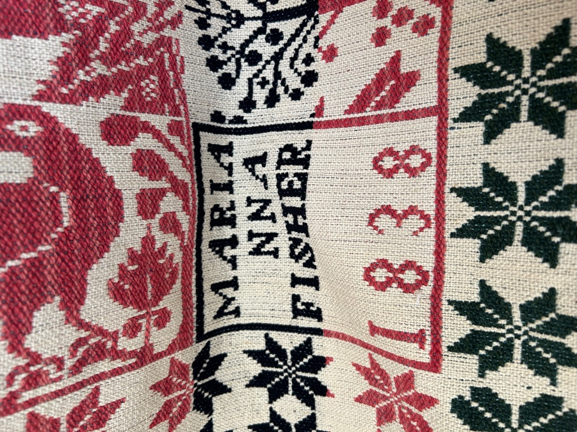

Edge Finish
Embellishments
Fringe | Ruffles |  | Cording
Lace | Ribbon

Conservation, Restoration, Repairs
Conservation
Measures to prevent further loss of quality. Examples:
- Stabilized with netting
Describe conversation measures

Restoration
Measures to return the item back to similar condition as its original state using vintage materials and techniques. Examples:
- Patched with vintage / period fabrics, not reproductions.
Describe restoration measures

Repairs
Measures taken to keep the item usable. Examples:
- Cut down to smaller size.
- Patched with new fabrics
- Rebound
- Tears / holes sewn together
Describe repair measures

Images for Conservation / Restoration / Repairs

