Documentation Form

Overview

Acquisition Information
Owner | From Date | To Date | Location | Cost
David Bailey | July, 2024 | - | Naperville, IL | $0.00

Display & Publication History
Date | Event | Location / Publication
Nov 18, 2024 | Anchor Bay Quilter’s Guild Meeting | New Baltimore, MI
Oct 7, 2024 | Montcomb County Quilter's Guild Meeting | Trinity Lutheran Church, Clinton Township, MI

General Description
Quilt Title or Name:  Madder Brown Fabric - 3 pieces | Date Made: 1865  Exact circa +/- 10 Years
Item Type: | Method of Determination:
Length: 73“ x Width: 11“ | This quilt was appraised in Year.
Additional Information: This piece of fabric was likely cut off fabric used to back a quilt. There is machine stitching along one edge. Each piece is about 11” wide. The shorter piece is about 65” long. The two longer pieces are about 73” long.

Images
Top | Back
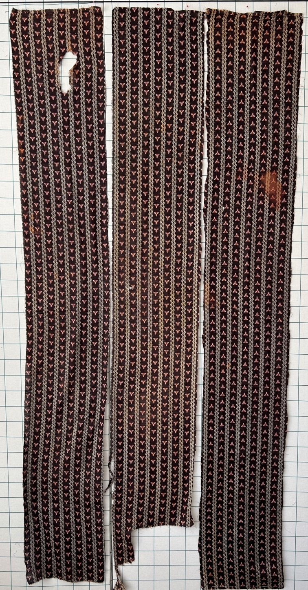 | 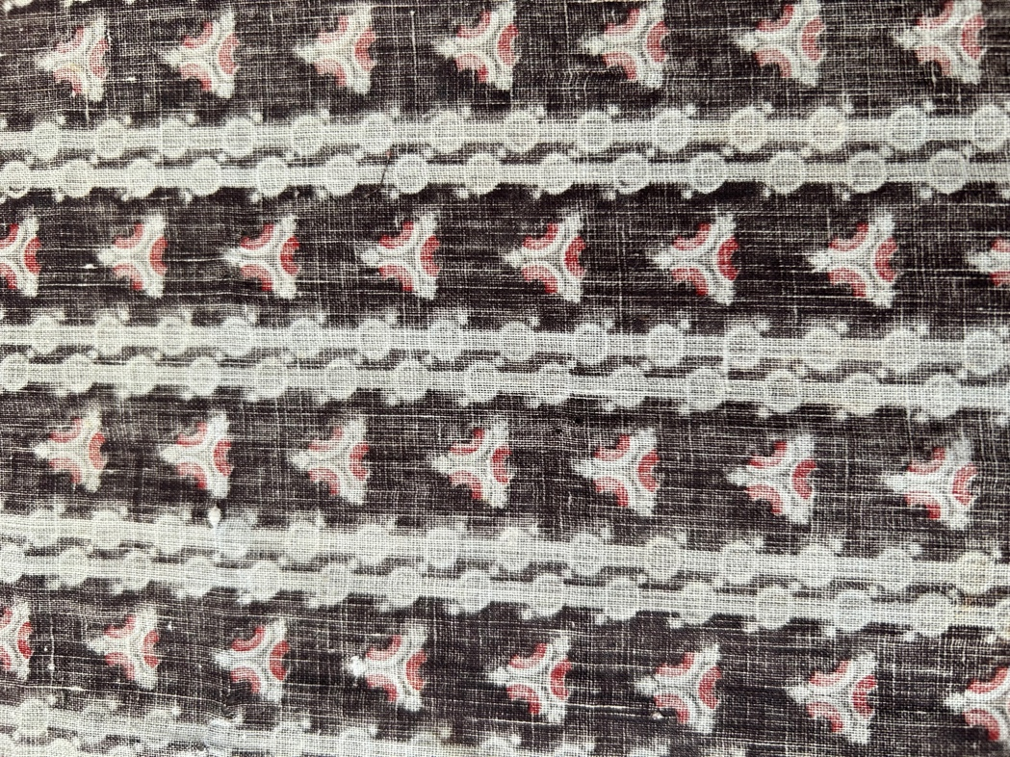
Close Up Front | Close Up Back
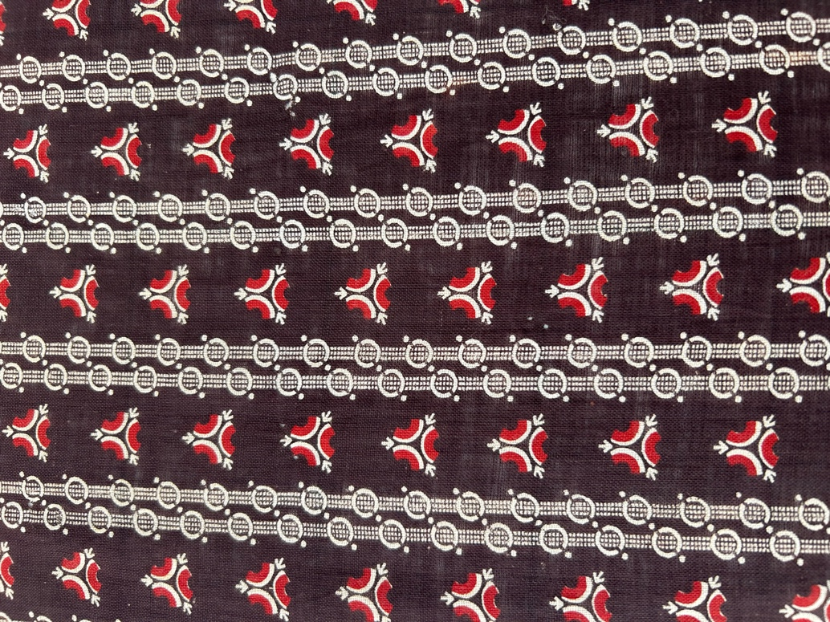 | 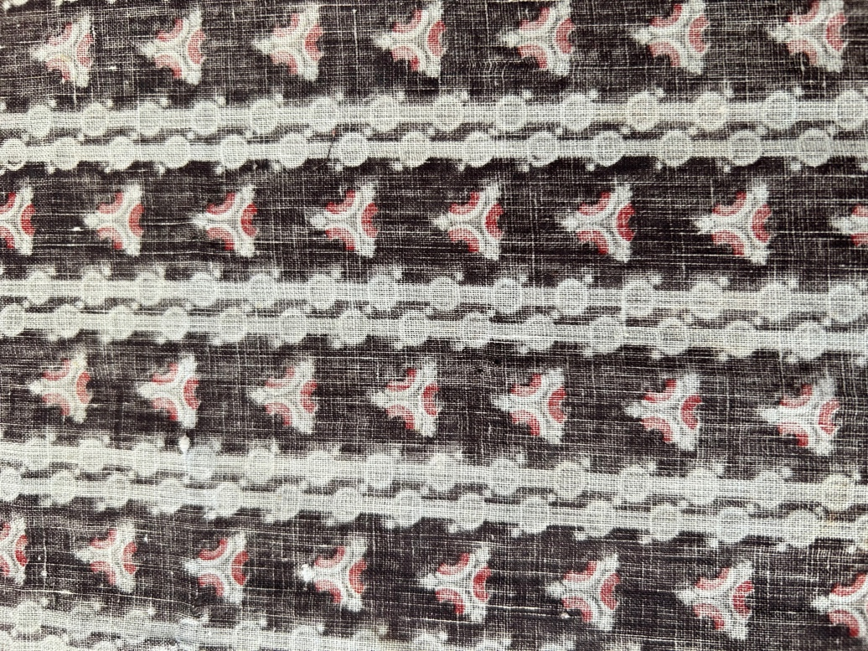

History

Condition

Flaws
Soiling
Dirty | Stains
Mildew stains | Musty Smell
Discoloration
Running / fugitive color | Faded / bleached color | Crocking
Fabric Damage
Tears / holes | Disintegrating / fall out | Insect damage
Thread bare | Shattering
Sewing / Quilting Damage
Split / open seams | Ties / tufting missing | Embellishments missing
Quilting threads missing | Batting has shifted
Storage Issues
Discoloration from wood | Damage from acid | Fold marks / creases
-
Images for Condition Issues
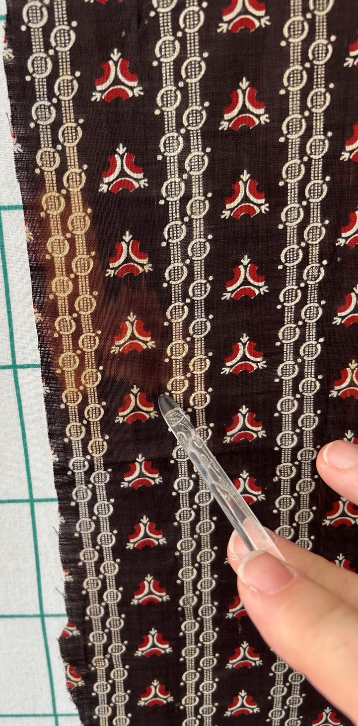 | 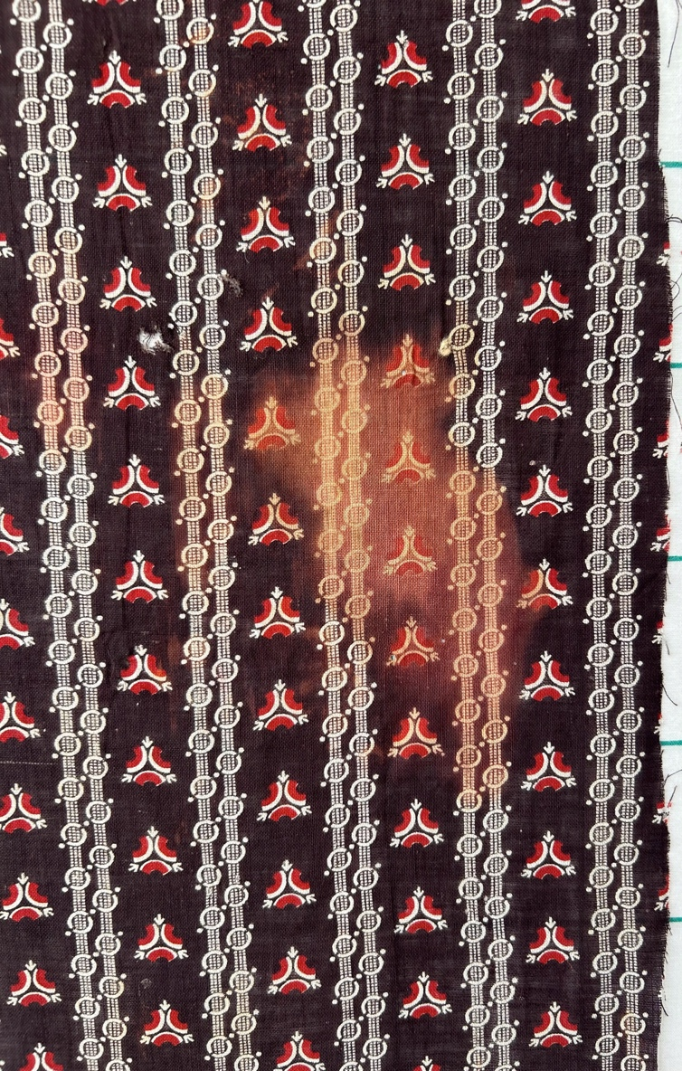
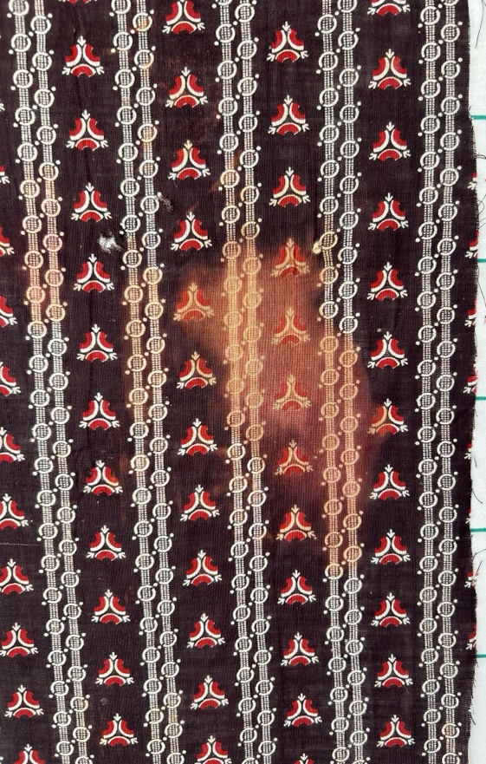 | 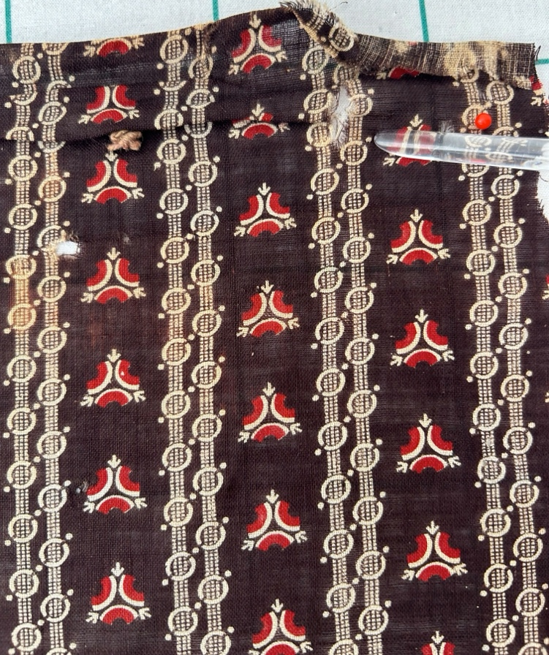
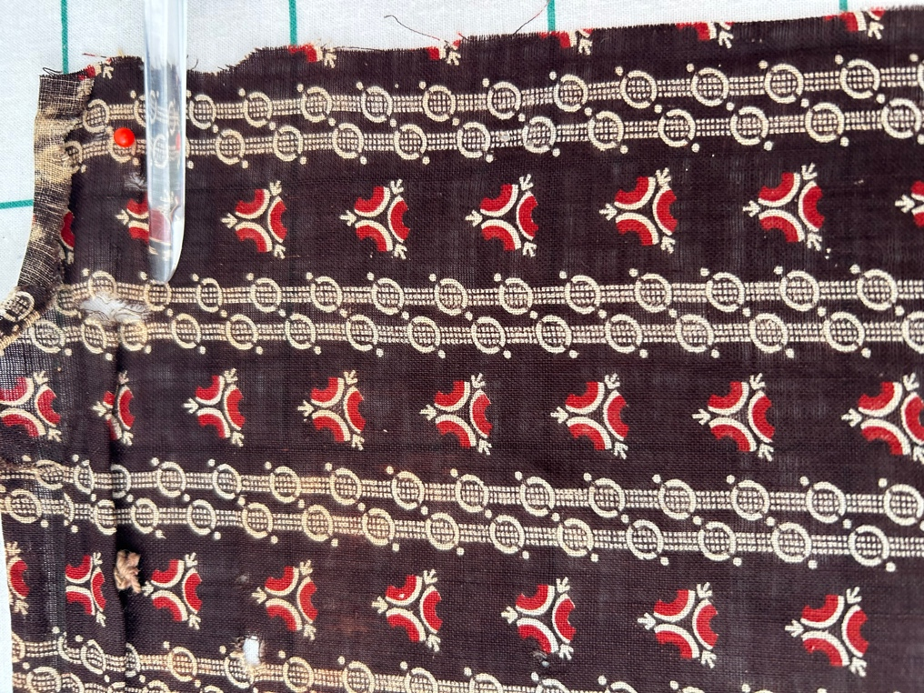 | 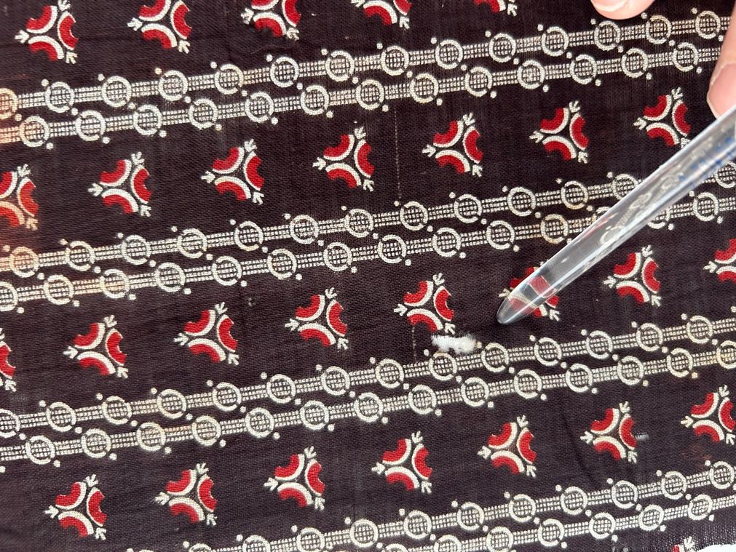

Design & Construction
Color
Predominant colors
 | Red | Blue | Black
 | Orange | Violet/Purple | Grey
 | Yellow | Brown | White
 | Green | Beige / Tan
Antique Colors
 | Red – claret / wine | Yellow – chrome | Blue – Lancaster
 | Red – madder / cinnamon | Green - chrome | Blue – Prussian / Lafayette
 | Red – turkey | Green – Nile | Brown – madder
 | Pinks - double | Blue – Cadet | Butterscotch
 | Orange - madder | Blue - Indigo | Bronze
 | Orange – cheddar / antimony / chrome |  | Late 1800’s Purple

Materials
Sources of Fabric
 | Companies | Designer | Fabric Name & Number
 | - | - | -
Fiber Types
 | Cotton | Silk | Wool
 | Cotton Blend | Linen | Synthetic
 | Not Yet Identified
 | Describe other fibers
Fabric Types
 | Broadcloth | Sateen | Upholstery
 | Flannel | Satin | Chintz
 | Shirting | Muslin | Glazed
 | Suiting | Velvet | Handwoven
 | Denim | Felt | Lindsey-Woolsey
 | Describe other fabrics
Print Types
 | Batik | Floral | Plaid
 | Cheater Panel | Geometric | Solid / Plain
 | Checked / Gingham | Hand-dyed | Stamped
 | Conversation / Novelty | Victorian Mourning Prints | Stripes
 | Dotted | Multiple scraps
 | Feed sack / Feed sack-like | Paisley
 | Describe other print types

