Documentation Form

Overview

Acquisition Information
Owner | From Date | To Date | Location | Cost
David Bailey | July 2024 |  | Naperville, IL | $0.00

Display & Publication History
Date | Event | Location / Publication
Nov 18, 2024 | Anchor Bay Quilter’s Guild Meeting | New Baltimore, MI
Oct 7, 2024 | Montcomb County Quilter's Guild Meeting | Trinity Lutheran Church, Clinton Township, MI

General Description
Quilt Title or Name:  Home Woven Indigo Geometric | Date Made: 1815  Exact circa +/- 15 Years
Item Type: | Method of Determination:
Length: 28“ x Width: 15“ | This quilt was appraised in Year.
Additional Information: Woven cloth like this was frequently produced in the early 1800’s. Here the fibers are dyed with indigo on white grounds. Weavers would move from home to home and weave cloth for the household in terms for room, board, and new fiber to weave.

Images
Top
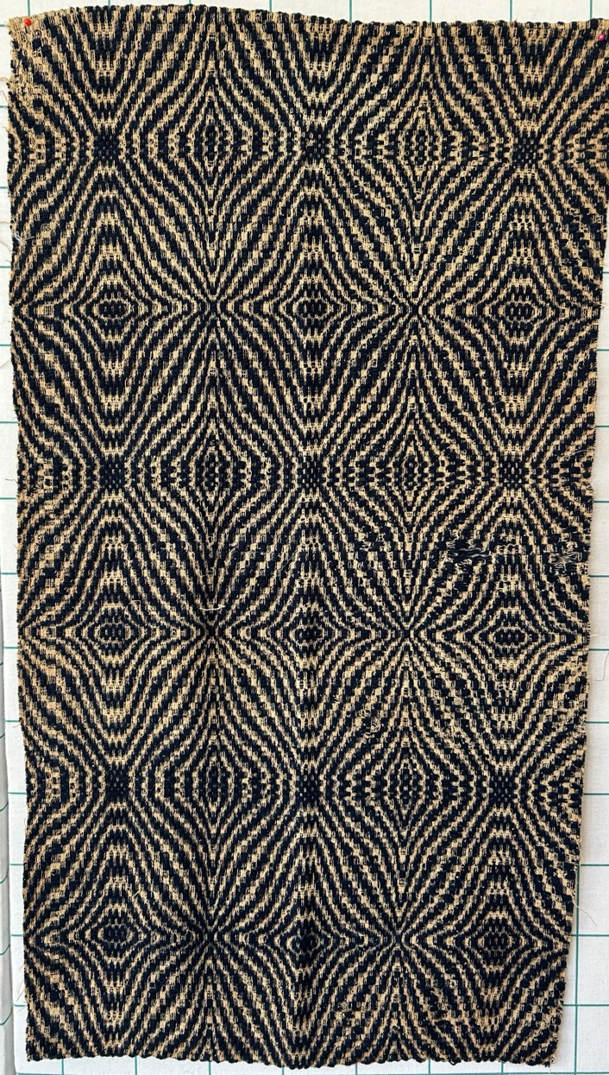

History

Provenance
This cloth was given to me by Chris Moline from a unknown appraiser who was retiring from the business. The weaver is unknown.
A note was attached to this piece - hand written. Carded, spun, dyed and woven by great, great grandmother in the Calhoun family about 100 years ago (1810.)

Condition

Flaws
Soiling
Dirty | Stains
Mildew stains | Musty Smell
Discoloration
Running / fugitive color | Faded / bleached color | Crocking
Fabric Damage
Tears / holes | Disintegrating / fall out | Insect damage
Thread bare | Shattering
Sewing / Quilting Damage
Split / open seams | Ties / tufting missing | Embellishments missing
Quilting threads missing | Batting has shifted
Storage Issues
Discoloration from wood | Damage from acid | Fold marks / creases
No additional comments.

Images for Condition Issues
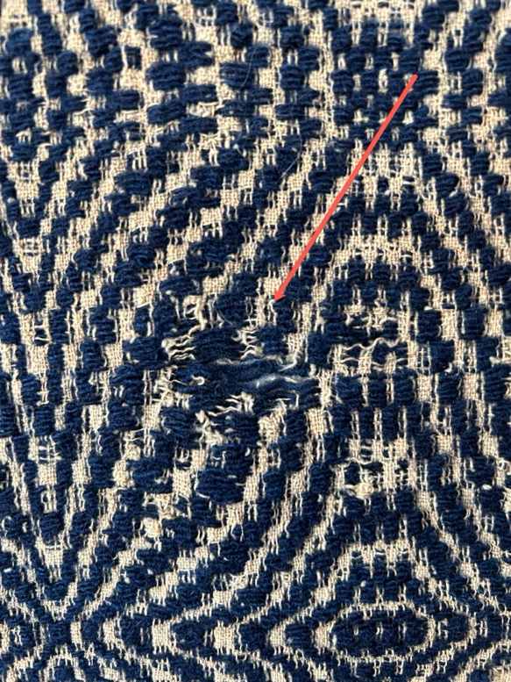 | 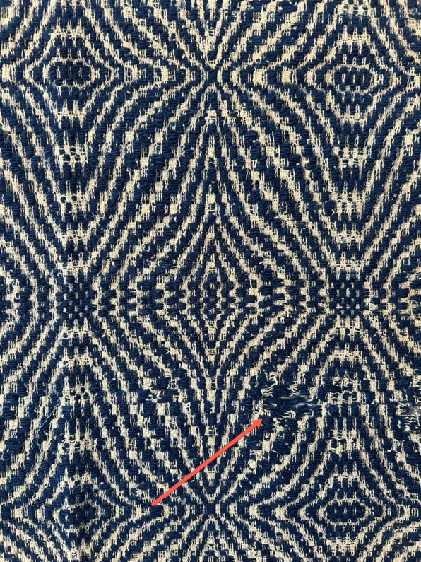
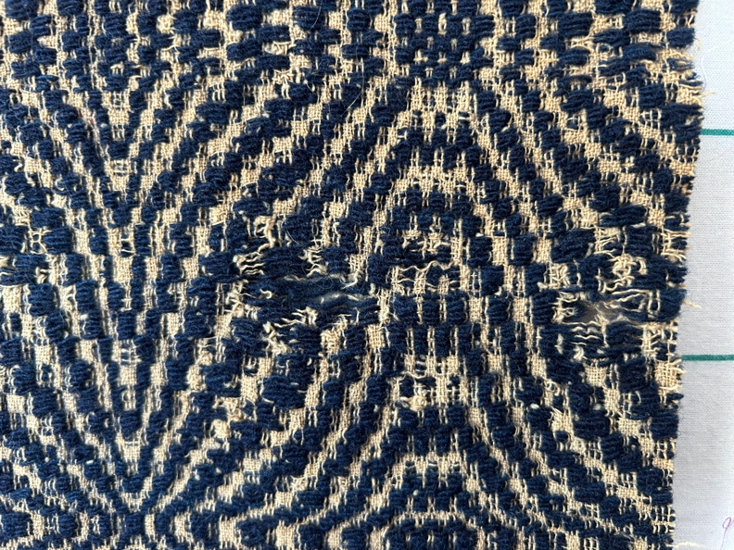 | 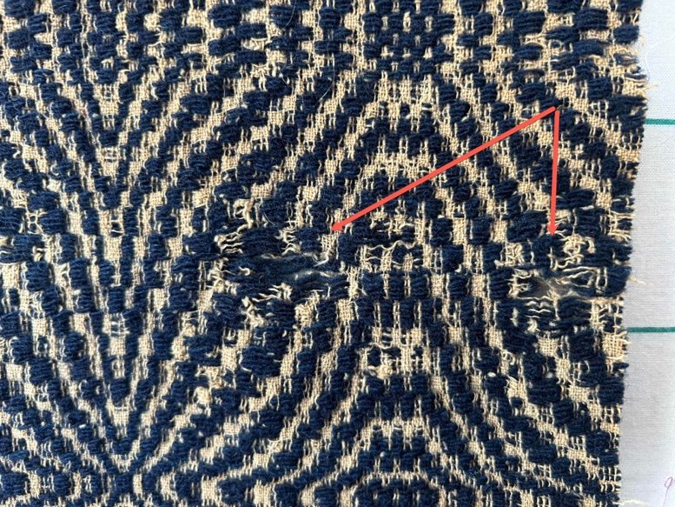

Design & Construction
Predominant colors
 | Red | Blue | Black
 | Orange | Violet/Purple | Grey
 | Yellow | Brown | White
 | Green | Beige / Tan
Antique Colors
 | Red – claret / wine | Yellow – chrome | Blue – Lancaster
 | Red – madder / cinnamon | Green - chrome | Blue – Prussian / Lafayette
 | Red – turkey | Green – Nile | Brown – madder
 | Pinks - double | Blue – Cadet | Butterscotch
 | Orange - madder | Blue - Indigo | Bronze
 | Orange – cheddar / antimony / chrome |  | Late 1800’s Purple

Materials
Fiber Types
 | Cotton | Silk | Wool
 | Cotton Blend | Linen | Synthetic
 | Not Yet Identified
 | Describe other fibers

