Quilt Documentation Form

Overview

Acquisition Information
Owner | From Date | To Date | Location | Cost
David Bailey | July 2024 |  | Naperville, IL | $0.00

Display & Publication History
Date | Event | Location / Publication
Nov 18, 2024 | Anchor Bay Quilter’s Guild Meeting | New Baltimore, MI
Oct 7, 2024 | Montcomb County Quilter's Guild Meeting | Trinity Lutheran Church, Clinton Township, MI

General Description
Quilt Title or Name:  Prussian Blue Ombre print | Date Made: 1830  Exact circa +/- 20 Years
Item Type: | Method of Determination:
Length: 19“ x Width: 20“ | This quilt was appraised in Year.
Additional Information: Given to me by another appraiser who was retiring.

Images
Top | Back
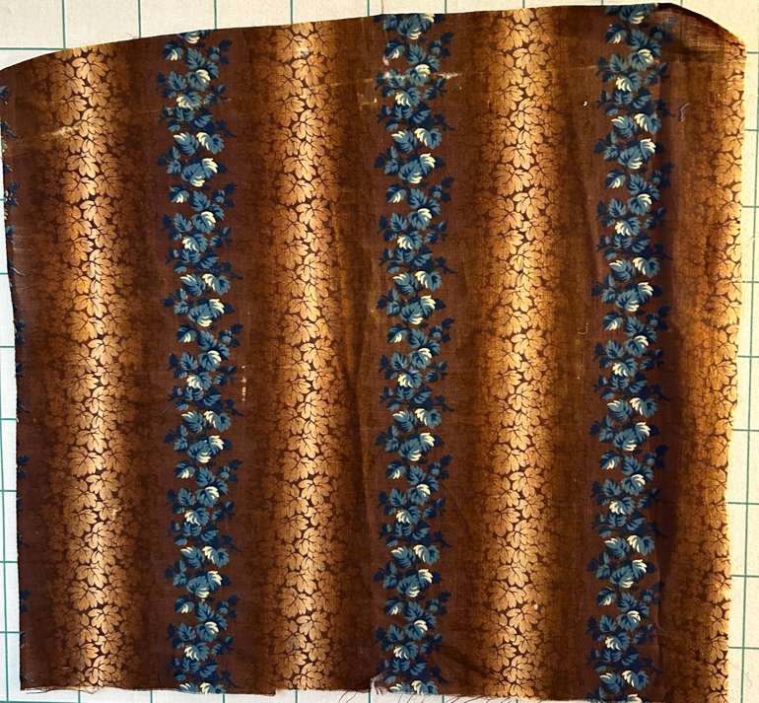 | 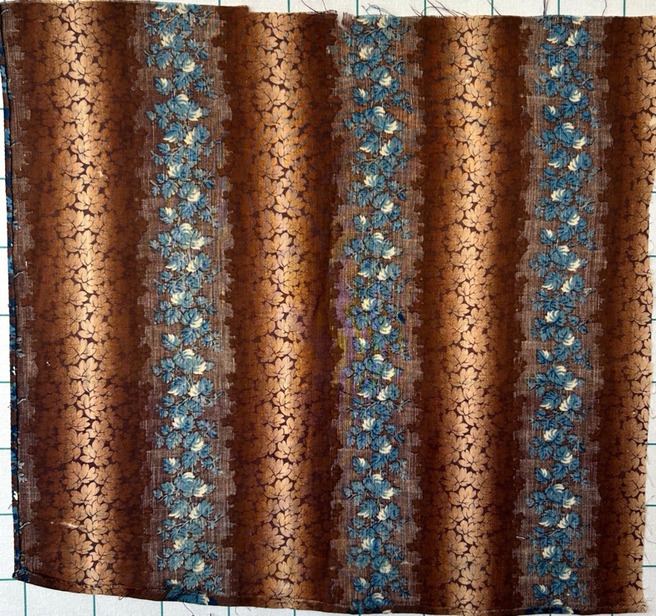
Close-up Front | Close-up Front
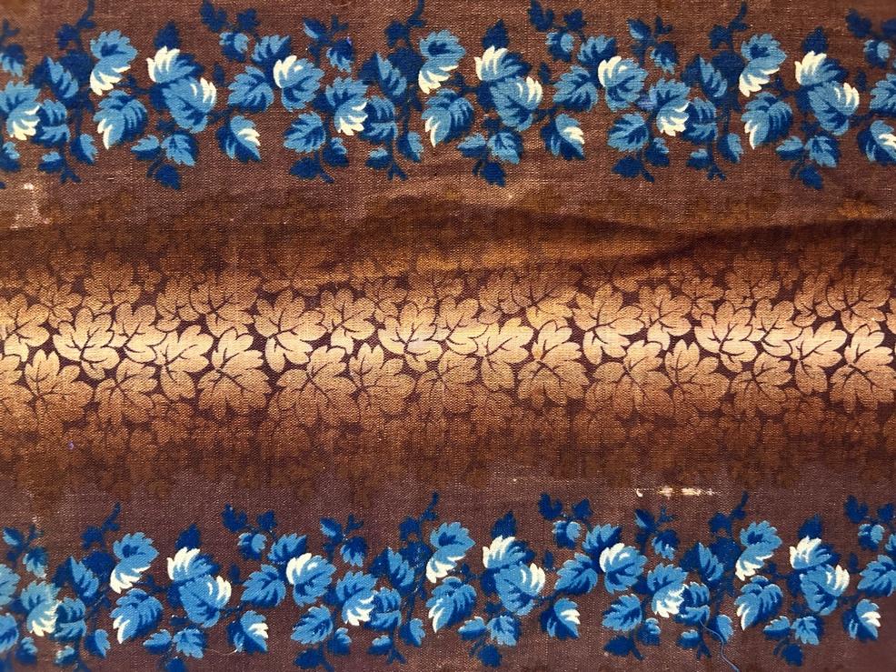 | 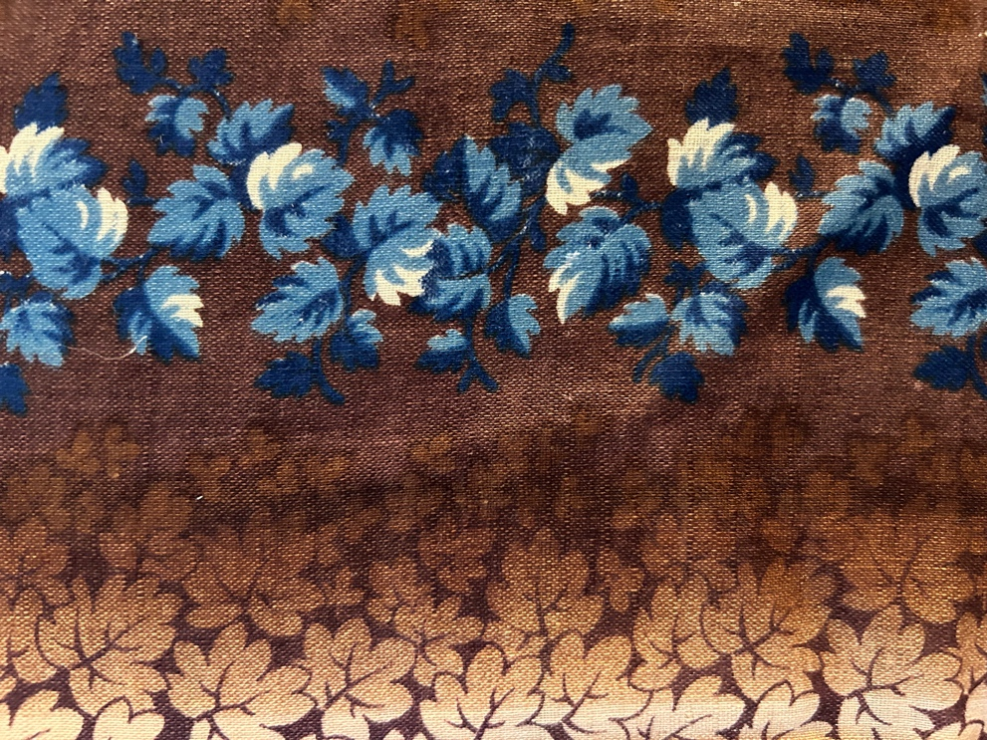
Close Up Front | Close Up Back
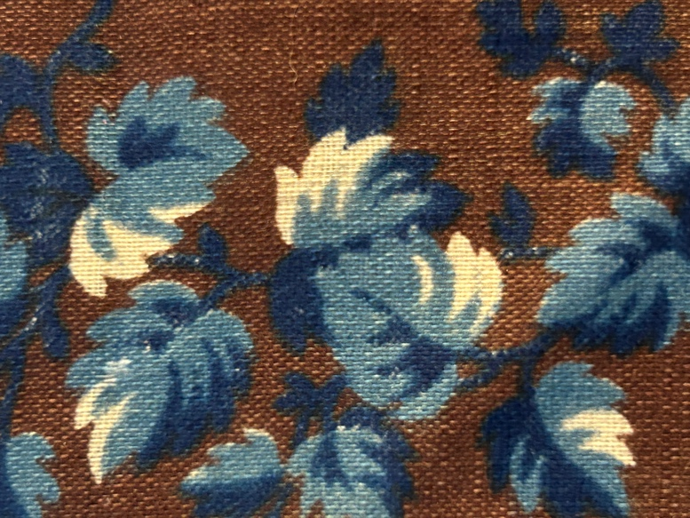 | 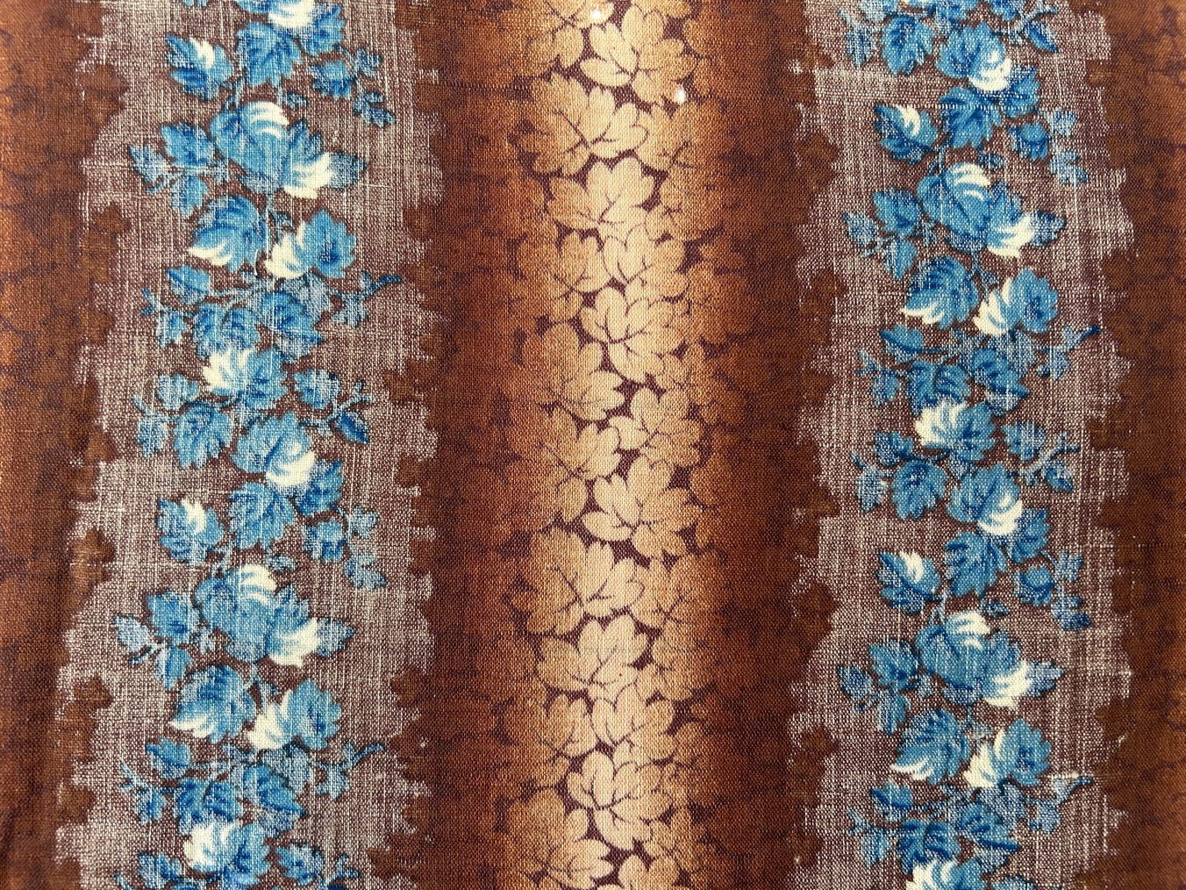

Condition

Flaws
Soiling
Dirty | Stains
Mildew stains | Musty Smell
Discoloration
Running / fugitive color | Faded / bleached color | Crocking
Fabric Damage
Tears / holes | Disintegrating / fall out | Insect damage
Thread bare | Shattering
Sewing / Quilting Damage
Split / open seams | Ties / tufting missing | Embellishments missing
Quilting threads missing | Batting has shifted
Storage Issues
Discoloration from wood | Damage from acid | Fold marks / creases
Describe condition issues
Images for Condition Issues
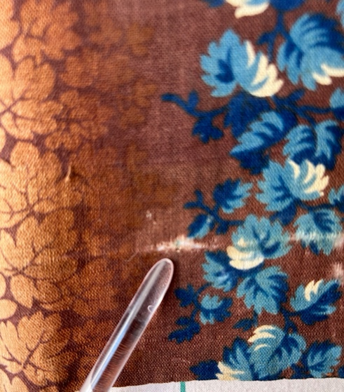 | 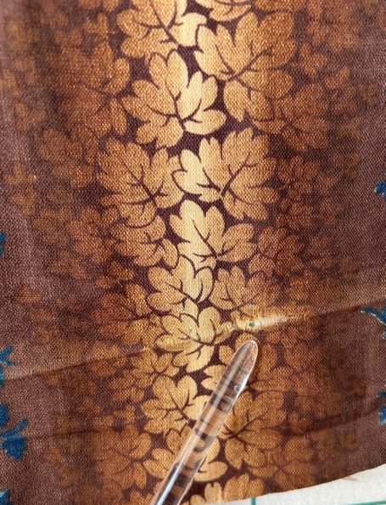
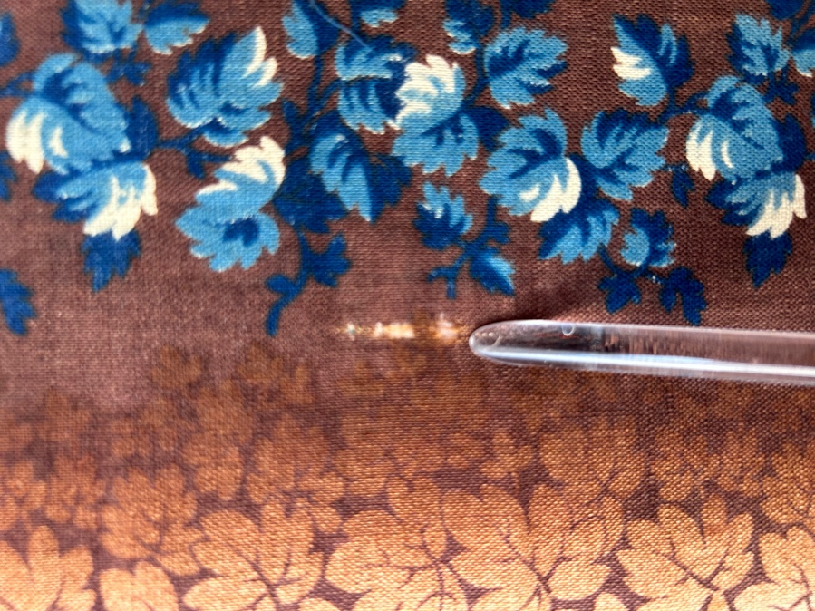 | 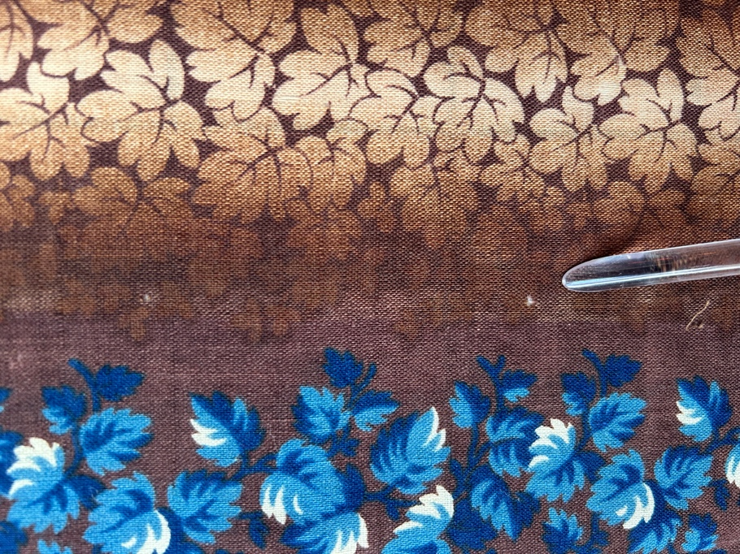
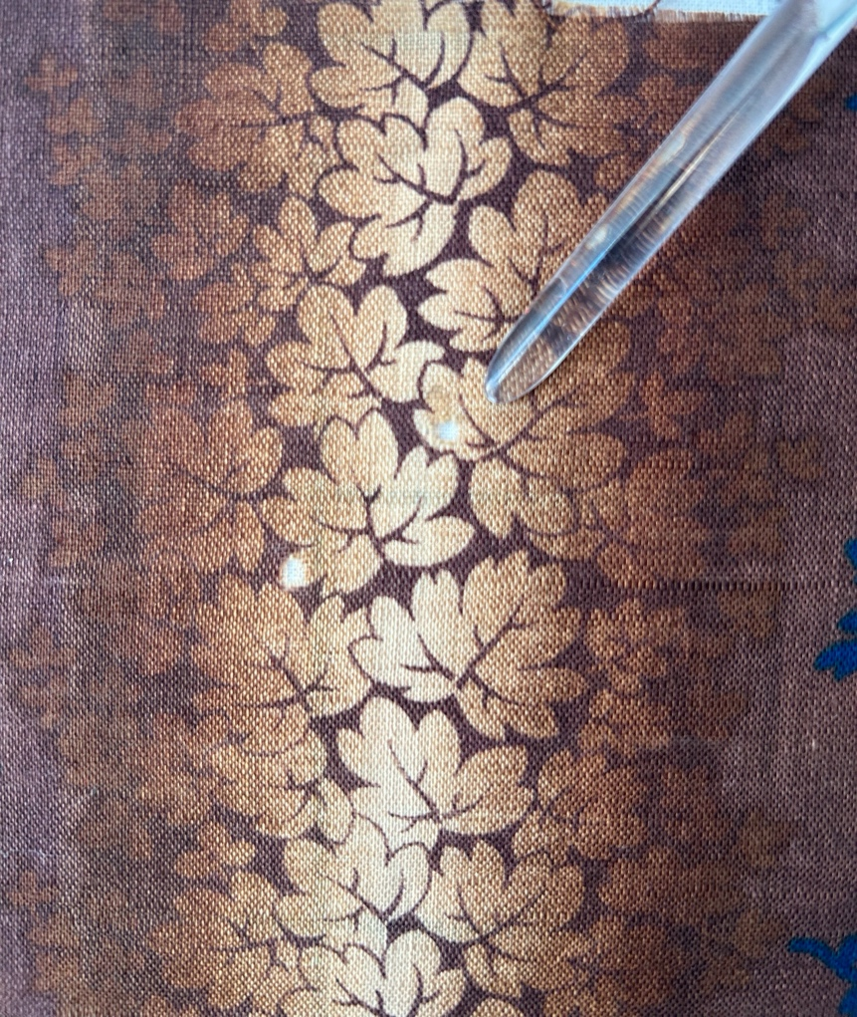

Design & Construction
Predominant colors
 | Red | Blue | Black
 | Orange | Violet/Purple | Grey
 | Yellow | Brown | White
 | Green | Beige / Tan
Antique Colors
 | Red – claret / wine | Yellow – chrome | Blue – Lancaster
 | Red – madder / cinnamon | Green - chrome | Blue – Prussian / Lafayette
 | Red – turkey | Green – Nile | Brown – madder
 | Pinks - double | Blue – Cadet | Butterscotch
 | Orange - madder | Blue - Indigo | Bronze
 | Orange – cheddar / antimony / chrome |  | Late 1800’s Purple
Notes: It is not clear to me which blue is present.
Materials
Fiber Types.
 | Cotton | Silk | Wool
 | Cotton Blend | Linen | Synthetic
 | Not yet identified
 | Describe other fibers
Print Types
 | Batik | Floral | Plaid
 | Cheater Panel | Geometric | Solid / Plain
 | Checked / Gingham | Hand-dyed | Stamped
 | Conversation / Novelty | Victorian Mourning Prints | Stripes
 | Dotted | Multiple scraps
 | Feed sack / Feed sack-like | Paisley
 | Ombre prints in a column format.

