Documentation Form

Overview

Acquisition Information
Owner | From Date | To Date | Location | Cost
David Bailey | Nov 2023 |  | Louisville, KY  AQSG Seminar Vendor  Loiseville KY  PIQUE Antique Quilts & Textiles  Julia Kelly-Hodenius  781 572 1856  www.piquerovouver.com  pique@piquerouver.com | $150

Display & Publication History
Date | Event | Location / Publication | Pro-Rated  Reimbursement
October 7, 2024 | Macomb County Quilting Guild | Clinton Township, Trinity Lutheran Church | $10

General Description
Quilt Title or Name:  French Toile | Date Made: 1785  Exact circa +/- 10 Years
Item Type: | Method of Determination:
Length: 24“ x Width: 23“ | This quilt was appraised in Year.
Additional Information: Chris Moline dates this fabric and felt it was made in France. A red or blue print might have placed it earlier, but brown was a later form of toile.

Images
Top | Back
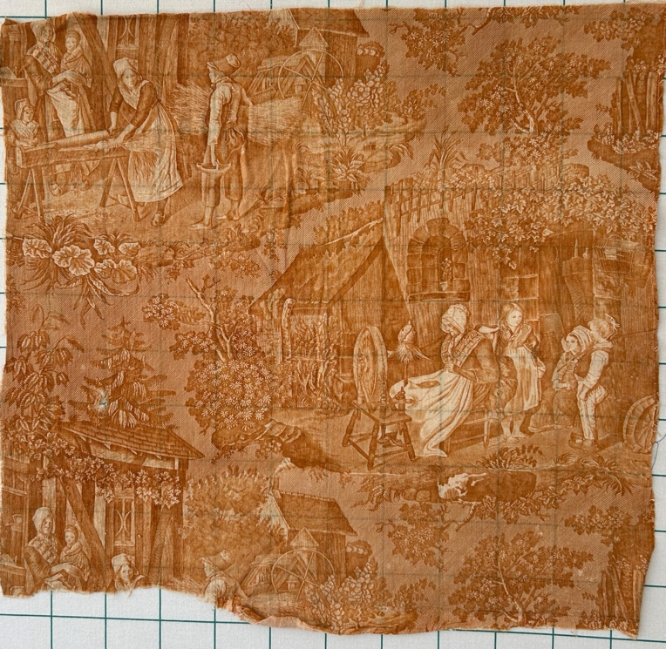 | 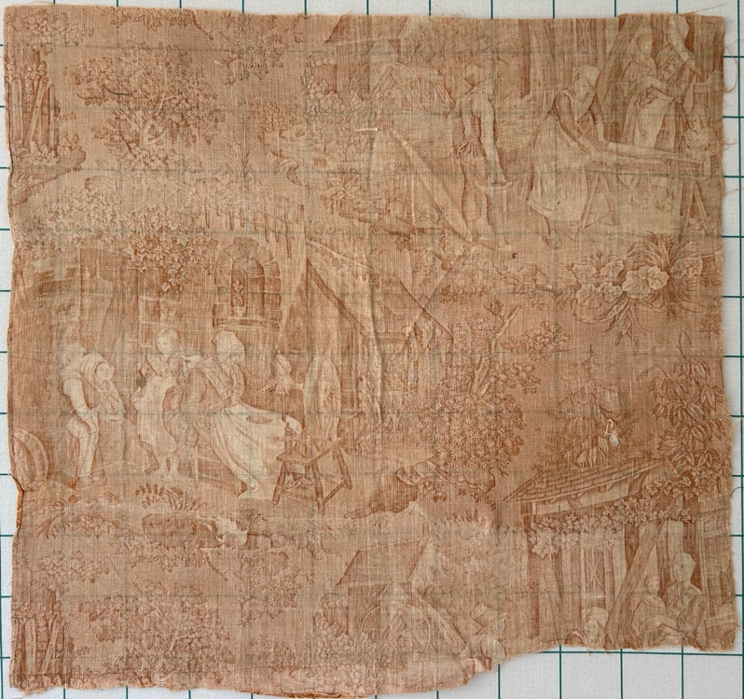
Close-ups
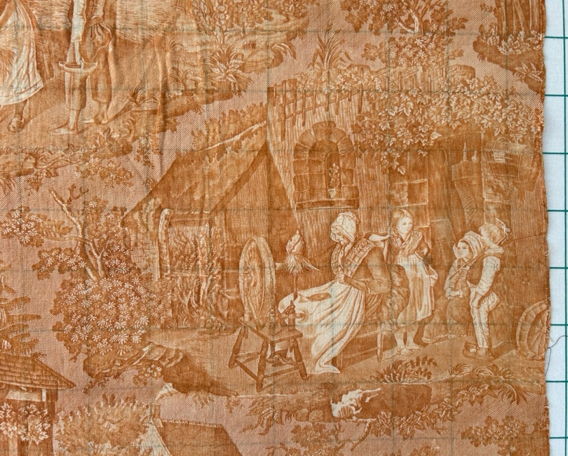 | 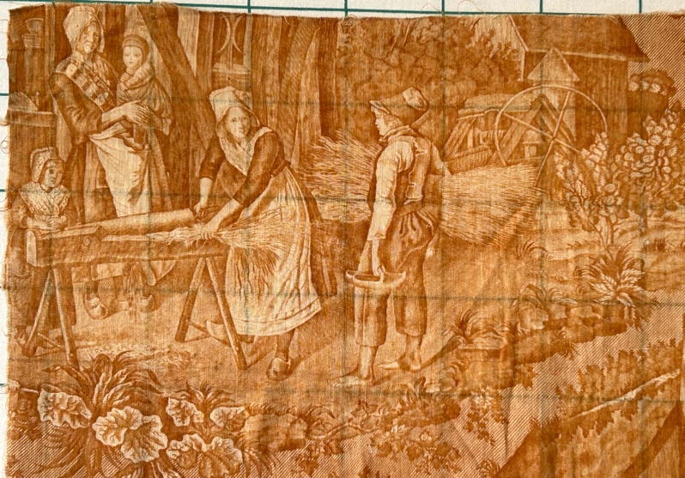

Flaws
Soiling
Dirty | Stains
Mildew stains | Musty Smell
Discoloration
Running / fugitive color | Faded / bleached color | Crocking
Fabric Damage
Tears / holes | Disintegrating / fall out | Insect damage
Thread bare | Shattering
Sewing / Quilting Damage
Split / open seams | Ties / tufting missing | Embellishments missing
Quilting threads missing | Batting has shifted
Storage Issues
Discoloration from wood | Damage from acid | Fold marks / creases
Describe condition issues
Images for Condition Issues
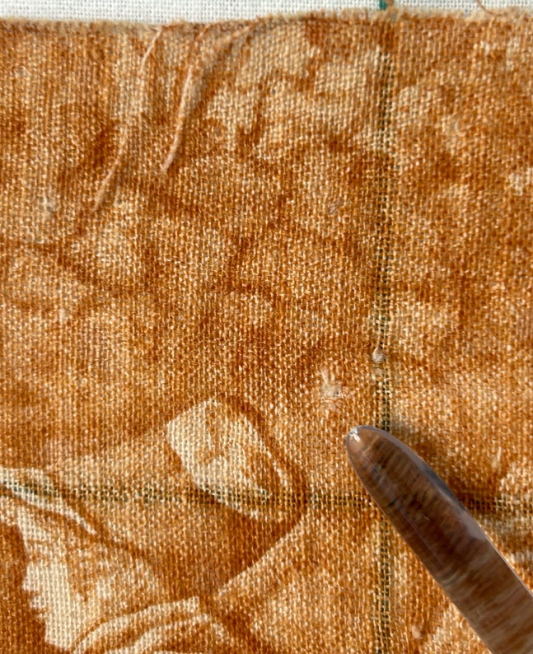 | 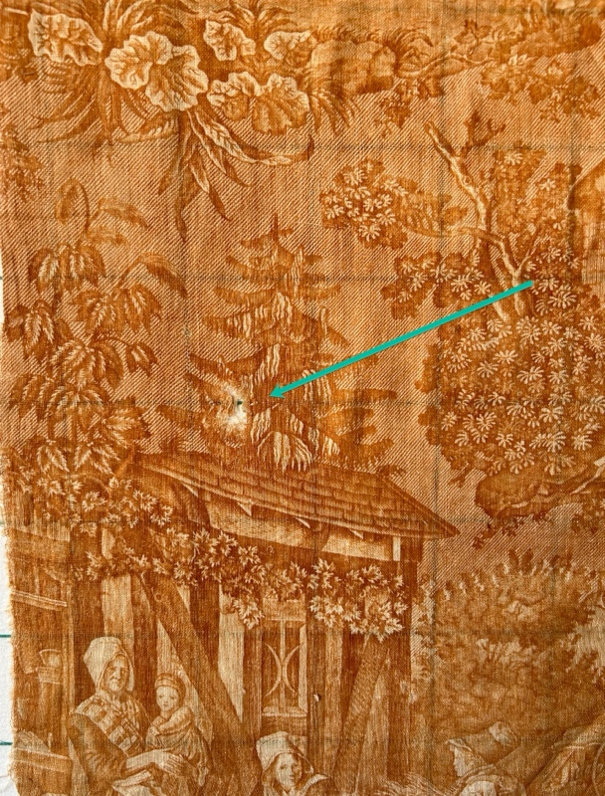

Color
Predominant colors
 | Red | Blue | Black
 | Orange | Violet/Purple | Grey
 | Yellow | Brown | White
 | Green | Beige / Tan
Antique Colors
 | Red – claret / wine | Yellow – chrome | Blue – Lancaster
 | Red – madder / cinnamon | Green - chrome | Blue – Prussian / Lafayette
 | Red – turkey | Green – Nile | Brown – madder
 | Pinks - double | Blue – Cadet | Butterscotch
 | Orange - madder | Blue - Indigo | Bronze
 | Orange – cheddar / antimony / chrome |  | Late 1800’s Purple

Materials
Sources of Fabric
 | Companies | Designer | Fabric Name & Number
 | Company name | Designer name | Fabric name & code
 | Not Known
Fiber Types
 | Cotton | Silk | Wool
 | Cotton Blend | Linen | Synthetic
 | Not confirmed - likely cotton or flax
Fabric Types
 | Broadcloth | Sateen | Upholstery
 | Flannel | Satin | Chintz
 | Shirting | Muslin | Glazed
 | Suiting | Velvet | Handwoven
 | Denim | Felt | Lindsey-Woolsey
 | Toile
Print Types
 | Scenes of country-side living – peasants farming and tending to livestock.

