Documentation Form

Overview

Acquisition Information
Owner | From Date | To Date | Location | Cost
David Bailey | April 28, 2023 | - | Purchased on-line | $71.65

Display & Publication History
Nov 18, 2024 | Anchor Bay Quilter’s Guild Meeting | New Baltimore, MI
Oct 7, 2024 | Montcomb County Quilter's Guild Meeting | Trinity Lutheran Church, Clinton Township, MI

General Description
Quilt Title or Name:
Palampore
Item Type:

Length: 92“ x Width: 52“
Additional Information: This fabric is a reproduction of a 1775 chintz print. Chintz is associated with large scale prints. Here the print colors were applied by woodblock stamping. This style print was being quickly and cheaply produced in India and exported to Europe. This flooded the English and French markets - much to the dismay of the textile industries in those countries. This prompted laws forbidding the trading and use of these imported cloths.

Notice the coloration - brown, greens, maroons and the subjects of the print. This print style is called Palampore and typically features a tree, birds, leaves, flowers and fruit. The different printed motifs would be cut out of the fabric and appliqued by broderie perse to form a new quilt top design.
For the purpose of making quilts, motifs were cut from this fabric and arranged and appliqued (broderie perse) to create the top design.

This reproduction print was printed in 2014 by Windham Fabrics.

Images
Top
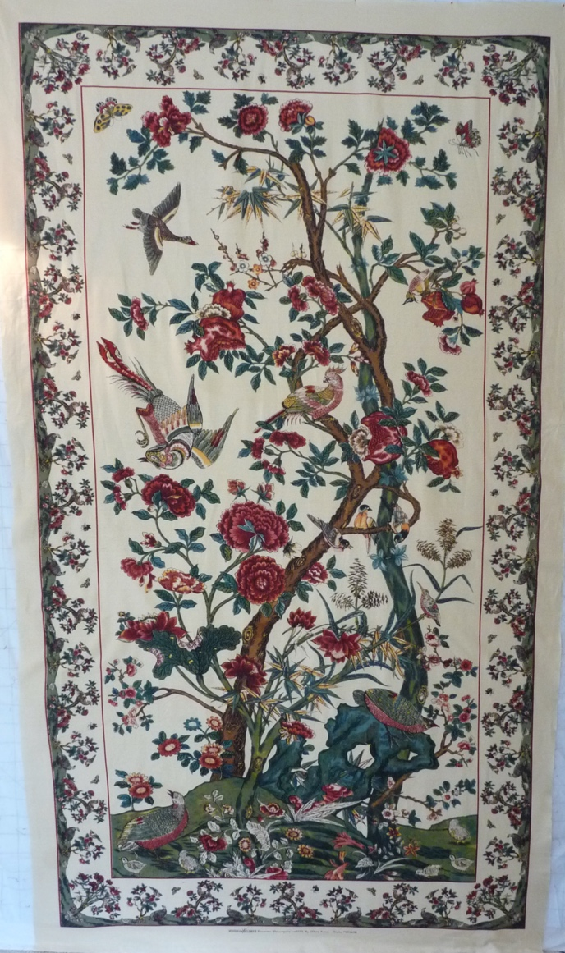 | 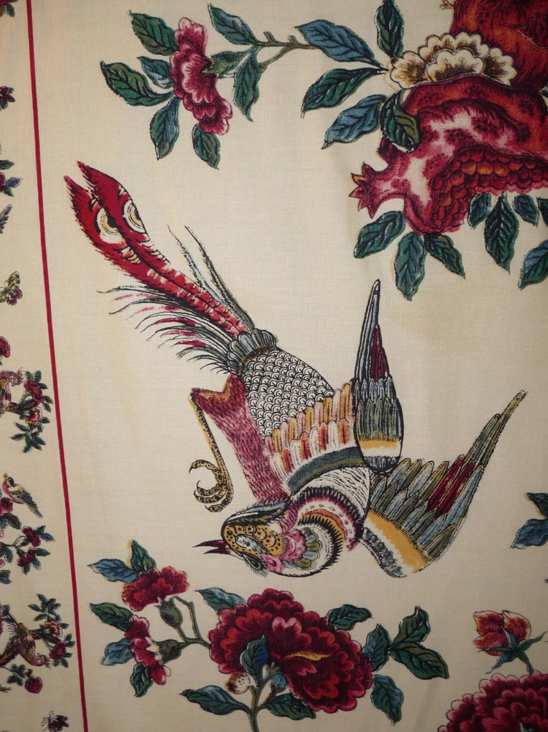
 | 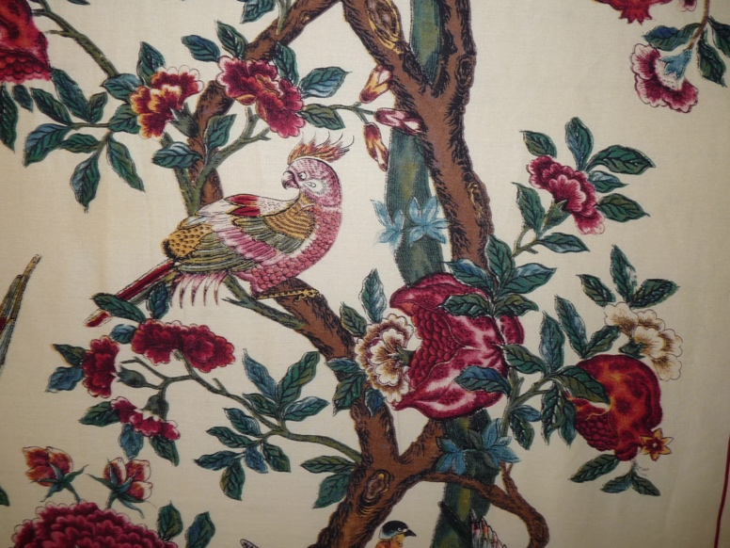

Predominant colors
 | Red | Blue | Black
 | Orange | Violet/Purple | Grey
 | Yellow | Brown | White
 | Green | Beige / Tan

